Sales of prescription medicines in 2024
3.7%
Increase in the number of prescriptions issued in 2024 compared to 2023

In 2024, 513.4 million prescriptions were issued, of which 97.4% were in electronic form, i.e. 0.8 percentage points more than in 2023

In 2024, 513.4 million prescriptions were issued (18.3 million more than the year before). 97.4% of them were electronic prescriptions, which means an increase of 0.8 percentage points compared to 96.6% of electronic prescriptions in 2023.
In 2024, 513.4 million prescriptions were issued (18.3 million more than the year before). The largest number of electronic prescriptions issued per inhabitant was recorded in Zamość (30.4), while the lowest amount was observed in łomżyński
poviat (3.0).

In 2024, there was no more than a 1.5 percentage points difference in the percentage of
electronic prescriptions issued across voivodeships. The highest percentage of electronic prescriptions was recorded, as in 2023, in the pomorskie voivodeship (98.2%) and the lowest in świętokrzyskie voivodeship (96.7%). In the case of poviats, the highest percentage of
electronic prescriptions were observed in poviats: moniecki (99.5%) and siedlecki (99.4%), while the lowest in golubsko-dobrzyński poviat (92.7%).
In 2024, the lowest percentages of electronic prescriptions per inhabitant were recorded in poviats: łomżyński (3.0) and przemyski (3.1), while the highest percentages were recorded in the city with poviat status: Zamość (30.4). However, it should be noted that the highest values of this indicator were observed in cities with poviat status, while the lowest were recorded in the poviats surrounding these cities. This occurs because cities with poviat status play the role of public service centers, with a reach extending beyond their administrative borders.
Map 1. Number of electronic prescriptions per capita in poviat in 2024
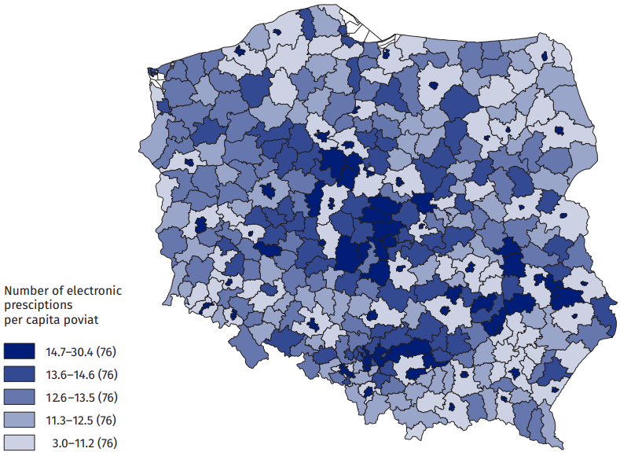
Source: The e-Health Centre.

In 2024, the value of prescription medicine sales amounted to PLN 29.6 billion, of which the value of refunds was PLN 13.3 billion and patients spent PLN 16.3 billion.
In 2024, the value of all prescription medicine sales amounted to PLN 29.6 billion (PLN 3.5 billion more than in 2023, i.e. by 13.4%). The value of the refund amounted to PLN 13.3 billion (PLN 2.8 billion more than in 2023, i.e. by 26.7%). Patients spent PLN 16.3 billion on prescription medicines (PLN 0.7 billion more than in 2023). In 2024, the refund represented 44.8% of the value of medicines sold on prescription (compared to 40.4% in 2023).
Table 1. Sale of prescription medicines in Poland
Specification | 2023 | 2024
Specification | in billions of PLN
Value of sales | 26.1 | 29.6
Value of refunds | 10.5 | 13.3
Value of patient’s surcharge | 15.6 | 16.3
Source: The e-Health Centre.

In 2024, the value of prescription medicines sold per capita in Poland amounted to PLN 787 (PLN 94 more than in 2023, i.e. by 13.6%), of which the surcharge by the patient amounted to PLN 434 (PLN 21 more than in 2023, i.e. by 5.1%) and refund by the National Health Fund amounted to PLN 353 (PLN 73 more than in 2023, i.e. by 26.1%).

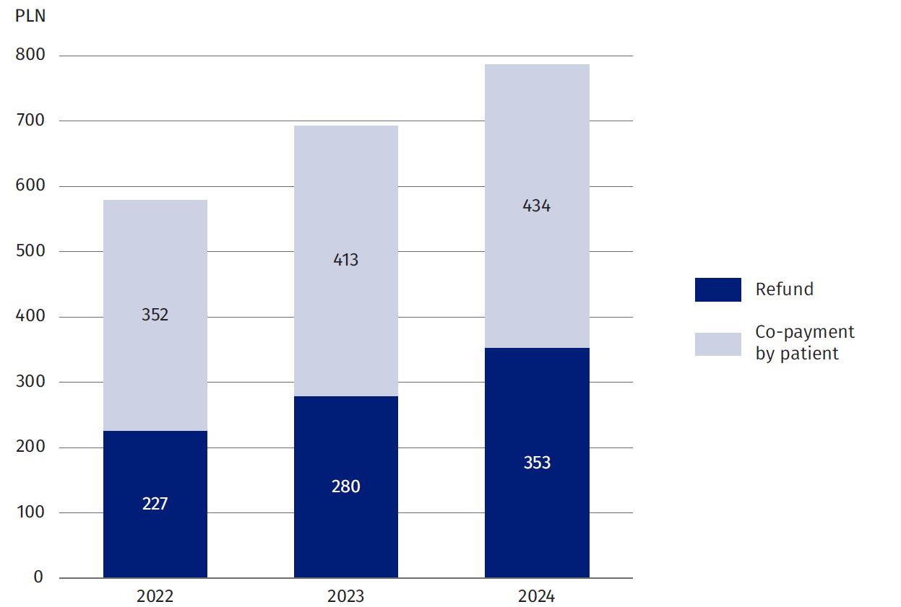
Chart 1. Value of reimbursement and co-payments for prescription medicines per capita Poland
In 2024, the value of prescription medicine sales per capita amounted to PLN 787, of which patient surcharge was PLN 434 and the value of refunds was PLN 353, which accounts for 44.8% of value of prescription medicine sales.

Source: The e-Health Centre.

In 2024, as in 2023, the highest value of prescription medicines sales and refund by the National Health Fund for medicines per capita was recorded in łódzkie voivodeship. These values amounted to: PLN 894 (medicine sales), PLN 415 (refund). The highest amount of patient surcharge for medicines per capita was recorded in mazowieckie voivodeship (PLN 495). As last year, the lowest value of prescription medicine sales and refund for medicines per capita was recorded in podkarpackie voivodeship. In this case, these values amounted to: PLN 669 (medicine sales), PLN 300 (refund). The lowest amount of patient surcharge for medicines per capita was recorded in warmińsko-mazurskie (PLN 361).

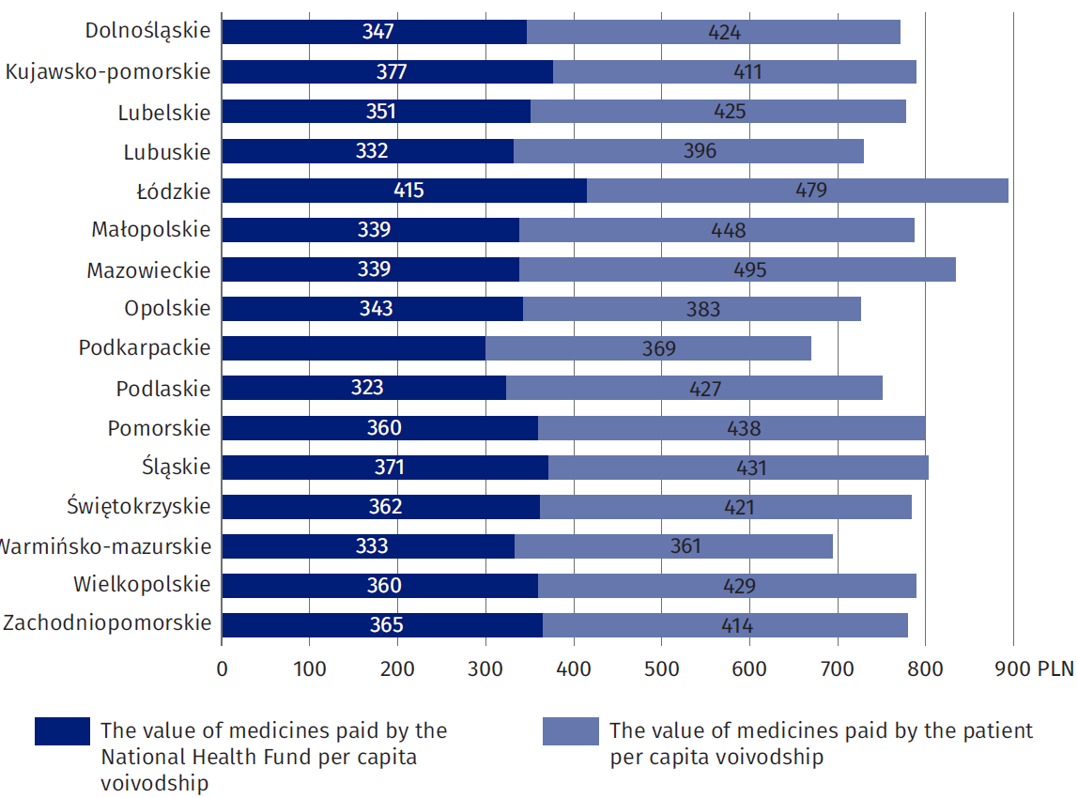
Chart 2. Prescription medicines sales value per capita voivodship in 2024
Source: The e-Health Centre.

Map 2. Medicine sales value per capita in poviat in 2024
In 2024, the highest value of presctiption medicine sales per inhabitant was recorded in Krosno (PLN 1 651), while the lowest value was observed in przemyski poviat (PLN 152).

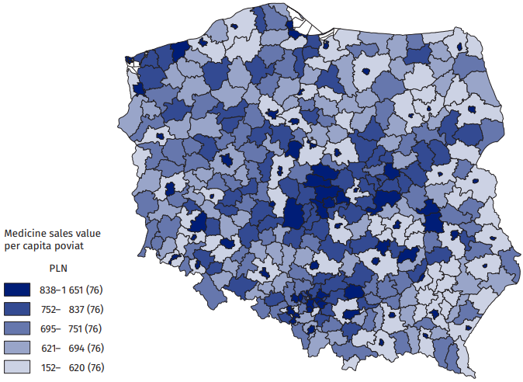
Source: The e-Health Centre.
In 2024, the highest values of prescription medicines sales per capita were observed in
cities with poviat status: Krosno (PLN 1 651) and Zamość (PLN 1 637). The lowest values were recorded in poviats: przemyski (PLN 152) and łomżyński (PLN 166). However, it should be noted that patients often buy medicines outside their poviat (especially in the case of poviats surrounding the cities with poviat status).

Map 3. Percentage of medicines refund in the value of medicines sold in poviats in 2024
In 2024, the highest
percentage of refunds in relation to the value of
prescription medicine sales was recorded in sępoleński poviat (53.8%), while the
lowest percentage was
observed in piaseczyński poviat (37.1%).

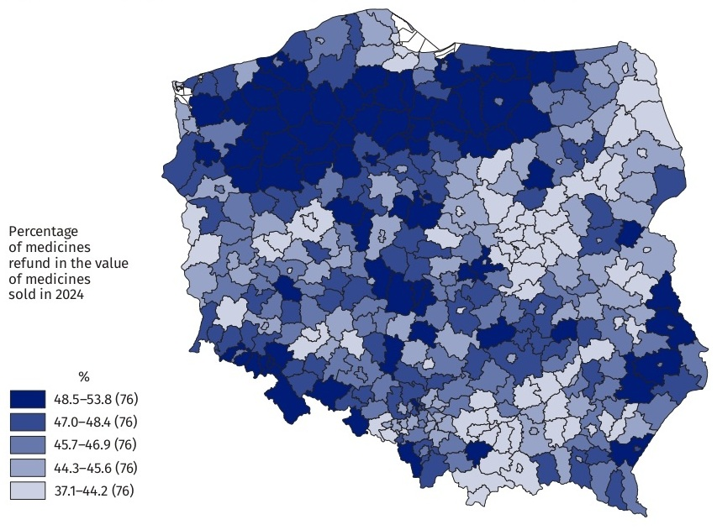
Source: The e-Health Centre.
Poviats with the lowest percentage of refunds in relation to the value of medicines sales in 2024 are: piaseczyński (37.1%) and Warszawa (37.5%). The poviats with the highest refund rate in the value of medicines sold are: sępoleński (53.8%) and myślenicki (53.1%).
Alimentary tract and metabolism medicines (21.4% of share) and cardiovascular system medicines (18.8% of share) accounted for the largest share in the value of medicines sold in 2024.

Chart 3. Share of prescription medicines sales by Anatomical-Therapeutic-Chemical Classification groups (ATC) in 2024
Alimentary tract and
metabolism medicines (21.4% of share), and cardiovascular system medicines (18.8%) accounted for the largest share in the value of medicines sold in 2024.

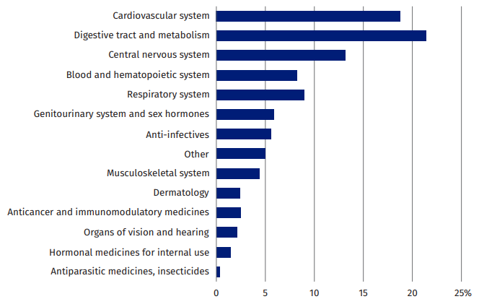
Source: The e-Health Centre.

In 2024, the lowest amount spent per poviat inhabitant on filling prescriptions for
cardiovascular system medicines was in the following poviats: przemyski (PLN 37), łomżyński (PLN 41) and the highest amount — in cities with the poviat status: Zamość (PLN 292) and Krosno (PLN 283).

Map 4. Sales value of prescription medicines related to the cardiovascular system
per capita in poviat in 2024

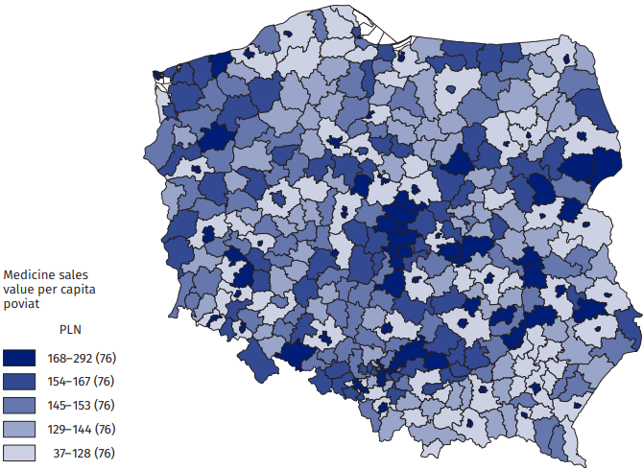
Source: The e-Health Centre.
In 2024, the lowest amount spent per poviat inhabitant on filling prescriptions for medicines for the alimentary tract and metabolism was observed in przemyski poviat (PLN 28) while the highest amount was recorded in cities with poviat status: Skierniewice (PLN 342) and Tarnów (PLN 338).

Map 5. Sales value of prescription medicines related to the alimentary tract and metabolism system per capita in poviat in 2024
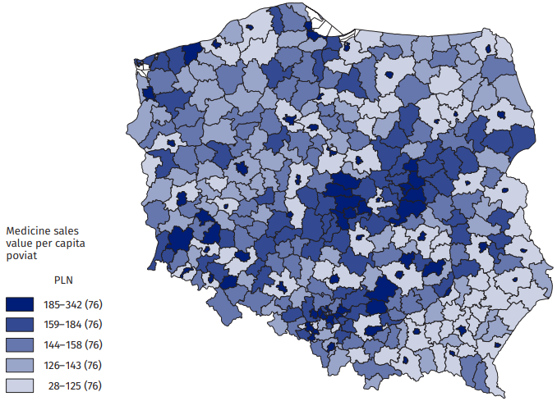

Source: The e-Health Centre.

The news release was based on data from the Medical Information System of the Ministry of Health regarding the implementation of prescriptions (including, among others, the number of prescriptions, the number of packages, the value of sales, reimbursement and patient subsidies for medicines according to the Anatomical-Therapeutic-Chemical Classification ATC).

When quoting Statistics Poland data, please provide the information: “Source of data: Statistics Poland”, and when publishing calculations made on data published by Statistics Poland, please include the following disclaimer: “Own study based on figures from Statistics Poland”.
Prepared by:  Social Surveys and Labour Market Department  Director Agnieszka Zgierska PhD  Phone: (+48 22) 608 30 15 | Issued by:  Press Office  Mobile: (+48) 695 255 032  Phone: (+48 22) 608 38 04, (+48 22) 449 41 45,  (+48 22) 608 30 09  e-mail: obslugaprasowa@stat.gov.pl

stat.gov.pl/en/

@StatPoland

@GlownyUrzadStatystyczny

gus_stat

glownyurzadstatystycznygus

glownyurzadstatystyczny
Related information
Health and health care in 2023
Methodological report. Health and health care statistics − Statistics Poland’s reports

According to the address of the pharmacy or pharmacy where the prescription was completed.

