Prices of agricultural products in September 2025
Procurement prices of basic agricultural products decreased in September 2025 in comparison with the previous month (by 0.7%), while compared to the corresponding period of the last year, they increased (by 9.8%).
9.8%
an increase in procurement prices of basic agricultural products in comparison with September 2024

Chart 1. Changes in procurement prices of basic agricultural products in relation to the previous month
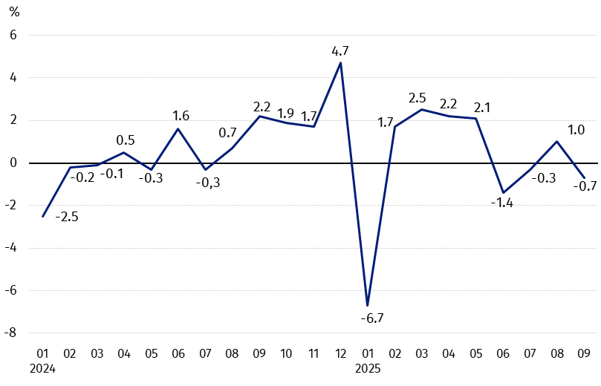
In September 2025, in comparison with August 2025, the procurement prices of basic agricultural products decreased except for cattle for slaughter and poultry

Chart 2. Changes in procurement prices of basic agricultural products in relation to the corresponding month of the previous year
Procurement prices of basic agricultural products, except for wheat and pigs for slaughter in September 2025 were higher than those recorded in September 2024

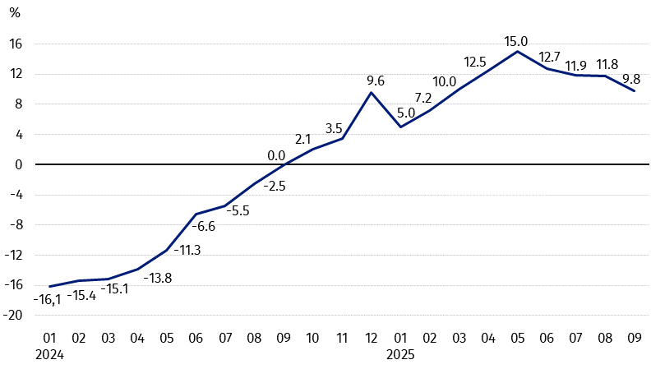

Procurement prices and marketplace prices received by farmers
In September 2025, grains, pigs for slaughter and milk were sold at the lower procurement prices than in the previous month, while prices of poultry increased. At marketplaces, there was less paid for the most agricultural products, except for rye and maize. On both markets, prices of cattle for slaughter increased.
Compared to the corresponding month of the previous year, in September this year a decrease was noted in the procurement prices of the most grains and pigs for slaughter, while prices of cattle for slaughter, poultry and milk increased. At marketplaces, the most grains were sold at higher prices, while prices of cattle for slaughter were lower. On both markets, prices of rye and maize increased, while prices of wheat, oats, and potatoes decreased.
Table 1. Prices of agricultural products (excluding VAT) in September 2025
Specification | Procurement prices |  |  | Marketplaces prices
Specification | 09 2025
Specification | in zloty | 08 2025=100 | 09 2024=100 | in zloty | 08 2025=100 | 09 2024=100
Cereal grain – per dt
Wheat | 74.90 | 96.7 | 88.3 | 107.93 | 96.0 | 99.7
Rye | 59.92 | 95.7 | 102.9 | 86.51 | 100.1 | 102.1
Barley | 74.73 | 97.8 | 94.9 | 102.98 | 96.8 | 101.4
Triticale | 69.24 | 98.0 | 92.5 | 94.25 | 97.4 | 100.8
Oat | 58.92 | 87.8 | 75.0 | 93.65 | 96.2 | 95.0
Maize | 86.79 | 93.2 | 149.5 | 128.59 | 102.4 | 104.1
Potatoes – per dt | 55.15 | 82.6 | 93.5 | 192.20 | 93.9 | 88.6
Animals for slaughter – per kg
Cattle (excl. calves) | 16.04 | 108.6 | 153.0 | 11.93 | 100.5 | 98.6
of which young cattle | 16.41 | 109.6 | 151.8 | . | . | .
Pigs | 6.47 | 95.7 | 90.0 | . | . | .
Poultry | 6.69 | 100.4 | 120.3 | . | . | .
Cows’ milk – per hl | 223.47 | 99.3 | 107.3 | . | . | .
Data on procurement prices were calculated on the basis of information on value and quantity of procurement by legal persons and independent organizational entities without legal personality (without natural persons).
Indices of procurement prices and prices received by farmers at marketplaces were calculated on the basis of absolute data expressed with more precision than in the tables.

Prices of major agricultural products in September 2025
In September 2025, PLN 77.90 was paid per dt of wheat in procurement, i.e. 3.3% less than in the previous month and 11.7% less than a year ago. At marketplaces, the price of wheat (PLN 107.93 per dt) decreased by 4.0% in comparison with August this year and by 0.3% compared to September last year.
The procurement price of rye (PLN 59.92 per dt) was lower by 4.3% in comparison with August this year, but higher by 2.9% than in September 2024. The price of rye at the marketplace (PLN 86.51 per dt) increased both on a monthly basis (by 0.1%) and on an annual basis (by 2.1%).
In September 2025, PLN 55.15 was paid per dt of potatoes in procurement, i.e. 17.4% less than in the previous month and 6.5% less than in the corresponding period of the last year. At marketplaces, the price of potatoes (PLN 192.20 per dt) decreased by 6.1% in comparison with August this year and by 11.4% compared to September 2024.
The procurement price of cattle of slaughter (PLN 16.04 per kg) was higher both on a monthly basis (by 8.6%) and on an annual basis (by 53.0%).
In September 2025, PLN 6.47 was paid per kg of pigs for slaughter in procurement, i.e. 4.3% less than a month ago and 10.0% less than a year ago.
The procurement price of poultry for slaughter (PLN 6.69 per kg) increased by 0.4% in the comparison with August this year and by 20.3% compared to September 2024.
PLN 223.47 was paid in procurement per hl of cows’ milk, i.e. 0.7% less than in the previous month, but 7.3% more than a year ago.

Chart 3. Procurement and marketplaces prices of wheat and rye

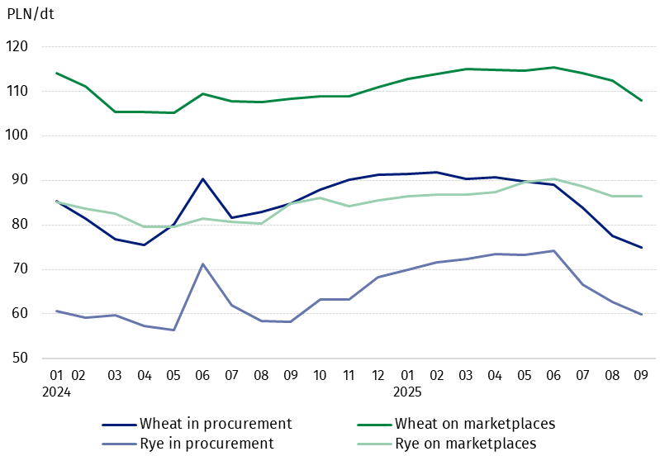

Chart 4. Procurement and marketplaces prices of potatoes

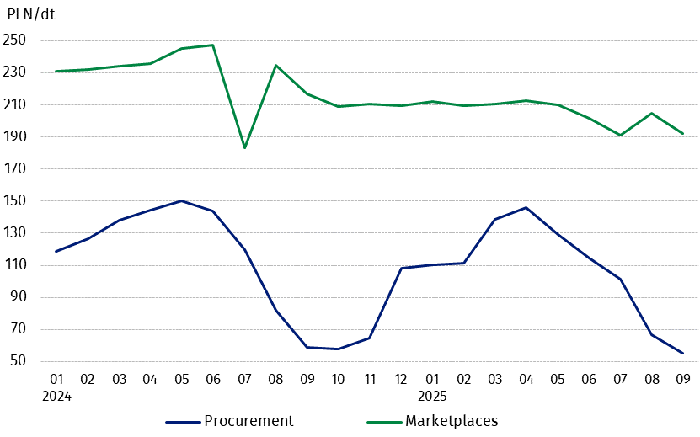

Chart 5. Procurement and marketplaces prices of cattle for slaughter and procurement prices of pigs for slaughter
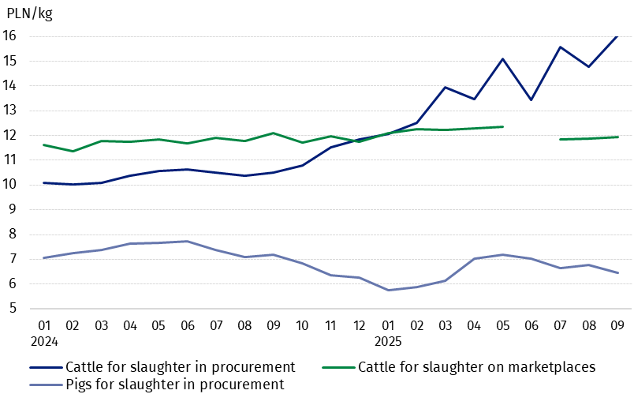

Chart 6. Procurement prices of poultry for slaughter and cows’ milk
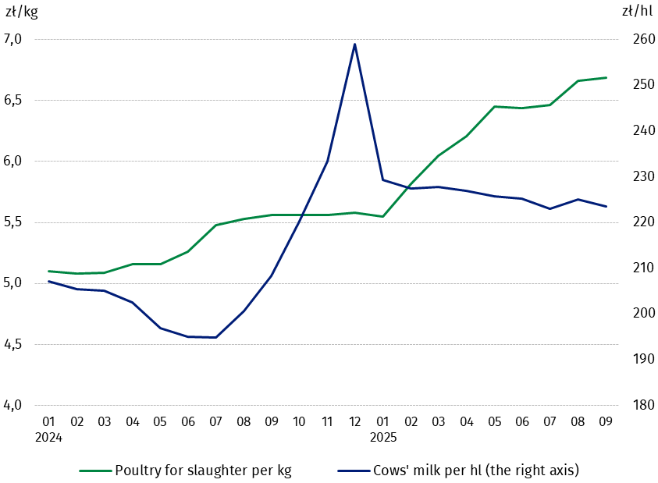

The differentiation of the level of prices of basic agricultural products in particular voivodships is presented in Table 2 for procurement prices and in Table 3 for prices obtained by farmers on marketplaces (Excel sheet).
In case of quoting Statistics Poland data, please provide information: “Source of data: Statistics Poland”, and in case of publishing calculations made on data published by Statistics Poland, please include the following disclaimer: “Own study based on figures from Statistics Poland”.

Prepared by:  Trade and Services Department  Director Ewa Adach-Stankiewicz  Phone: (+48 22) 608 31 24 | Issued by:  Press Office  Mobile: (+48) 695 255 032  Phone: (+48 22) 608 38 04, (+48 22) 449 41 45.  (+48 22) 608 30 09  e-mail: obslugaprasowa@stat.gov.pl

stat.gov.pl/en/

@StatPoland

@GlownyUrzadStatystyczny

gus_stat

glownyurzadstatystycznygus

glownyurzadstatystyczny
Related information
Socio-economic situation of the country in 2025
Procurement and prices of agricultural products in 2024

Data available in databases
BDL – Prices - Prices in agriculture
Knowledge Databases – Economy - Prices – Producer prices - Prices in agriculture

Terms used in official statistics
Procurement of agricultural products
Procurement prices
Marketplace
Marketplace prices

Wheat, rye, cattle for slaughter, pigs for slaughter, poultry, cow's milk
Procurement prices – excluding sowing seed.
Procurement prices – total (of which: edible early kinds, seed, edible late, industrial, of which starch). Marketplaces prices – edible excluding early kinds.
Marketplaces prices – average weighted price of cattle for slaughter calculated with the adoption of the structure of procurement quantity of young cattle and cows for slaughter.

