Prices of agricultural products in October 2025
Procurement prices of basic agricultural products decreased in October 2025 in comparison with the previous month (by 1.6%), while compared to the corresponding period of the last year, they increased (by 6.4%).
6.4%
an increase in procurement prices of basic agricultural products in comparison with October 2024

Chart 1. Changes in procurement prices of basic agricultural products in relation to the previous month
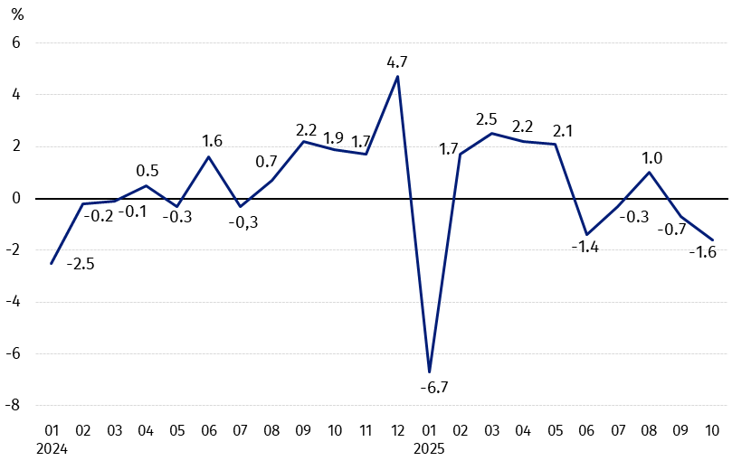
In October 2025, in comparison with September 2025, the procurement prices of basic agricultural products decreased except for rye

Chart 2. Changes in procurement prices of basic agricultural products in relation to the corresponding month of the previous year
Procurement prices of basic agricultural products, except for wheat, rye and pigs for slaughter, were higher in October 2025 than those recorded in October 2024

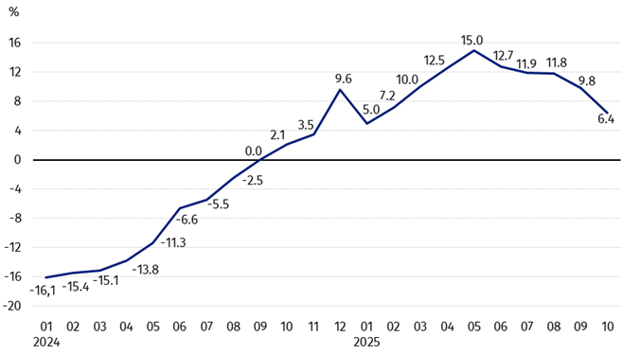

Procurement prices and marketplace prices received by farmers
In October 2025, the majority of agricultural products were sold at the lower procurement prices than in the previous month, while prices of rye and triticale increased.
At the marketplaces, there was less paid for all agricultural products.
Compared to the corresponding month of the previous year, in October this year there was recorded the decrease in prices of the majority of agricultural products both in procurement and at the marketplaces, except for poultry and milk in procurement and maize at the marketplaces as well as cattle for slaughter at both markets.

Table 1. Prices of agricultural products (excluding VAT) in October 2025
Specification | Procurement prices |  |  | Marketplaces prices
Specification | 10 2025
Specification | in zloty | 09 2025=100 | 10 2024=100 | in zloty | 09 2025=100 | 10 2024=100
Cereal grain – per dt
Wheat | 74.47 | 99.4 | 84.7 | 104.31 | 96.6 | 95.9
Rye | 60.15 | 100.4 | 95.2 | 82.73 | 95.6 | 96.2
Barley | 74.41 | 99.6 | 93.6 | 100.12 | 97.2 | 98.1
Triticale | 71.28 | 102.9 | 92.1 | 91.11 | 96.7 | 96.6
Oat | 58.11 | 98.6 | 68.2 | 90.59 | 96.7 | 92.0
Maize | 53.87 | 62.1 | 87.9 | 123.54 | 96.1 | 103.0
Potatoes – per dt | 53.61 | 97.2 | 92.7 | 179.09 | 93.2 | 85.7
Animals for slaughter – per kg
Cattle (excl. calves) | 15.95 | 99.4 | 147.8 | 11.80 | 98.9 | 100.6
of which young cattle | 16.50 | 100.5 | 148.6 | . | . | .
Pigs | 6.10 | 94.3 | 89,0 | . | . | .
Poultry | 6.66 | 99.5 | 119.8 | . | . | .
Cows’ milk – per hl | 220.64 | 98.7 | 100.2 | . | . | .
Data on procurement prices were calculated on the basis of information on value and quantity of procurement by legal persons and independent organizational entities without legal personality (without natural persons).
Indices of procurement prices and prices received by farmers at marketplaces were calculated on the basis of absolute data expressed with more precision than in the tables.

Prices of major agricultural products in October 2025
In October 2025, PLN 74.47 was paid per dt of wheat in procurement, i.e. 0.6% less than in the previous month and 15.3% less than a year ago. At the marketplaces, the price of wheat (PLN 104.31 per dt) decreased by 3.4% in comparison with September this year and by 4.1% compared to October last year.
The procurement price of rye (PLN 60.15 per dt) was higher by 0.4% in comparison with September this year, but it was lower by 4.8% than in October 2024. The price of rye at the marketplace (PLN 82.37 per dt) decreased both on a monthly basis (by 4.4%) and on an annual basis (by 3.8%).
In October 2025, PLN 53.61 was paid per dt of potatoes in procurement, i.e. 2.8% less than in the previous month and 7.3% less than in the corresponding period of the last year. At the marketplaces, the price of potatoes (PLN 179.09 per dt) decreased by 6.8% in comparison with September this year and by 14.3% compared to October 2024.
The procurement price of cattle of slaughter (PLN 15.95 per kg) was lower by 0.6% on a monthly basis and it was higher by 47.6% on an annual basis.
In October 2025, PLN 6.66 was paid per kg of pigs for slaughter in procurement, i.e. 5.7% less than a month ago and 11.0% less than a year ago.
The procurement price of poultry for slaughter (PLN 6.66 per kg) decreased by 0.5% in the comparison with September this year, while the price increased by 19.8% compared to October 2024.
PLN 220.64 was paid in procurement per hl of cows’ milk, i.e. 1.3% less than in the previous month, but 0.2% more than a year ago.

Chart 3. Procurement and marketplaces prices of wheat and rye

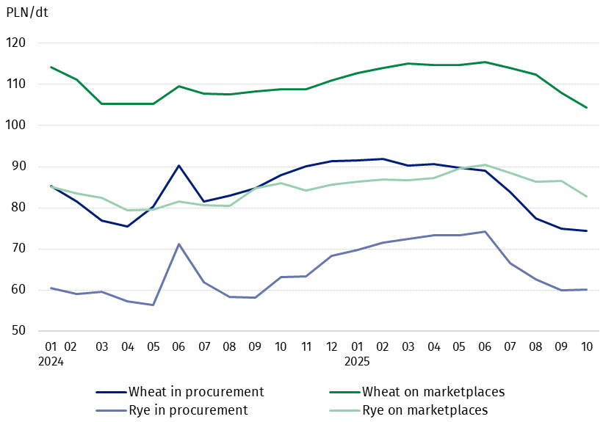

Chart 4. Procurement and marketplaces prices of potatoes

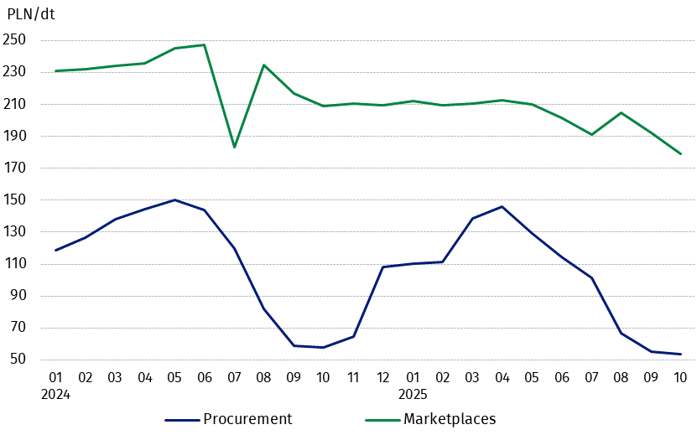

Chart 5. Procurement and marketplaces prices of cattle for slaughter and procurement prices of pigs for slaughter
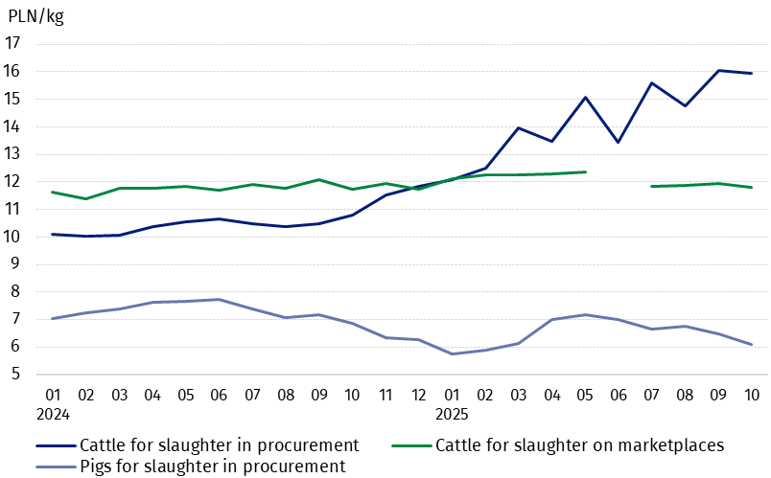

Chart 6. Procurement prices of poultry for slaughter and cows’ milk
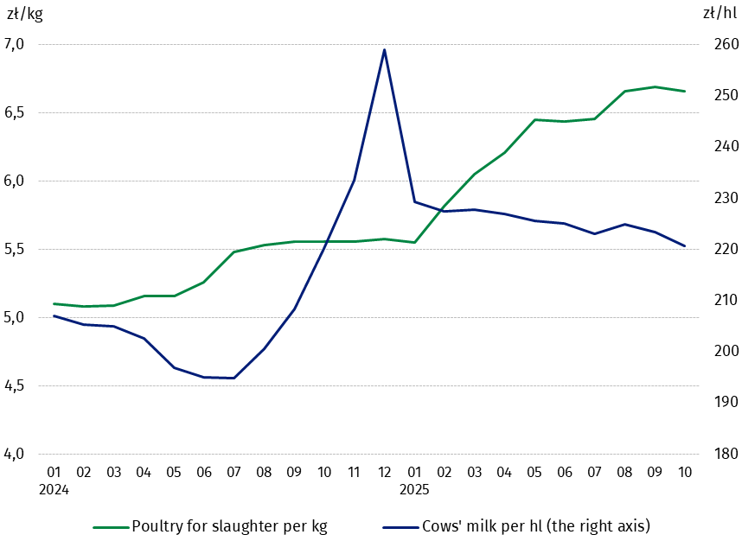

The differentiation of the level of prices of basic agricultural products in particular voivodships is presented in Table 2 for procurement prices and in Table 3 for prices obtained by farmers on marketplaces (Excel sheet).
In case of quoting Statistics Poland data, please provide information: “Source of data: Statistics Poland”, and in case of publishing calculations made on data published by Statistics Poland, please include the following disclaimer: “Own study based on figures from Statistics Poland”.

Prepared by:  Trade and Services Department  Director Ewa Adach-Stankiewicz  Phone: (+48 22) 608 31 24 | Issued by:  Press Office  Mobile: (+48) 695 255 032  Phone: (+48 22) 608 38 04, (+48 22) 449 41 45.  (+48 22) 608 30 09  e-mail: obslugaprasowa@stat.gov.pl

stat.gov.pl/en/

@StatPoland

@GlownyUrzadStatystyczny

gus_stat

glownyurzadstatystycznygus

glownyurzadstatystyczny
Related information
Socio-economic situation of the country in 2025
Procurement and prices of agricultural products in 2024

Data available in databases
BDL – Prices - Prices in agriculture
Knowledge Databases – Economy - Prices – Producer prices - Prices in agriculture

Terms used in official statistics
Procurement of agricultural products
Procurement prices
Marketplace
Marketplace prices

Wheat, rye, cattle for slaughter, pigs for slaughter, poultry, cow's milk
Procurement prices – excluding sowing seed.
Procurement prices – total (of which: edible early kinds, seed, edible late, industrial, of which starch). Marketplaces prices – edible excluding early kinds.
Marketplaces prices – average weighted price of cattle for slaughter calculated with the adoption of the structure of procurement quantity of young cattle and cows for slaughter.

