Active enterprises in the fourth quarter of 2025

In the fourth quarter of 2025, there were 2 909 645 active enterprises in Poland. With regard to the kind of economic activity, the largest population were enterprises from section trade; repair of motor vehicles (17.0% of total). The largest number of active enterprises had their registered offices in the Mazowieckie voivodship (20.2% of total).
4.3%
Increase in the number of active enterprises in the fourth quarter of 2025 compared to the corresponding period of the previous year

Basic information on active enterprises
The share of micro entities increased year-on-year to 95.9% of active enterprises

In the fourth quarter of 2025, compared to the same period in 2024, there was an increase of 4.3% in the number of active enterprises. Micro entities (i.e., with up to 9 employees) accounted for 95.9% of all active enterprises, and compared to the fourth quarter of 2024, their number increased by 4.6%. Small entities (i.e., with 10 to 49 employees), medium entities (i.e., with 50 to 249 employees), and large entities (i.e., with 250 or more employees) accounted for 3.4%, 0.6%, and 0.1% of all active enterprises, respectively. Compared to the fourth quarter of 2024, the number of small and medium enterprises decreased by 0.4% and 0.7%, respectively. Meanwhile, the number of large enterprises increased by 5 entities.

Table 1. Number of active enterprises by the number of persons employed
Quarter | Active enterprises
Quarter | total | by the number of persons employed
Quarter | total | up to 9 persons | 10-49 | 50-249 | 250 and more persons
Q4 2025 | 2 909 645 | 2 790 429 | 97 542 | 17 486 | 4 188
Q4 2024 | 2 788 814 | 2 669 110 | 97 920 | 17 601 | 4 183
The largest increase in the number of active enterprises was observed in administration and support service activities section

Active enterprises by kind of economic activity
In the fourth quarter of 2025, the majority of enterprises operated in the sections: trade; repair of motor vehicles (17.0% of all active enterprises), construction (15.2%), and professional, scientific, and technical activities (13.8%). The smallest share was held by enterprises in the mining and quarrying section (0.1%).
Compared to the same period in 2024, the largest increase in the number of enterprises was recorded in the administration and support service activities section (18.2%).
In populations of large and medium-sized enterprises, the largest share was held by manufacturing enterprises, accounting for 43.1% and 34.9%, respectively. Among small enterprises, the largest share was held by entities in the trade; repair of motor vehicles (22.3%), manufacturing (21.8%), and construction (14.5%).
In the number of micro entities, the largest share was noticed, similarly to enterprises in general, in the sections: trade; repair of motor vehicles (16.8%), construction (15.3%), and professional, scientific, and technical activities (14.2%).
Chart 1. Number of active enterprises

Table 2. Number of active enterprises by size classes and NACE Rev. 2 section in the fourth quarter of 2025
Specification | Active enterprises
Specification | total | by the number of persons employed
Specification | total | up to 9 persons | 10-49 | 50-249 | 250 and more persons
Total | 2 909 645 | 2 790 429 | 97 542 | 17 486 | 4 188
Agriculture, forestry, hunting and fishing | 25 731 | 23 522 | 1 749 | 444 | 16
Mining and quarrying | 2 493 | 2 033 | 320 | 106 | 34
Manufacturing | 239 334 | 210 188 | 21 248 | 6 095 | 1 803
Energy generation and supply | 9 993 | 9 453 | 322 | 169 | 49
Water supply; sewage and waste management | 8 467 | 6 424 | 1 295 | 649 | 99
Construction | 442 374 | 426 939 | 14 137 | 1 177 | 121
Trade; repair of motor vehicles | 493 452 | 468 046 | 21 776 | 3 104 | 526
Transportation and storage | 169 655 | 158 171 | 9 814 | 1 369 | 301
Accomodation and catering | 82 294 | 77 081 | 4 792 | 342 | 79
Information and communication | 240 069 | 236 682 | 2 540 | 636 | 211
Financial and insurance activities | 58 292 | 56 607 | 1 086 | 461 | 138
Real estate activities | 79 108 | 76 660 | 2 017 | 399 | 32
Professional, scientific and technical activities | 401 124 | 394 926 | 5 208 | 747 | 243
Administrative and support service activities | 133 087 | 128 178 | 3 669 | 898 | 342
Education | 88 691 | 86 034 | 2 319 | 310 | 28
Human health and social work activities | 251 112 | 246 420 | 4 091 | 461 | 140
Arts, entertainment and recreation activities | 33 092 | 32 638 | 381 | 61 | 12
Other service activities | 151 277 | 150 427 | 778 | 58 | 14

Active enterprises by registered office
In the fourth quarter of 2025, the largest number of active enterprises (according to the place of registered offices) was in the Mazowieckie (20.2% of all active enterprises), as well as in the Wielkopolskie (10.3%), Śląskie (10.3%), and Małopolskie (10.0%) voivodships. The smallest number of enterprises were located in the Opolskie voivodship (1.9% of active entities).
Compared to the same period in 2024, the largest increase in the number of active enterprises was recorded in the Małopolskie (5.2%), Pomorskie (5.1%), and Mazowieckie (5.0%) voivodeships, the smallest increase was in the Warmińsko-Mazurskie (3.0%), Kujawsko-Pomorskie (3.4%), and Lubuskie (3.4%) voivodships.
In the population of large entities, the largest share was held by enterprises based in the Mazowieckie (26.9%), Śląskie (12.1%), and Wielkopolskie (11.0%) voivodships. In the population of micro-entities, the highest percentage of entities was recorded in the Mazowieckie (20.3%), Wielkopolskie(10.2%), Śląskie (10.2%), and Małopolskie (10.0%) voivodships.
In the fourth quarter of 2025, the highest number of active enterprises per 1000 population was recorded in the Mazowieckie (106.7), Pomorskie (86.0), Wielkopolskie (85.9), Małopolskie (85.1), and Dolnośląskie (83.2) voivodships. The lowest number was observed in the Podkarpackie voivodship (57.5).
In the powiats that are not cities with powiat status, the highest number of active enterprises per 1000 population was observed in the powiats: piaseczyński (127.0), pruszkowski (115.6), and warszawsko zachodni (113.6). The lowest number of active enterprises per 1000 populaton occurred in the powiats: chełmski (34.4), hrubieszowski (36.0), and przemyski (36.2).

Chart 2. Structure of active enterprises by voivodships in the fourth quarter of 2025

%
Table 3. Number of active enterprises by size classes and voivodships in the fourth quarter of 2025
Specification | Active enterprises
Specification | total | by the number of persons employed
Specification | total | up to 9 persons | 10-49 | 50-249 | 250 and more persons
Total | 2 909 645 | 2 790 429 | 97 542 | 17 486 | 4 188
Dolnośląskie | 238 639 | 230 272 | 6 685 | 1 309 | 373
Kujawsko-Pomorskie | 127 304 | 121 594 | 4 680 | 859 | 171
Lubelskie | 117 277 | 112 453 | 4 115 | 615 | 94
Lubuskie | 67 413 | 64 611 | 2 271 | 441 | 90
Łódzkie | 166 437 | 159 159 | 6 056 | 1 015 | 207
Małopolskie | 291 659 | 280 112 | 9 667 | 1 526 | 354
Mazowieckie | 587 924 | 565 606 | 17 711 | 3 482 | 1 125
Opolskie | 55 601 | 53 017 | 2 105 | 394 | 85
Podkarpackie | 118 653 | 113 200 | 4 515 | 780 | 158
Podlaskie | 70 636 | 67 823 | 2 315 | 435 | 63
Pomorskie | 202 870 | 195 114 | 6 388 | 1 122 | 246
Śląskie | 298 242 | 284 431 | 11 314 | 1 989 | 508
Świętokrzyskie | 68 653 | 65 822 | 2 381 | 378 | 72
Warmińsko-Mazurskie | 77 775 | 74 676 | 2 550 | 474 | 75
Wielkopolskie | 298 859 | 285 109 | 11 288 | 2 000 | 462
Zachodniopomorskie | 121 703 | 117 430 | 3 501 | 667 | 105

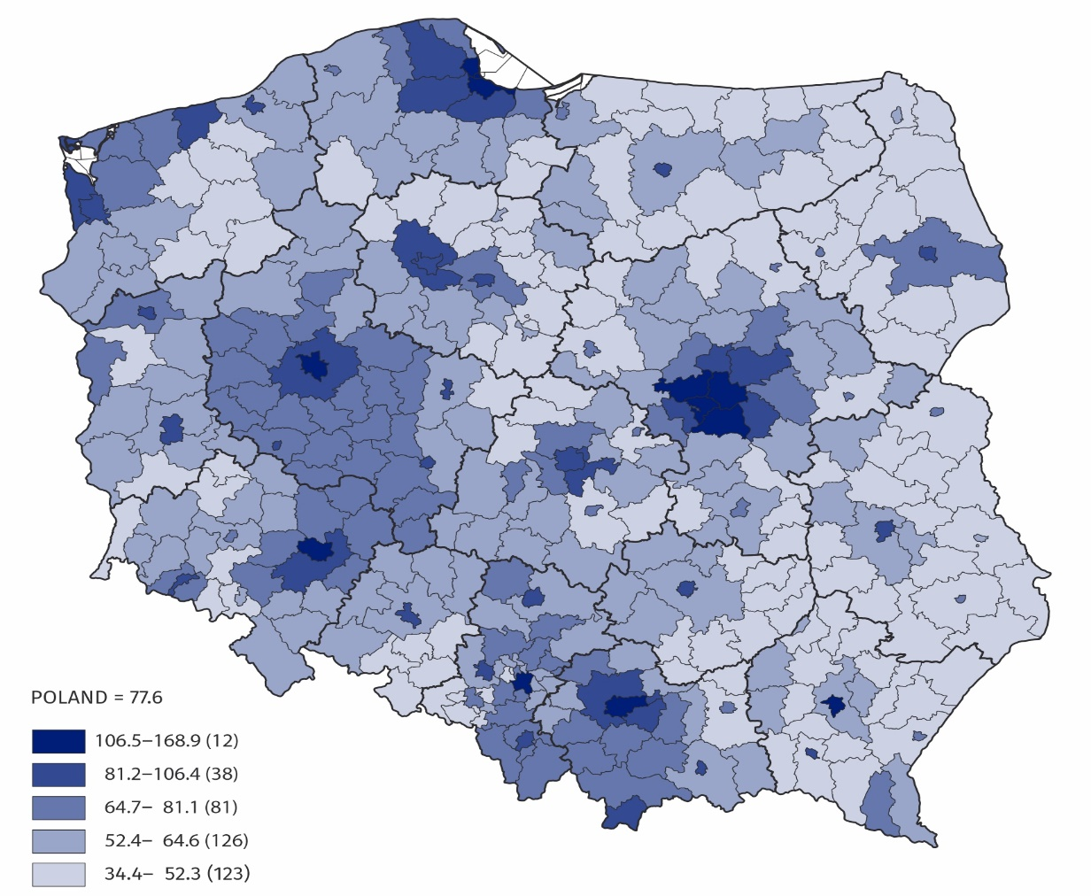
Map 1. Number of active enterprises by powiats per 1 000 population in the fourth quarter of 2025

The data presented in this news release concern active enterprises (understood as a one legal unit) regardless of the size class by number of persons employed and the kind of accounting record kept. The data include entities of the national economy which are market producers, for which the predominant activity is classified according to the NACE Rev. 2 to section A (excluding indywidual agricultural holdings), B, C, D, E, F, G, H, I, J, K, L, M, N, P, Q, R, S (excluding division 94).
The enterprises method was used for preparing the data, and this method involves taking entire enterprises as the basic for grouping data according to clasifications and territorial divisions.
Code | Full name | Abbreviation
A* | Agriculture, forestry, hunting and fishing | –
B | Mining and quarrying | –
C | Manufacturing | –
D | Electricity, gas, steam, hot water and air conditioning manufacturing and supply | Energy generation and supply
E | Water supply; sewerage, waste management and remediation activities | Water supply; sewage and waste management
F | Construction | –
G | Wholesale and retail trade; repair of motor vehicles including motorcycles | Trade; repair of motor vehicles
H | Transportation and storage | –
I | Accommodation and food service activities | Accommodation and catering
J | Information and communication | –
K | Financial and insurance activities | –
L | Real estate activities | –
M | Professional, scientific and technical activities | –
N | Administrative and support service activities | –
P | Education | –
Q | Human health and social work activities | –
R | Arts, entertainment and recreation activities | –
S** | Other service activities | –
An enterprise is considered to have been active in the quarter if it conducted economic activity at least in one month of that quarter (regardless of the number of days of activity conduted).
In this news release, abbreviated names of some sections of NACE Rev. 2 were used; the list of letter symbols of the section (code), full names and abbreviated names is as follows:

* Section A– excluding indywidual agricultural holdings
** Section S – excluding division 94 Activities of membership organisations

An integral part of this news release are tables in XLSX format (downloadable files) with a set of tables presenting data in detailed breakdown, including by NACE Rev. 2 groups and by powiats.

In case of quoting Statistics Poland data, please provide information: “Source of data: Sta-tistics Poland”, and in case of publishing calculations made on data published by Statistics Poland, please include the following disclaimer: “Own study based on figures from Statistics Poland”.

Prepared by:  Enterprise Statistics Department  Director Katarzyna Walkowska-Macias  Phone: (+48 22) 608 31 25 | Issued by:  Press Office  Mobile: (+48) 695 255 032  Phone: (+48 22) 608 38 04, (+48 22) 449 41 45,  (+48 22) 608 30 09  e-mail: obslugaprasowa@stat.gov.pl

stat.gov.pl/en/

@StatPoland

@GlownyUrzadStatystyczny

gus_stat

glownyurzadstatystycznygus

glownyurzadstatystyczny

Related publications
Enterprises active in the third quarter of 2025

