Activity of leasing companies in 2024
The survey covered 87 enterprises conducting leasing activity in 2024. Throughout 2024, the surveyed enterprises concluded 594 thousand new lease agreements for 796 thousand of items (assets) leased. The value of concluded contracts in 2024 amounted to PLN 89.0 billion.
PLN 89.0 billion

Value of lease granted

Basic data on leasing companies
In the group of 87 leasing enterprises surveyed, there were 56 limited liability companies, 27 joint-stock companies and four companies with a different legal form. For 29 of these enterprises leasing was the only type of their activity, for 37 - the dominant type of the activity, and for 21 enterprises it was their secondary activity.
The capital groups included 67 entities from the surveyed group of leasing enterprises, of which 53 were subsidiaries, 9 dominant entities, and 5 dominant and subsidiary entities at once.
As of the end of the previous year, 10.3 thousand employees performed work connected with leasing in the surveyed entities, of this 8.7 thousand persons on the basis of an employment contract, 0.5 thousand persons on the basis of a mandate contract, agency contract or specific task contract and 1.0 thousand self-employed persons.
The distribution network of leasing products comprised 1.8 thousand branches and authorized representative offices.
Among the surveyed enterprises, only one indicated that the flood in September 2024 had an impact on its activity, while four entities reported that the assets leased by them were damaged or lost due to the flood.
As of the end of 2024 1,068 thousand lessees used leasing services; they leased 2,502 thousand items (assets) worth PLN 156.0 billion

Characteristics of leasing services
During 2024, the surveyed leasing companies concluded 594 thousand new contracts with 476 thousand lessees, leasing 796 thousand items (assets) for an amount of PLN 88,964 million. The subject of these leasing agreements were both new items (assets) (worth PLN 68,672 million) and the used ones (PLN 20,292 million).
Table 1. General information about enterprises and their leasing activities in the period from 1 January to 31 December
Financial leasing agreements by value accounted for 78.6% of the value of all agreements concluded in 2024, and operational leasing – 21.4%
SPECIFICATION | 2023 | 2024
The number of surveyed entities | 84 | 87
Number of new contracts concluded | 599 199 | 594 220
Number of items (assets) leased according to the new contracts | 726 299 | 796 223
Value of items (assets) leased in PLN million according to the new contracts | 84 218 | 88 964
The leasing of means of road transport had the largest share in the value of new contracts concluded in 2023 – 76.5% of the total lease value. The second important segment of leasing were industrial machinery and equipment, responsible for 19.8% of the total value of newly concluded lease agreements. The share of computers and office equipment and real estate leased amounted to respectively 0.9% and 0.6% of the total value of new lease agreements while 0.5% was accounted for by other funds.
The share of passenger cars in the total value of lease granted amounted to 54.2%
Characteristics of lessees (clients)
Clients from the mazowieckie voivodship constituted 36.8% of the number of lessees who concluded new contracts in 2024
The entity structure of customers (lessees) was dominated by entities of the national economy, which leased items (assets) in the amount of PLN 84,639 million.
The sectors that most frequently used leasing services in 2024 were NACE sections: wholesale and retail trade, transportation and storage, manufacturing as well as construction. These industries have concluded new contracts for a value of PLN 52,598 million, which was 59.1% of the total value of contracts.
Chart 1. The value of new lease contracts by type of the lessee’s business (NACE section)
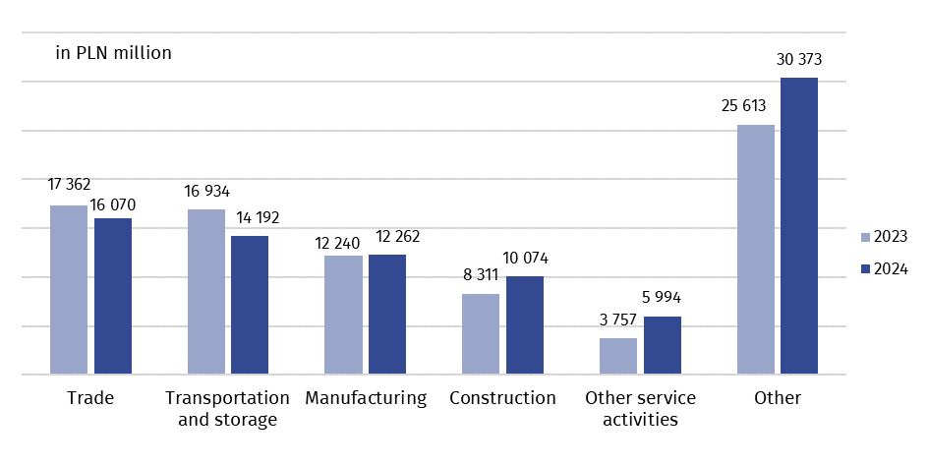
Financial situation of leasing companies
From the entities included in the survey only these were taken into account to assess their financial situation for which leasing was the only or dominant type of their activity and at the same time declaring full accounting (66 enterprises in total).
The value of assets of these 66 companies increased by 7.7% during 2024 (from PLN 206,442 million to PLN 222,419 million). The dominant item of total assets (66.2%) were fixed assets with a value of PLN 147,172 million. The share of long-term receivables in fixed assets reached 42.6% and amounted to PLN 62,715 million. The second largest item of fixed assets were long-term investments – PLN 43,426 million (29.5%). Current assets amounted to PLN 75,247 million, which accounted for 33.8% of total assets.
The total liabilities of the 66 enterprises described above were dominated by liabilities and provisions for liabilities, the value of which amounted to PLN 209,711 million (94.3% of the total value of total liabilities).
Revenues from total activity of these 66 companies in 2024 amounted to PLN 30,327 million and increased by 7.3% compared to the previous year, of which sales revenues accounted for 83.2%. Costs from total operations increased by 6.0% and amounted to PLN 28,072 million.
The net financial result of 66 enterprises with full accounting for which leasing activity was the only or dominant type of activity amounted to PLN 1,450 million. Of this group of companies, 50 companies generated a positive net financial result in 2024 for the total amount of PLN 2,172 million, while the remaining 16 recorded a loss of PLN 722 million.

In case of quoting Statistics Poland data, please provide information: “Source of data: Statistics Poland”, and in case of publishing calculations made on data published by Statistics Poland, please include the following disclaimer: “Own study based on figures from Statistics Poland”

Prepared by:  Macroeconomic Studies and Finance  Department  Director Mirosław Błażej  Phone: (+48 22) 608 37 73 | Issued by:  Press Office  Mobile: (+48) 695 255 032  Phone: (+48 22) 608 38 04, (+48 22) 449 41 45,  (+48 22) 608 30 09  e-mail: obslugaprasowa@stat.gov.pl

stat.gov.pl/en/

@StatPoland

@GlownyUrzadStatystyczny

gus_stat

glownyurzadstatystycznygus

glownyurzadstatystyczny

Related information
Specialized financial market segments in 2023
Macroeconomic situation in Poland in the context of the world economic processes in 2023

Terms used in official statistics
Leasing
Leaseholder, lessee
Leaser, lessor

It is possible to link the financial situation with the company's operations only for entities for which leasing activity is the only or dominant and at the same time maintaining full accounting. The requirement for the surveyed enterprises to conduct full accounting results from the necessity to use uniform and comparable accounting categories for the purposes of the conducted analyzes.

