Political parties in 2024
2.6%
Increase of the number of political party members compared to 2022
At the end of 2024, 97 groupings had an entry in the register of political parties, of which 70 parties were active. They had 209.2 thousand members, with 19.8 thousand people. Party revenues amounted to PLN 301.2 million.

Number of political parties
Political parties in Poland acquire legal personality with an entry in the register of political parties, kept by the District Court in Warsaw. In 2024, 7 new political parties were registered and 16 final and binding decisions were issued to remove parties from the register. As of December 31, 2024, 97 groupings had an entry in the register, i.e. 2 fewer parties than at the end of 2022, but 24 parties more than in 2014.
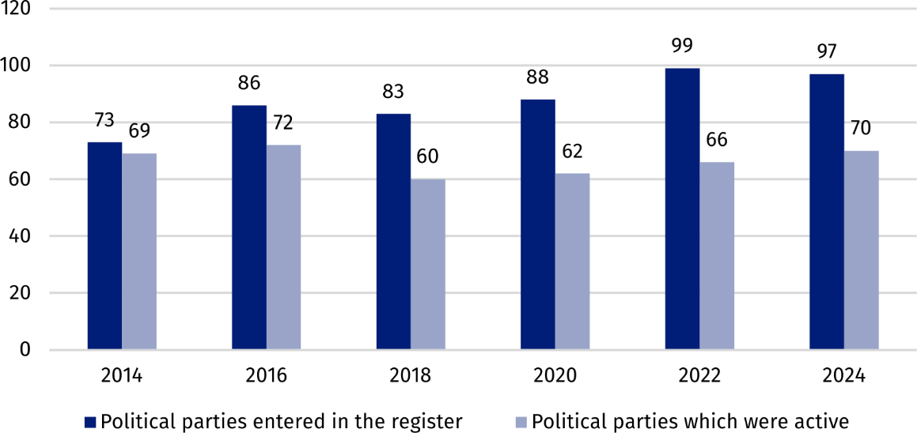
Chart 1. Number of political parties
In the framework of the survey conducted by the Statistics Poland confirmed the activity of 70 of the 97 political parties, that had an entry in the register at the end of 2024. Further analysis refers only to active political groupings.
In 2024, 70 parties were active
In 2024, representatives of 21 political parties sat in parliament or government, 12 groupings were represented only in local government bodies, while 37 parties had no representation in the public authorities.
The majority of 70 parties (47) had their headquarters located in the Mazowieckie
voivodship, of which 46 in Warsaw. Remaining parties were registered in the following
voivodships: Śląskie – 8, Małopolskie – 4, Lubelskie, Łódzkie and Wielkopolskie – 2 each and Dolnośląskie, Podkarpackie, Podlaskie, Pomorskie and Warmińsko-Mazurskie voivodships – 1 each.

Organizational structures
More than a half of political parties (42) declared having field organizational units. In case of 15 groupings, the scope of operation of the lowest level of field structures covered gmina or a part of it. Another 11 parties indicated powiat, as the lowest organizational level, 11 –
indicated a voivodship and 5 parties – indicated the area beyond one voivodship.
Among the parties declaring to have field structures, the average number of lowest-level units was 108, with a median of 16 (in 2022, these figures were 152 and 26, respectively).

Forms of activity
Pursuant to the Act on Political Parties, the purpose of a parties’ operation is to participate in public life by shaping the policy of the state or exercising state authority. Goals are achieved on the basis of the statute and may take various forms.
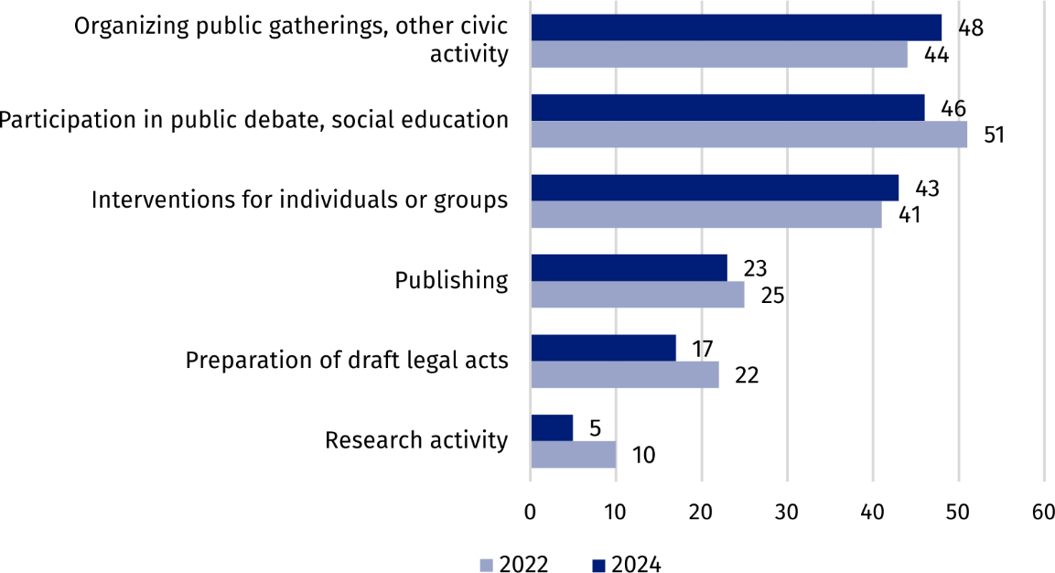
Chart 2. Forms of activity of political partiesª
a The data does not sum up to the total value due to the possibility of selecting more than one answer.
In 2024, 48 political parties organized public gatherings and other forms of civic activity
The most frequently declared form of activity was organizing public gatherings and other forms of civic activity – 48 groups indicated this type of activity. The second most popular form of parties’ activity was participation in public debates and educational activities. As part of this, parties organized press conferences, participated in television and radio programs, and took part in conferences and seminars – 46 parties declared this form of activity.
Interventionist activities aimed at solving the problems of specific social groups or individuals coming forward for help, were undertaken by 43 groupings. Publishing activities were also an important area of activity for the parties, including the distribution of publications and informational materials about the parties – 23 groupings indicated this type of activity. The preparation of draft legislation was declared by 17 political parties, and 5 engaged in research activities.

Cooperation with other organizations
Cooperation with other non-profit organizations was declared by 47 political parties. The primarily indicated cooperation partners were other political parties – 40 groupings, as well associations, similar organizations or foundations – 32 groupings. On the other hand, employers' organizations and churches, and other religious associations were mentioned by the smallest number of parties – 9 groupings each.
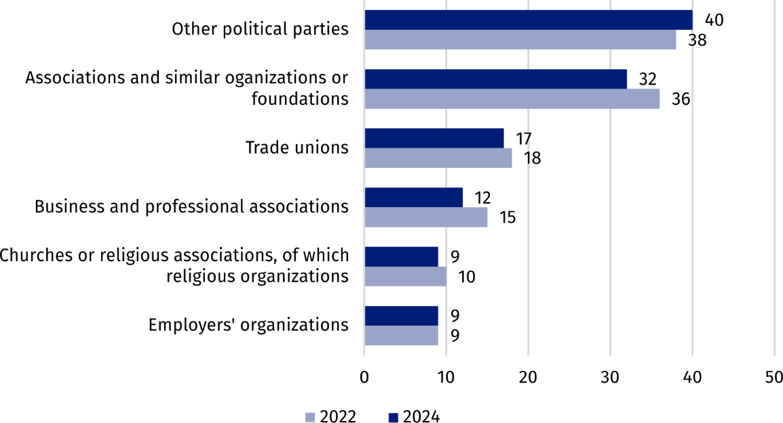
Chart 3. Cooperation of political parties by type of partnership organizationª
a The data does not sum up to the total value due to the possibility of selecting more than one answer.

Membership base
Political parties had a total membership of 209.2 thousand people
At the end of 2024 the number of political parties members amounted to 209.2 thousand people, it means 2.6% more compared to 2022 and 29.8% less compared to 2014. The highest number of members was affiliated among groupings with representation in parliament – they accounted for over 90.0% of all party activists, although they constituted less than
one-third (30.0%) of all political parties.
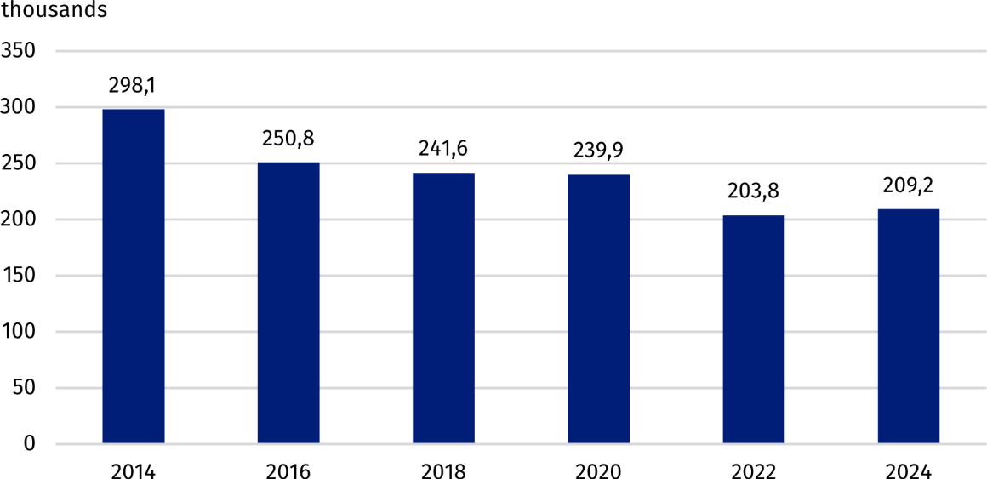
Chart 4. Number of political parties members
Almost half of the political parties (33) had less than 100 members, while 4 largest groupings had more than 10.0 thousand activists.
Men constituted the majority of the total number of political party members – 140.9
thousand, i.e. 67.3% and their share decreased by 0.9 percentage points compared to 2022 and by 3.4 percentage points compared to 2014.

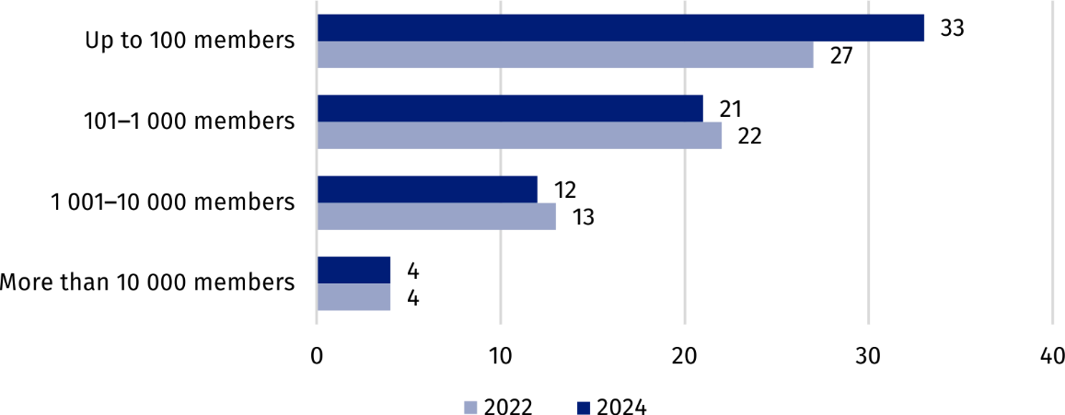
Chart 5. Political parties by the number of members
In 2024, 14 political groupings declared that they had youth associations – organizational units bringing together young people, including minors, who support the activities of the party. In the case of 11 groupings, the youth associations functioned as internal party structures, and in 3 as separately registered associations.
At the end of the year, youth associations had 4.2 thousand people, which is a decrease of 2.9 thousand compared to 2022. As many as 99.0% of the members of these structures belonged to groupings represented in parliament. Men accounted for 71.9% of youth associations members. More than a quarter of all people active in youth associations were minors (28.4%).

Volunteer work
Unpaid work for political parties was provided by 19.8 thousand people
All political parties benefited from the voluntary work of their members. Additionally 14 groupings engaged external volunteers. Unpaid work for the parties was provided by a total of 19.8 thousand people, of whom 77.3% were men. Compared to 2022, the number of people involved in voluntary work increased by 3.1 thousand people (by 18.3%) and decreased by 115.0 thousand (by 85.3%) compared to 2014. On average, each political party used social work of 0.3 thousand people, but in half of the groupings this number did not exceed 16 people.
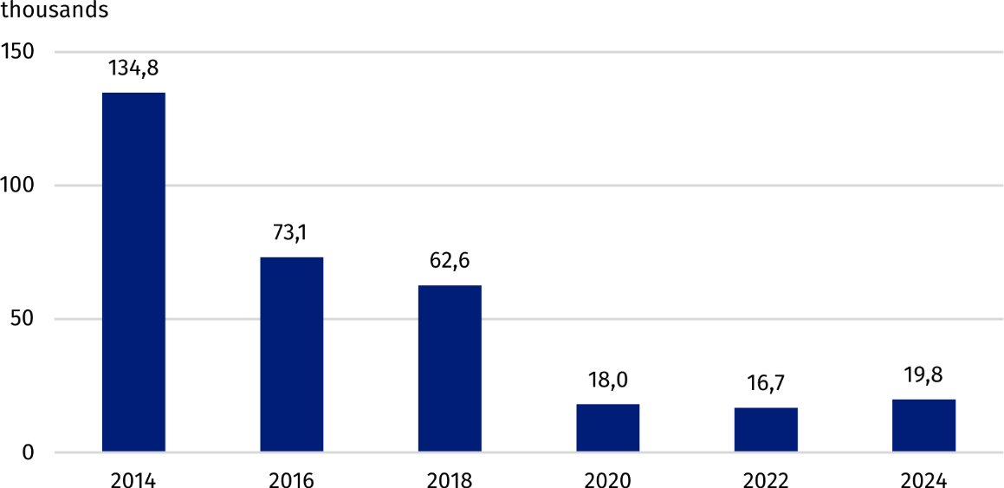
Chart 6. Number of volunteer workers in political parties
The vast majority of people doing voluntary work for parties were their members – 94.0%. Among those working on a voluntary basis, 17.7 thousand (89.4%) supported parties with parliamentary representation, 0.6 thousand (3.0%) – supported groupings present only in local government, and 1.5 thousand (7.6%) – supported other parties. This means that most people focused on supporting parties with parliamentary representation, while involvement in parties operating only at the local government level or in other groupings was significantly lower.

Paid work
The majority of political parties did not rely on paid work. Out of 70 groupings, only 14 declared employing personnel – including 7 parties that employed staff on the basis of an employment contract and the remaining 7 employed exclusively on the basis of civil law contracts.
At the end of 2024 parties employed 192 persons carried out their work on the basis of an employment contract (by 11.5% less than in 2022). For the entire year, the number of those providing work on the basis of civil law contracts amounted to 229 people, which was 22.4% lower than in 2022. Men accounted for 39.1% of full-time employees and 56.3% of people employed under civil law contracts.

Revenues of political parties
Revenues of political parties amounted to PLN 301.2 million
In 2024, 62 parties generated revenues totaling PLN 301.2 million. More than half of this amount (55.7%) consisted of public funds transferred in the form of grants and subventions. In total, parties received PLN 167.9 million from the state budget. The total amount of revenues increased by PLN 219.1 million compared to 2022, and public funds by PLN 97.5 million. This significant difference was mainly due to a one-off subjective subsidy granted to parties in connection with obtaining seats in the parliamentary elections held in 2023, as well as an increase in funds transferred by individuals to parties. This should be taken into account when comparing revenues in individual years.
Political parties represented in parliament received a total of PLN 300.2 million, which accounted for 99.7% of the revenues of all groupings.
Half of the parties declaring to have revenues, achieved revenues not exceeding PLN 13.0 thousand. Revenues higher than PLN 10.0 thousand were achieved by 31 parties, of which 6 achieved revenues exceeding PLN 1.0 million. The revenues of these 6 political parties accounted for a total of 98.7% of total revenues. In turn, 12 groupings declared revenues not exceeding PLN 1.0 thousand.

Methodological notes
This news release was prepared on the basis of the results of the Political Parties survey conducted by the Statistics Poland every 2 years using the SOF-3 form Report on the activities of political parties in ... and data from administrative sources. The survey covered 97 parties entered in the register of political parties. As a result of the verification conducted as part of the survey, it was determined that 70 parties were conducting activities and data for them was obtained on the SOF-3 form.
By means of the research form SOF-3 data regarding, among other subjects, the organizational structure, territorial scope and statutory form of party activity, membership, volunteer work, cooperation with other organizations and conditions, in which parties conduct their activities. Based on administrative sources, information was compiled on:
- the number of parties in the register of political parties (data from the District Court in Warsaw),
- the revenue structure, including sums from the state budget (data from National Electoral Commission),
- the scope and type of employment (data from the Social Insurance Institution).
In the case of quoting data from the Statistics Poland, please provide information: "Statistics Poland data source", and in the case of publishing calculations made on the data published by Statistics Poland, please provide information: "Own study based on Statistics Poland data".

Prepared by:  Social Surveys and Labour Market Department  Director Agnieszka Zgierska  Phone: (+48 22) 608 30 15  Statistical Office in Kraków  Director Agnieszka Szlubowska  Phone: (+48 12) 420 40 50 | Issued by:  Press Office  Mobile: (+48) 695 255 032  Phone: (+48 22) 608 38 04, (+48 22) 449 41 45,  (+48 22) 608 30 09  e-mail: obslugaprasowa@stat.gov.pl

stat.gov.pl/en/

@StatPoland

@GlownyUrzadStatystyczny

gus_stat

glownyurzadstatystycznygus

glownyurzadstatystyczny
Related information
Political parties in 2022
The non-profit sector in 2022

The survey of political parties is conducted by the Statistics Poland every 2 years.

