Financial results of cultural institutions in 2025 (preliminary data)
In 2025, total revenues of cultural institutions increased by 11.1% in comparison to 2024, while total costs – by 10.9%. At the same time, investment outlays decreased by 6.5%.
11.1%
Total revenue increased y/y
In 2025, total revenues of cultural institutions amounted to PLN 18,378.3 million and were higher by 11.1% than in the previous year. In the structure of revenues, 92.0% were net revenues from sale of products, goods and materials, 7.7% – other operating revenues and 0.3% – financial revenues. Cultural institutions from Mazowieckie Voivodship had the largest (25.2%) share in the total revenues.
Average total revenues per one cultural institution amounted to PLN 3,903.6 thousand. The highest total revenues per one institution were achieved by cultural institutions in Mazowieckie Voivodship (PLN 7,096.3 thousand), and the lowest in Lubelskie Voivodship (PLN 1,878.0 thousand).
Total revenues of government cultural institutions accounted for 81.2% of the total revenues of cultural institutions
Revenues of local government cultural institutions amounted to PLN 14,921.7 million (81.2%) and revenues of national government cultural institutions – PLN 3,456.6 million (18.8%). The largest share in the total revenues of cultural institutions had entities operating arts facilities – 41.2%.
Total costs of cultural institiutions amounted to PLN 18,057.7 million and were higher by 10.9% than in the previous year. Operating costs accounted for 98.5%, other operating costs for 1.4% and financial costs for 0.1%. Over 25% of total costs of cultural institutions were the costs of entities in Mazowieckie Voivodship. The largest share in the total costs of cultural institutions had entities operating arts facilities – 41.3%.
Gross financial result of cultural institutions amounted to PLN 320.6 million (gross profit: PLN 439.2 million, gross loss: PLN 118.6 million). Net financial result of cultural institutions amounted to PLN 317.6 million (PLN 248.6 million in the previous year), with an increase both in net profit by 22.8% and net loss by 11.3%.

Table 1. Financial results of cultural institutions
In 2025, the net financial result of cultural institutions amounted to PLN 317.6 million
Specification | 01–12 2024 | 01–12 2025
Specification | in PLN million |  | 01–12 2024=100
Total revenues | 16,536.6 | 18,378.3 | 111.1
Total costs | 16,285.8 | 18,057.7 | 110.9
Gross financial result | 250.8 | 320.6 | 127.8
Net financial result | 248.6 | 317.6 | 127.8
Net profit | 355.6 | 436.8 | 122.8
Net loss | 107.1 | 119.2 | 111.3
Investment outlays | 1,980.1 | 1,852.3 | 93.5
Outlays on intangible fixed assets | 34.8 | 40.4 | 116.3
In 2025, the investment outlays of cultural institutions amounted to PLN 1,852.3 million and were lower by 6.5% than in the previous year. Over 37% of total investment outlays were investment outlays of entities from Mazowieckie Voivodship.
Investment outlays of local government cultural institutions amounted to PLN 1,203.7 million, i.e. 65.0% of the total amount of investment outlays.

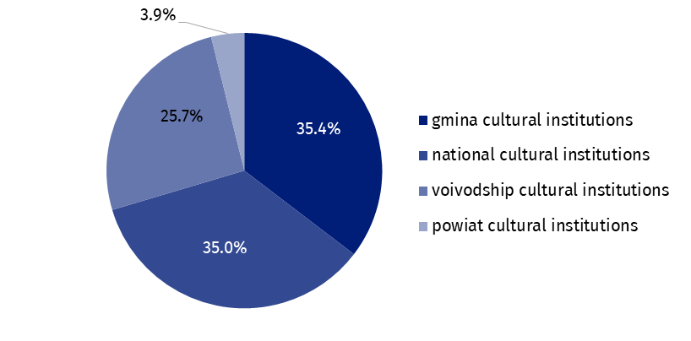
Chart 1. Investment outlays of cultural institutions by legal forms in 2025
In 2025, outlays of cultural institutions on intangible fixed assets were 16.3% higher in comparison to 2024 and amounted to PLN 40.4 million. Over 45% of total outlays on intangible fixed assets incurred cultural institutions from Mazowieckie Voivodship.
Table 2. Total revenues and total costs of cultural institutions by selected divisions and classes of PKD 2007 classification in 2025
The largest share in the total revenues of cultural institutions had entities operating arts facilities – 41.2%
Specification | Number of cultural institutions | Total revenues | Total costs
Specification | Number of cultural institutions | in PLN million
Grand total | 4,708 | 18,378.3 | 18,057.7
local government units property | 4,632 | 14,921.7 | 14,752.1
government property | 76 | 3,456.6 | 3,305.6
of which:
creative, arts and entertainment activities | 2,342 | 11,115.3 | 10,975.6
of which:
performing arts activities | 153 | 3,358.3 | 3,342.6
operation of arts facilities | 2,180 | 7,575.2 | 7,452.6
libraries, archives, museums and other cultural activities | 2,360 | 7,011.0 | 6,839.6
of which:
libraries and archives activities | 1,955 | 2,932.7 | 2,920.9
museums activities | 397 | 3,964.9 | 3,804.9
The data presented in this study were prepared on the basis of the form with the symbol
F-1/dk Quarterly report on the finances of cultural institutions. Information on the survey methodology can be found in the Methodological report. Culture Statistics.
In the case of quoting data from the Statistics Poland, please provide information: “Statistics Poland data source”, and in the case of publishing calculations made on data published by the Statistics Poland, please provide information: “Own study based on Statistics Poland data”.
Prepared by:  Statistical Office in Kraków  Director Agnieszka Szlubowska  Phone: (+48 12) 420 40 50 | Issued by:  Press Office  Mobile: (+48) 695 255 032  Phone: (+48 22) 608 38 04, (+48 22) 449 41 45,  (+48 22) 608 30 09  e-mail: obslugaprasowa@stat.gov.pl

stat.gov.pl/en/

@StatPoland

@GlownyUrzadStatystyczny

gus_stat

glownyurzadstatystycznygus

glownyurzadstatystyczny
Related information
Financial results of cultural institutions in the period January-September 2025 (preliminary data)
Methodological report. Culture statistics
Terms used in official statistics
Total revenues
Total costs
Gross financial result
Net financial result
Investment outlays
Outlays on intangible fixed assets
Cultural institution

