Physical education in Poland in 2024
In 2024, there were 16 612 sports clubs and 70 sports associations in Poland. Compared to 2022, the number of sports clubs increased by 14.8%.
30.1%
Increase in the number of people practising sports in sports clubs compared to 2022

Sports clubs
The largest number of sports clubs operated in the Mazowieckie Voivodship (11.3%), followed by the following voivodships: Wielkopolskie (9.9%), Śląskie (9.7%) and Małopolskie (9.5%), while the fewest in the Świętokrzyskie Voivodship (2.3%). In 2024, sports clubs had 1.4 million members and people exercising. Compared to 2022, both the number of members (by 27.0%) and the number of people exercising (by 30.1%) increased. As in previous years, the vast majority of people exercising were men - 72.0%. Among those exercising, young people under 18 still dominated – 72.6%.
In the structure of sports clubs, the largest share was held by sports clubs that did not declare affiliation with any sports division - 53.8%. Their number increased by 21.8% compared to 2022. The next in terms of number were student sports clubs (30.4%) and sports clubs belonging to the Rural Sports Teams National Association (14.3%), the number of which also increased compared to 2022 (by 6.6% and 9.0% respectively).
The number of people practicing shooting sports increased by 40.2% compared to 2022, football by 30.8% and volleyball by 25.9%
Half of those practising sports in sports clubs participated in team sports. As in previous years, the most popular among those practicing sports was football (excluding beach and indoor football), practiced by 36.1% of those practicing. Sports shooting was in second place, practiced by 7.8% of people practicing in sports clubs. Volleyball (excluding beach volleyball) was in third place (5.7% of those practicing). The next sports, in terms of the number of people practicing, are: swimming - 4.5%, karate (including traditional karate) - 4.1%, basketball - 3.3% and athletics - 3.2%.
Combat sports were practiced by 13.8% of people. Of these, karate was the most popular, followed by judo. Water sports were practiced by 5.8% of people, while winter sports were practiced by 1.1% of people.
The sports in which the share of practicing women in sports sections was over 90% were women's wrestling, rhythmic gymnastics, cheerleading, artistic swimming and softball
The number of people practicing sports per 1,000 people of Poland in 2024 was 39 (in 2022 - 29). The highest value of this indicator was recorded in the Zachodniopomorskie Voivodship - 46, followed by the Dolnośląskie, Małopolskie and Mazowieckie Voivodships - 43 each. The lowest indicator was recorded in the Świętokrzyskie Voivodship and amounted to 28.

Table 1. Basic information on sports clubs
Specification | 2022 | 2024
Specification | In absolute numbers |  | 2022=100
Sports clubs | 14 476 | 16 612 | 114.8
Members (in thousand) | 1 099 | 1 395 | 127.0
Persons practising sports (in thousand) | 1 112 | 1 447 | 130.1
of which:
females | 306 | 405 | 132.3
aged up to 18 | 789 | 1 050 | 133.0
Coaching staff | 58 669 | 72 594 | 123.7
coaches | 33 079 | 41 674 | 126.0
instructors | 18 107 | 21 953 | 121.2
other persons running sports classes | 7 483 | 8 967 | 119.8
Chart 1. Persons practising sports in sports sections by selected kinds of sports in 2024
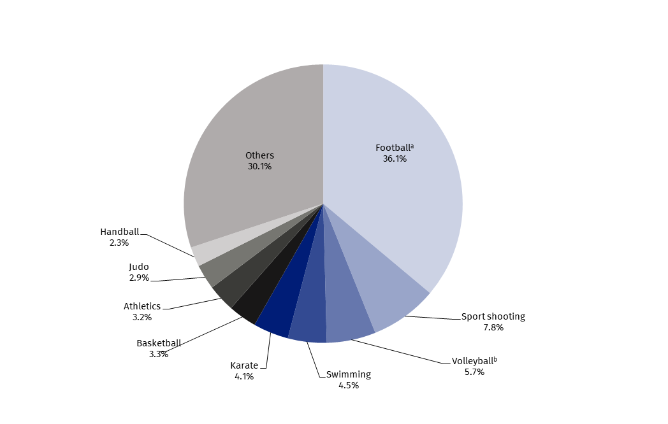
a Excluding indoor football and beach football. b Excluding beach volleyball.
In 2024, the training staff in sports clubs (including volunteers) numbered 72.6 thousand people, of which 19.1% were women. Coaches made up 57.4%, instructors – 30.2%, and other people conducting sports activities – 12.4%. Compared to 2022, the number of coaches increased by 26.0%, instructors by 21.2%, and other persons running sports classes by 19.8%.
The largest number of coaches and instructors worked in sports clubs in the Mazowieckie Voivodship (13.8% and 16.1%, respectively). Their fewest number worked in the Świętokrzyskie Voivodship (2.2%), and instructors in the Opolskie Voivodship (1.9%).
In 2024, there were 5.0 members of coaching staff (instructors, coaches or other people conducting sports classes) per 100 people practising sports in Poland. This indicator reached the highest value in the Kujawsko-pomorskie and Warmińsko-mazurskie Voivodships - 5.6, while the lowest in the Mazowieckie Voivodship - 4.5. For comparison, in 2022 this indicator for the whole of Poland was 5.3.
Map 1. Persons practising sports in sports clubs by voivodship in 2024
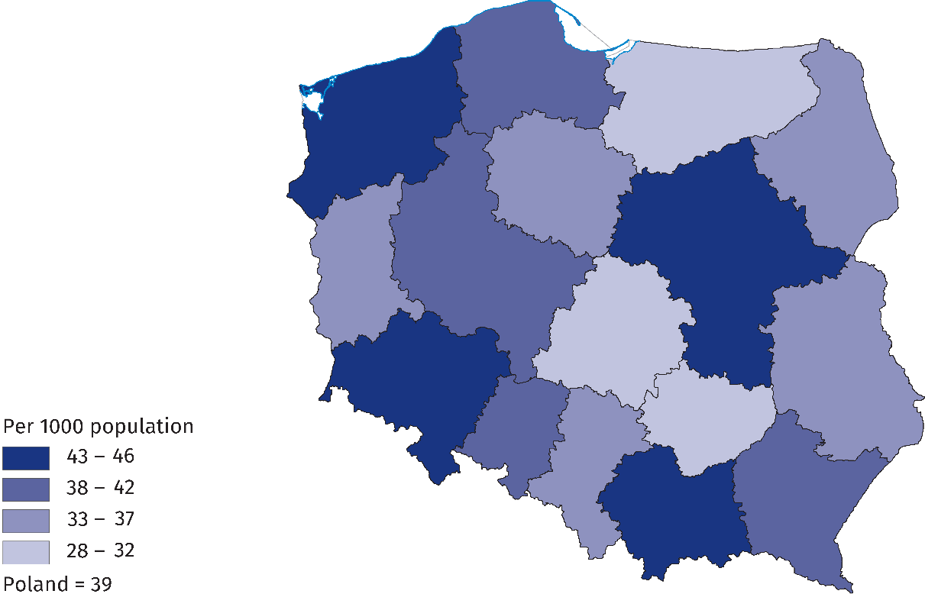

Polish sports associations
In 2024, Polish sports associations selected 9,411 members of the national team
In 2024, there were 70 Polish sports associations (in 2023 – 69; Water Volunteer Search and Rescue (WOPR) obtained the status of a Polish sports association) and 545 district sports associations. Polish sports associations selected 9.4 thousand members of the national team (including 404 who were players of foreign clubs), of whom 38.6% were women. There were 43.6% of Polish representatives in junior categories. Compared to 2023, the number of Polish representatives increased by 4.6%, while the number of representatives who were members of foreign clubs decreased by 12.6%.

Table 2. Basic information on Polish sports associations in 2024
Specification | Total | Of which females
Polish representatives | 9 411 | 3 637
of which:
juniors | 4 103 | 1 712
Competitorsª | 850 127 | 167 678
of which:
junior competitors^{b} | 537 876 | 127 127
Coaching staff^{c}
coaches | 37 944 | 3 755
instructors | 13 317 | 3 894
Judges^{c} | 35 451 | 8 797
of which:
with international class | 1 801 | 448
a Including foreign competitors performing in Poland. The competitors can be shown several times if they are licensed in several sports supervised by one sports association. b Total juniors, younger junior "cadets", sub-juniors and children. c Members of the coaching staff and judges can be shown several times if they are licensed in several sports supervised by one sports association.

The Polish Basketball Association had the largest number of members of the national team in 2024 (760), followed by the Polish Football Association (437) and the Polish Deaf Sports Association (408). In 2023, the Polish Basketball Association also had the largest team (726 representatives).
Chart 2. Polish representatives in 2024
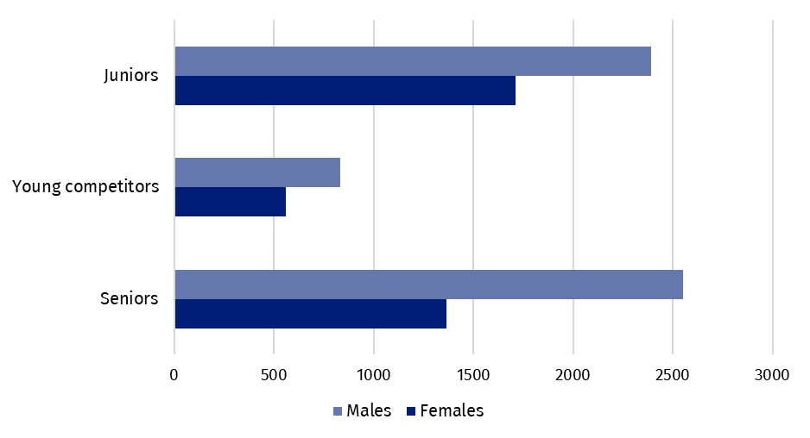
In 2024, 850.1 thousand competitors held licenses of the Polish sports associations (in 2023 - 833.1 thousand), of whom women constituted 19.7%. There were 32.6% of players in the senior category. As in previous years, the highest percentage were players with licenses from the Polish Football Association - 49.2%. In second place in terms of the number of players was the Polish Sports Shooting Association - 10.3%, followed by the Polish Volleyball Association - 6.0%.
In 2024, the number of competitors having licences of Polish Sports Association increased compared to 2023 by 2.0%
The number of disabled players with licenses from Polish sports associations in 2024 was 3,044 people (a decrease compared to 2023 by 2.4%), including 74.6% men. The percentage of disabled players in relation to the total number of players was, as in 2023, 0.4%.
Foreign players with licenses from Polish sports associations in 2024 constituted 1.3% of all players. The most common discipline they represented was football (69.9%).
In 2024, Polish sports associations employed 666 people in coaching staff. This number decreased compared to 2023 (by 95 people). However, an increase was noted in the employment of medical staff (304 people in 2024, compared to 292 people in 2023).
Current licenses of Polish sports associations in 2024 were held by 37.9 thousand coaches and 13.3 thousand instructors. Compared to the previous year, the number of coaches increased by 2.1 thousand and instructors by 0.4 thousand.
Chart 3. Coaching staff in Polish sports associations in 2024
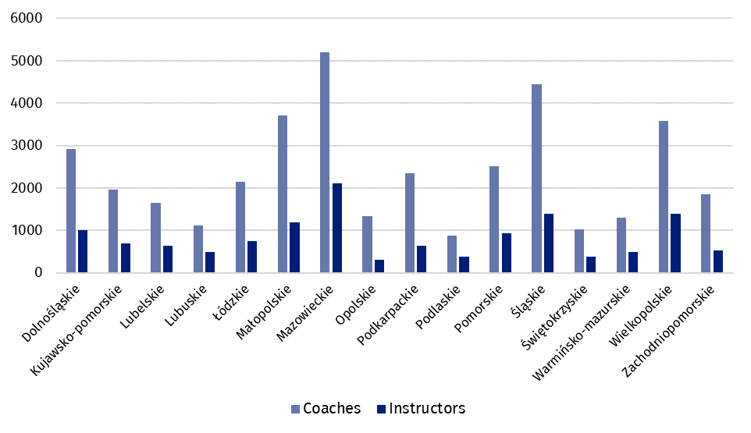
In 2024, the number of coaches and instructors with Polish sports association licenses increased by 5.9% and 3.0%, respectively, compared to 2023, while the number of judges decreased by 13.7%

In 2024, there were 35.5 thousand sports judges registered in Polish sports associations (a decrease of 13.7% compared to 2023). Women made up 24.8% of all judges. The percentage of judges with international class was 5.1%. The largest number of judges had licenses in football (22.8%). A significant group were sports shooting judges (10.5%).
In artistic gymnastics, only women had judge’s licenses. Their participation was also significant in artistic swimming (85.0%), equestrian (71.4%) and wheelchair rugby (70.6%).

Achievements of Polish competitors in the international arena
In 2024, Polish representatives won 10 Olympic medals and 813 medals at the World and European Championships

In 2024, the Polish team participated in the Summer Olympic Games for the 23rd time, which was celebrated in Paris. 214 Polish representatives took part in the competition (116 women and 98 men), who competed in 28 disciplines, out of 45 held at the Games. Poles won 10 medals at the Games of the XXXIII Olympiad in Paris 2024 - 1 gold, 4 silver and 5 bronze.
The 17th Summer Paralympic Games were also held in Paris, with 82 Polish representatives (40 women and 42 men) taking part. They competed in 15 of the 22 sports held at the Paralympic Games and won 8 gold, 6 silver and 9 bronze medals.
In 2024, Polish representatives took 311 podium places at the World Championships (222 in 2023). They won 70 gold, 94 silver and 147 bronze medals. The most medal places in 2024 were won by competitors in kickboxing (92 medals, including 17 gold), followed by kayaking (33 medals, including 7 gold) and air sports (25 medals, including 8 gold).
At European Championships sports events, Poles won a total of 502 medals in 2024 (480 in 2023), including 141 gold, 175 silver and 186 bronze. The greatest successes were recorded in air sports (41 medals, including 18 gold) and sumo (also 41 medals, including 6 gold), followed by water skiing (37, including 6 gold).
Table 3. Medals won by Polish competitors in the international arena in 2024
Specification | Medals
Specification | total | gold | silver | bronze
XXXIII Paris 2024 Olympic Games | 10 | 1 | 4 | 5
XVII Paris 2024 Summer Paralympic Games | 23 | 8 | 6 | 9
World Championships | 311 | 70 | 94 | 147
of which young competitors and juniors | 204 | 44 | 58 | 102
European Championships | 502 | 141 | 175 | 186
of which young competitors and juniors | 297 | 79 | 114 | 104
World Championships for persons with disabilities | 56 | 13 | 20 | 23
European Championships for persons with disabilities | 86 | 30 | 31 | 25
Athletes with disabilities won a total of 56 medals at the World Championships (13 gold, 20 silver, 23 bronze) and 86 medals at the European Championships (30 gold, 31 silver, 25 bronze). At the World Championships, disabled athletes most often stood on the podium in athletic competitions (16 medals, including 4 gold), and at the European Championships – in bowling (14 medals, including 4 gold). In 2023, at the World Championships, disabled athletes won 117 medals, and at the European Championships – 95.
Physical education organizations
In 2024, physical culture organizations such as: Academic Sports Association (AZS), Rural Sports Teams National Association (LZS), The Polish Sports Association for the Disabled ’’Start’’ (PZSN “Start”) and the Society for the Promotion of Physical Education (TKKF) amounted to a total of 6.4 thousand organizational units (a 1.9% decrease compared to 2023), 327.6 thousand members (an increase of 6.2%) and 309.1 thousand persons practising sports (an increase of 3.9%). The most numerous, both in terms of the number of members and people actively practising, was the National „Rural Sports Teams” Association (208.0 thousand members, 178.9 thousand persons practising sports). The Society for Promotion of Physical Education also had a large membership base (47.0 thousand members and 76.9 thousand persons practising sports). The Academic Sports Association amounted to 70.6 thousand members and 51.8 thousand people practising sports, and the Polish Sports Association for the Disabled "Start" counted 2.0 thousand members and 1.5 thousand people practising sports.
The largest number of members of physical culture organizations was recorded in the Lubelskie Voivodship (11.8% of all members of the organization). The largest number of people actively practising was registered in the Wielkopolskie Voivodship - 12.8% of all people practising sports.

When quoting Statistics Poland data, please provide information: “Source of data: Statistics Poland”, and when publishing calculations made on data published by Statistics Poland, please provide information: “Own study based on Statistics Poland data”.
Prepared by:  Statistical Office in Rzeszów  Acting Director Teresa Krzemińska  Phone: (+48 17) 853 52 10,  (+48 17) 853 52 19 | Issued by:  Press Office  Mobile: (+48) 695 255 032  Phone: (+48 22) 608 38 04, (+48 22) 449 41 45,  (+48 22) 608 30 09  e-mail: obslugaprasowa@stat.gov.pl

stat.gov.pl

@GUS_STAT

@GlownyUrzadStatystyczny

gus_stat

glownyurzadstatystycznygus

glownyurzadstatystyczny
Related information
Physical education in years 2021 and 2022

Data available in databases
Local Data Bank
Knowledge Databases - Construction

Terms used in official statistics
Person practising sport
Other person running sports classes
Sports instructor
Sports club
District sports association
Organisation of physical education
Sports judge
Sport
Sports
Sports coach
Competitor
Sports association

The sources of data used in the release are the results of surveys conducted by Statistics Poland on sports clubs (conducted every 2 years), Polish sports associations and physical culture organizations (conducted every year).
Sports associations according to the list of Polish sports associations announced by the Minister of Sport and Tourism - Communication of July 22, 2024. The data are preliminary.
Competitors can be shown more than once if they hold licences in several sports supervised by one sports association.
Members of coaching staff be shown more than once if they hold licences in several sports supervised by one sports association.
Sports judges may be shown more than once if they hold licence in several sports.
In sports supervised by sports associations with the status of a Polish sports association.
This news release covers: in AZS - clubs, in LZS - teams, sports clubs and student sports clubs, in PZSN "Start" - organizational units, in TKKF - centres and clubs.

