Activity of debt collection companies in 2024
In 2024, 89 debt collection entities were included in the study. These companies accepted for service 10.2 million receivables worth 48.4 billion PLN in 2024.
As at the end of 2024, the surveyed enterprises serviced 21.3 million active receivables (both those taken into service in 2024 and those remaining from previous years) with a nominal value of PLN 223.2 billion
48.4 bn PLN
Value of receivables accepted for service in 2024

Basic information on debt collection companies
In the group of 89 examined debt collection companies there were 50 limited liability companies, 20 joint-stock companies and 19 entities with other legal forms. Domestic capital dominated in 72 enterprises, and foreign capital in 17 enterprises.
Among the examined entities, 59 entities indicated debt collection as the only type of conducted activity, for 25 entities it was the dominant type of activity and for 5 companies – a secondary type. The capital groups included 23 enterprises.
As at the end of 2024, there were 6,801 people involved in debt collection activities in the surveyed entities. Debt collection companies additionally had 85 branches and authorized representative offices.

Characteristics of debt collection services
In 2024, there were 9.3 million consumer debts and 0.9 million corporate debts accepted for service
In 2024, debt collection companies accepted for service 10.2 million debts, of which 91.0% were consumer debts and 10.0% were corporate debts. The nominal value of the debts accepted for service amounted to 48.4 billion PLN, with consumer debts accounting for 71.4% and corporate debts for 28.6%. The average value of receivables accepted for service in 2024 was 4,672 PLN (compared to 4,496 PLN in the previous year).
Chart 1. Value of claims accepted for service
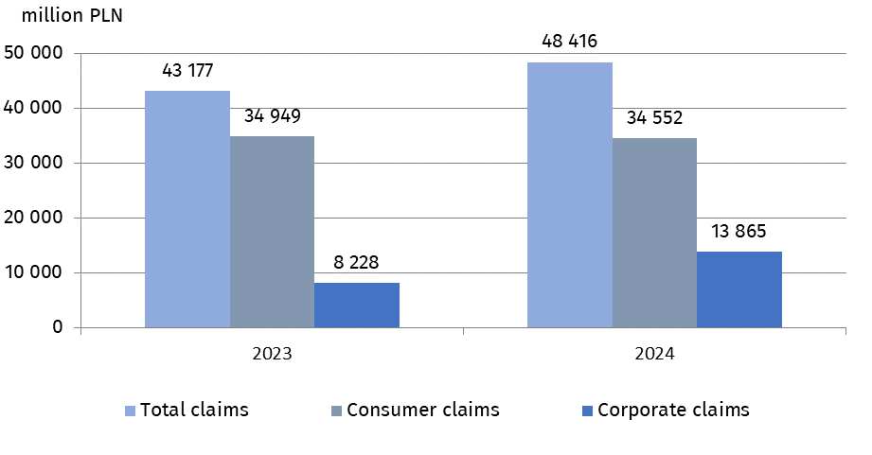
As of the end of 2024, debt collection companies had 21.3 million active receivables in service, which included those accepted for servicing in 2024 and those remaining from previous years, with a nominal value of 223.2 billion PLN.
Table 1. Activities of the surveyed debt collection companies in 2024
Specification | Total | Consumer  debts | Corporate  debts
Number of cases* accepted for service  in 2024, in thousands | 10 204 | 9 287 | 917
Value of receivables* accepted for service in 2024, in million PLN | 48 416 | 34 552 | 13 865
Value of active receivables* - as at the end of 2024, in million PLN | 21 256 | 19 362 | 1 895
Value of recovered receivables* in 2024, in million PLN | 223 200 | 170 689 | 52 511
* without cases accepted for service on behalf of external investment funds
Financial situation of the examined debt collection companies
The value of assets of enterprises in which debt collection activity was the only or dominant type of activity and which conducted full accounting increased by 10.6%
To assess the financial situation, only these entities included in the survey were taken into account for which debt collection was the only or dominant type of their activity and which, at the same time, declared full accounting. Out of 84 enterprises in which debt collection activity was the only or dominant type of activity, 73 entities kept full accounting and 11 kept revenue and expense ledgers.
The value of assets of 73 entities keeping full accounting during 2024 increased from PLN 12,694 million to PLN 14,033 million. Fixed assets of PLN 12,292 million constituted the dominant asset (87.6%), while current assets amounted to PLN 1,735 million (12.4% of total assets).
In the liabilities of the 73 enterprises described above, 52.8% of the value constituted liabilities and provisions for liabilities, and 47.2% equity.
In 2024, the revenues from total activity of the analyzed group of 73 enterprises amounted to PLN 3,713 million and decreased by 0.7% compared to 2023, while the costs from the total activity increased by 1.5% and amounted to PLN 2,281 million.
The net financial result of 73 companies conducting full accounting, for which debt collection activity was the only or dominant type of activity, amounted to PLN 1,474 million. Out of this group of enterprises, 54 entities generated a positive net financial result in the amount of PLN 1,504 million, the remaining 19 incurred losses in the amount of minus PLN 31 million.

In case of quoting Statistics Poland data, please provide information: “Source of data: Statistics Poland”, and in case of publishing calculations made on data published by Statistics Poland, please include the following disclaimer: “Own study based on figures from Statistics Poland.

Prepared by:  Macroeconomic Studies and Finance Statistics Department  Director Mirosław Błażej  Phone: (+48 22) 608 37 73 | Issued by:  Press Office  Mobile: (+48) 695 255 032  Phone: (+48 22) 608 38 04, (+48 22) 449 41 45,  (+48 22) 608 30 09  e-mail: obslugaprasowa@stat.gov.pl

stat.gov.pl/en/

@StatPoland

@GlownyUrzadStatystyczny

gus_stat

glownyurzadstatystycznygus

glownyurzadstatystyczny

Related information
Specialized financial market segments in 2023
Macroeconomic situation in Poland in the context of the world economic processes in 2023

Terms used in official statistics

Debt collection company
A securitization fund

This number includes both natural persons conducting business activity and other commercial law companies.
It is possible to link the financial situation with the company's operations only for entities for which debt collection activity is the only or dominant and at the same time maintaining full accounting. The requirement for the surveyed enterprises to conduct full accounting results from the necessity to use uniform and comparable accounting categories for the purposes of the conducted analyzes.

