Consumer price indices in February 2026
Consumer pirces in February 2026 increased by 2.1% compared with the corresponding month of the previous year (with an increase of prices of services by 4.8% and goods by 1.0%).
As related to the previous month consumer prices increased by 0.3% (of which services by 0.7% and goods by 0.2%).
2.1%
price increase compared with February 2025

NOTE: Starting with data for 2026, the CPI is calculated according to the international COICOP 2018 classification.
Data presented in this news release take into account the annual update of the weighting system.
More information on the changes in the consumer price survey was published on the Statistics Poland website: Current information on inflation.
Table 1. Consumer price indices in January and February 2026
SPECIFICATION | 01 2026ª |  | 02 2026 |  |  | 01-02 2026
SPECIFICATION | 01 2025=  =100 | 12 2025=  =100 | 02 2025=  =100 | 12 2025=  =100 | 01 2026=  =100 | 01-02 2025=100
TOTAL | 102.1 | 100.7 | 102.1 | 101.0 | 100.3 | 102.1
Food and non-alcoholic beverages | 102.4 | 101.4 | 102.4 | 101.7 | 100.3 | 102.4
Alcoholic beverages and tobacco | 106.9 | 100.7 | 106.9 | 102.0 | 101.3 | 106,9
Clothing and footwear | 97.3 | 95.9 | 96.6 | 93.6 | 97.5 | 96.9
Housing, water, electricity, gas and other fuels | 103.8 | 101.6 | 104.3 | 102.2 | 100.7 | 104.1
Furnishings, household equipment and routine household maintenance | 98.7 | 100.2 | 98.7 | 100.2 | 100.0 | 98.7
Health | 105.0 | 101.2 | 104.8 | 101.7 | 100.5 | 104.9
Transport | 94.2 | 97.8 | 94.3 | 97.4 | 99.6 | 94.2
Information and communication | 103.7 | 101.8 | 104.3 | 102.6 | 100.8 | 104.0
Recreation, sport and culture | 104.3 | 101.8 | 102.4 | 103.4 | 101.6 | 103.3
Education services | 106.1 | 100.2 | 106.1 | 100.4 | 100.1 | 106.1
Restaurants and accommodation services | 105.1 | 100.3 | 104.6 | 100.5 | 100.2 | 104.8
Insurance and financial services | 100.8 | 98.2 | 99.8 | 98.2 | 100.0 | 100.3
Personal care, social protection and miscellaneous goods and services | 101.2 | 100.9 | 101.7 | 101.1 | 100.2 | 101.5
A table with indices in more detail is available in the data file attached to this news release and in the Knowledge Databases.
a Final data was compiled after introducing the annually updated weighting system, which is based on the structure of households’ expenditure (excluding own consumption) from the year preceding the surveyed year.

Annual update of the weighting system
Statistics Poland, similarly to previous years, in February of the current year carried out
an update of the weighting system used in the compilations of the consumer price index.
The weighting system is based on the structure of households’ expenditures on purchasing consumer goods and services from the year preceding the surveyed year (currently the year 2025), obtained from the household budget survey.
There was an increase in the share of households’ expenditures for: Housing, water, electricity, gas and other fuels, Recreation, sport and culture, Health, Insurance and financial services and Food and non-alcoholic beverages. There was a decrease in the share of expenditures for: Transport, Alcoholic beverages and tobacco, Furnishings, household equipment and routine household maintenance, Clothing and footwear, Information and communication, Restaurants and accommodation services, Personal care, social protection and miscellaneous goods and services and Education services.
In January 2026, as related to January 2025, consumer prices increased by 2.1% compared with the preliminarily estimated increase of 2.2%
Due to these changes, the contribution of price indices of particular groups to the total consumer price index differs from the one published with preliminary data for January of the current year. According to final data in January of the current year, as related to January of the previous year, consumer prices increased by 2.1%, compared with the preliminarily estimated increase of 2.2%. According to final data in January of the current year, as related to previous month, the consumer price increase amounted to 0.7% (against 0.6% in the preliminary data).
More detailed information on changes in the “inflation basket” is available in the note.

Table 2. Weighting system used in the compilations of consumer price indices according to COICOP 2018 classification (in %)
SPECIFICATION | 2025 | 2026
Food and non-alcoholic beverages | 25,85 | 25,91
Alcoholic beverages and tobacco | 5,19 | 4,81
Clothing and footwear | 3,90 | 3,75
Housing, water, electricity, gas and other fuels | 19,53 | 20,35
Furnishings, household equipment and routine household maintenance | 5,33 | 5,18
Health | 5,81 | 6,20
Transport | 11,07 | 10,18
Information and communication | 5,13 | 5,02
Recreation, sport and culture | 5,89 | 6,37
Education services | 1,07 | 1,03
Restaurants and accommodation services | 5,66 | 5,55
Insurance and financial services | 1,09 | 1,24
Personal care, social protection and miscellaneous goods and services | 4,48 | 4,41

Contributions of price changes to the total consumer price index
In February of the current year, compared with the previous month, the highest contribution to the total consumer price index came from higher prices related to: Housing, water, electricity, gas and other fuels (by 0.7%), Recreation, sport and culture (by 1.6%), Food and non-alcoholic beverages (by 0.3%), Alcoholic beverages and tobacco (by 1.3%), Information and communication (by 0.8%) and Health (by 0.5%), which increased the index by: 0.14 pp, 0.10 pp, 0.07 pp, 0.06 pp, 0.04 pp and 0.03 pp, respectively. Lower prices related to Clothing and footwear (by 2.5%) and Transport (by 0.4%) decreased the index by 0.09 pp and 0.04 pp, respectively.
Compared with the corresponding month of the previous year, higher prices related, among others, to: Housing, water, electricity, gas and other fuels (by 4.3%), Food and non-alcoholic beverages (by 2.4%), Alcoholic beverages and tobacco (by 6.9%), Health (by 4.8%), Restaurants and accommodation services (by 4.6%), Information and communication (by 4.3%) and Recreation, sport and culture (by 2.4%) increased the total index by: 0.87 pp, 0.62 pp, 0.33 pp, 0.29 pp, 0.25 pp, 0.21 pp and 0.16 pp, respectively. Lower prices related to Transport (by 5.7%), Clothing and footwear (by 3.4%) and Furnishings, household equipment and routine household maintenance (by 1.3%) decreased the index by 0.60 pp, 0.13 pp and 0.07 pp, respectively.
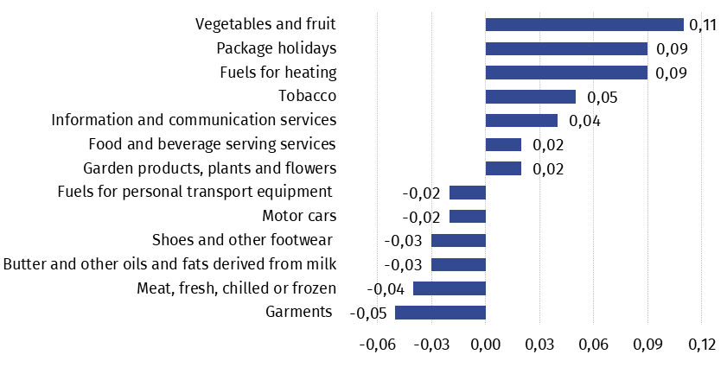
Chart 1. Contribution of price changes of selected groups of consumer goods and services in February 2026 (change in pp compared with the previous period)

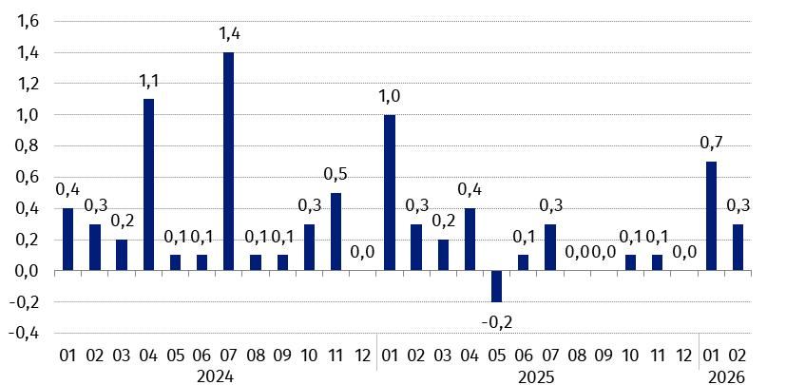
Chart 2. Changes in consumer prices as related to the previous month (in %)

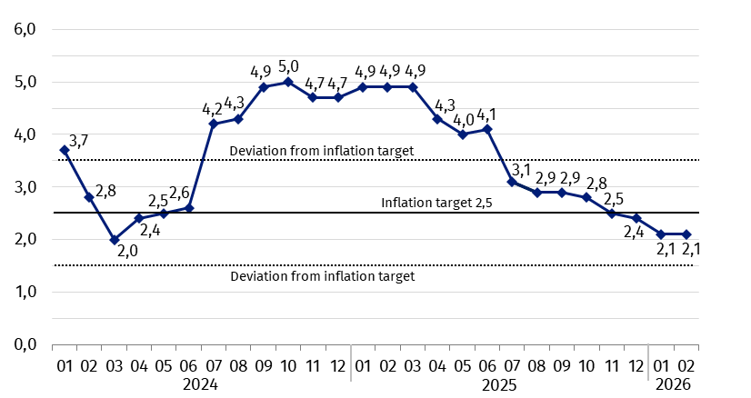
Chart 3. Changes in consumer prices as related to the corresponding period of the previous year (in %)
In February 2026 the consumer price index was within the deviations from inflation target determined by the Monetary Policy Council (2.5% +/- 1 pp)

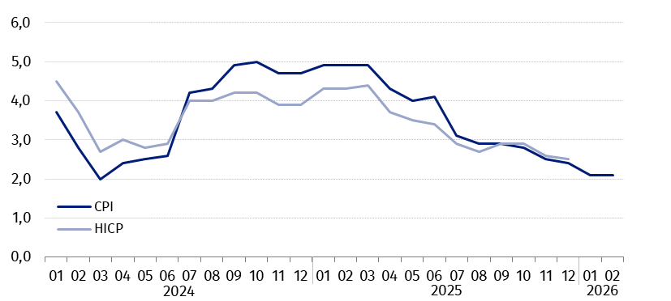
Chart 4. Changes in prices according to consumer price index (CPI) and harmonised index of consumer prices (HICP) as related to the corresponding period of the previous year (in %)
In case of quoting Statistics Poland data. please provide information: “Source of data: Statistics Poland”. and in case of publishing calculations made on data published by Statistics Poland. please include the following disclaimer: “Own study based on figures from Statistics Poland”.
Prepared by:  Prices and Services Department  Director Ewa Adach-Stankiewicz  Phone: (+48 22) 608 31 24 | Issued by:  Press Office  Mobile (+48) 695 255 032  Phone (+48 22) 608 38 04  (+48 22) 608 30 09  (+48 22) 449 41 45  e-mail: obslugaprasowa@stat.gov.pl

stat.gov.pl/en/

@StatPoland

@GlownyUrzadStatystyczny

gus_stat

glownyurzadstatystycznygus

glownyurzadstatystyczny
Related information
Communications and Announcements
News releases
Information on the implementation of the COICOP 2018 classification with 2026 data
Information on the changes in the consumer price survey in 2026
Data available in databases
Knowledge Database Prices
Macroeconomic Data Bank
Local Data Bank
Price indices (Topics: Prices. Trade)
Prices (Topics: Prices. Trade)
Terms used in official statistics
Price index of consumer goods and services
Retail price

