Energy efficiency in the years 2013–2023
1.5%
An increase of energy efficiency in Poland in 2023 compared to 2022.
Poland's energy efficiency increased by 1.5% in 2023 compared to 2022. Between 2013 and 2022, the annual cumulative growth rate of energy efficiency amounted to 1.1%. Primary energy intensity of GDP decreased by an average of 3.8% per year during this period, while final energy intensity of GDP decreased by 2.8% per year. The fastest rate of energy efficiency improvement was observed in industry (by 2.6% per year).

Total primary energy consumption decreased between 2013 and 2023 from 93.4 Mtoe to 93.3 Mtoe (cumulative annual growth rate - 0.1%). In contrast, final energy consumption increased from 63.5 to 70.0 Mtoe during the analysed period (a cumulative annual growth rate of - 1.0%). Total consumption reached its peak in 2018 (104.1 Mtoe), final energy consumption in 2021 (75.5 Mtoe).
In 2023, both total primary energy consumption and final energy consumption were lower than in 2022.
Chart 1. Total primary energy consumption and final energy consumption
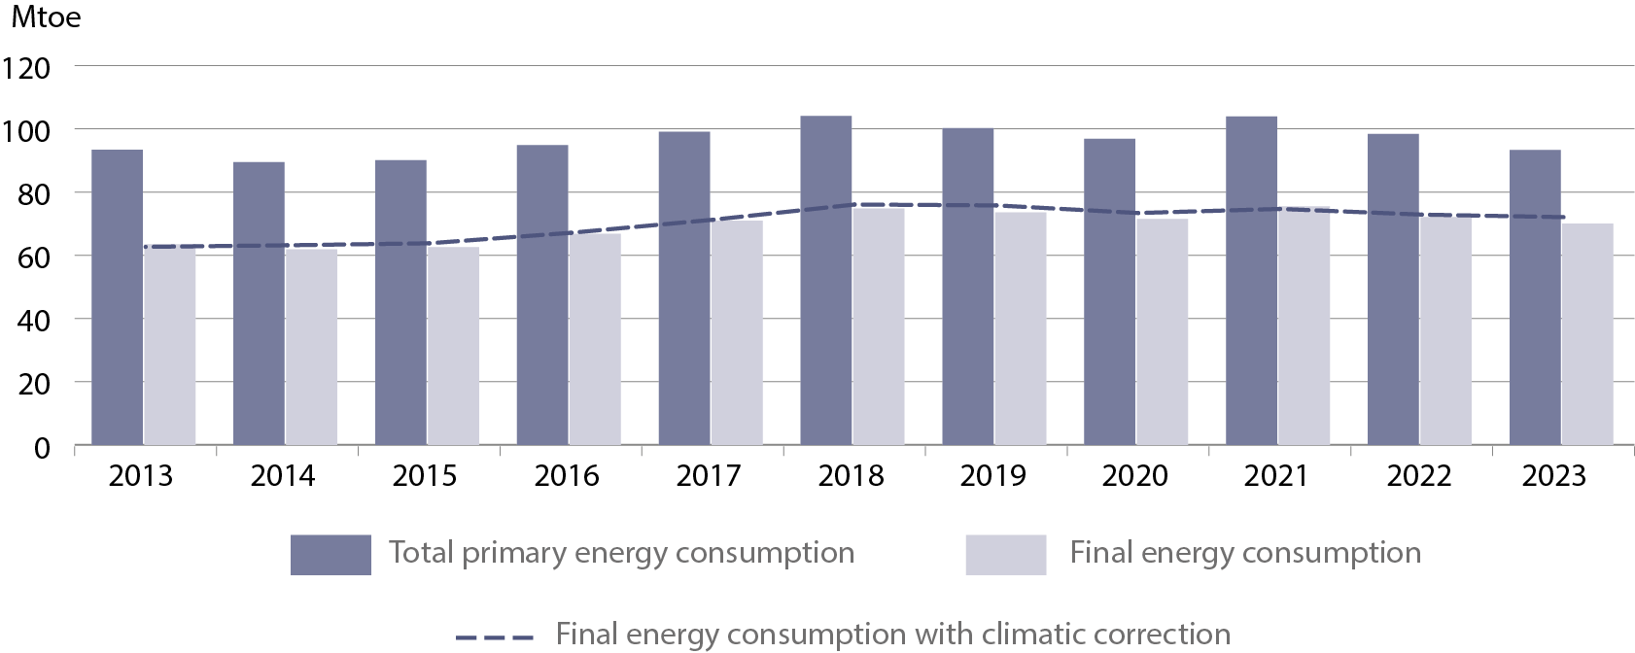
Primary energy intensity of GDP in 2023 decreased by 6.1% compared to the previous year, while final energy intensity of GDP decreased by 3.0%.
Compared to 2013, the primary energy intensity of GDP in 2023 decreased by 31.8% and final energy intensity of GDP by 23.8%. The rate of improvement for primary intensity with climatic corrections was slightly lower (30.3%) and for final energy intensity of GDP was also slightly lower (21.2%).

Table 1. The annual cumulative growth rate of energy efficiency of GDP
Rate of improvement | 2014–2018 | 2019–2023 | 2014–2023
Rate of improvement | %/year
Primary energy intensity of GDP | -2.4 | -5.1 | -3.8
Primary energy intensity of GDP  with climatic corrections | -2.0 | -5.0 | -3.5
Final energy intensity of GDP | -1.3 | -4.0 | -2.7
Final energy intensity of GDP  with climatic corrections | -0.8 | -3.9 | -2.4

Households
In 2023 household energy consumption accounted for 28.8% of final energy consumption. The most commonly consumed energy carrier was natural gas with a share of 21.1% in 2023. This was followed by solid fossil fuels (20.6%), heat (17.5%) electricity (12.5%) liquid fuels (2.8%). The consumption of other energy carriers, which included solid biofuels and ambient heat, was 25.5%.
The most important direction of energy use was space heating, with a 62.1% share in 2023. Water heating consumed 18.6% of energy, lighting and electrical appliances 10.2% and preparing meals 9.1%.
Table 2. Structure of energy consumption in households by directions of use
The share of energy used for space heating in 2023 decreased by 6.3 percentage points compared to 2018.
Specification | 2018 | 2019 | 2020 | 2021 | 2022 | 2023
Specification | %
Total | 100.0 | 100.0 | 100.0 | 100.0 | 100.0 | 100.0
Space heating | 68.4 | 66.4 | 66.1 | 65.4 | 63.1 | 62.1
Water heating | 15.5 | 16.2 | 16.3 | 17.1 | 18.0 | 18.6
Cooking | 7.4 | 8.1 | 8.1 | 8.3 | 9.1 | 9.1
Lighting and electrical  appliances | 8.7 | 9.3 | 9.5 | 9.2 | 9.8 | 10.2
The household energy consumption rate per m² showed a decreasing trend. The volume of consumption in 2023 amounted to 18.7 kgoe/m², compared with 22.1 kgoe/m² in 2013 (cumulative annual decrease of 1.6% per year). Adjusted for climatic corrections, consumption per m2 decreased by 0.6% per year.

Chart 2. Energy consumption in households per m²
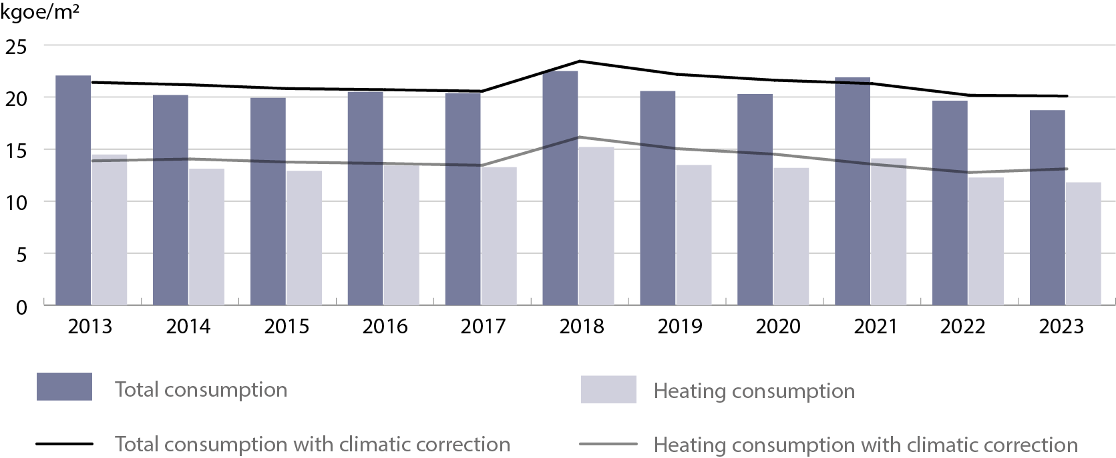

Industry
Between 2013 and 2015, final energy consumption in industry showed slight fluctuations, followed by a clear increase starting in 2016, reaching a peak of 18.2 Mtoe in 2019. Since 2021, a steady decline in consumption has been observed, amounting to 14.7 Mtoe in 2023. This represents a decrease of 9.7% compared to the previous year and marks the lowest level in the analysed period.
Final energy consumption in the industrial sector has continued to decline.
Between 2013 and 2023, a decrease in consumption was observed for manufactured gases (by 38.2%), solid fossil fuels (by 34.8%), and electricity (by 11.0%). On the other hand, consumption increased for liquid fuels (excluding biofuels) by 29.0%, heat by 16.9%, natural gas by 13.3%, energy from renewable sources (RES) and biofuels by 23.5%, and non-renewable waste by 69.2%.
Within the structure of final energy consumption in the manufacturing industry, three energy-intensive sectors dominated: the food, chemical, and mineral industries, which together accounted for 55.1% of total energy consumption in this sector in 2023 (compared to 52.9% in 2013).
Chart 3. Structure of final energy consumption in manufacturing by branch
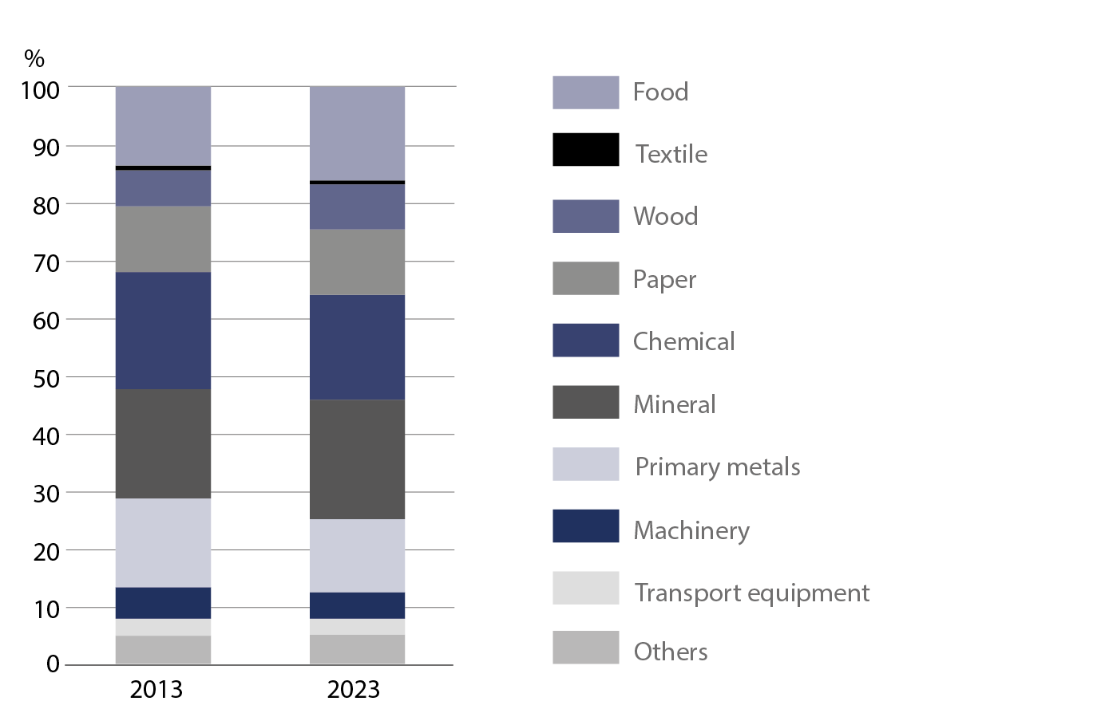

ODEX indicator
The ODEX index, which measures progress in energy efficiency for the entire economy (base year 2000 = 100), decreased from 76.0 to 68.1 between 2013 and 2023, indicating a 10.5% improvement in energy efficiency during the analysed period. The cumulative improvement rate was 1.1% per year. The fastest rate of improvement was recorded in industry, with an annual increase of 2.6%. For this sector, the index value reached 39.5 in 2023, representing a 23.4% improvement in energy efficiency compared to 2013. The slowest progress was observed in the transport sector, where the annual improvement rate was 0.4% between 2013 and 2023. In the household sector, the average improvement rate was 1.0% per year, resulting in a 9.8% increase in energy efficiency over the period.
Energy efficiency of the economy improved during the 2013–2023 period. The fastest rate of improvement (2.6% per year) was recorded in industry, while the slowest was in the transport sector (0.4% per year).
Chart 4. ODEX indicator
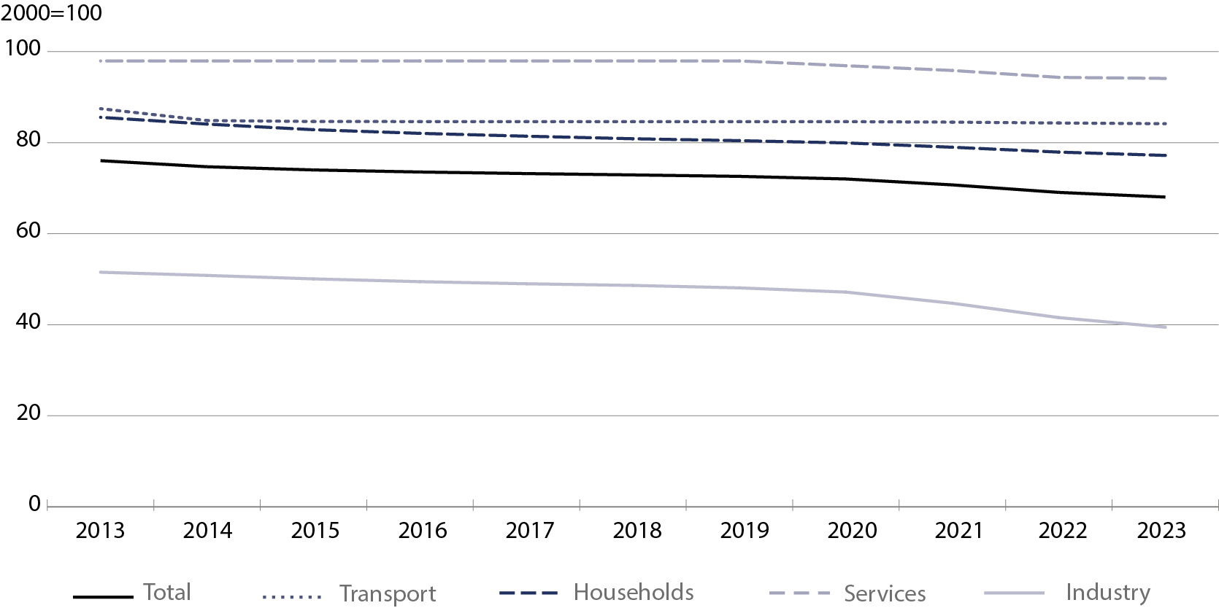
Decomposition of energy consumption
Economic activity had the greatest impact on the increase in energy demand
Between 2013 and 2023, final energy consumption in the economy increased by 6.3 Mtoe. This increase was mainly driven by factors related to economic activity (15.1 Mtoe), particularly in industry (7.3 Mtoe) and transport (4.3 Mtoe). The increase in consumption was also influenced by the growing number of households (1.6 Mtoe) and changes in lifestyle (0.8 Mtoe). The most significant factor limiting energy consumption was the implementation of energy-saving measures, which reduced consumption by 7.7 Mtoe, especially in industry (4.8 Mtoe) and households (2.3 Mtoe). Additionally, favourable weather conditions contributed to a reduction of 2.9 Mtoe. The transport sector recorded the largest increase in energy consumption (8.0 Mtoe), whereas in agriculture, consumption remained unchanged, and in industry and services, it declined slightly.

Table 3. Influence of factors on the change in final energy consumption
Specification | Industry | Households | Transport | Services | Agriculture | Total
Specification | Mtoe
Consumption change | -0.5 | -1.1 | 8.0 | -0.1 | 0.0 | 6.3
Factors:
Activity | 7.3 | — | 4.3 | 3.5 | 0.1 | 15.1
Stock of dwellings | — | 1.6 | — | — | — | 1.6
Lifestyle | — | 0.8 | — | — | — | 0.8
Structural changes | -2.4 | — | 0.5 | — | — | -1.9
Energy  savings | -4.8 | -2.3 | -0.2 | -0.4 | — | -7.7
Weather  conditions | — | -2.0 | — | -0.8 | — | -2.9
Others | -0.6 | 0.9 | 3.4 | -2.3 | -0.1 | 1.2

When quoting Statistics Poland data, please provide the information: “Source of data: Statistics Poland”, and when publishing calculations made on data published by Statistics Poland, please include the following disclaimer: “Own study based on figures from Statistics Poland”.
Prepared by:  Statistical Office in Rzeszow  Acting Director Teresa Krzemińska  Phones: (+48 17) 853 52 10,  (+48 17) 853 52 19 | Issued by:  Press Office  Mobile: (+48) 695 255 032  Phone: (+48 22) 608 38 04, (+48 22) 449 41 45,  (+48 22) 608 30 09  e-mail: obslugaprasowa@stat.gov.pl

stat.gov.pl/en/

@StatPoland

@GlownyUrzadStatystyczny

gus_stat

glownyurzadstatystycznygus

glownyurzadstatystyczny
Related information
Energy statistics
Energy efficiency in Poland
Data available in databases
Knowledge databases - Energy statistics
Poland macroeconomic indicators
Macroeconomic Data Bank
Terms used inn official statistics
Primary energy
Derived energy
Energy consumption

