Consumer price indices in June 2025
Consumer prices in June 2025 increased by 4.1% compared with the corresponding month of the previous year (with an increase of prices of ser-vices by 6.3% and goods by 3.2%).
The increase of consumer prices in annual terms (4.1%) was the same as published in the flash estimate for June this year.
4.1%
price increase compared with June 2024
As related to the previous month consumer prices increased by 0.1% (of which services by 0.8%, while the prices of goods decresed by 0.2%).

Table 1. Consumer price indices in June 2025

SPECIFICATION | 06 2025 |  |  | Q2 2025 |  | 01-06 2025 | CONTRIBUTION OF CHANGES  05 2025=  =100
SPECIFICATION | 06 2024=  =100 | 12 2024=  =100 | 05 2025=  =100 | Q2 2024=100 | Q1 2025=100 | 01-06 2024=100 | CONTRIBUTION OF CHANGES  05 2025=  =100
TOTAL | 104.1 | 101.8 | 100.1 | 104.1 | 100.6 | 104.5 | x
Food and non-alcoholic beverages | 104.9 | 103.5 | 100.2 | 105.3 | 101.4 | 105.7 | 0.04
Alcoholic beverages  and tobacco | 106.7 | 105.9 | 100.6 | 106.4 | 102.5 | 105.7 | 0.03
Clothing and footwear | 98.5 | 98.7 | 98.3 | 98.4 | 103.2 | 98.6 | -0.06
Housing. water. electricity. gas and other fuels | 110.5 | 102.1 | 99.9 | 110.6 | 100.2 | 110.7 | -0.02
Furnishings. household  equipment and routine  household maintenance | 99.9 | 99.8 | 99.9 | 99.8 | 99.7 | 100.0 | 0.00
Health | 104.6 | 103.3 | 100.2 | 104.9 | 101.3 | 105.2 | 0.01
Transport | 94.0 | 95.8 | 99.6 | 93.7 | 96.9 | 95.8 | -0.04
Communication | 104.4 | 101.7 | 100.7 | 103.5 | 100.8 | 103.0 | 0.03
Recreation and culture | 103.3 | 102.5 | 101.4 | 103.4 | 99.9 | 103.9 | 0.10
Education | 108.0 | 101.0 | 100.0 | 108.1 | 100.4 | 108.2 | 0.00
Restaurants and hotels | 106.0 | 103.7 | 100.6 | 106.0 | 102.0 | 106.2 | 0.03
Miscellaneous goods  and services | 101.3 | 100.9 | 99.9 | 101.8 | 100.7 | 102.2 | -0.01

A table with indices in more detail is available in the data file attached to this news release and in the Knowledge Databases.

Contributions of price changes to the total consumer price index
In June of the current year, compared with the previous month, the highest contribution to the total consumer price index came from higher prices related to: Recreation and culture (by 1.4%), Food (by 0.2%), Restaurants and hotels and Alcoholic beverages and Tobacco (by 0.6% each) and Communication (by 0.7%), which increased the index by: 0.10 pp, 0.04 pp and by 0.03 pp each, respectively. Lower prices related to Clothing and footwear (by 1.7%) and Transport (by 0.4%) decreased the index by 0.06 pp and 0.04 pp, respectively.
Compared with the corresponding month of the previous year, higher prices related, among others, to: Dwelling (by 8.2%), Food (by 4.8%), Alcoholic beverages and tobacco (by 6.7%), Restaurants and hotels (by 6.0%), Health (by 4.6%) and Recreation and culture (by 3.3%) increased the total index by: 1.97 pp, 1.15 pp, 0.35 pp, 0.34 pp, 0.27 pp and 0.23 pp, respectively. Lower prices related to Transport (by 6.0%) and Clothing and footwear (by 1.5%) decreased the index by 0.67 pp and 0.06 pp, respectively.
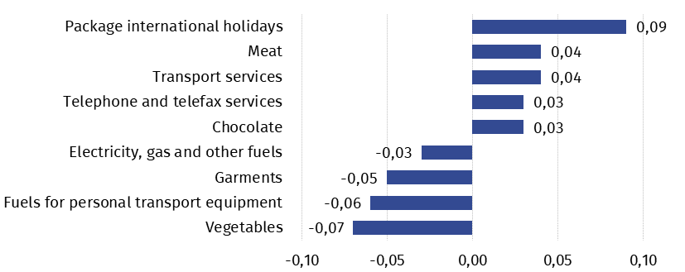
Chart 1. Contribution of price changes of selected groups of consumer goods and services in June 2025 (change in pp compared with the previous period)

Chart 2. Weighting system used in the compilations of consumer price indices in 2025
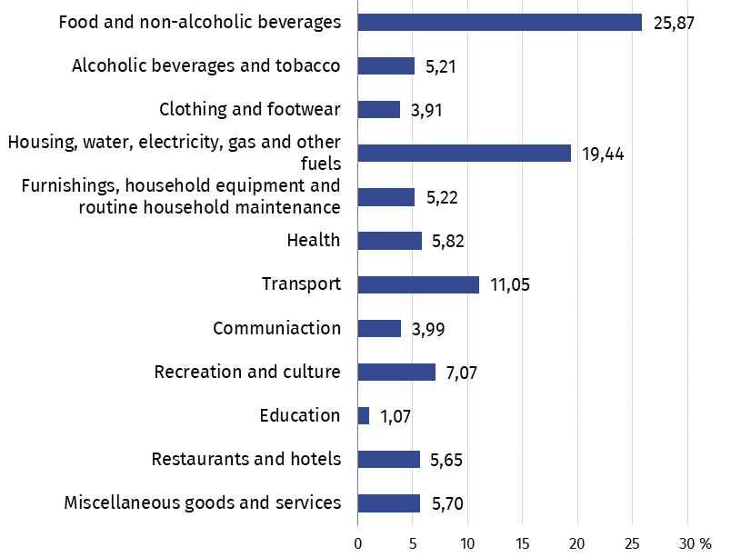

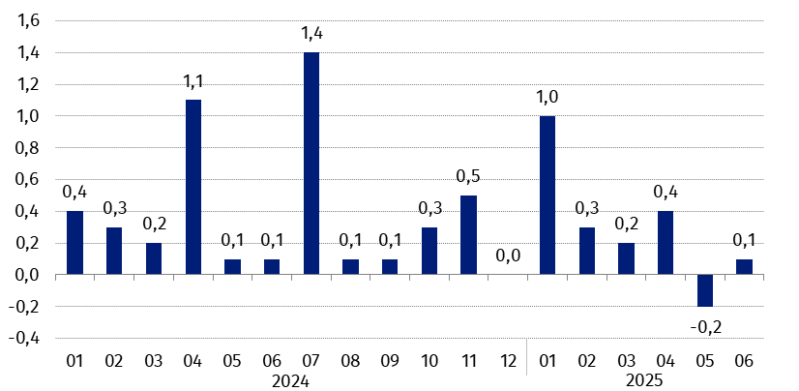
Chart 3. Changes in consumer prices as related to the previous month (in %)

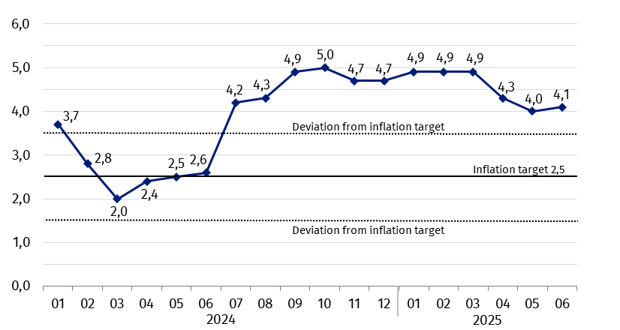
Chart 4. Changes in consumer prices as related to the corresponding period of the previous year (in %)
Since July 2024 the consumer price index is above the upper band for deviations from inflation target determined by the Monetary Policy Council (2.5% +/- 1 pp)

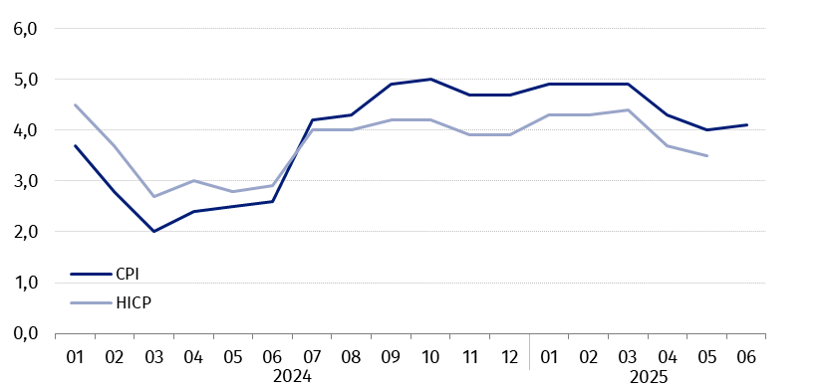
Chart 5. Changes in prices according to consumer price index (CPI) and harmonised index of consumer prices (HICP) as related to the corresponding period of the previous year (in %)
In case of quoting Statistics Poland data. please provide information: “Source of data: Statistics Poland”. and in case of publishing calculations made on data published by Statistics Poland. please include the following disclaimer: “Own study based on figures from Statistics Poland”.
Prepared by:  Trade and Services Department  Director Ewa Adach-Stankiewicz  Phone: (+48 22) 608 31 24 | Issued by:  Press Office  Mobile (+48) 695 255 032  Phone (+48 22) 608 38 04  (+48 22) 608 30 09  (+48 22) 449 41 45  e-mail: obslugaprasowa@stat.gov.pl

stat.gov.pl/en/

@StatPoland

@GlownyUrzadStatystyczny

gus_stat

glownyurzadstatystycznygus

glownyurzadstatystyczny
Related information
Communications and Announcements
News releases
Data available in databases
Knowledge Database Prices
Macroeconomic Data Bank
Local Data Bank
Price indices (Topics: Prices. Trade)
Prices (Topics: Prices. Trade)
Terms used in official statistics
Price index of consumer goods and services
Retail price

