Construction and assembly production in February 2026
Unfavorable weather conditions resulted in fewer orders, which translated into a scale of decline in production in the construction industry

According to preliminary data construction and assembly production (in constant prices) carried out domestically was in February 2026 lower by 13.7% than in the same period of 2025. It is worth noting that compared to January 2026 an increse was noted by 6.4%.
13.7%
Decrease of construction and assembly production
compared to February 2025
After seasonally adjusted, the decrease was noted in construction and assembly production of 12.4% an annual

In February 2026, after eliminating the seasonal factors, construction and assembly production reached the level by 12.4% lower than in the corresponding month of the previous year and lower by 3.8% in comparison to January 2026.
Chart 1. Construction and assembly production (constant prices; average monthly base 2021=100) ª
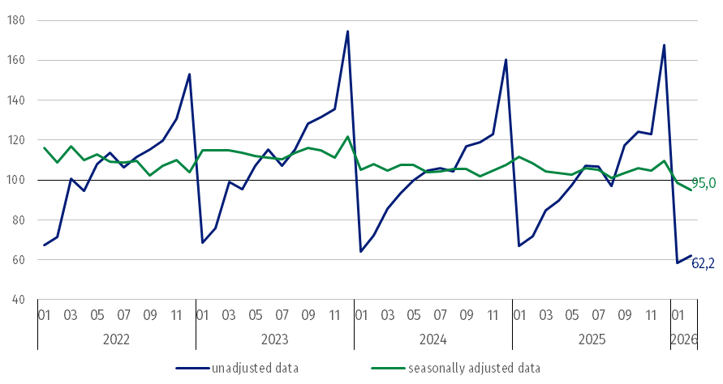
ª Preliminary data for February 2026.
The decrease in construction and assembly production in February 2026 (in constant prices), compared to the average monthly value of 2021, was 37.8%.
Construction and assembly production in February 2026 decreased for entities dealing mainly with construction of buildings of 16.7%, performing specialised construction activities of 12.2% and in entities whose basic type of activity was civil engineering of 11.7% an annual.

In Ferbruary 2026 compared to January 2026, an increase in the sales of construction and assembly production was noted in entities whose basic type of activity was construction of buildings of 10.1%, dealing mainly with civil engineering works of 5.1% and performing specialised construction activities of 3.9%.
Table 1. Construction and assembly production (constant prices) ª
Specification | 2026
Specification | 01 | 02 | 01 | 02 | 01-02
Specification | previous month = 100 |  | corresponding period of the previous year = 100
CONSTRUCTION | 34.8 | 106.4 | 87.1* | 86.3 | 86.9
Construction of buildings ^{Δ} | 45.8* | 110.1 | 81.7* | 83.3 | 84.3
Civil engineering works ^{Δ} | 25.1 | 105.1 | 92.3* | 88.3 | 89.7
Specialised construction activities | 41.6 | 103.9 | 88.2* | 87.8 | 87.1
ª Data including final information on production and prices in January and preliminary data in February 2026.
* The data has been changed compared to what was previously published.
^{Δ} Abbreviated form according to PKD 2007.
In the period January-February 2026 construction and assembly production decreased of 13.1%

In the period January-February 2026, in relation to the same period of the previous year, a decrease in the sales of construction and assembly production was noted of 13.1%. The decrease was observed in entities whose basic type of activity was construction of buildings of 15.7%, performing specialised construction activities of 12.9% and in entities dealing mainly with civil engineering works of 10.3%.
Analyzing the value of construction and assembly production in February 2026 in terms of construction works (investment and restoration works) were observed:
In February 2026, compared to January 2026 was noted an increase for investment works of 9.9%
- an annual decrease for restoration works by 29.8% and for investment works by 5.3% (in February 2025, a decrease for restoration of 2.6% and an increase for investment of 1.3%),
- compared to January 2026, an increase for investment works by 9.9% and an decrease by 1.7% for restoration works.
In the period January-February 2026, in relation to the same period of the previous year, a decrease in the sales of construction and assembly production were noted for restoration works by 29.6% and for investment works by 4.5% (in 2025, a decrease for works restoration works of 8.0% and an increase investment works of 5.3%).

In case of quoting Statistics Poland data, please provide information: “Source of data: Statistics Poland” and in case of publishing calculations made on data published by Statistics Poland, please include the following disclaimer: “Own study based on figures from Statistics Poland”.

Prepared by:  Statistical Office in Lublin  Director Krzysztof Markowski, Ph.D.  Phone: (+48) 695 255 301 | Issued by:  Press Office  Mobile: (+48) 695 255 032  Phone: (+48 22) 608 38 04, (+48 22) 449 41 45,  (+48 22) 608 30 09  e-mail: obslugaprasowa@stat.gov.pl

stat.gov.pl/en/

@StatPoland

@GlownyUrzadStatystyczny

gus_stat

glownyurzadstatystycznygus

glownyurzadstatystyczny
Related information
Statistical Bulletin
Socio-economic situation of the country
Data available in databases
Knowledge Database - Construction
Macroeconomic Data Bank
Macroeconomic indicators
Local Data Bank

Terms used in official statistics
Sale of construction and assembly production
Seasonally unadjusted index of sale of construction and assembly production in constant prices
Seasonally adjusted index of sale of construction and assembly production
Sale of construction works with an investment character
Sale of construction works with a restoration character and other works

Preliminary data; comprise enterprises employing over 9 persons, whose the main type of activity is included in the section F “Construction” in accordance with the Polish Classification of Activities (PKD 2007).

