Price indices of sold production of industry in February 2026
According to preliminary data, the prices of sold production of industry in February 2026 decreased compared to February 2025 – by 2.3%, but increased compared to January 2026 — by 0.1%.
2.3%
the decrease of producer prices in industry compared to February 2025

Table 1. Price indices of sold production of industry
Specification | 01 2026 |  | 02 2026 |  |  | 01‒02 2026
Specification | 12 2025=100 | Corresponding period 2025=100 |  | 01 2026=100 | 12 2025=100 | 01‒02 2025
TOTAL | 99.7 | 97.4 | 97.7 | 100.1 | 99.8 | 97.6
Mining and quarrying | 101.3 | 102.3 | 101.2 | 98.9 | 100.2 | 101.8
Manufacturing | 99.7 | 97.0* | 97.7 | 100.3 | 100.0 | 97.4
Electricity. gas. steam and air conditioning supply | 99.3* | 98.4* | 95.9 | 98.6 | 97.9 | 97.1
Water supply; sewerage. waste management and remediation activities | 100.3 | 102.0 | 101.7 | 100.2 | 100.5 | 101.8

* Data revised.

Prices changes of sold production of industry in February 2026 compared to the previous month
According to preliminary data the prices of sold production of industry in February 2026 increased compared to January 2026 – by 0.1%. In the following months of 2025, except June and November, and in January 2026, slight price declines were recorded.

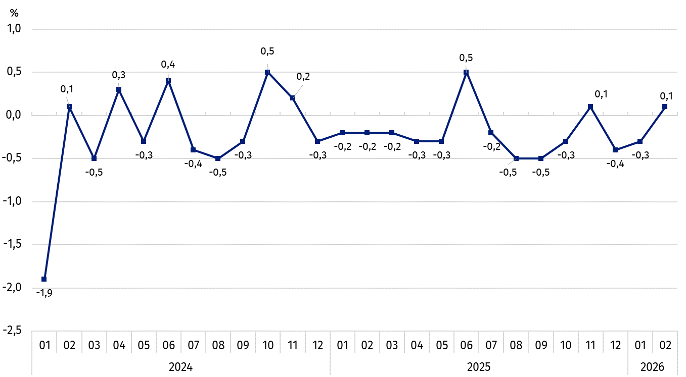
Chart 1. Prices changes of sold production of industry compared to the previous month
In February 2026 prices of sold production of industry increased by 0.1% compared to the previous month

The price increases were recorded in manufacturing – by 0.3%, as well as in water supply; sewerage, waste management and remediation activities – by 0.2%.
The prices have decreased in electricity. gas. steam and air conditioning supply section – by 1.4%, and in mining and quarrying – by 1.1% (including the mining of metal ores – by 3.0%, with increase in the mining of hard coal and lignite– by 1.8%).

Chart 2. Prices changes of sold production of industry by divisions in February 2026 compared to the previous month
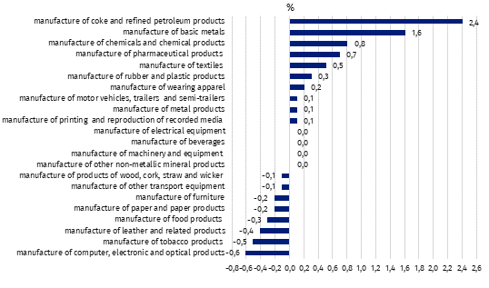
In February 2026 among divisions of manufacturing in comparison to the previous month the prices increased the most in manufacture of coke and refined petroleum products – by 2.4%. The largest price decrease was recorded in the manufacture of printing and reproduction of computer, electronic and optical products - by 0.6%

Prices changes of sold production of industry in February 2026 compared to the corresponding month of the previous year
In February 2026 the prices of sold production of industry compared to the corresponding month of the previous year decreased by 2.3%. Starting from July 2023, this is the next month in which a price decline was recorded on an annual basis. Throughout 2025 and until February 2026, the rate of price change remains lower than before.

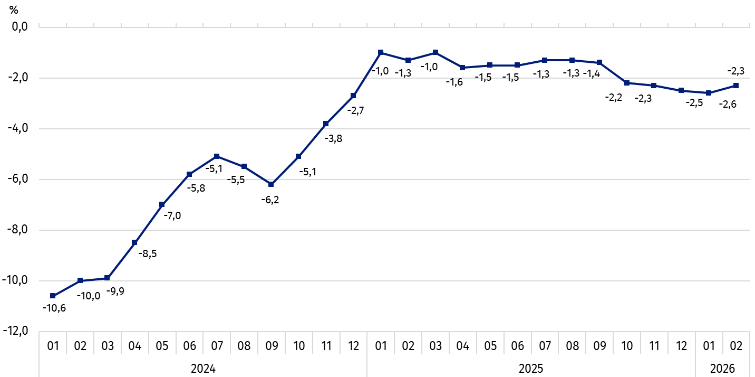
Chart 3. Prices changes of sold production of industry compared to the corresponding period of the previous year
In February 2026 a decline in the dynamics of prices of sold production of industry per year was observed by 2.3%

Among the sections prices drop was recorded in electricity, gas, steam and air conditioning supply section – by 4.1% . as well as in manufacturing section – by 2.3%.
Higher than in February were prices in water supply; sewerage, waste management and remediation activities section – by 1.7%, as well as in mining and quarrying section – by 1.2% (including in the mining of metal ores – by 8.5%, compared to a 7.6% decline in the mining of coal and lignite prices).

Chart 4. Prices changes of sold production of industry by divisions in February 2026 compared to the corresponding month of the previous year

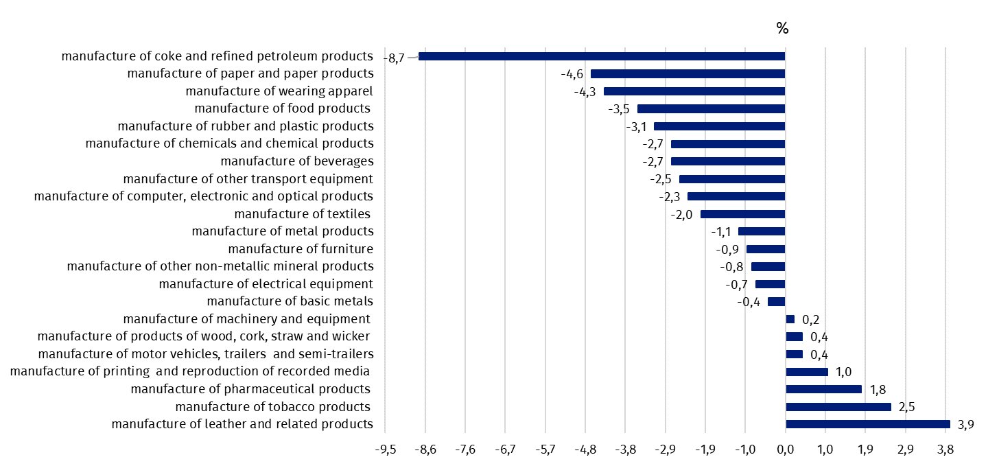
In February 2026 in comparison to the corresponding month of the previous year, the prices decreased the most in manufacture of coke and refined petroleum products – by 8.7%, and increased the most in manufacture of leather and related products - by 3.9%

Chart 5. Prices changes of sold production of industry by sections NACE rev. 2 compared to December 2023
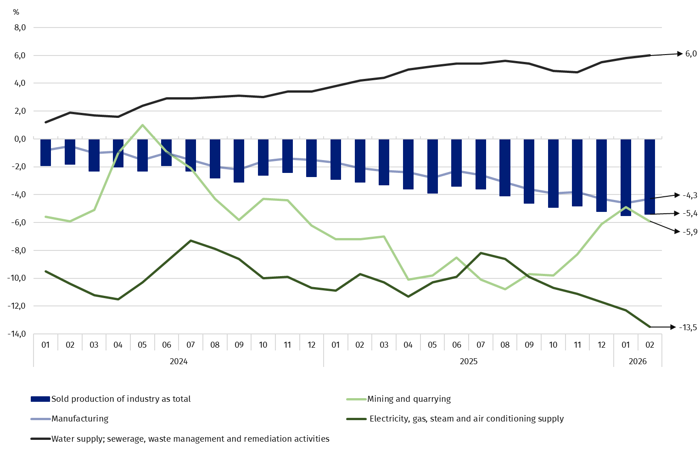

In case of quoting Statistics Poland data. please provide information: “Source of data: Statistics Poland”. and in case of publishing calculations made on data published by Statistics Poland. please include the following disclaimer: “Own study based on figures from Statistics Poland”.
Prepared by:  Prices and Services Statistics Department  Director Ewa Adach-Stankiewicz  Phone: (+48 22) 608 31 24 | Issued by:  Press Office  Mobile: (+48) 695 255 032  Phone: (+48 22) 608 38 04. (+48 22) 449 41 45.  (+48 22) 608 30 09  e-mail: obslugaprasowa@stat.gov.pl

stat.gov.pl/en/

@StatPoland

@GlownyUrzadStatystyczny

gus_stat

glownyurzadstatystycznygus

glownyurzadstatystyczny
Related information
Statistical Bulletin
News Releases
Socio-economic situation of the country
Data available in databases
Analytical Platform - Knowledge Databases
Macroeconomic Data Bank
Prices indices (Topics: Prices. Trade)
Terms used in official statistics
Price index of sold production of industry

Preliminary data for February 2025, final data for January 2026.

