Residential construction in the period of January–February 2026

In the period January–February 2026, 3.7% less dwellings were completed compared to the same period last year. The number of dwellings in which construction began also decreased (by 21.8%), whereas the number of dwellings for which permits were granted increased by 0.1%.
3.7%
Decrease in the number of dwellings completed compared to the corresponding period of 2025

Dwellings completed
Developers and private
investors completed respectively: 58.4% and 39.6% of the total number of dwellings
According to the preliminary data, 29.3 thousand dwellings were completed in in the period January–February 2026, i.e. by 3.7% less than in the corresponding period of 2025. Developers completed 17.1 thousand dwellings – by 6.7% less than a year ago, whereas private investors completed – 11.6 thousand dwellings, i.e. by 3.5% more. Within these two forms of construction, 98.0% of the total number of new dwellings was completed. In other forms, 590 dwellings were completed (893 in the previous year).
The total useful floor area of newly completed dwellings amounted to 2.7 million m², i.e. by 1.2% less than a year ago and its average value for 1 dwelling was 93.2 m².

Table 1. Dwellings completed
SPECIFICATION | 02 2026 |  |  | 01-02 2026
SPECIFICATION | number  of dwellings | 01 2026=100 | 02 2025=100 | number  of dwellings | 01-02 2025=100
TOTAL | 14 629 | 99.7 | 100.9 | 29 303 | 96.3
Private | 5 888 | 103.0 | 106.1 | 11 603 | 103.5
For sale or rent | 8 501 | 98.7 | 98.6 | 17 110 | 93.3
of which for rent | 114 | 285.0 | 158.3 | 154 | 131.6
Cooperative | – | . | . | 112 | 80.6
Municipal | – | . | . | 44 | 35.5
Public building society | 240 | 123.7 | 153.8 | 434 | 69.1
Company | – | . | . | – | .

Dwellings for which permits have been granted
In the period January–February 2026, building permits were issued for 40.3 thousand dwellings, i.e. by 0.1% more than a year ago, of which 27.4 thousand permits to developers (an increase of 1.0% y/y) and 12.3 thousand to private investors (an increase of 10.6%). Within these two forms of construction, permits were granted for 98.6% of dwellings in total. In other forms of construction, building permits were issued for 575 dwellings (2002 in the previous year).

Table 2. Dwellings for which permits have been granted
SPECIFICATION | 02 2026 |  |  | 01-02 2026
SPECIFICATION | number  of dwellings | 01 2026=100 | 02 2025=100 | number  of dwellings | 01-02 2025=100
TOTAL | 22 686 | 128.7 | 112.4 | 40 307 | 100.1
Private | 6 513 | 111.9 | 116.0 | 12 332 | 110.6
For sale or rent | 15 720 | 134.6 | 116.1 | 27 400 | 101.0
Cooperative | – | . | . | 2 | 30-fold less
Municipal | 179 | 149.2 | 36.4 | 299 | 26.8
Public building society | 250 | . | 46.2 | 250 | 30.2
Company | 24 | . | . | 24 | .

Dwellings in which construction has begun
In the period January–February 2026, construction of 26.4 thousand dwellings began, i.e. by 21.8% less than a year before. Developers have started construction of 18.5 thousand dwellings (by 21.3% less than in the previous year), and private investors – 6.9 thousand (by 27.9% less). Altogether the share of these forms of construction amounted to 96.4% of the total number of dwellings. In other forms of construction the number of dwellings in which construction has begun was 960 dwellings (655 in the previous year).

Table 3. Dwellings in which construction has begun
SPECIFICATION | 02 2026 |  |  | 01-02 2026
SPECIFICATION | number  of dwellings | 01 2026=100 | 02 2025=100 | number  of dwellings | 01-02 2025=100
TOTAL | 14 127 | 114.8 | 85.2 | 26 434 | 78.2
Private | 4 061 | 141.1 | 74.2 | 6 939 | 72.1
For sale or rent | 9 647 | 108.5 | 88.3 | 18 535 | 78.7
of which for rent | 4 | 44.4 | 57.1 | 13 | 21.7
Cooperative | – | . | . | – | .
Municipal | 76 | 45.5 | 74.5 | 243 | 73.2
Public building society | 343 | 93.2 | over 19- fold more | 711 | 278.8
Company | – | . | . | 6 | 120.0
It is estimated that at the end of February 2026, there were 835.9 thousand dwellings under construction, i.e. by 0.3% less than in the corresponding month of 2025.

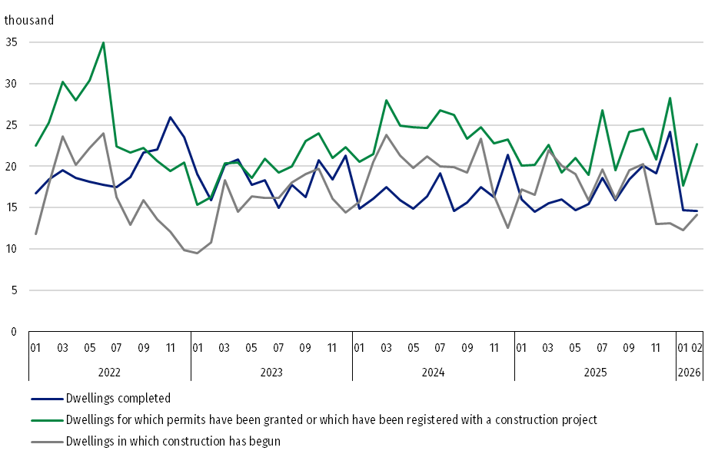
Chart 1. Residential construction in Poland
In February 2026, compared to the previous month, the number of dwellings for which permits were granted and the number of dwellings in which construction began increased (by 28.7% and 14.8%, respectively), whereas the number of dwellings completed decreased (by 0.3%)

In the period January-February 2026, the highest total number of dwellings - completed, as well as dwellings for which permits were granted and in which construction began - was recorded in Mazowieckie voivodship (5.9 thousand, 7.6 thousand and 4.4 thousand dwellings, respectively), Śląskie (2.2 thousand, 5.2 thousand and 2.4 thousand) and Wielkopolskie (3.0 thousand, 3.3 thousand and 2.9 thousand).

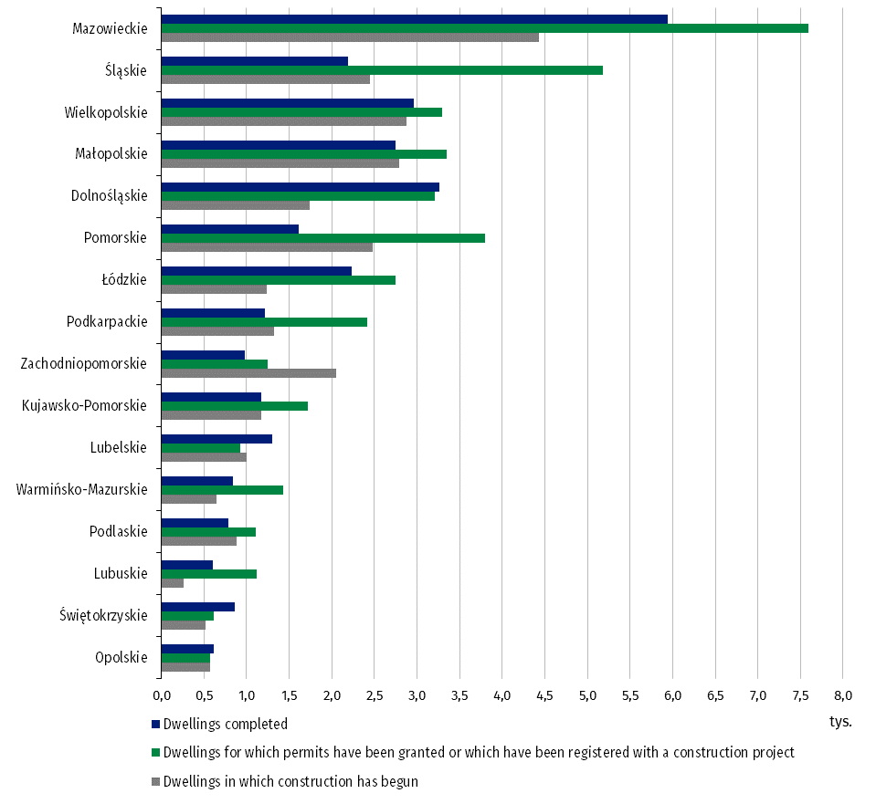
Chart 2. Residential construction by voivodships in January-February 2026

Meaning of symbols:
Dash (–) – means magnitude zero.
Dot ( . ) – means: data not available, classified data (statistical confidentiality) or providing data impossible or purposeless.

In case of quoting Statistics Poland data, please provide information: “Source of data: Statistics Poland” and in case of publishing calculations made on data published by Statistics Poland, please include the following disclaimer: “Own study based on figures from Statistics Poland”.
Prepared by:  Statistical Office in Lublin  Director Krzysztof Markowski, Ph.D.  Phone: (+48) 695 255 301 | Issued by:  Press Office  Mobile +48 695 255 032  Phone +48 22 608 38 04, +48 22 449 41 45,  +48 22 608 30 09  e-mail: obslugaprasowa@stat.gov.pl

www.stat.gov.pl/en/

@StatPoland

@GlownyUrzadStatystyczny

gus_stat

glownyurzadstatystycznygus

glownyurzadstatystyczny
Related information
Statistical Bulletin
Socio-economic situation of the country
Construction results
Data available in databases
Macroeconomic Data Bank
Knowledge Databases - Construction
Local Data Bank
Terms used in official statistics
Dwellings for which permits have been granted or which have been registered with a construction project
Dwellings in which construction has begun
Dwellings completed

Preliminary data.
The form of construction - “For sale or rent”.
Including registrations with a construction project and a simplified procedure for single-family residential buildings.

