Human resources in selected medical professions based on administrative sources in 2023
The study is the result of an analysis of administrative sources, including registers, in relation to five medical professions: doctors, dentists, nurses, midwives and physiotherapists. It showcases the resulting statistical data for the resources of the medical staff, as well as description of applied methodology of data analysis.
In 2023, the number of doctors working directly with patients per 10,000 population amounted to 36,5, dentists – 9.6, nurses – 57.4, physiotherapists – 15,7, and midwives – 14.7 per 10,000 women
In 2023, the number of doctors working directly with patients was 137,420; dentists – 36,002; nurses – 216,086; midwives – 28,527 and physiotherapists – 59,136.

Doctors
An increase in the number of doctors with a license to practice by 4.3 thousand in 2023 compared to 2022
In 2023, the number of doctors living in Poland with a license to practice their profession amounted to 163.2 thousand (in 2022 – 158.9 thousand).
Among doctors authorized to practice, the dominant group – 19.8% – were people aged 30-39 (in the previous year people aged 50-59 were the dominant group – 20.2% - and people aged 30-39 were second – 19.4%). The dominance of people aged 30-39 in 2023 was smaller among men than among women doctors.

Table 1. Doctors entitled to perform profession by sex and age
As of 31 December
Specification | 2022 |  |  |  | 2023
Specification | total |  | males | females | total |  | males | females
Specification | in thousands | in % | in thousands |  | in thousands | in % | in thousands
Grand total | 158.9 | 100.0 | 64.4 | 94.5 | 163.2 | 100.0 | 65.7 | 97.5
to 29 years | 16.9 | 10.6 | 6.3 | 10.6 | 18.2 | 11.1 | 6.8 | 11.4
30–39 | 30.8 | 19.4 | 11.3 | 19.5 | 32.4 | 19.8 | 11.8 | 20.6
40–49 | 22.6 | 14.2 | 9.1 | 13.5 | 23.0 | 14.1 | 8.9 | 14.1
50–59 | 32.1 | 20.2 | 14.7 | 17.3 | 31.3 | 19.2 | 14.4 | 17.0
60–69 | 30.1 | 19.0 | 13.2 | 17.0 | 30.5 | 18.7 | 13.4 | 17.1
70–79 | 16.0 | 10.1 | 6.2 | 9.9 | 17.3 | 10.6 | 6.8 | 10.5
80 years and more | 10.5 | 6.6 | 3.7 | 6.8 | 10.5 | 6.4 | 3.6 | 6.9

The overall population of doctors authorized to practice their professions in Poland includes all persons with such a right, regardless of their status on the labor market and place of work, therefore the number of persons working directly with the patient is more reliable data.
In 2023, the number of doctors working directly with patients amounted to – 137,4 thousand (131.4 thousand in 2022).
An increase in the number of doctors working directly with patients by 6,0 thousand in 2023 compared to 2022

Table 2. Doctors working directly with patient by sex and age
As of 31 December
Specification | 2022 |  |  |  | 2023
Specification | Total |  | males | females | total |  | males | Females
Specification | in thousands | in % | in thousands |  | in thousands | in % | in thousands
Grand total | 131.4 | 100.0 | 54.3 | 77.1 | 137.4 | 100.0 | 56.5 | 80.9
to 29 years | 14.7 | 11.2 | 5.5 | 9.1 | 16.7 | 12.1 | 6.3 | 10.4
30–39 | 29.1 | 22.2 | 10.7 | 18.4 | 30.9 | 22.5 | 11.3 | 19.6
40–49 | 20.7 | 15.8 | 8.3 | 12.4 | 21.3 | 15.5 | 8.3 | 13.1
50–59 | 29.2 | 22.2 | 13.3 | 15.9 | 28.7 | 20.9 | 13.0 | 15.7
60–69 | 26.0 | 19.8 | 11.5 | 14.5 | 26.6 | 19.4 | 11.9 | 14.8
70–79 | 9.8 | 7.5 | 4.1 | 5.7 | 11.2 | 8.1 | 4.8 | 6.3
80 years and more | 1.9 | 1.4 | 0.9 | 1.0 | 2.1 | 1.5 | 1.0 | 1.1

Among all doctors working directly with patients in 2023, the largest group (22.5%) were people aged 30–39 (a year earlier – about 22.2%). Among men the largest group were people aged 50-59 – 23.0% (1.4 percentage points less than in 2022), while in the case of women, in 2023 the largest group were people aged 30–39 (24.2% – 0.3 percentage points more than in 2022).

Chart 1. Structure of doctors working directly with patient by sex and age
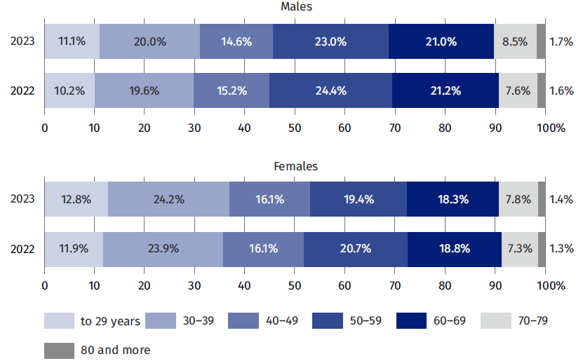
As of 31 December

In 2023, the largest number of doctors worked directly with the patient in the 2 largest voivodships: Mazowieckie – 27.3 thousand and Śląskie – 16.3 thousand and the least in the following voivodships: Lubuskie and Opolskie (2.4 thousands each).

Table 3. Doctors working directly with patient by voivodships
As of 31 December
Voivodships | 2022 |  |  | 2023
Voivodships | in thousands | in % | per 10,000 population | in thousands | in % | per 10,000 population
Poland | 131.4 | 100.0 | 34.8 | 137.4 | 100.0 | 36.5
Dolnośląskie | 10.7 | 8.1 | 37.1 | 11.0 | 8.0 | 38.4
Kujawsko-pomorskie | 6.0 | 4.6 | 30.0 | 6.2 | 4.5 | 31.0
Lubelskie | 7.6 | 5.8 | 37.6 | 7.6 | 5.6 | 38.0
Lubuskie | 2.3 | 1.8 | 23.8 | 2.4 | 1.7 | 24.5
Łódzkie | 9.8 | 7.4 | 41.1 | 9.9 | 7.2 | 41.8
Małopolskie | 12.0 | 9.1 | 35.0 | 12.4 | 9.0 | 36.1
Mazowieckie | 23.7 | 18.1 | 43.1 | 27.3 | 19.8 | 49.5
Opolskie | 2.3 | 1.8 | 24.8 | 2.4 | 1.7 | 25.3
Podkarpackie | 5.7 | 4.4 | 27.5 | 5.8 | 4.2 | 28.0
Podlaskie | 4.5 | 3.4 | 39.1 | 4.6 | 3.3 | 40.1
Pomorskie | 8.2 | 6.2 | 34.7 | 8.4 | 6.1 | 35.8
Śląskie | 15.9 | 12.1 | 36.6 | 16.3 | 11.9 | 37.8
Świętokrzyskie | 3.6 | 2.8 | 30.9 | 3.7 | 2.7 | 31.7
Warmińsko-mazurskie | 3.5 | 2.7 | 25.7 | 3.5 | 2.5 | 25.8
Wielkopolskie | 10.2 | 7.8 | 29.2 | 10.5 | 7.6 | 30.1
Zachodniopomorskie | 5.3 | 4.0 | 32.1 | 5.4 | 3.9 | 33.1

With regard to the number of doctors working directly with patients to the number of inhabitants in 2023, the following voivodships were ranked first: Mazowieckie and Łódzkie (49.5 and 41.8 doctors per 10,000 population, respectively). The smallest number of doctors per 10,000 population in 2023 occurred in the following voivodships: Lubuskie (24.5) and Opolskie (25.3).

Map 1. Doctors working directly with patient per 10 thousand of the population by
by voivodships in 2023
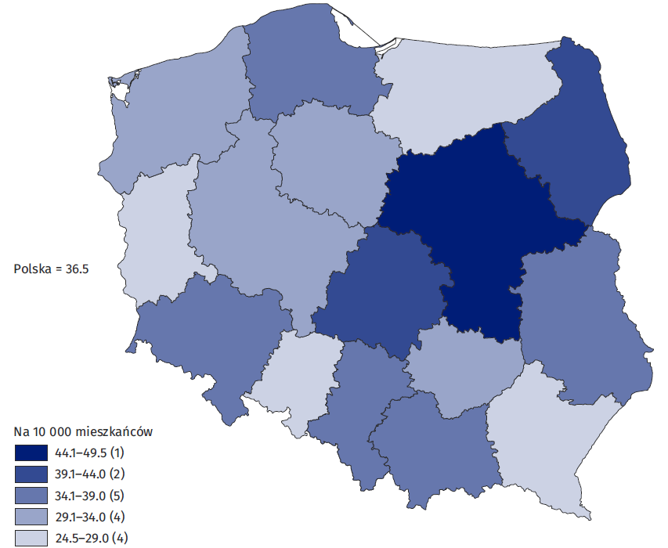
As of 31 December
Within the group of doctors working directly with patients, there were 89.7 thousand specialists in 2023 which accounted for 65.3% of the total number of physicians (in 2022 – 87.8 thousand, or 66.8% of the total number of doctors).
In 2023, similarly to the previous year, the largest number of doctors (about 18.2 thousand in 2023 and 0.2 thousand less in 2022) had a specialization in internal medicine. In second place were general practitioners (10.7 thousand in 2023 and 0.2 thousand less the year before) and the next was pediatrics (7.3 thousand in 2023 and 0.1 thousand less the year before).

Table 4. Most common specializations of doctors working directly with patient
As of 31 December
Specializations | 2022 |  | 2023
Specializations | in thousands | in % of all specialist doctors | in thousands | in % of all specialist doctors
Internal diseases | 18.0 | 20.5 | 18.2 | 20.3
General practitioners | 10.5 | 12.0 | 10.7 | 11.9
Paediatrics | 7.2 | 8.2 | 7.3 | 8.2
Obstetrics and gynaecology | 6.0 | 6.9 | 6.1 | 6.8
General surgery | 5.7 | 6.5 | 5.8 | 6.4
Anaesthesiology and intensive care | 5.4 | 6.1 | 5.5 | 6.2
Cardiology | 4.9 | 5.6 | 5.1 | 5.6
Trauma and orthopaedic surgery | 3.7 | 4.2 | 3.8 | 4.3
Psychiatry | 3.6 | 4.1 | 3.7 | 4.1
Ophthalmology | 3.5 | 4.0 | 3.6 | 4.0
Radiology and diagnostic imaging | 3.4 | 3.9 | 3.5 | 3.9
Neurology | 3.4 | 3.9 | 3.5 | 3.9
Respiratory diseases | 2.4 | 2.7 | 2.4 | 2.7
Otorhinolaryngology | 2.0 | 2.3 | 2.1 | 2.3
Dermatology and venereology | 1.8 | 2.0 | 1.9 | 2.1
Medical rehabilitation | 1.7 | 1.9 | 1.7 | 1.9
Endocrinology | 1.6 | 1.8 | 1.6 | 1.8
Rheumatology | 1.6 | 1.8 | 1.7 | 1.8
Neonatology | 1.5 | 1.7 | 1.5 | 1.7
Diabetology | 1.5 | 1.7 | 1.6 | 1.7
Occupational medicine | 1.5 | 1.7 | 1.5 | 1.7
Allergology | 1.4 | 1.6 | 1.4 | 1.5
Nephrology | 1.4 | 1.6 | 1.4 | 1.5
Urology | 1.3 | 1.5 | 1.3 | 1.5

Note: One person may have more than one specialization.

Dentists
An increase in the number of dentists with a license to practice by 0.8 thousand in 2023 compared to 2022
In 2023, the number of dentists living in Poland with the legal right to practice their profession was 45.2 thousand (in 2022 – 44.3 thousand), of which 599 were authorized to practice medicine both as a doctor and a dentist.
Among dentists authorized to practice their profession the largest group represented people aged 30-39 (21.1% in 2023 – 0.1 percentage points more than in 2022), although the group of people aged 50–59 was only slightly smaller and in 2023 amounted to 20.1% (0.7 percentage points less than in the previous year).
Table 5. Dentists entitled to perform profession by sex and age
As of 31 December
Specification | 2022 |  |  |  | 2023
Specification | total |  | males | females | total |  | males | females
Specification | in thousands | in % | in thousands |  | in thousands | in % | in thousands
Grand total | 44.3 | 100.0 | 10.5 | 33.8 | 45.2 | 100.0 | 10.7 | 34.4
to 29 years | 4.6 | 10.3 | 1.2 | 3.4 | 4.6 | 10.3 | 1.2 | 3.5
30–39 | 9.3 | 21.0 | 2.6 | 6.7 | 9.5 | 21.1 | 2.7 | 6.8
40–49 | 7.9 | 17.8 | 2.3 | 5.6 | 8.1 | 17.9 | 2.3 | 5.8
50–59 | 9.2 | 20.8 | 2.1 | 7.1 | 9.1 | 20.1 | 2.2 | 6.9
60–69 | 6.3 | 14.2 | 1.4 | 4.9 | 6.5 | 14.5 | 1.4 | 5.1
70–79 | 4.0 | 9.1 | 0.6 | 3.5 | 4.4 | 9.7 | 0.6 | 3.7
80 years and more | 3.0 | 6.7 | 0.3 | 2.6 | 3.0 | 6.6 | 0.3 | 2.6

As in the case of doctors, the more reliable information is the number of dentists working directly with patient, which in 2023 amounted to – 36.0 thousand (34.9 thousand in 2022).
An increase in the number of dentists working directly with patients by 1.1 thousands in 2023 compared to 2022

Table 6. Dentists working directly with patient by sex and age
As of 31 December
Specification | 2022 |  |  |  | 2023
Specification | total |  | males | females | total |  | males | females
Specification | in thousands | in % | in thousands |  | in thousands | in % | in thousands
Grand total | 34.9 | 100.0 | 9.1 | 25.8 | 36.0 | 100.0 | 9.4 | 26.6
to 29 years | 4.3 | 12.3 | 1.1 | 3.2 | 4.4 | 12.2 | 1.1 | 3.3
30–39 | 8.7 | 24.8 | 2.5 | 6.2 | 8.9 | 24.8 | 2.5 | 6.4
40–49 | 7.2 | 20.5 | 2.1 | 5.1 | 7.4 | 20.5 | 2.1 | 5.3
50–59 | 8.4 | 24.0 | 1.9 | 6.4 | 8.3 | 23.1 | 2.0 | 6.3
60–69 | 4.8 | 13.6 | 1.2 | 3.6 | 5.1 | 14.0 | 1.2 | 3.9
70–79 | 1.5 | 4.3 | 0.3 | 1.2 | 1.7 | 4.9 | 0.4 | 1.4
80 years and more | 0.2 | 0.5 | 0.0 | 0.1 | 0.2 | 0.5 | 0.1 | 0.1

Among dentists working directly with the patient in 2023, the largest number of people belonged to the 30–39 age group (24.8%, similarly to the year earlier – 24.8%) and this group was also the largest among men (27.1% and in the previous year – 27.2%). Among women, the largest groups in the analyzed medical profession were people aged 30-39 and 50–59, which accounted for 24.0% and 23.6% respectively in 2023 (24.0% and 25.0% respectively in the previous year).

Chart 2. Structure of dentist working directly with patient by sex and age
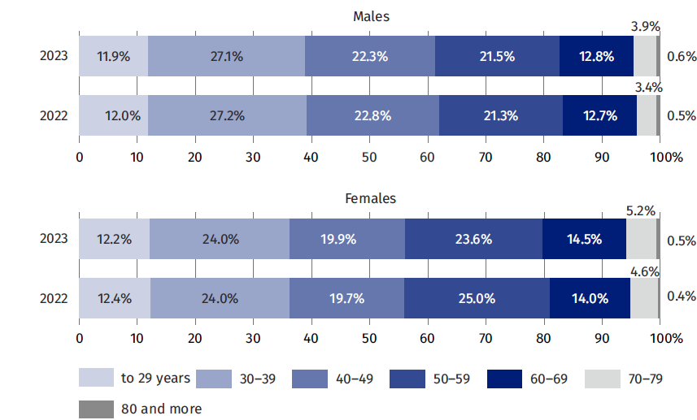
As of 31 December

Among dentists, in 2023, the largest number of people worked directly with the patient in the following voivodships: Mazowieckie (6.4 thousand) and Śląskie (3.9 thousand) and the least in the following voivodships: Opolskie (0.7 thousand) and Lubuskie (0.8 thousand).

Table 7. Dentists working directly with patient by voivodships
As of 31 December
Voivodships | 2022 |  |  | 2023
Voivodships | in thousands | in % | per 10,000 population | in thousands | in % | per 10,000 population
Poland | 34.9 | 100.0 | 9.2 | 36,0 | 100,0 | 9,6
Dolnośląskie | 3.0 | 8.5 | 10.2 | 3,0 | 8,4 | 10,5
Kujawsko-pomorskie | 1.2 | 3.5 | 6.2 | 1,3 | 3,5 | 6,4
Lubelskie | 2.0 | 5.8 | 10.0 | 2,1 | 5,7 | 10,2
Lubuskie | 0.7 | 2.1 | 7.4 | 0,8 | 2,1 | 7,8
Łódzkie | 2.7 | 7.6 | 11.1 | 2,7 | 7,4 | 11,3
Małopolskie | 3.3 | 9.4 | 9.5 | 3,3 | 9,2 | 9,7
Mazowieckie | 5.9 | 17.0 | 10.8 | 6,4 | 17,8 | 11,7
Opolskie | 0.7 | 1.9 | 7.0 | 0,7 | 1,9 | 7,1
Podkarpackie | 1.6 | 4.7 | 7.9 | 1,7 | 4,6 | 8,0
Podlaskie | 1.2 | 3.5 | 10.7 | 1,2 | 3,4 | 10,8
Pomorskie | 2.3 | 6.5 | 9.6 | 2,3 | 6,5 | 9,9
Śląskie | 3.8 | 11.1 | 8.8 | 3,9 | 10,9 | 9,1
Świętokrzyskie | 1.0 | 2.8 | 8.4 | 1,0 | 2,8 | 8,7
Warmińsko-mazurskie | 0.9 | 2.5 | 6.7 | 0,9 | 2,6 | 7,0
Wielkopolskie | 2.9 | 8.4 | 8.3 | 3,0 | 8,3 | 8,6
Zachodniopomorskie | 1.7 | 4.7 | 10.1 | 1,7 | 4,8 | 10,5

With regard to the number of population – in 2023 the largest number of dentists working directly with the patient was in the following voivodships: Mazowieckie (11.7 per 10,000 population), followed by Łódzkie (11.3 dentists) and the lowest in the following voivodships: Kujawsko-pomorskie (6.4 dentists per 10,000 population) and Warmińsko-mazurskie (7.0).

Map 2. Dentists working directly with patient per 10 thousand of the population by voivodships in 2023
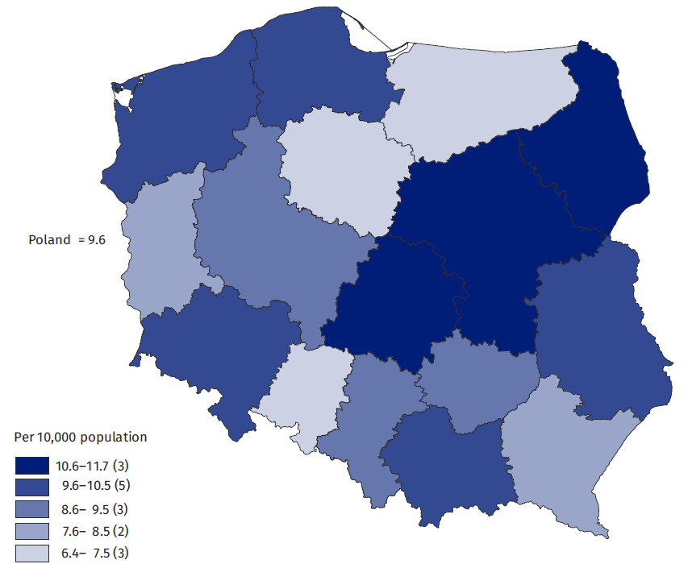
As of 31 December

Nurses
In 2023, the number of nurses living in Poland and having the right to practice was 315.2 thousand (in 2022 – 310.0 thousand).
An increase in the number of nurses with a license to practice by 5.2 thousand in 2023 compared to 2022
Among people entitled to practice this profession, the dominant group, almost 1/3 of the total, were people aged 50–59. Among the nurses, women were definitely dominant (97.0% in 2023) and the number of male nurses, especially in older age groups (over 60), was negligible.

Table 8. Nurses entitled to perform profession by sex and age
As of 31 December
Specification | 2022 |  |  |  | 2023
Specification | total |  | males | females | total |  | males | females
Specification | in thousands | in % | in thousands |  | in thousands | in % | in thousands
Grand total | 310.0 | 100.0 | 8.7 | 301.3 | 315.2 | 100.0 | 9.4 | 305.8
to 29 lat | 22.5 | 7.2 | 1.4 | 21.1 | 23.3 | 7.4 | 1.5 | 21.9
30–39 | 27.9 | 9.0 | 2.6 | 25.3 | 29.4 | 9.3 | 2.8 | 26.5
40–49 | 55.3 | 17.8 | 2.5 | 52.8 | 50.1 | 15.9 | 2.7 | 47.5
50–59 | 98.0 | 31.6 | 1.5 | 96.4 | 98.3 | 31.2 | 1.7 | 96.7
60–69 | 79.2 | 25.5 | 0.6 | 78.6 | 81.9 | 26.0 | 0.7 | 81.2
70–79 | 25.5 | 8.2 | 0.1 | 25.4 | 30.1 | 9.6 | 0.1 | 30.0
80 years and more | 1.7 | 0.5 | 0.0 | 1.7 | 2.1 | 0.7 | 0.0 | 2.1

In 2023, the number of nurses working directly with patients was 216.1 thousand (214.4 thousand in 2022).
An increase in the number of nurses working directly with the patient by 1.7 thousand in 2023 compared to 2022

Table 9. Nurses working directly with patient by sex and age
As of 31 December
Specification | 2022 |  |  |  | 2023
Specification | total |  | males | females | total |  | males | females
Specification | in thousands | in % | in thousands |  | in thousands | in % | in thousands
Grand total | 214.4 | 100.0 | 6.9 | 207.4 | 216.1 | 100.0 | 7.6 | 208.5
to 29 years | 19.7 | 9.2 | 1.2 | 18.5 | 20.6 | 9.6 | 1.3 | 19.4
30–39 | 24.3 | 11.3 | 2.3 | 22.0 | 26.0 | 12.0 | 2.5 | 23.4
40–49 | 45.5 | 21.2 | 1.9 | 43.6 | 41.4 | 19.1 | 2.1 | 39.2
50–59 | 84.1 | 39.2 | 1.1 | 82.9 | 84.2 | 39.0 | 1.2 | 83.0
60–69 | 37.5 | 17.5 | 0.3 | 37.2 | 40.0 | 18.5 | 0.4 | 39.6
70–79 | 3.1 | 1.5 | 0.0 | 3.1 | 3.8 | 1.8 | 0.0 | 3.8
80 years and more | 0.0 | 0.0 | 0.0 | 0.0 | 0.1 | 0.0 | 0.0 | 0.1

Among all nurses working directly with patients in 2023, the largest group (39.0%) represented people aged 50-59 (a year earlier – about 39.2%). Among women working as nurses, the largest group was also people aged 50–59, which accounted for 39.8% in 2023 (40.0% a year earlier). On the other hand, among men, people aged 30–39 were the most numerous – 33.4% in both analyzed years.

Chart 3. Structure of nurses working directly with patient by sex and age
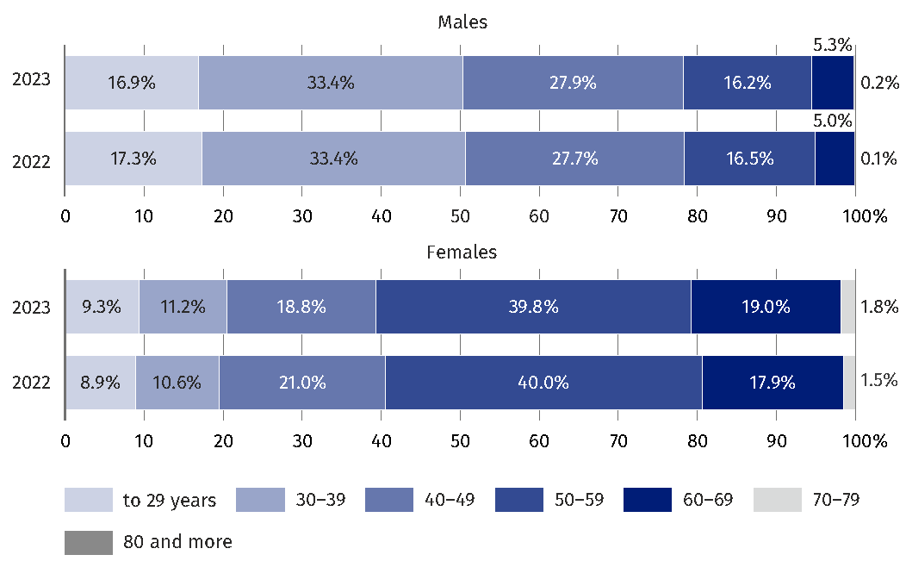
As of 31 December

Among nurses working directly with patients, the largest number in 2023 was recorded in the following voivodships: Mazowieckie (35.0 thousand) and Śląskie (26.3 thousand). The lowest number of nurses working directly with the patient was in the smallest voivodships: Lubuskie (4.6 thousand) and Opolskie (5.2 thousand).

Table 10. Nurses working directly with patients by voivodships
As of 31 December
Voivodships | 2022 |  |  | 2023
Voivodships | in thousands | in % | per 10,000 population | in thousands | in % | per 10,000 population
Poland | 214.4 | 100.0 | 56.8 | 216.1 | 100.0 | 57.4
Dolnośląskie | 16.1 | 7.5 | 55.8 | 16.0 | 7.4 | 55.7
Kujawsko-pomorskie | 10.9 | 5.1 | 54.4 | 11.0 | 5.1 | 55.1
Lubelskie | 13.7 | 6.4 | 67.7 | 13.8 | 6.4 | 68.4
Lubuskie | 4.6 | 2.1 | 46.6 | 4.6 | 2.1 | 47.0
Łódzkie | 12.9 | 6.0 | 54.4 | 13.1 | 6.1 | 55.5
Małopolskie | 19.4 | 9.1 | 56.6 | 19.6 | 9.1 | 57.1
Mazowieckie | 34.1 | 15.9 | 61.9 | 35.0 | 16.2 | 63.6
Opolskie | 5.2 | 2.4 | 55.3 | 5.2 | 2.4 | 55.4
Podkarpackie | 13.4 | 6.3 | 64.5 | 13.5 | 6.2 | 65.0
Podlaskie | 7.0 | 3.3 | 61.6 | 7.2 | 3.3 | 63.2
Pomorskie | 10.8 | 5.0 | 45.9 | 10.8 | 5.0 | 45.8
Śląskie | 26.2 | 12.2 | 60.4 | 26.3 | 12.2 | 60.9
Świętokrzyskie | 8.1 | 3.8 | 69.0 | 8.2 | 3.8 | 70.2
Warmińsko-mazurskie | 7.2 | 3.3 | 52.3 | 7.2 | 3.3 | 53.0
Wielkopolskie | 16.7 | 7.8 | 47.8 | 16.7 | 7.7 | 48.0
Zachodniopomorskie | 7.9 | 3.7 | 47.9 | 7.9 | 3.6 | 48.1

The largest number of nurses working directly with the patient per 10,000 population in 2023 occurred in the following voivodships: Świętokrzyskie (70.2 nurses) and Lubelskie (68.4) and the lowest in the following voivodships: Pomorskie (45.8) and Lubuskie (47.0).

Map 3. Nurses working directly with patient per 10 thousand of the population
by voivodships in 2023
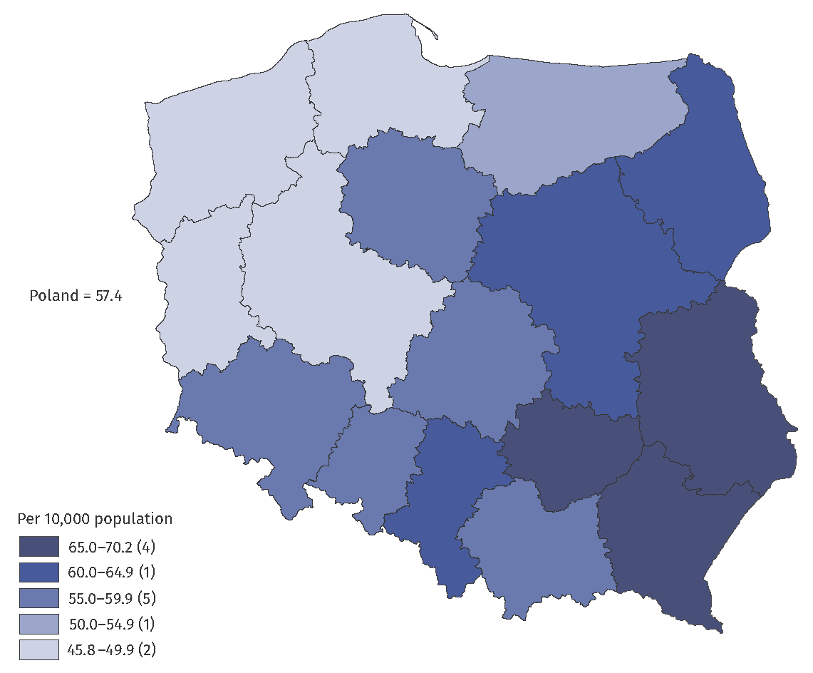
As of 31 December

Midwives
In 2023, the number of midwives living in Poland and having the right to practice the profession amounted to 41.9 thousand (in 2022 – 41.1 thousand).
An increase in the number of midwives with a license to practice by 0.8 thousand in 2023 compared to 2022
Among midwives entitled to practice the profession, the dominant group represented people aged 50–59 (28.2% in 2023 and 29.5% in 2022).

Table 11. Midwives entitled to perform profession by sex and age
As of 31 December
Specification | 2022 |  |  |  | 2023
Specification | total |  | males | females | total |  | males | females
Specification | in thousands | in % | in thousands |  | in thousands | in % | in thousands
Grand total | 41.1 | 100.0 | 0.1 | 41.0 | 41.9 | 100.0 | 0.1 | 41.8
to 29 years | 5.6 | 13.5 | 0.0 | 5.6 | 5.8 | 13.8 | 0.0 | 5.8
30–39 | 4.9 | 12.0 | 0.0 | 4.9 | 5.2 | 12.5 | 0.0 | 5.2
40–49 | 6.1 | 14.9 | 0.0 | 6.1 | 5.7 | 13.6 | 0.0 | 5.7
50–59 | 12.1 | 29.5 | 0.0 | 12.1 | 11.8 | 28.2 | 0.0 | 11.8
60–69 | 9.1 | 22.2 | 0.0 | 9.1 | 9.5 | 22.8 | 0.0 | 9.5
70–79 | 3.0 | 7.2 | 0.0 | 3.0 | 3.5 | 8.3 | 0.0 | 3.5
80 years and more | 0.3 | 0.7 | 0.0 | 0.3 | 0.4 | 0.9 | 0.0 | 0.4

The vast majority of midwives were women (99.8% in both analyzed years).
An increase in the number of midwives working directly with the patient by 0.1 thousand in 2023 compared to 2022
The number of midwives working directly with the patient was 28.5 thousand in 2023
(28.4 thousand in 2022).
The total number of men working directly with the patient in this profession in 2023 was 65 people, in 2022 – 61, therefore the data of men from this occupational group were limited
to general data.

Table 12. Midwives working directly with patient by sex and age
As of 31 December
Specification | 2022 |  |  |  | 2023
Specification | total |  | males | females | total |  | males | females
Specification | in thousands | in % | in thousands |  | in thousands | in % | in thousands
Grand total | 28.4 | 100.0 | 0.1 | 28.4 | 28.5 | 100.0 | 0.1 | 28.5
to 29 years | 4.5 | 15.9 | 0.0 | 4.5 | 4.7 | 16.3 | 0.0 | 4.6
30–39 | 4.1 | 14.6 | 0.0 | 4.1 | 4.5 | 15.6 | 0.0 | 4.4
40–49 | 4.8 | 16.7 | 0.0 | 4.7 | 4.4 | 15.6 | 0.0 | 4.4
50–59 | 10.1 | 35.5 | 0.0 | 10.1 | 9.8 | 34.4 | 0.0 | 9.8
60–69 | 4.5 | 15.9 | 0.0 | 4.5 | 4.7 | 16.5 | 0.0 | 4.7
70–79 | 0.4 | 1.4 | 0.0 | 0.4 | 0.5 | 1.6 | 0.0 | 0.5
80 years and more | 0.0 | 0.0 | 0.0 | 0.0 | 0.0 | 0.1 | 0.0 | 0.0

Among midwives working directly with patient in 2023, the largest group (34.4%) represented women aged 50-59 (a year earlier – about 35.6%).

Chart 4. Structure of midwives (women) working directly with patient by sex and age
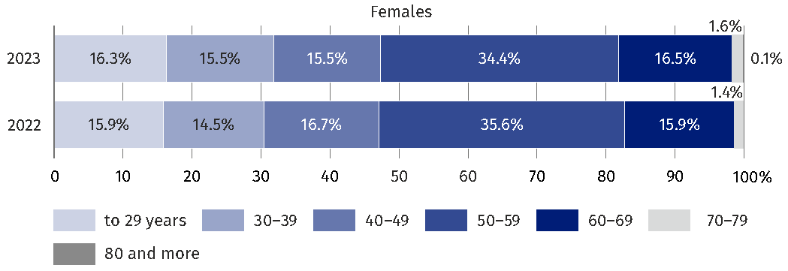
As of 31 December

Among midwives working directly with patient, the largest number in 2023 was recorded in the following voivodships: Mazowieckie (4.7 thousand) and Śląskie (3.2 thousand) and the lowest was in voivodships: Lubuskie (0.5 thousand) i Opolskie (0.6 thousand).

Table 13. Midwives working directly with patient by voivodships
As of 31 December
Voivodships | 2022 |  |  | 2023
Voivodships | in thousands | in % | per 10,000 women | in thousands | in % | per 10,000 women
Poland | 28.4 | 100.0 | 14.6 | 28.5 | 100.0 | 14.7
Dolnośląskie | 1.8 | 6.4 | 12.1 | 1.8 | 6.4 | 12.2
Kujawsko-pomorskie | 1.4 | 5.0 | 13.6 | 1.4 | 4.9 | 13.7
Lubelskie | 1.7 | 6.1 | 16.7 | 1.7 | 6.1 | 16.7
Lubuskie | 0.5 | 1.9 | 10.7 | 0.5 | 1.9 | 10.7
Łódzkie | 2.0 | 7.1 | 16.3 | 2.1 | 7.2 | 16.7
Małopolskie | 2.6 | 9.1 | 14.6 | 2.6 | 9.2 | 14.8
Mazowieckie | 4.6 | 16.3 | 16.1 | 4.7 | 16.4 | 16.3
Opolskie | 0.6 | 2.2 | 12.8 | 0.6 | 2.2 | 12.9
Podkarpackie | 1.8 | 6.4 | 17.1 | 1.8 | 6.2 | 16.8
Podlaskie | 1.0 | 3.5 | 16.9 | 1.0 | 3.4 | 16.8
Pomorskie | 1.4 | 5.0 | 11.7 | 1.5 | 5.1 | 12.0
Śląskie | 3.2 | 11.2 | 14.1 | 3.2 | 11.2 | 14.2
Świętokrzyskie | 1.0 | 3.4 | 16.0 | 1.0 | 3.4 | 16.0
Warmińsko-mazurskie | 0.8 | 2.9 | 11.8 | 0.8 | 3.0 | 12.2
Wielkopolskie | 2.8 | 9.8 | 15.6 | 2.8 | 9.7 | 15.4
Zachodniopomorskie | 1.1 | 3.8 | 12.7 | 1.1 | 3.7 | 12.6

With regard to the number of population (women) – in 2023, the largest number of midwives occurred in the following voivodships: Podkarpackie and Podlaskie (16.8 people per 10,000 population – women each) and and the lowest in the following voivodships: Lubuskie (10.7) and Pomorskie (12.0 midwives per 10,000 population – women in the voivodship).

Map 4. Midwives working directly with patient per 10 thousand females by voivodships
in 2023
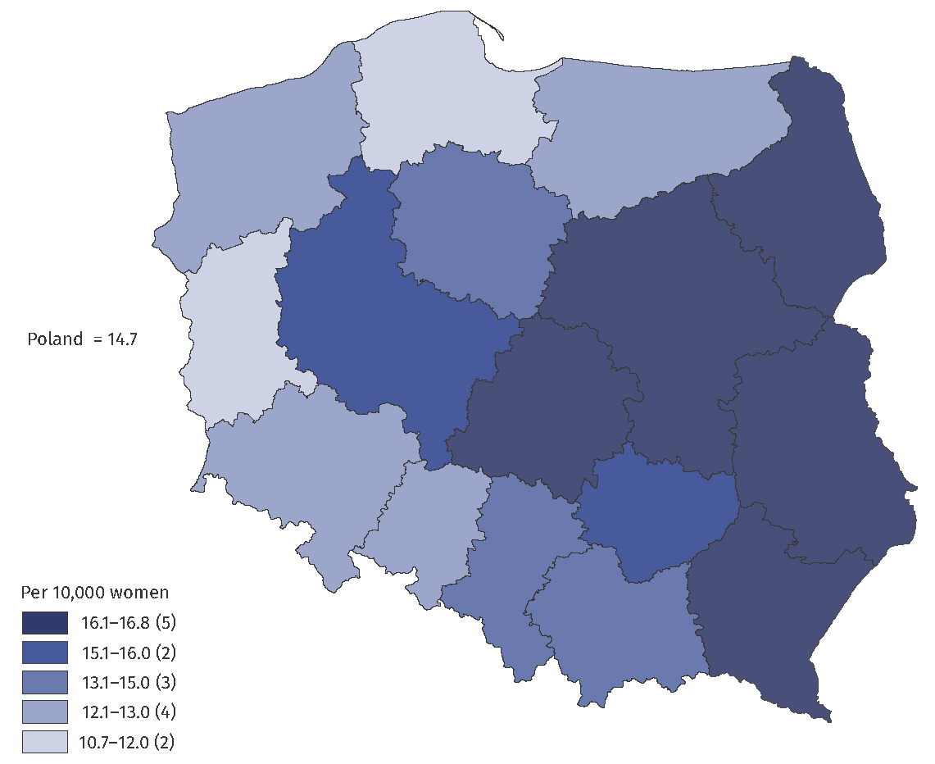
As of 31 December

Physiotherapists
In 2023 the number of physiotherapists living in Poland with a license to practice their profession amounted to 77.7 thousand (74.6 thousand in the previous year).
An increase in the number of physiotherapists with a license to practice by 3.1 thousand in 2023 compared to 2022
Among the physiotherapists authorized to practice in 2023, the dominant group were people aged 30–39 (44.0% in 2023 and 45.7% in 2022).

Table 14. Physiotherapists entitled to perform profession by sex and age
As of 31 December
Specification | 2022 |  |  |  | 2023
Specification | total |  | males | females | total |  | males | females
Specification | in thousands | in % | in thousands |  | in thousands | in % | in thousands
Grand total | 74.6 | 100.0 | 19.4 | 55.2 | 77.7 | 100.0 | 20.6 | 57.1
to 29 years | 12.9 | 17.3 | 3.5 | 9.5 | 15.9 | 20.4 | 4.5 | 11.4
30–39 | 34.1 | 45.7 | 9.0 | 25.1 | 34.2 | 44.0 | 9.0 | 25.2
40–49 | 16.0 | 21.4 | 4.2 | 11.7 | 16.1 | 20.7 | 4.3 | 11.8
50–59 | 7.0 | 9.4 | 1.7 | 5.2 | 7.0 | 9.0 | 1.8 | 5.2
60–69 | 4.1 | 5.4 | 0.8 | 3.3 | 4.0 | 5.1 | 0.8 | 3.2
70–79 | 0.5 | 0.7 | 0.1 | 0.3 | 0.5 | 0.6 | 0.2 | 0.3
80 years and more | 0.1 | 0.1 | 0.0 | 0.0 | 0.0 | 0.1 | 0.0 | 0.0

In 2023 the number of physiotherapists working directly with patient amounted to 59.1 thousand (55.8 thousand in 2022).
An increase of number of physiotherapists working directly with patient by 3.3 thousand in 2023 compared to 2022

Table 15. Physiotherapists working directly with patient by sex and age
As of 31 December
Specification | 2022 |  |  |  | 2023
Specification | total |  | males | females | total |  | males | females
Specification | in thousands | in % | in thousands |  | in thousands | in % | in thousands
Grand total | 55,8 | 100,0 | 15,2 | 40,6 | 59,1 | 100,0 | 16,3 | 42,8
to 29 years | 9,3 | 16,8 | 2,5 | 6,7 | 11,9 | 20,1 | 3,5 | 8,4
30–39 | 25,3 | 47,3 | 7,2 | 18,1 | 26,0 | 44,0 | 7,3 | 18,7
40–49 | 12,6 | 22,3 | 3,4 | 9,2 | 12,8 | 21,7 | 3,4 | 9,4
50–59 | 5,8 | 9,1 | 1,4 | 4,4 | 5,8 | 9,8 | 1,4 | 4,4
60–69 | 2,5 | 3,9 | 0,6 | 1,9 | 2,3 | 3,9 | 0,6 | 1,7
70–79 | 0,3 | 0,5 | 0,1 | 0,2 | 0,3 | 0,4 | 0,1 | 0,2
80 years and more | 0,0 | 0,1 | 0,0 | 0,0 | 0,0 | 0,0 | 0,0 | 0,0

Among physiotherapists working directly with patient in 2023, the largest group (44.0%) represented people aged 30-39 (a year earlier – 47.3%). Also among females performing as physiotherapists the largest group were people aged 30-39, which amounted to 43.6% in 2023 and 44.6% the year before. It is also the dominant group (30-39) among males (45.1% in 2023, 2.2 percentage points less than in the year before).

Chart 5. Structure of physiotherapists working directly with patient by age
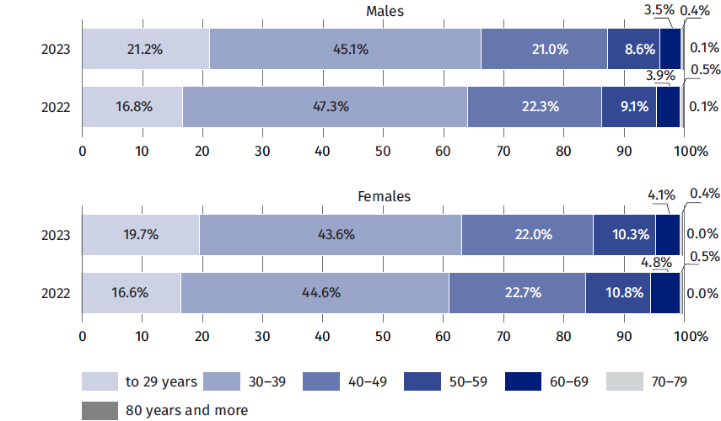
As of 31 December

Among physiotherapists working directly with patient, the largest number in 2023 was recorded in the Mazowieckie voivodship (9.9 thousand, the year before 8.5 thousand) and the lowest in Lubuskie voivodship (1.0 thousand, the year before 1.3 thousand).

Table 16. Physiotherapists working directly with patient by voivodships
As of 31 December
Voivodships | 2022 |  |  | 2023
Voivodships | in thousands | in % | per 10,000 population | in thousands | in % | per 10,000 population
Poland | 55.8 | 100.0 | 14.8 | 59,1 | 100,0 | 15.7
Dolnośląskie | 4.6 | 8.2 | 15.9 | 4.8 | 8.1 | 16.7
Kujawsko-pomorskie | 2.8 | 5.1 | 14.1 | 3.0 | 5.1 | 15.1
Lubelskie | 2.9 | 5.2 | 14.3 | 2.9 | 4.9 | 14.5
Lubuskie | 1.3 | 2.3 | 12.9 | 1.0 | 1.7 | 10.2
Łódzkie | 3.0 | 5.3 | 12.5 | 3.1 | 5.2 | 13.0
Małopolskie | 5.8 | 10.4 | 16.9 | 6.1 | 10.3 | 17.7
Mazowieckie | 8.5 | 15.3 | 15.5 | 9.9 | 16.8 | 17.9
Opolskie | 1.5 | 2.7 | 15.9 | 1.5 | 2.5 | 15.6
Podkarpackie | 4.0 | 7.2 | 19.3 | 4.2 | 7.1 | 20.3
Podlaskie | 1.3 | 2.3 | 11.1 | 1.3 | 2.2 | 11.4
Pomorskie | 2.9 | 5.2 | 12.2 | 3.1 | 5.2 | 13.2
Śląskie | 6.4 | 11.5 | 14.8 | 7.4 | 12.5 | 17.0
Świętokrzyskie | 2.4 | 4.2 | 20.0 | 2.3 | 3.9 | 19.4
Warmińsko-mazurskie | 1.5 | 2.8 | 11.3 | 1.5 | 2.5 | 10.7
Wielkopolskie | 4.6 | 8.3 | 13.3 | 5.0 | 8.5 | 14.3
Zachodniopomorskie | 2.3 | 4.1 | 14.0 | 2.3 | 3.9 | 14.0

With regard to the number of population – in 2023 the largest number of physiotherapists worked in the following voivodships: Podkarpackie (20.3 people per 10,000 population) and Świętokrzyskie (19.4) and the lowest number in the following voivodships: Lubuskie (10.2) and Warmińsko-mazurskie (10.7 physiotherapists per 10,000 population in the voivodship).

Map 5. Physiotherapists working directly with patient per 10 thousand population in 2023
As of 31 December
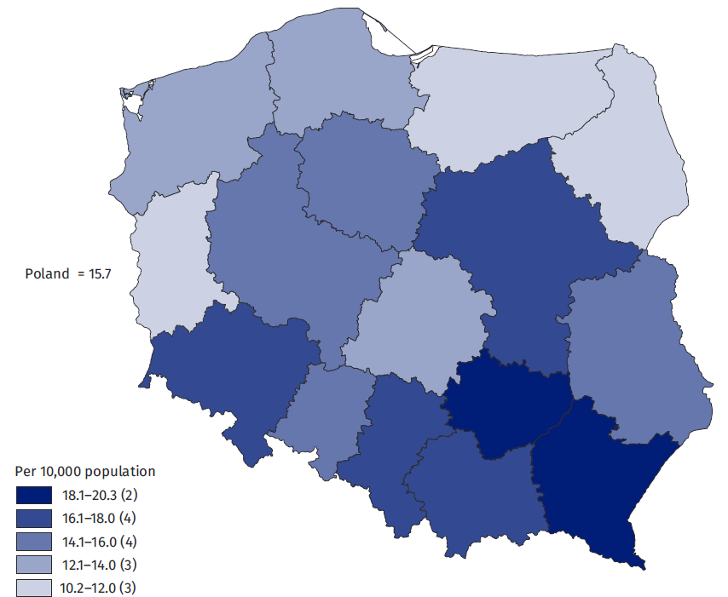

Conclusions
The method of estimating the resources of medical personnel based on administrative sources, allowed a significant reduction in the information gap resulting from the incomplete completeness of the survey conducted using only reports. This allowed a significant improvement in the quality of the results for medical personnel working directly with the patient.
In addition, the simultaneous use of several sources of administrative data has minimized data gaps, which are a significant problem with reporting. In addition, there is room for improvement (to a certain, limited degree) in the quality of these sources, either by correcting errors or filling in missing data. It is also much more possible to analyze, on the basis of the information obtained, such characteristics as gender and age of those working with the patient or place of work.

Methodological notes
Until 2022, the official resultant information published by public statistics on medical Staff resources, was primarily based on data from reporting by the Ministry of Health (MZ) and, consistent with it, reporting by the Ministry of Interior and Administration (MSWiA). The survey forms capture information on medical personnel working in a given unit, including those based on subcontracts, such as civil law contracts.
Due to the incomplete fulfilment of the statistical obligation by medical entities, especially professional practices, the data on people working with the patient may be lower than the actual state. Therefore, as a result of the methodological work carried out, data on doctors, dentists, nurses and midwives since 2019 were estimated based solely on administrative sources, including registries. In 2024 the assumed method was also applied for physiotherapists, for whom data for 2022-2023 were calculated. These results are incomparable with the data published earlier.
The following administrative sources were used in the work on the algorithm used to estimate the number of doctors, dentists, nurses, midwives and physiotherapists:
- Social Insurance Institution’s list of premium payers (Social Insurance Institution – ZUS),
- Register of entities performing medical activities (Ministry of Health - MZ),
- Registers of medical practices, nurses and midwives practices, physiotherapists practices (individual and group) (Ministry of Health - MZ),
- List of entities with which the National Health Fund (NFZ) has signed a contract for the provision of medical services,
- Central Register of Nurses and Midwives (General Chamber of Nurses and Midwives - NIPiP),
- Central Register of Physicians and Dentists (The Polish Chamber of Physicians and Dentists - NIL),
- National Register of Physiotherapists (The Polish Chamber of Physiotherapists - KIF),
- PESEL,
- Central list of insured persons (CWU from the National Health Fund - NFZ).

The work also made use of collections developed at the CSO for other statistical surveys, such as the collection of people working in the national economy developed by the Statistical Office in Bydgoszcz and the BJS (Database of Statistical Units), which made it possible to avoid duplication of some of the work.

When quoting Statistics Poland data, please provide the information: “Source of data: Statistics Poland”, and when publishing calculations made on data published by Statistics Poland, please include the following disclaimer: “Own study based on figures from Statistics Poland”.
Prepared by:  Social Surveys and Labour Market Department  Director Piotr Łysoń, Ph.D.  Phone: (+48 22) 449 40 27 | Issued by:  Press Office  Mobile: (+48) 695 255 032  Phone: (+48 22) 608 38 04, (+48 22) 449 41 45,  (+48 22) 608 30 09  e-mail: obslugaprasowa@stat.gov.pl

stat.gov.pl/en/

@StatPoland

@GlownyUrzadStatystyczny

gus_stat

glownyurzadstatystycznygus

glownyurzadstatystyczny
Related information
Health and health care in 2022
Human resources in selected medical professions based on administrative sources in 2022
Data available in databases
OECD database
Terms used in official statistics
doctor
dentist
nurse
midwife

The presented data include: doctors and dentists (of any gender), as well as nurses and midwives (of any gender) and physiotherapists (of any gender) residing in Poland.
The voivodships have been determined on the basis of the location of the place of work.
In order to become a specialist, a doctor must meet additional requirements prescribed by law. The data on specialists refers to physicians and dentists with a second-degree specialization and, since 2005, holding the title of a specialist in the relevant field of medicine, in accordance with the Regulation of the Minister of Health dated 29 March 2019 on the specialization of physicians and dentists (Journal of Laws of 2020, item 1566, as amended).
The results of surveys on Ministry of Health (MZ) reports are supplemented by the results of surveys of units not classified as medical entities, but providing health care services (social welfare institutions, nurseries, pharmacies).
More information on the adopted algorythm are presented in the work from 2023: https://stat.gov.pl/obszary-tematyczne/zdrowie/zdrowie/zasoby-kadrowe-w-wybranych-zawodach-medycznych-na-podstawie-zrodel-administracyjnych-w-2022-r-,28,2.html.

