Financial results of non-financial enterprises
in 2025
In 2025 gross financial result of the surveyed non-financial enterprises was higher by 12.4% comparing to a year earlier. The economic and financial indicators improved. Investment outlays were higher by 3.2% than in the previous year (when there was a decrease by 7.8%).
2.9%
Increase in total revenues y/y

Total revenues were higher (by 2.9%) comparing to the previous year (5,279.8 bn PLN in 2025, 5,133.0 bn PLN a year ago) and total costs of obtaining the revenues increased by 2.4% (from 4,914.7 bn PLN to 5,034.5 bn PLN). The cost level indicator was lower than in the previous year (95.4% in 2025, 95.7% a year before). Gross turnover profitability indicator improved (4.6%, compared to 4.3% in the previous year) as well as net turnover profitability indicator (respectively, 3.7% and 3.4%). Net revenues from sale of products, goods and materials increased by 2.8% and the costs of obtaining by 2.7%.
The financial result from the sale of products, goods and materials amounted to 233.1 bn PLN and was by 6.7% higher than in 2024. The financial result from other operating activity amounted to 13.8 bn PLN and was higher by 11.7 bn PLN over the year, the result on financial activities amounted to minus 1.5 bn PLN compared to minus 2.2 bn PLN in 2024.
In 2025 net financial result of non-financial enterprises was by 13.5% higher than the year before
Gross financial result amounted to 245.3 bn PLN (compared to 218.4 bn PLN in 2024) and its obligatory encumbrances amounted to 48.3 bn PLN (compared to 44.7 bn PLN a year before). Net financial result amounted to 197.1 bn PLN and was by 13.5% higher than the year before. Net profit amounted to 261.3 bn PLN and was higher by 18.6 bn PLN (by 7.7%) than in 2024 while net loss amounted to 64.2 bn PLN and was lower by 4.8 bn PLN compared to the previous year. Net profit was recorded by 78.1% of all enterprises (compared to 77.2% a year before) and the revenues obtained by them constituted 85.1% of total revenues of the surveyed enterprises (compared to 82.9% the year before). In manufacturing, net profit was recorded by 75.8% of all enterprises (it was 74.8% a year before) and the share of the total revenues generated by these entities in the total revenues of all enterprises in this section was 84.4% (compared to 83.7% a year before).
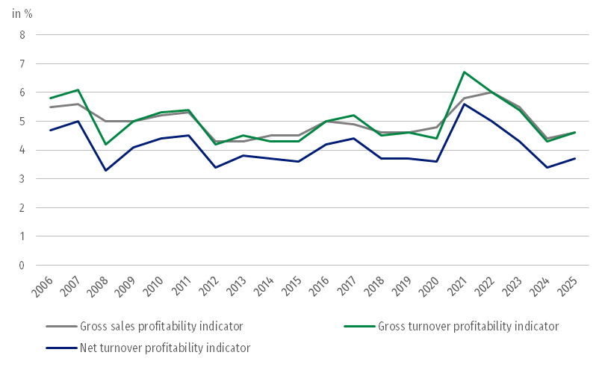
Chart 1. Profitability indicators from 2006 to 2025

Table 1. Basic financial data of surveyed non-financial enterprises
SPECIFICATION | Jan.-Dec. 2024 | Jan.-Dec. 2025 | Jan.-Dec. 2024 = 100
SPECIFICATION | in million PLN |  | Jan.-Dec. 2024 = 100
Total revenues | 5,133,029.9 | 5,279,802.3 | 102.9
of which net revenues from sale  of products, goods and materials | 4,960,631.4 | 5,101,520.8 | 102.8
Total costs | 4,914,664.2 | 5,034,454.2 | 102.4
of which cost of products,  goods and materials sold | 4,742,079.1 | 4,868,420.9 | 102.7
Financial result from the sale of products, goods and materials | 218,552.3 | 233,099.9 | 106.7
Financial result from other  operating activity | 2,062.2 | 13,766.6 | 667.6
Result on financial activity | -2,248.8 | -1,518.4 | .
Gross financial result | 218,365.7 | 245,348.1 | 112.4
Net financial result | 173,704.2 | 197,087.5 | 113.5
Net profit | 242,709.2 | 261,319.6 | 107.7
Net loss | 69,004.9 | 64,232.1 | 93.1
 | in %
Cost level indicator | 95.7 | 95.4 | .
Gross sales profitability indicator | 4.4 | 4.6 | .
Gross turnover profitability indicator | 4.3 | 4.6 | .
Net turnover profitability indicator | 3.4 | 3.7 | .
First degree financial liquidity indicator | 44.6 | 48.9 | .
Second degree financial liquidity indicator | 107.5 | 109.0 | .
Gross sales profitability indicator improved (4.6% in 2025 compared to 4.4% in 2024) as well as gross turnover profitability indicator (4.6% compared to 4.3%) as well as net turnover profitability indicator (3.7% compared to 3.4%).
An improvement in net turnover profitability indicator was recorded i.a. in electricity, gas, steam and air conditioning supply (from 3.1% to 5.5%), professional, scientific and technical activities (from 6.2% to 8.4%), transportation and storage (from 3.4% to 4.4%), water supply; sewerage, waste management and remediation activities (from 6.3% to 6.7%), construction (from 5.3% to 5.6%), in trade; repair of motor vehicles (from 2.4% to 2.5%) as well as in mining and quarrying (from minus 10.2% to minus 7.4%). In manufacturing net turnover profitability indicator was the same as in the previous year and amouted to 3.7%. A deterioration of net turnover profitability indicator was recorded i.a. in administrative and support service activities (from 6.5% to 5.2%), in real estate activities (from 5.6% to 4.7%), information and communication (from 8.1% to 8.0%) as well as in accommodation and catering (from 9.2% to 9.1%).
First degree financial liquidity indicator improved to 48.9% (compared to 44.6% in 2024) and second degree financial liquidity indicator amouted to 109.0% (compared to 107.5% a year before). First degree financial liquidity indicator at the level over 20% was achieved by 59.0% of the surveyed enterprises (compared to 58.5% a year before). Second degree financial liquidity indicator ranged from 100% to 130% was recorded by 11.4% of the surveyed enterprises, 11.5% in the previous year.
Chart 2. Net turnover profitability indicator
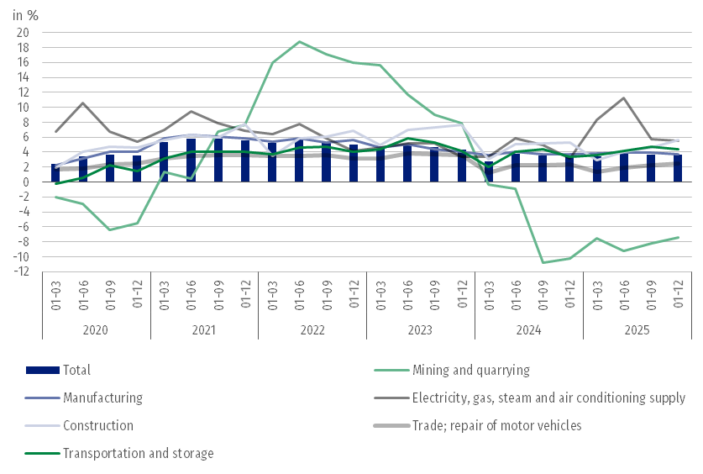
In the total costs by type the share of external services and wages and salaries increased the most (by 0.8 pp.), whereas share of consumption of materials decreased the most (by 1.5 pp.)

In the structure of total costs by type, there was an increase compared to 2024 in the share of external services (by 0.8 pp.), wages and salaries (by 0.8 pp.), other costs by kind (by 0.6 pp.), social insurances and other benefits (by 0.2 pp.) as well as depreciation (by 0.1 pp.). There was a decrease in the consumption of materials (by 1.5 pp.), share of taxes and fees (by 0.7 pp.) as well as consumption of energy (by 0.3 pp.).
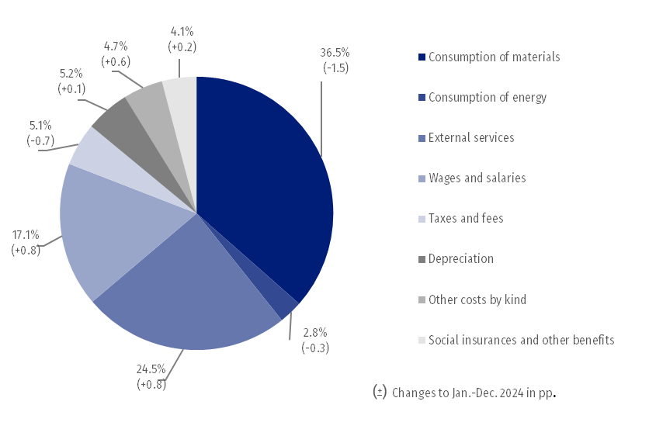
Chart 3. Structure of costs by type in 2025

55.0% of the surveyed enterprises reported net revenues from sale of products, goods and materials for export in 2025 (compared to 54.6% in 2024). The revenues from export sales were by 2.3% higher than a year before. The share of export sales in total sales revenues of all surveyed enterprises amounted to 23.3% (23.4% in the previous year). The share of the exporting enterprises which reported net profit was 77.5% (compared to 76.4% a year before). The basic economic and financial relations of the exporting enterprises improved.
There was an increase in investment outlays of the surveyed enterprises by 3.2% compared to 2025. Expenditures on purchases increased, while outlays on buildings and structures decreased

In 2025 investment outlays of the surveyed enterprises amounted to 217.6 bn PLN and were (in constant prices) by 3.2% higher than in the previous year (when a decrease by 7.8% was recorded). The expenditures on purchases increased by 5.4% (in the previous year they decreased by 4.3%), including increase of outlays on machinery, technical equipment and tools by 4.1% (in comparison to the decrease in the previous year by 4.9%) as well as increase of outlays on transport equipment – by 9.4% (in comparison to the decrease in the previous year by 2.4%). Expenditures on buildings and structures decreased by 0.3% (in the previous year they decreased by 13.4%).
The increase in investment outlays (in current prices) was noticed i.a. information and communication (by 32.4%, compared to the decrease by 10.7%), in construction (by 30.3%, compared to the increase by 23.8% the year earlier), water supply; sewerage, waste management and remediation activities (by 17.3%, compared to the decrease by 18.2%), electricity, gas, steam and air conditioning supply (by 12.0%, compared to the decrease by 7.4%), transportation and storage (by 11.6%, compared to the decrease by 21.8%), administrative and support service activities (by 9.6%, compared to the increase by 11.6%) and trade; repair of motor vehicles (by 6.5%, compared to the increase by 0.3%). The decrease in investment outlays was recorded i.a. in mining and quarrying (by 14.9%, compared to the increase by 3.7%), real estate activities (by 6.0%, compared to the decrease by 26.9%), manufacturing (by 5.7%, compared to the decrease by 8.3%) and accommodation and catering (by 1.6%, compared to the decrease by 1.1%).
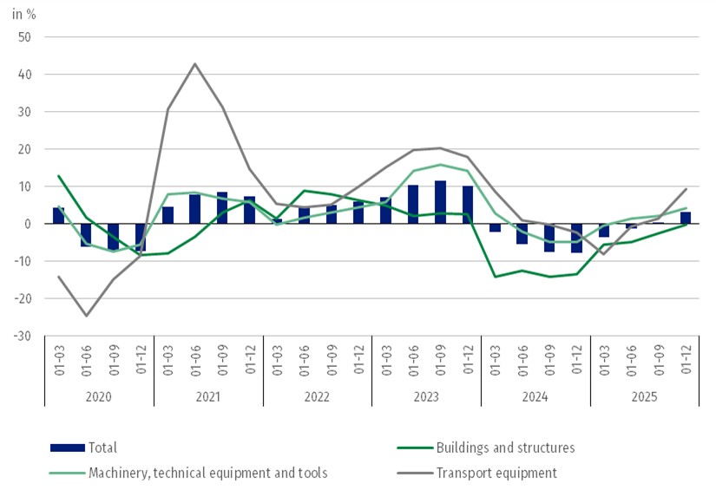
Chart 4. Investment outlays – change compared to the corresponding period of the previous year

The data refer to 17 903 non-financial enterprises (legal units) with 50 and more persons employed keeping accounting ledgers. The data do not include agriculture, forestry, hunting and fishing (section A according to NACE Rev. 2); financial and insurance activities (section K according to NACE Rev. 2); higher education institutions; independent public health care facilities; cultural institutions with legal personality; trade unions, religious and political organisations.

Due to the rounding of data, in some cases sums of components may slightly differ from the amount given in the item ‘total’. Relative numbers (indices, percentages) are usually calculated on the basis of absolute data expressed with greater precision than that presented in the news release.

When quoting Statistics Poland data, please provide the information: “Source of data: Statistics Poland”, and when publishing calculations made on data published by Statistics Poland, please include the following disclaimer: “Own study based on figures from Statistics Poland”.
Prepared by:  Enterprise Statistics Department  Director Katarzyna Walkowska-Macias  Phone: (+48 22) 608 31 25 | Issued by:  Press Office  Mobile: (+48) 695 255 032  Phone: (+48 22) 608 38 04, (+48 22) 449 41 45,  (+48 22) 608 30 09  e-mail: obslugaprasowa@stat.gov.pl

stat.gov.pl/en/

@StatPoland

@GlownyUrzadStatystyczny

gus_stat

glownyurzadstatystycznygus

glownyurzadstatystyczny
Related information
Statistical Bulletin
Information on the socio-economic situation of the country
News releases. Financial results of non-financial enterprises
Methodological report. Non-financial enterprises surveys
Data available in databases
Local Data Bank
Knowledge Database Non-financial Enterprises
Macroeconomic Data Bank
Terms used in official statistics
Total revenues
Total costs
Gross financial result
Net financial result
Cost level indicator
Gross turnover profitability indicator
Net turnover profitability indicator
First degree financial liquidity indicator
Second degree financial liquidity indicator
Investment outlays

Machinery, technical equipment and tools as well as transport equipment.

