Prices of agricultural products in February 2026
Procurement prices of basic agricultural products increased in February 2026 in comparison with the previous month (by 0.8%), while the prices decreased compared to the corresponding period of 2025 (by 9.9%).
9.9%
decrease in procurement prices of basic agricultural products in comparison with February 2025

Chart 1. Changes in procurement prices of basic agricultural products in relation to the previous month
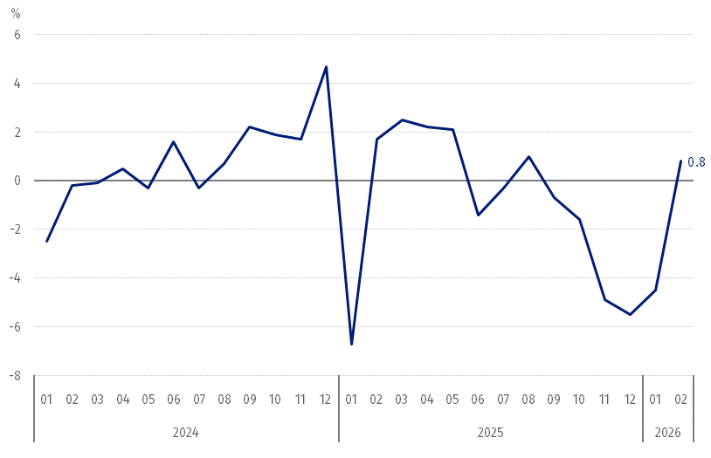
In February 2026, compared to January 2026, in the procurement prices of animals for slaughter: cattle and pigs increased, the prices of poultry for slaughter remained unchanged, but the prices of wheat, rye and cow's milk decreased

Chart 2. Changes in procurement prices of basic agricultural products in relation to the corresponding month of the previous year
Procurement prices of basic agricultural products, except for cattle for slaughter, were lower in February 2026 than those recorded in February 2025

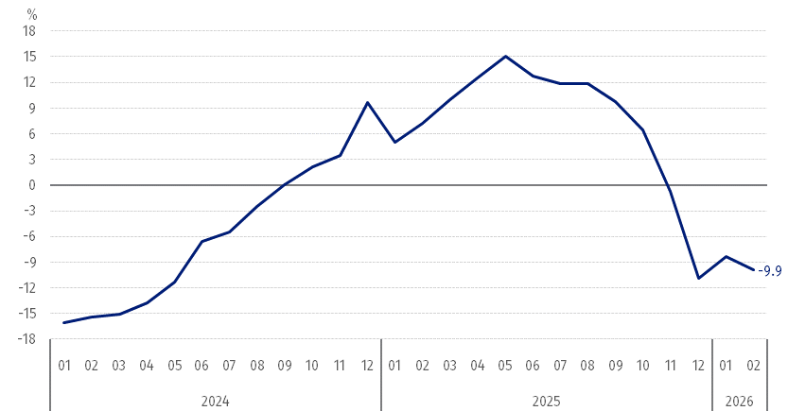

Procurement prices and marketplace prices received by farmers
In February 2026, the majority of agricultural products were sold at the higher procurement prices than in the previous month. At marketplaces, there was less paid for the most agricultural products, except for wheat and rye. At the both markets, the prices of maize increased, while the prices of barley decreased.
Compared to the corresponding month of 2025, in February 2026 there was recorded the decrease in prices of the agricultural products both in procurement and at the marketplaces, except for cattle for slaughter in procurement.
Table 1. Prices of agricultural products (excluding VAT) in February 2026
Specification | Procurement prices |  |  | Marketplaces prices
Specification | 02 2026
Specification | in zloty | 01 2026 =100 | 02 2025 =100 | in zloty | 01 2026 =100 | 02 2025 =100
Cereal grain – per dt
Wheat | 74.58 | 99.6 | 81.2 | 104.7 | 100.2 | 91.9
Rye | 60.83 | 99.3 | 84.9 | 80.51 | 101.8 | 92.7
Barley | 74.18 | 98.6 | 86.9 | 99.76 | 98.9 | 92.4
Triticale | 70.39 | 100.2 | 84.7 | 90.09 | 98.4 | 92.2
Oat | 61.47 | 111.1 | 78.1 | 89.13 | 99.8 | 87.6
Maize | 74.72 | 101.2 | 88.9 | 117.34 | 101.9 | 95.9
Potatoes – per dt | 89.35 | 109.0 | 80.3 | 177.79 | 99.1 | 84.8
Animals for slaughter – per kg
Cattle (excl. calves) | 16.17 | 105.6 | 129.2 | 12.01 | 99.5 | 98.0
of which young cattle | 16.82 | 107.0 | 131.7 | . | . | .
Pigs | 5.09 | 107.1 | 86.5 | . | . | .
Poultry | 5.68 | 100.0 | 97.6 | . | . | .
Cows’ milk – per hl | 186.44 | 98.7 | 82.0 | . | . | .
Data on procurement prices were calculated on the basis of information on value and quantity of procurement by legal persons and independent organizational entities without legal personality (without natural persons).
Indices of procurement prices and prices received by farmers at marketplaces were calculated on the basis of absolute data expressed with more precision than in the tables.

Prices of major agricultural products in February 2026
In February 2026, PLN 74.58 was paid per dt of wheat in procurement, i.e. 0.4% less than in the previous month and 18.8% less than a year ago. At the marketplaces, the price of wheat (PLN 104.70 per dt) increased by 0.2% in comparison with January 2026, while the price decreased by 8.1% compared to February last year.
The procurement price of rye (PLN 60.83 per dt) was lower by 0.7% in comparison with January 2026 and lower by 15.1% than in February 2025. The price of rye at the marketplace (PLN 80.51 per dt) increased on a monthly basis (by 1.8%), but the price decreased on an annual basis (by 7.3%).
In February 2026, PLN 89.35 was paid per dt of potatoes in procurement, i.e. 9.0% more than in the previous month, but 19.7% less than in the corresponding period of 2025. At the marketplaces, the price of potatoes (PLN 177.79 per dt) decreased both in comparison with January 2026 (by 0.9%) and compared to February 2025 (by 15.2%).
The procurement price of cattle of slaughter (PLN 16.17 per kg) was higher both on a monthly basis (by 5.6%) and on an annual basis (by 29.2%). At the marketplaces, cattle for slaughter (PLN 12.01 per kg) were sold cheaper both compared to January 2026 (by 0.5%) and in comparison with February last year (by 2.0%).
In February 2026, PLN 5.09 was paid per kg of pigs for slaughter in procurement, i.e. 7.1% more than a month ago, but 13.5% less than a year ago.
The procurement price of poultry for slaughter (PLN 5.68 per kg) remained unchanged in the comparison with January 2026, while the price decreased by 2.4% compared to February last year.
PLN 186.44 was paid in procurement per hl of cows’ milk, i.e. 1.3% less than in the previous month and 18.0% less than a year ago.

Chart 3. Procurement and marketplaces prices of wheat and rye

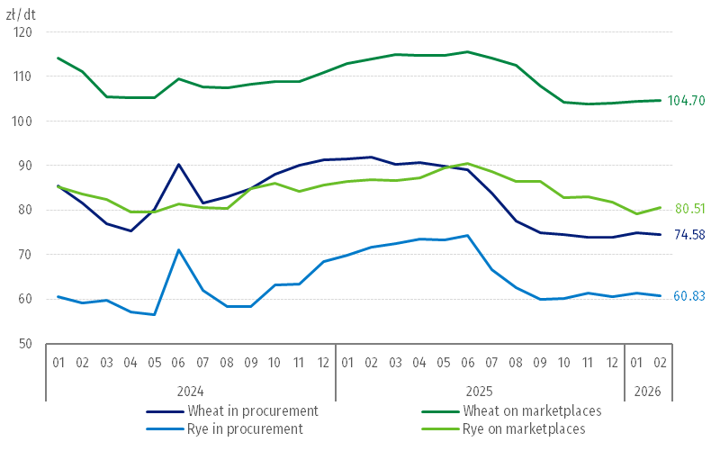

Chart 4. Procurement and marketplaces prices of potatoes

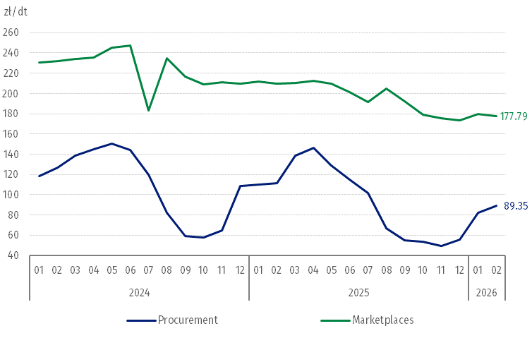

Chart 5. Procurement and marketplaces prices of cattle for slaughter and procurement prices of pigs for slaughter
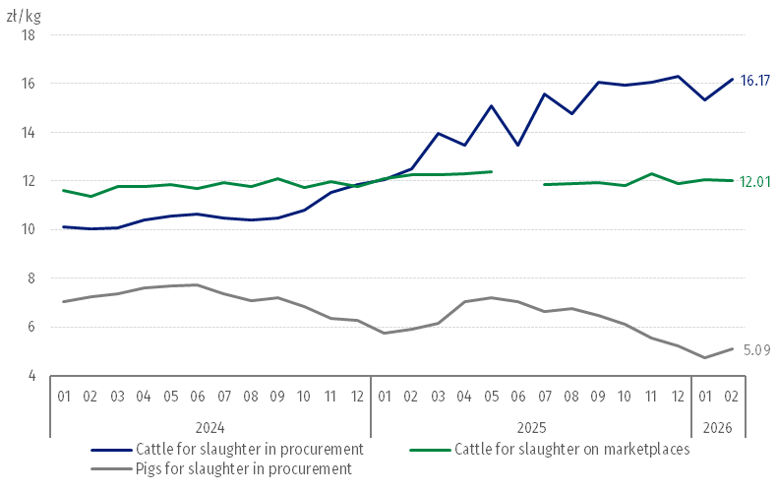

Chart 6. Procurement prices of poultry for slaughter and cows’ milk
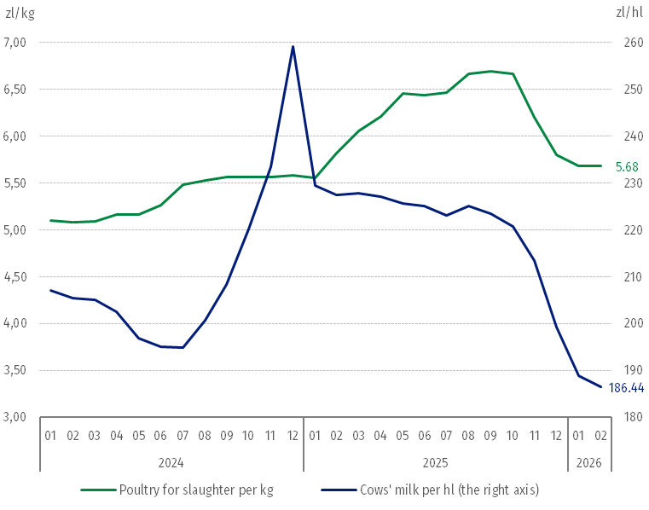

The differentiation of the level of prices of basic agricultural products in particular voivodships is presented in Table 2 for procurement prices and in Table 3 for prices obtained by farmers at the marketplaces (Excel sheet).

In case of quoting Statistics Poland data, please provide information: “Source of data: Statistics Poland”, and in case of publishing calculations made on data published by Statistics Poland, please include the following disclaimer: “Own study based on figures from Statistics Poland”.

Prepared by:  Prices and Services Department  Director Ewa Adach-Stankiewicz  Phone: (+48 22) 608 31 24 | Issued by:  Press Office  Mobile: (+48) 695 255 032  Phone: (+48 22) 608 38 04, (+48 22) 449 41 45.  (+48 22) 608 30 09  e-mail: obslugaprasowa@stat.gov.pl

stat.gov.pl/en/

@StatPoland

@GlownyUrzadStatystyczny

gus_stat

glownyurzadstatystycznygus

glownyurzadstatystyczny
Related information
Socio-economic situation of the country in 2025
Procurement and prices of agricultural products in 2025

Data available in databases
BDL – Prices - Prices in agriculture
Knowledge Databases – Economy - Prices – Producer prices - Agricultural prices

Terms used in official statistics
Procurement of agricultural products
Procurement prices
Marketplace
Marketplace prices

Wheat and rye grain, animals for slaughter: cattle, pigs and poultry, cow's milk
Procurement prices – excluding sowing seed.
Procurement prices – total (of which: edible early kinds, seed, edible late, industrial, of which starch). Marketplaces prices – edible excluding early kinds.
Marketplaces prices – average weighted price of cattle for slaughter calculated with the adoption of the structure of procurement quantity of young cattle and cows for slaughter.
In June 2025, the price of cattle for slaughter at marketplaces was classified as a statistical confidentiality due to the low number of quotations.

