First aid and emergency medical services in 2025
3.6%
Increase in the number of persons who received health care benefits in the occurrence place compared to 2024

In 2025 emergency rescue teams provided health care benefits in the occurrence place to 3.3 million of persons. In hospital emergency wards or admission rooms 6.6 million patients received health care benefits (increase by 2.9%). 4.9 million were discharged home and 1.7 million received inpatient treatment.

Units of the State Emergency Medical Services System (denoted as PRM)
The State Emergency Medical Services System covered: 1,699 emergency rescue teams, 21 medical air rescue teams and 251 hospital emergency wards
In 2025 the State Emergency Medical System covered functioning of the 1,699 emergency rescue teams (35 more than in previous year). There were 1,479 basic emergency rescue teams and 220 specialist (87.1% and 12.9% respectively). The number of basic teams has increased by 63 (4.4%) while the number of specialist teams has decreased by 28 (11.3%) compared to 2024.
The emergency medical treatment was also offered by 21 medical air rescue teams (the number remained at the same level compared to 2024) and 251 hospital emergency wards (denoted as SOR) – 1 more than in previous year.
The cooperating units role with PRM system was played by 150 admission rooms, 17 trauma centers and 11 children trauma centers.

Map 1. Units of the State Emergency Medical Services System by voivodships in 2025
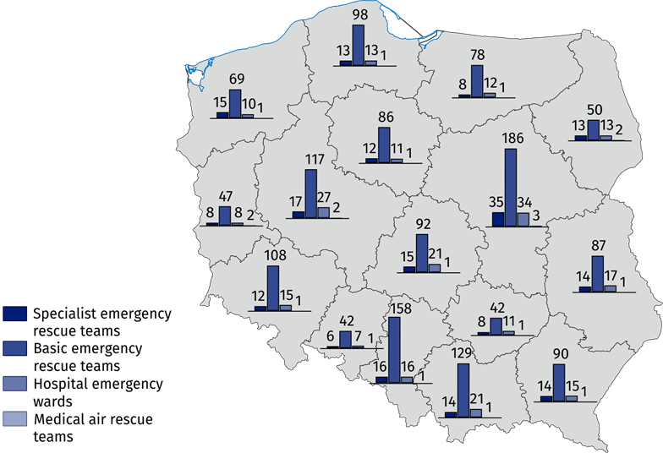
As of 31 December

Emergency rescue teams, medical air rescue teams
3.2 million of calls of the emergency rescue teams (including medical air rescue teams) to the occurrence places were recorded, of which 77.1% was at the patient’ home
The emergency rescue teams provided medical treatment for patients whose life is threatened. In 2025 there were 3.2 million of calls of the emergency rescue teams (including medical air rescue teams) during which the emergency medical activities were provided. The number of calls of the emergency rescue teams (including medical air rescue teams) to the occurrence places increased by 3.5% (109.0 thousand) compared to previous year. Among all emergency rescue teams’ call (including medical air rescue teams) 77.1% was at the patient’ home (compared to 76.7% in 2024).

Chart 1. Calls of the emergency rescue teams to the occurrence places by the type of occurrence place in 2025

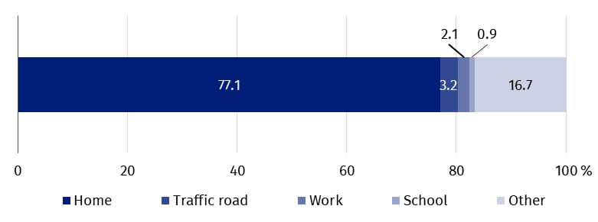
The emergency rescue teams provided medical treatment to 3.3 million of persons (3.6% more than in previous year). Among these persons 5.8% were children and youth under 18 years and 51.5% - persons aged 65 and more (in 2024 5.9% and 50.5% respectively).

Chart 2. Occurrence places where emergency rescue teams provided health care benefits by the age of persons in 2025

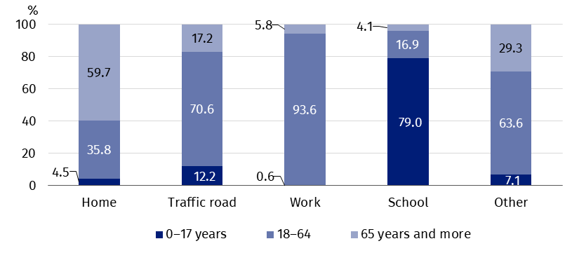
Per 1,000 population, the emergency rescue teams provided medical treatment to 87 persons
There were 87 persons to whom emergency rescue teams provided medical treatment per 1,000 population (compared to 84 in 2024). The maximum value (105) was observed in Zachodniopomorskie Voivodship and the minimum value (67) in Wielkopolskie Voivodship.

Map 2. Emergency rescue teams and persons who received health care benefits in the place of occurrence by voivodships in 2025

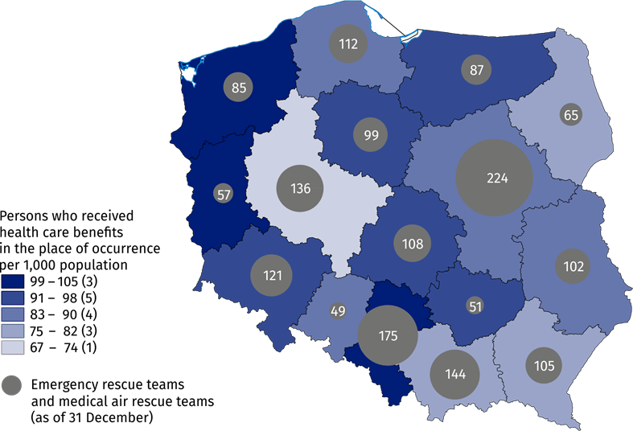
The number of medical personnel of emergency rescue teams as well as medical air rescue teams amounted to 13.2 thousand workers (as of 31 of December 2025). Compared to 2024, the total number of medical personnel of emergency rescue teams as well as medical air rescue teams increased by 2.0%. The largest group was constituted by emergency medical technicians. Their number amounted to 11.8 thousand (by 0.4 thousand more than in previous year). Moreover, there were almost 1.0 thousand of nurses of emergency medical services, nearly 0.2 thousand of physicians of emergency medical services and over 0.2 thousand of other personnel.

Hospital emergency wards and admission rooms
The number of persons who received health care benefits in both hospital emergency wards and admission rooms increased by 2.9% compared to previous year
Hospital emergency wards (SOR) as well as admission rooms provide medical treatment for patients whose life is threatened.
In 2025 the number of patients who received health care benefits in both hospital emergency wards and admission rooms amounted to 6.6 million persons (increase by 2.9% as compared to 2024). 4.9 million were discharged home and 1.7 million received inpatient treatment. Children and youth under 18 years stood for 18.3% of the total number of treated in hospital emergency wards or in admission rooms while persons aged 65 and more – 29.0% (in 2024 19.1% and 27.6% respectively).

Chart 3. Persons who received health care benefits in the hospital emergency wards or admission rooms by the age in 2025

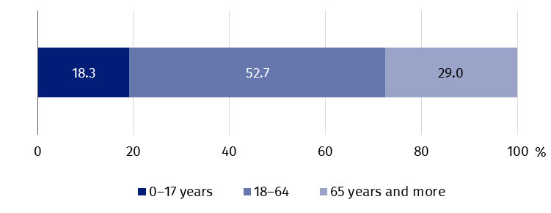
Per 1,000 population, there were 177 persons who received health care benefits in the hospital emergency wards or in admission rooms
There were 177 persons who received health care benefits in the hospital emergency wards or in admission rooms per 1,000 population (171 persons in 2024). The maximum ratio of this indicator was observed in Kujawsko-pomorskie Voivodship (228) and the minimum value (117) in Śląskie Voivodship.

Map 3. Persons who received health care benefits in the hospital emergency wards or admission rooms by voivodships in 2025

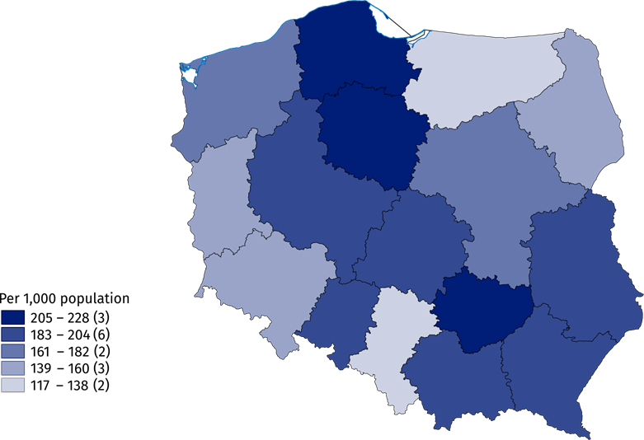
In the case of quoting data from the Statistics Poland, please provide information: "Statistics Poland data source", and in the case of publishing calculations made on data published by the Statistics Poland, please provide information: "Own study based on Statistics Poland data".

Prepared by:  Statistical Office in Kraków  Director Agnieszka Szlubowska  Phone: (+48 12) 420 40 50 | Issued by:  Press Office  Mobile: (+48) 695 255 032  Phone: (+48 22) 608 38 04, (+48 22) 449 41 45,  (+48 22) 608 30 09  e-mail: obslugaprasowa@stat.gov.pl

stat.gov.pl/en/

@StatPoland

@GlownyUrzadStatystyczny

gus_stat

glownyurzadstatystycznygus

glownyurzadstatystyczny
Related information
Health and health care in 2024
Methodological report. Health and health care statistics − Statistics Poland’s reports
Data available in databases
Local Data Bank -> Health care, social welfare and benefits to the family
Knowledge Databases -> Society -> Health and healthcare
Terms used in official statistics
Emergency medical services
Units of emergency medical service
Hospital emergency ward
The place of occurrence
Trauma center
Physician of emergency medical services
Nurse of emergency medical services

Population as of 30 June.
Medical personnel for whom it was the main workplace, regardless of the form of employment contract.
Drivers and pilots.
Population as of 30 June.

