Cultural and creative industries in 2024
15.8%
Increase in the number of entities belonging to the cultural and creative industries in comparison to 2023
In 2024, there were 143.7 thousand enterprises classified as cultural and creative industries. The number of employed persons amounted to 281.0 thousand (an increase by 18.7%), and the average paid employment amounted to 96.5 thousand full-time jobs (an increase by 4.3%). The average gross monthly wages and salaries amounted to PLN 9,193. Increase of both number of persons employed and average paid employment was recorded only for micro-companies.
Cultural and creative industries are the part of non-financial enterprises, separated according to specific PKD classes. These are economic entities engaged in mass production and sale of cultural and creative goods and services. Cultural industries produce cultural goods and services based on copyright, using industrial production techniques, and these are primarily: the publishing industry, the phonographic industry, TV, radio, the film industry and creating computer games. Creative industries are made up of entities whose activities are primarily related to design, architecture, advertising and translations – culture serves here as a source of inspiration and a creative contribution.

Number and types of entities belonging to the cultural and creative industries
The number of entities belonging to the cultural and creative industries increased by 19.6 thousand in comparison to 2023
In 2024, the number of entities belonging to the cultural and creative industries amounted to 143.7 thousand, which means an increase by 15.8% as compared to 2023.

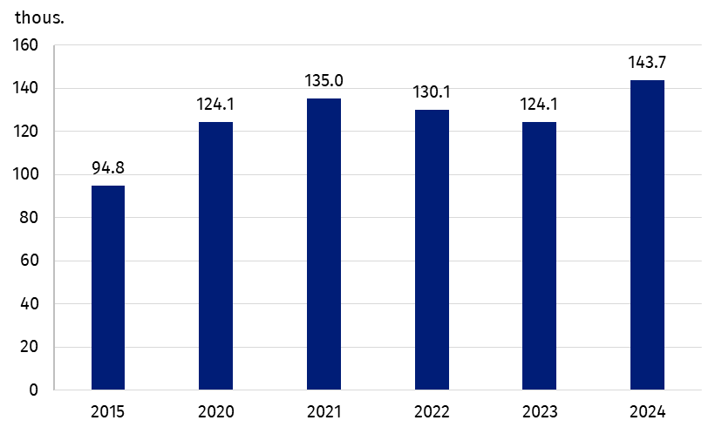
Chart 1. Number of enterprises belonging to the cultural and creative industries
The most numerous group consisted of entities operating in the Visual arts domain (39.1 thousand), while the least numerous – in Libraries and archives domain (0.2 thousand). The structure of entities by domains of culture has not changed in comparison to 2023. An increase in the number of entities in all domains of culture was observed, the largest was observed in the Cultural education domain (by 19.8%) and the lowest in Books and press domain (by 8.7%).

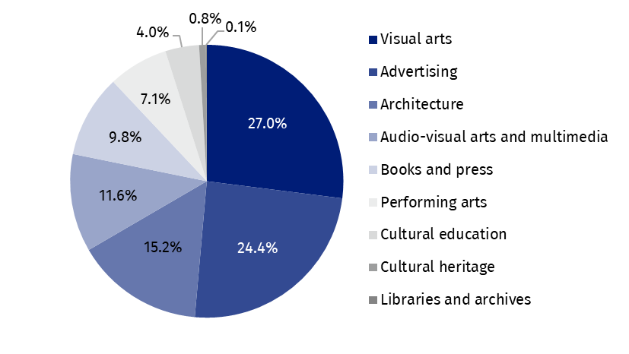
Chart 2. Entities classified as cultural and creative industries by domain of culture in 2024
Entities belonging to the cultural and creative industries accounted for 6.1% of all non-financial enterprises in Poland. The overwhelming majority of entities were micro-enterprises (142.6 thousand entities, i.e. 99.2%), which constituted 6.2% of all non-financial micro-enterprises. In other enterprise size categories, the number of entities classified as cultural and creative industries was as follows: small – 926; medium – 164; large – 46. Their share in the group of non-financial enterprises was as follows: 1.9% in group of small enterprises, 1.1% in group of medium enterprises and 1.2% among large enterprises. Within the cultural and creative industries, an increase in the number of entities was recorded only among micro-enterprises (by 16.0%), while in the remaining size classes there was a decrease in the number of entities (among small enterprises – by 1.0%, medium – by 5.7%, large – by 4.2%).
Micro-enterprises belonging to the cultural and creative industries constituted 6.2% of all non-financial micro-enterprises

Persons employed, average paid employment, wages and salaries
As of the end of 2024, the number of persons employed in enterprises belonging to the cultural and creative industries reached 281.0 thousand, which is 18.7% more than in the previous year. The average paid employment during the year was 96.5 thousand full-time jobs (increase by 4.3% as compared to 2023). An increase in both the number of persons employed and average paid employment was recorded only in micro-enterprises (by 27.8% and 21.8%, respectively).
The gross monthly wages and salaries was PLN 9,193, i.e. 3.7% more than in 2023 with the highest increase recorded in small enterprises – by 11.5% and in medium enterprises – by 11.3%. In large enterprises, the average wages and salaries increased by 7.7% and in micro-enterprises only by 1.3%.
Total average gross monthly wages and salaries in the cultural and creative industries was higher than in the total non-financial enterprises – by PLN 779. This difference amounted to PLN 402 in micro-enterprises, PLN 2,165 in small enterprises, PLN 2,898 in medium enterprises, and PLN 2,621 in large enterprises.
Average gross monthly wages and salaries in the cultural and creative industries was higher by PLN 779 compared to the total non-financial enterprises
The share of gross wages and salaries in total costs for enterprises classified as cultural and creative industries was 10.7%, i.e. 0.6 percentage points less than in 2023.
Table 1. Employed persons, average employment, average gross wages and salaries in cultural and creative industries in 2024
Specification | Number  of persons employedª  (in persons) | Average paid employment  (in full-time jobs) | Gross wages and salaries  in thousand PLN | Average monthly gross wages and salaries (per full-time jobs) in PLN
Total | 281,047 | 96,479 | 10,643,170 | 9,193
Micro-enterprises | 221,347 | 39,467 | 2,691,377 | 5,683
Small enterprises | 18,029 | 16,796 | 2,085,960 | 10,349
Medium enterprises | 16,524 | 15,680 | 2,254,753 | 11,983
Large enterprises | 25,147 | 24,536 | 3,611,080 | 12,265
a As of 31 December.

Financial results
In 2024, entities classified as cultural and creative industries generated total revenues of PLN 115.5 billion, with total costs of PLN 99.1 billion. As in previous years, a positive financial result was recorded, i.e. a surplus of total revenues over total costs, which amounted to PLN 16.5 billion (PLN 0.3 billion less than in 2023). Compared to the previous year, total revenues increased by 10.8%, while total costs increased by 13.2%.
In 2024, the cost level indicator, understood as the ratio of total costs to total revenues, in the case of enterprises classified as cultural and creative industries amounted to 85.7% (1.8 percentage points more compared to 2023). This ratio was 6.5 percentage points lower compared to all non-financial enterprises. Total costs per one entity amounted to PLN 689.4 thousand (PLN 16.1 thousand less than in the previous year), while total revenues – PLN 804.1 thousand (PLN 36.7 thousand less than in 2023). The share of total revenues and total costs generated by enterprises classified as cultural and creative industries in total revenues and total costs generated by all non-financial enterprises amounted to 1.4% and 1.3%, respectively.
Value added generated by enterprises belonging to the cultural and creative industries reached PLN 32.9 billion (PLN 0.3 billion more than in 2023), which accounted for 1.5% of the value added generated by all non-financial enterprises. The largest contribution made micro-enterprises which generated PLN 14.8 billion, i.e. 45.0% of total value added in this area. In case of large enterprises, the value added amounted to PLN 9.3 billion (28.1% of the total), while for small and medium enterprises – PLN 4.4 billion each. The value added of the cultural and creative industries per one enterprise was four times lower than the value added per one non-financial enterprise.

International trade of cultural and creative goods and services
In 2024, a positive balance of international trade of cultural and creative goods was recorded in the amount of PLN 4.5 billion. The balance of trade of cultural and creative services was negative and amounted to minus PLN 3.1 billion
In 2024, a decrease both in exports and imports of cultural and creative goods was recorded. The total value of sales abroad amounted to PLN 10.4 billion, i.e. PLN 3.4 billion less than in 2023. The value of imports also decreased and amounted to PLN 5.8 billion (PLN 3.4 billion less than in the previous year). Despite the decline in the value of exports and imports, the foreign trade balance remained positive and amounted to PLN 4.5 billion (PLN 4.6 billion in 2023).
The largest amount of export of cultural and creative goods was obtained in the Books and press domain (PLN 4.5 billion, i.e. PLN 0.8 billion less than in 2023), while the lowest – in the Arts and crafts domain (PLN 1.1 million). The highest balance of international trade in goods was recorded in the Books and press domain (PLN 2.7 billion), while the lowest balance was observed in Performing arts domain (minus PLN 67.3 million).
The value of cultural and creative services delivered abroad amounted to PLN 19.5 billion (PLN 1.8 billion more than in 2023), while cultural and creative services purchased abroad – PLN 22.6 billion (PLN 1.9 billion more than in 2023). Therefore, the balance of turnover was negative and amounted to minus PLN 3.1 billion.
The highest value of both exports and imports of cultural and creative services was recorded in the Advertising domain (PLN 15.9 billion and PLN 16.4 billion, respectively). A positive balance in trade of services was recorded in the Cultural heritage domain (PLN 402.0 million) and Architecture domain (PLN 251.9 million).
The share of cultural and creative goods in exports of goods in 2024 accounted for 0.7%, while in imports – 0.4%. The share of cultural and creative services in foreign trade of services was higher than in cultural and creative goods: the share amounted to 4.1% in exports and 7.6% in imports.
The recipients of Polish cultural and creative goods and services were mainly EU countries (86.6% and 59.3% of the value of exports, respectively). The situation was similar with regard to imports, where the main turnover was mainly with EU countries (52.2% of the value of imports for goods; 73.2% – for services).

Table 2. Foreign trade in cultural and creative goods and services by cultural domains in 2024
The highest value of exports of cultural and creative goods was recorded in the Books and press domain (PLN 4.5 billion), and in the case of cultural and creative services – in the Advertising domain (PLN 15.9 billion)
Specification | Cultural  and creative goods |  | Cultural  and creative services
Specification | exports | imports | exports | imports
Specification | in PLN million
Total | 10,357.5 | 5,828.8 | 19,511.2 | 22,646.6
Cultural heritage | 25.1 | 58.5 | 792.3 | 390.3
Books and press | 4,526.1 | 1,783.8 | 288.8 | 1,020.8
Visual arts | 383.1 | 160.4 | – | –
Architecture | 2.8 | 1.9 | 385.1 | 133.2
Performing arts | 213.9 | 281.2 | 416.8 | 932.0
Audio-visual arts and multimedia | 3,989.9 | 3,421.2 | 1,770.2 | 3,735.8
Advertising | 1,215.5 | 120.7 | 15,858.0 | 16,434.6
Arts and crafts | 1.1 | 1.1 | – | –
Note: Data does not add up due to rounding.
Information on the data sources used and the methodological solutions used can be found in Methodological report. Culture statistics and the publication Cultural and creative industries 2017–2021.
In the case of quoting data from the Statistics Poland, please provide information: "Statistics Poland data source", and in the case of publishing calculations made on data published by the Statistics Poland, please provide information: "Own study based on Statistics Poland data".

Prepared by:  Statistical Office in Kraków  Director Agnieszka Szlubowska  Phone: (+48 12) 420 40 50 | Issued by:  Press Office  Mobile: (+48) 695 255 032  Phone: (+48 22) 608 38 04, (+48 22) 449 41 45,  (+48 22) 608 30 09  e-mail: obslugaprasowa@stat.gov.pl

stat.gov.pl/en/

@StatPoland

@GlownyUrzadStatystyczny

gus_stat

glownyurzadstatystycznygus

glownyurzadstatystyczny
Related information
Cultural and creative industries 2017–2021
Cultural and creative industries in 2023
Culture and national heritage in 2024
Methodological report. Culture statistics
Terms used in official statistics
Exports of goods and services
Imports of goods and services
Total costs
Average monthly gross wages and salaries
Average paid employment
Total revenues
Balance foreign trade commodity turnover
Balance of services
Cost level indicator
Gross earnings

Calculated per full-time jobs.
Micro-enterprises – entities with 9 or fewer employees.
Small enterprises – entities with 10–49 employees; medium enterprises – entities with 50–249 employees; large enterprises – entities with 250 or more employees.
The data cover entities of national economy and residents engaged in international trade in goods and services, with the exception of entities trading in goods whose trade with EU member states has not exceeded the basic statistical threshold.

