Living conditions – material and social deprivation in year 2025
In 2025, 2.0% of people living in Poland declared that they were unable to meet at least 7 out of 13 material and social needs due to financial reasons. This percentage decreased slightly compared to the previous year (2.3% in 2024).
2.0%
This part of Poland’s population in 2025 was unable, due to financial constraints, to meet basic material and social needs that are regarded by the majority of people as essential for a dignified standard of living
Severe material and social deprivation
Material deprivation is the inability to meet basic needs due to financial reasons, while social deprivation refers to the inability to participate in social and cultural life, leading to isolation and social exclusion. Both cases describe a multidimensional poverty in which part of society with limited financial resources may experience social marginalization.
Graph 1. Severe material and social deprivation rate in Poland in years 2015-2025
Between 2015 and 2025, the proportion of persons experiencing severe material and social deprivation decreased from 7.8% to 2.0%, i.e., a drop of 5.8 pp.
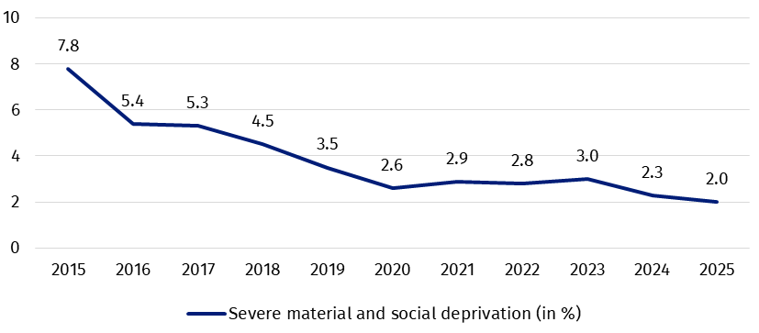
Data presented in Graph 1 show a significant improvement in the indicator of severe material and social deprivation in Poland over the past 10 years. The decrease of 5.8 pp. in the proportion of people unable to meet (at least 7 out of 13) basic needs in the years 2015–2025 (the largest decrease between 2015 and 2020) suggests a reduction in the scale of this matter.
After a period of significant decrease in the value of the indicator until 2020, this trend stopped in the years 2021–2023, resulting from the accumulation of negative factors, including high inflation caused by the pandemic and the war in Ukraine. However, the deprivation rate in 2024-2025 indicates a return to a downward trend.

Items of severe material and social deprivation indicator

Below there are the percentages of people who in the years 2015–2025 were unable to meet the listed needs (which are items of the severe material and social deprivation indicator).

Table 1. Items of severe material and social deprivation indicator in Poland in years
2015 – 2025
Needs (items) |  | Percentage of people unable to meet specific needs  due to financial reasons
 |  | year of survey
 |  | 2015 |  |  |  | 2016 |  |  |  | 2017 |  |  |  | 2018 |  |  |  | 2019 |  |  |  | 2020 |  |  |  | 2021 |  |  |  | 2022 |  |  |  | 2023 |  |  |  | 2024 |  |  |  | 2025
Life needs
Ability to afford a meal including meat, fish or  a vegetarian equivalent every second day | 8.2 |  |  |  | 6.4 |  |  |  | 6.3 |  |  |  | 4.9 |  |  |  | 4.1 |  |  |  | 3.6 |  |  |  | 3.6 |  |  |  | 4.1 |  |  |  | 3.5 |  |  |  | 2.8 |  |  |  | 3.0
Afford to keep home  adequately warm | 7.5 |  |  |  | 7.1 |  |  |  | 6.0 |  |  |  | 5.1 |  |  |  | 4.2 |  |  |  | 3.2 |  |  |  | 3.2 |  |  |  | 4.9 |  |  |  | 4.7 |  |  |  | 3.3 |  |  |  | 3.4
Financial security
Ability to meet  unexpected expenses (60.0% of the national median of yearly equivalised disposable income) |  |  | 42.3 |  |  |  | 37.9 |  |  |  | 34.8 |  |  |  | 31.7 |  |  |  | 29.3 |  |  |  | 25.7 |  |  |  | 24.5 |  |  |  | 27.1 |  |  |  | 25.7 |  |  |  | 22.8 |  |  |  | 22.0
Avoid arrears (in mortgage rent, utility bills and/or hire purchase instalments) |  |  | 11.0 |  |  |  | 11.0 |  |  |  | 10.3 |  |  |  | 7.7 |  |  |  | 7.4 |  |  |  | 5.5 |  |  |  | 7.0 |  |  |  | 6.0 |  |  |  | 5.1 |  |  |  | 4.2 |  |  |  | 2.8
Material needs
Afford to replace worn-out furniture |  |  |  | 27.8 |  |  |  | 21.7 |  |  |  | 19.1 |  |  |  | 17.2 |  |  |  | 15.0 |  |  |  | 13.2 |  |  |  | 12.0 |  |  |  | 12.6 |  |  |  | 11.5 |  |  |  | 9.6 |  |  |  | 9.9
Afford to replace worn-out clothes by some new ones |  |  |  | 10.4 |  |  |  | 7.6 |  |  |  | 8.2 |  |  |  | 7.2 |  |  |  | 6.4 |  |  |  | 5.0 |  |  |  | 5.3 |  |  |  | 4.7 |  |  |  | 4.4 |  |  |  | 3.7 |  |  |  | 3.7
Afford to have two pairs  of properly fitting shoes |  |  |  | 1.3 |  |  |  | 1.2 |  |  |  | 1.1 |  |  |  | 1.1 |  |  |  | 0.9 |  |  |  | 0.9 |  |  |  | 1.5 |  |  |  | 2.0 |  |  |  | 1.0 |  |  |  | 0.8 |  |  |  | 0.8
Have access to a car for personal use |  |  |  | 9.1 |  |  |  | 7.3 |  |  |  | 7.0 |  |  |  | 6.1 |  |  |  | 5.5 |  |  |  | 3.9 |  |  |  | 3.7 |  |  |  | 3.5 |  |  |  | 3.6 |  |  |  | 3.5 |  |  |  | 3.5
Have access to an Internet connection |  |  |  | 4.1 |  |  |  | 2.7 |  |  |  | 2.2 |  |  |  | 2.0 |  |  |  | 1.6 |  |  |  | 1.0 |  |  |  | 1.0 |  |  |  | 1.0 |  |  |  | 0.8 |  |  |  | 0.8 |  |  |  | 0.6
Social needs
Afford to spend a small amount of money each week on personal needs |  |  |  | 12.8 |  |  |  | 9.0 |  |  |  | 11.9 |  |  |  | 11.8 |  |  |  | 10.3 |  |  |  | 9.0 |  |  |  | 9.4 |  |  |  | 8.5 |  |  |  | 9.7 |  |  |  | 8.1 |  |  |  | 6.8
Afford to get together with friends/family for  a drink/meal at least once  a month |  |  |  | 10.2 |  |  |  | 7.2 |  |  |  | 6.8 |  |  |  | 6.5 |  |  |  | 5.3 |  |  |  | 4.5 |  |  |  | 4.9 |  |  |  | 4.8 |  |  |  | 4.9 |  |  |  | 4.1 |  |  |  | 3.4
Leisure activities
Ability to afford  a one-week holiday |  |  |  | 44.0 |  |  |  | 41.2 |  |  |  | 38.4 |  |  |  | 34.6 |  |  |  | 33.2 |  |  |  | 29.4 |  |  |  | 26.5 |  |  |  | 27.6 |  |  |  | 27.6 |  |  |  | 25.5 |  |  |  | 24.4
Afford to have regular  leisure activities |  |  |  | 18.6 |  |  |  | 14.6 |  |  |  | 13.3 |  |  |  | 12.4 |  |  |  | 10.7 |  |  |  | 8.0 |  |  |  | 8.7 |  |  |  | 9.0 |  |  |  | 9.5 |  |  |  | 8.0 |  |  |  | 6.9

In the years 2015–2025, there was a clear improvement in the financial situation of some Polish households, reflected by a decrease in the percentage of people struggling with limitations in meeting the needs included in the indicator of severe material and social deprivation.
The decrease in the share of people unable to afford a one-week holiday, from 44.0% in 2015 to 24.4% in 2025, indicates an almost twofold improvement in access to leisure.
The largest average annual decreases in the share of people unable to meet specific needs were observed in the areas that were the most difficult in 2015. The proportion of people who could not afford a one-week holiday decreased fastest, reaching 24.4% in 2025, although in 2015 this problem affected 44.0% of the population.
The second need with the greatest improvement was meeting unexpected expenses. In 2025, the proportion of people unable to meet this need was 22.0%, compared to 42.3% in 2015. This means that households gained greater financial stability during the analyzed period, allowing them to meet more than just their basic consumption needs.
The analysed period of time was characterised by a varying pace of decline and may be divided into two periods. First (2015–2020) was marked by an improvement, reflected in a decrease or stabilisation in the share of people reporting an inability to meet their needs due to financial reasons. This trend applied to nearly all analysed needs.
A particularly high rate of decrease (an annual average of over 2%) was observed in the inability to meet the following needs:
- ability to meet unexpected expenses (annual average decrease of 3.3% ),
- ability to afford a one-week holiday (annual average decrease of 2.9%),
- afford to replace worn-out furniture (annual average decrease of 2.9%),
- afford to have regular leisure activities (annual average decrease of 2.1%),
The exception during this period was the proportion of people who, due to financial reasons, could not spend a small amount of money each week on themselves. This group increased by 2.9 percentage points between 2016 and 2017.
The second period highlighted is 2021–2025, which was characterized by instability for nearly all of the analysed needs due to a reversal of trends.
The first year when the percentage of people reported an inability to meet a specific need increased was 2021. A deterioration was observed in the financial capacity to avoid arrears in mortgage rent, utility bills and/or hire purchase instalments (an increase of 1.5 percentage points between 2020 and 2021). In subsequent years, more people were unable to meet their needs in other areas due to financial reasons. In the 2021–2022 period, these needs included:
- ability to meet unexpected expenses (by 2.6 pp.),
- afford to keep home adequately warm (by 1.7 pp.),
- ability to afford a one-week holiday (by 1.1 pp.).
In 2023, compared to 2022, the percentage of people unable to spend a small amount of money on their own needs once a week due to financial reasons increased by 1.2 pp.
Despite the adverse trends observed between 2021 and 2023, the situation improved significantly by 2025. The percentage of people unable to meet their needs in the specified categories due to financial reasons decreased to the 2020 level.

The categories with the largest declines in 2025 compared to 2020 were those related to paying for a week-long vacation (a 5.0 pp. drop, from 29.4% in 2020 to 24.4% in 2025) and covering unexpected expenses (3.7 pp. drop, from 25.7% in 2020 to 22.0% in 2025).

Selected aspects of severe social and material deprivation by region in 2025
To compare the situation of people living in urban and rural areas, several aspects have been selected from the list of needs included in the severe material and social deprivation indicator (Table 1).
The selection of areas for further analysis, from an urban-rural perspective, was based on two criteria. The first involved identifying areas with the highest percentages of unmet needs. These were:
- ability to afford a one-week annual holiday for all household members;
- ability to meet unexpected expenses (60.0% of the national median of yearly equivalised disposable income).
The second criterion was the importance of satisfying these needs for proper human functioning. Taking it into account, the following areas of need were selected for further analysis:
- ability to afford a meal including meat, fish or a vegetarian equivalent every second day;
- afford to keep home adequately warm;
- afford to spend a small amount of money each week on personal needs;
- ability to afford regular leisure activities.
The selected aspects also include the inability to pay mortgage, rent or utility bills. This is due to the serious health, social, and economic consequences of permanent inability to meet needs in this area.
A relevant context for understanding material and social deprivation is the income situation of households. Considering this aspect is crucial for a reliable assessment of the circumstances of people experiencing deprivation. Table 2 summarizes data on the class of locality, income level and the ability to meet needs.
The average annual equivalised disposable income, together with median values, indicates differences in income levels between urban and rural populations. The highest income was recorded in the largest urban areas (towns with 500 thousand or more inhabitants), reaching PLN 86,200 per person annually. As city size decreases, average income also declines, with cities less than 20,000 inhabitants reporting approximately PLN 64 thousand.
In 2025, the income gap between urban and rural areas remained, with rural residents having lower disposable incomes (urban areas overall – PLN 71.6 thousand; rural areas overall – PLN 60.4 thousand).
At the same time, average incomes also varied significantly among residents of different types of rural areas. People living in densely populated rural areas within agglomerations achieved considerably higher incomes than those living in rural households located far from large cities (non-agglomeration areas).

Table 2. Severe material and social deprivation indicator, median and equivalised annual
disposable income per person in Poland in 2025 on class of locality
Class of locality |  |  | Severe material and social deprivation indicator | Annual equivalised disposable income per person | Median of annual equivalised disposable income
 |  |  | in % | in PLN
Poland |  |  | 2.0 | 67 120 | 61 976
Urban | total |  | 2.0 | 71 561 | 65 470
Urban | town by size in thousand | 500 and more | 0.7 | 86 213 | 76 859
Urban | town by size in thousand | 200-499 | 2.1 | 75 420 | 69 286
Urban | town by size in thousand | 100-199 | 1.7 | 69 563 | 63 891
Urban | town by size in thousand | 20-99 | 2.5 | 66 750 | 62 317
Urban | town by size in thousand | less than 20 | 2.6 | 63 965 | 60 843
Rural  areas by delimitation of rural areas | total |  | 2.1 | 60 435 | 56 726
Rural  areas by delimitation of rural areas | agglomeration  rural areas | total | 1.5 | 68 552 | 64 125
Rural  areas by delimitation of rural areas | agglomeration  rural areas | of high population density | 1.4 | 74 284 | 68 682
Rural  areas by delimitation of rural areas | agglomeration  rural areas | of low population density | 1.5 | 62 832 | 59 659
Rural  areas by delimitation of rural areas | non-agglomeration rural areas | total | 2.3 | 57 566 | 54 610
Rural  areas by delimitation of rural areas | non-agglomeration rural areas | of high population density | 2.5 | 58 630 | 55 944
Rural  areas by delimitation of rural areas | non-agglomeration rural areas | of low population density | 1.4 | 55 438 | 51 844

The data in the table above indicate a link between the average annual equivalised disposable income of household members and material and social deprivation rate — the higher average income - the lower level of deprivation.
The largest cities, with the highest average disposable income (PLN 86,200 in cities with 500 thousand or more inhabitants), recorded the lowest material and social deprivation rate (below 1%) in 2025. In contrast, household members living in the smallest towns (with 20 thousand or fewer inhabitants) had an average annual equivalised disposable income over PLN 22,000 lower and a deprivation rate almost 2 percentage points higher than persons living in the largest cities.
The average annual equivalised disposable income of household members in agglomeration rural areas of high population density in 2025 was approximately PLN 11,000 higher than that of people living in villages located far from large cities.
Rural areas were also characterized by disparities in average disposable income and deprivation rates. There was a PLN 11,000 difference in disposable income between people living in rural areas closer to cities and those in non-agglomeration rural areas. Rural areas located far from agglomerations, which were characterized by lower incomes, also showed a higher proportion of people affected by basic needs deprivation. The difference in the severe material and social deprivation rate between the two types of rural areas in 2025 was 0.8 percentage points (agglomeration villages: 1.5%; non-agglomeration villages: 2.3%).
The situation of inhabitants of agglomeration rural areas was more similar to medium-sized cities than inhabitants of non-agglomeration rural areas.
Graph 2. Severe material and social deprivation and the average yearly equivalised
disposable income per person by class of locality in Poland in 2025
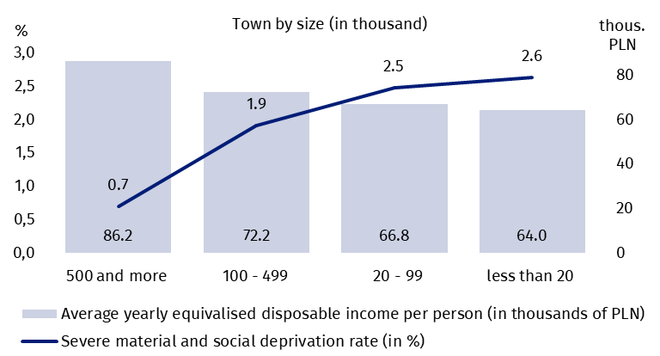
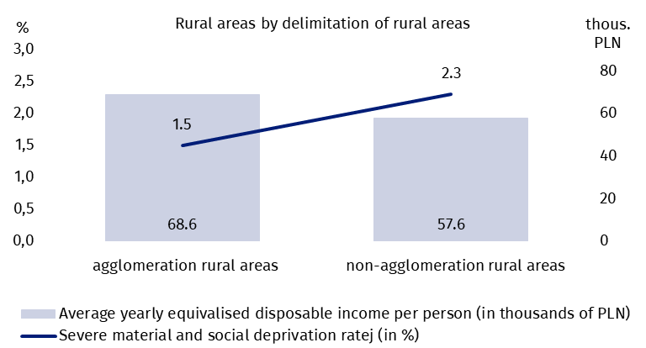
Rural areas remain more vulnerable to material and social deprivation than urban areas. Graph 3 shows the differences between place of residence and the inability to meet selected needs.
A similar percentages were unable to afford basic needs, such as a meal containing meat, fish or a vegetarian equivalent every second day, keeping home adequately warm, and a key component of financial security, namely the ability to make housing-related payments on time. Regardless of the place of residence, between 2.7% and 3.7% of people reported being unable to afford these essential items in 2025.
All other needs important for human well-being, but addressed only after basic needs such as food and adequate heating, show greater deprivation in rural areas. The largest difference between urban and rural residents in the financial capacity to meet these needs was observed in 2025 for a one-week holiday (difference: 11.1 percentage points). In 2025, rural households had significantly less access to financing for at least a week-long trip for all household members.
Graph 3. Selected aspects of material and social deprivation by class of locality in 2025
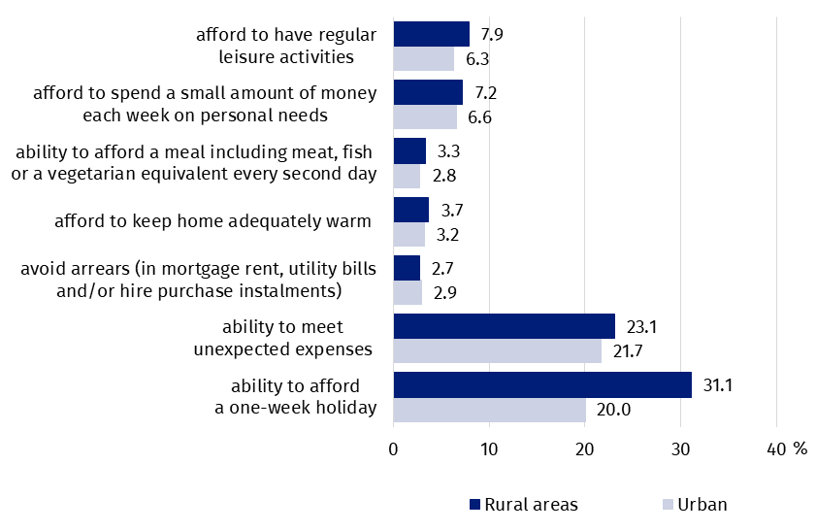

Situation of urban residents
The income situation of household members in 2025 was clearly associated with the class of locality, with the highest incomes concentrated in large agglomerations of over 500 thousand inhabitants (Graph 2). Equivalent household income decreased with city size, which in turn affected households’ ability to meet both basic needs (food, housing, heating) and higher-order needs (financial security, social contacts and leisure activities).

The largest urban areas (population over 500 thousand) were characterized by the highest level of satisfaction of residents’ basic needs. Inhabitants of these cities were least often report a lack of financial resources to eat meat or fish (or vegetarian equivalents) every second day (1.4%) and keep home adequately warm (2.3%). The situation in other cities was more difficult. Between 2.5% of residents in the smallest towns (up to 20 thousand inhabitants) and 3.7% in medium-sized towns (100–499 thousand) reported being unable to eat meat or fish (or vegetarian equivalents) every second day. Approximately 3.5% of people in smaller and medium-sized towns reported insufficient resources to keep home adequately warm.
The similar percentage of households reporting difficulties with housing-related payments in urban areas (3.4%) and in the smallest towns (3.3%) suggests that financial security depends on the balance between income and living costs.
In 2025, a different trend was observed regarding the financial inability to make timely payments for housing-related expenses (including rent, mortgage, and utility bills). Although residents of the largest metropolitan areas had the highest incomes among city inhabitants, 3.4% reported arrears due to financial reasons—similar to the 3.3% of residents in the smallest towns. This suggests that higher living costs in metropolitan areas offset income differences, resulting in similar scale of late payments as in the smallest towns.
Analysis of the remaining surveyed needs indicates that in 2025, the situation of residents in the largest cities was significantly more favourable than that of inhabitants of smaller towns. The greatest disparities in the percentage of people reporting an inability to meet their needs across different city classes were observed for paying for a one-week holiday for all household members once a year and for covering an unexpected expense. In 2025, the differences between the largest cities (500 thousand inhabitants or more) and the smallest (20 thousand inhabitants or fewer) reached 15.9 and 13.9 percentage points, respectively. The gap between the two highest city classes (i.e., cities with 500 thousand or more and with 100-499 thousand inhabitants) was also significant, reaching approximately 7 pp. for both needs, favouring the largest agglomerations.
Indicators of the inability to meet other needs—such as spending a small amount of money each week on personal needs and having regular leisure activities — also show differences in 2025 across city classes. The differences in the percentage of people reporting an inability to meet these needs were smaller than those observed for a one-week holiday or unexpected expense, but a clear pattern can be seen: as city size decreases, the proportion of households reporting an inability to meet these needs increases. In 2025, the difference between the largest cities (500 thousand inhabitants or more) and the smallest (20 thousand or fewer) reached 2.7 pp. (for spending on personal expenses) and 3.6 pp. (for regular participation in leisure activities).
In 2025, the scale of unmet needs was highest in smaller towns and lowest in large metropolitan areas.

Graph 4. Selected aspects of material and social deprivation by city class (size) in 2025
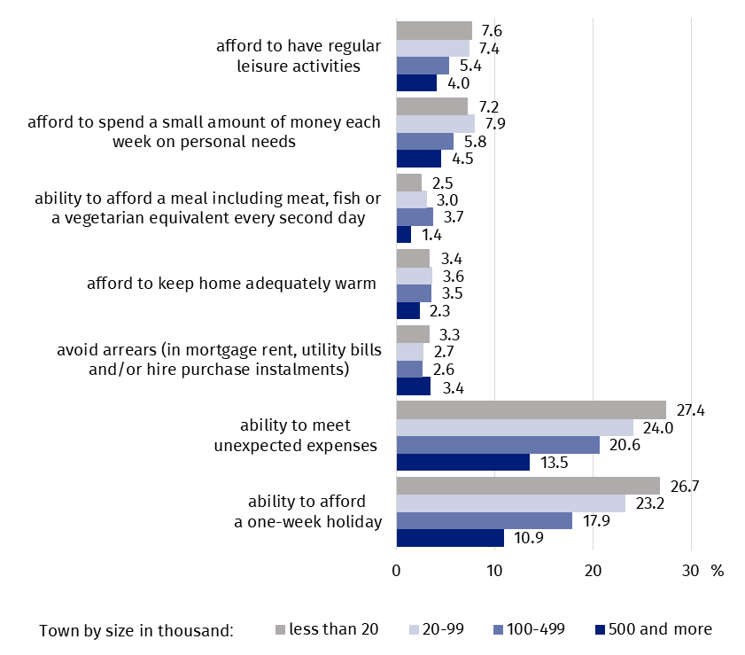

Differences in the situation of rural residents
The division of rural areas into agglomeration areas (within the direct zone of influence of large cities) and non-agglomeration areas (outside large urban centers, often peripheral) allows for a more precise analysis of differences in the situation of rural residents in Poland.
The graph below shows the proportion of rural residents who were unable to meet selected needs due to financial reasons in 2025. As shown before, the distance of a village from an urban agglomeration has an impact on residents’ income levels. The difference in average income among residents of suburban villages and those in peripheral areas reached approximately PLN 11,000.
Similar to the cities, comparable proportions of rural residents were observed in the case of inability to meet basic needs (food, housing, heating). Rural areas, both those located close to agglomerations and those in peripheral regions, showed similar proportions of residents unable to meet these needs. A significant difference was observed only for the ability to consume meat, fish (or a vegetarian equivalent) every second day. Rural residents in agglomeration areas were unable to meet this need more often than those in non-agglomeration areas (4.5% vs. 2.9%, respectively).
In 2025, the greatest differences in rural areas were observed in meeting needs related to paying for a week-long vacation for all household members once a year and covering unexpected expenses. A significantly higher percentage of residents in non-urban areas were unable to face a week-long vacation (34.5%) compared to those living near large cities (21.7%). A similar pattern was observed for the inability to cover an unexpected expense (25.4% vs. 16.5%).
Rural residents living far from metropolitan areas were more often (12 pp.) unable to afford a one-week holiday for financial reasons than those living in suburban areas.
The last group of needs, related to spending money for personal expenses and participating in leisure activities in rural areas, was characterized by slightly smaller differences in the proportion of people compared to the other needs described above.
Graph 5. Selected aspects of material and social deprivation by rural agglomeration
and non-agglomeration areas in 2025
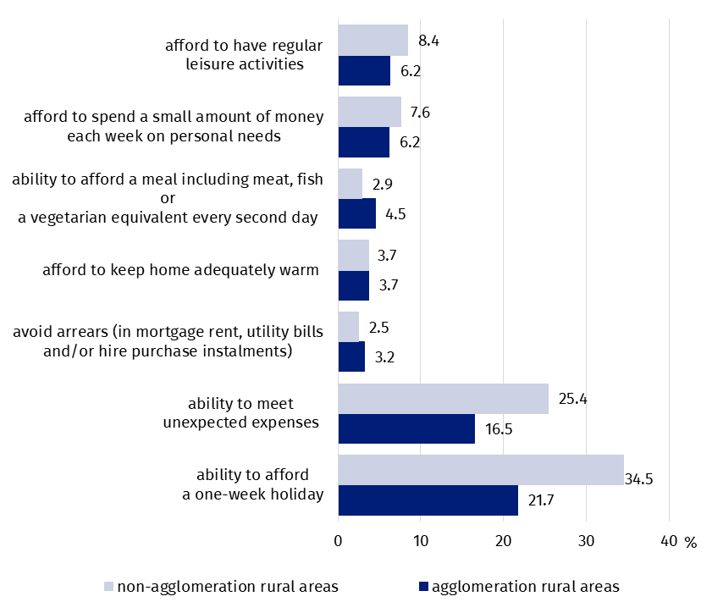
When quoting Statistics Poland data, please provide the information: ‘Source of data: Statistics Poland’, and when publishing calculations made on data published by Statistics Poland, please include the following disclaimer: ‘Own study based on figures from Statistics Poland’.

Prepared by:  Social Research Department  Director Izabela Grabowska  Phone: (+48 22) 608 31 22 | Issued by:  Press Office  Mobile: (+48) 695 255 032  Phone: (+48 22) 608 38 04, (+48 22) 449 41 45,  (+48 22) 608 30 09  e-mail: obslugaprasowa@stat.gov.pl

stat.gov.pl/en/

@StatPoland

@GlownyUrzadStatystyczny

gus_stat

glownyurzadstatystycznygus

glownyurzadstatystyczny
Related information
Incomes and living conditions of the population in Poland - report from the EU-SILC survey of 2024
European Union Statistics on Income and Living Conditions (EU-SILC) survey
Data available in the databases
Statistics Poland - Local Data Bank
Terms used in the official statistics
https://stat.gov.pl/en/metainformation/glossary/terms-used-in-official-statistics/3073,term.html

Severe material and social deprivation rate concerns the percentage of people living in households in Poland (excluding collective households and institutions).
Regarding the need to replace worn-out clothing with new ones, the difference in the indicator value is at the level of statistical error, and therefore cannot be considered a change, it is treated as remaining at a similar level.
This Income is a measure used in statistics to analyse the income situation of household members, taking into account not only total income but also household size and structure. The modified OECD equivalence scale has been used: this assigns a value of 1 to the first household member; of 0.5 to each additional member aged 14 or more; of 0.3 to each child under 14.
This income was calculated on the basis of data from the survey carried out in 2024, but refers to the yearly income from the year preceding the survey, i.e. from January to December 2023. When indicating income, this publication uses the year of the survey, as done by the Eurostat.
In the following part of the study, the average annual equivalised disposable income per person is referred to simply as “disposable income” or “average disposable income”.
The differences in percentages between urban and rural areas were not statistically significant.
A classification of localities based on the number of inhabitants (KLM) was applied.
Based on the classification of rural area delimitations, which takes into account their diversity, population density, and functional links with cities (agglomeration areas: divided into high and low population density, located under the direct influence of large cities; non-agglomeration areas: areas located far from major urban centers, often with different socio-economic issues).

