Financial results of insurance companies in 2025
5.8%
Increase in gross premiums written y/y
The overall net financial result of insurance companies in 2025 was higher than a year earlier and amounted to PLN 12.5 billion (PLN 10.0 billion in 2024). This was due to the improved performance of non-life insurance companies (Branch II), which increased by 35.4% year-on-year.

Incomes and costs
Earned premium was the dominant item in the total income structure. In 2025, the total gross written premium amounted to PLN 90,608.9 million (PLN 85,672.0 million in 2024), of which PLN 24,822.0 million were premiums of life insurance companies, and PLN 65,789.9 million of non-life insurance.
Annual gross written premiums increased by 5.2% in life sector and by 6.0% in non-life sector

Chart 1. Life insurers financial results (Branch I)

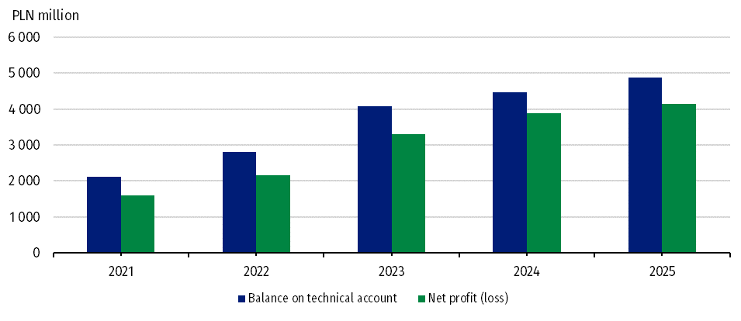

Chart 2. Non-life insurers financial results (Branch II)

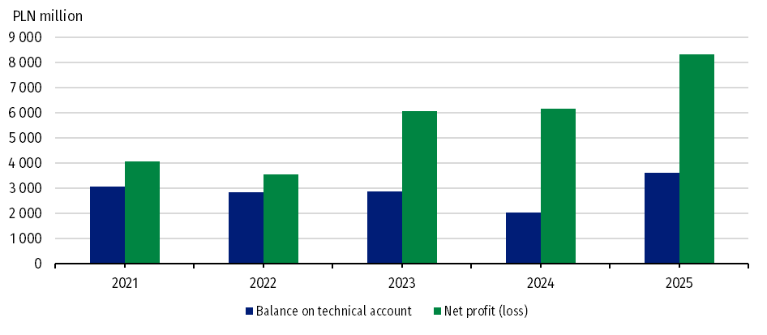

Claims incurred constituted the dominant position in the total cost structure. Total gross claims paid in 2025 amounted to PLN 53,783.7 million (PLN 50,262.5 million in 2024). In Branch I they increased to PLN 17,499.6 million (an increase of 7.0%), and in Branch II their value increased to PLN 36,284.2 million (an increase of 7.0%).
Total gross claims paid increased by 7.0% year-on-year

Fianncial results and balance on technical account
The total net financial result of insurance companies in 2025 amounted to PLN 12,473.6 million, representing a year-over-year increase of 24.3%. Life insurance companies generated a result of PLN 4,139.7 million, and non-life insurance companies’ profits amounted to PLN 8,333.9 million.
Net financial result of insurance companies in life sector increased by 6.7% year-on-year, and in non-life sector by 35.4%
The technical result (in aggregate) amounted to PLN 8,500.1 million and was 31.0% higher than in 2024. The technical result in life insurance (branch I) increased to PLN 4,883,8 million (by 9.3%), which was mostly due to the technical results generated in the insurance class 5 “Accident and sickness insurance if they are supplementary to insurance from classes 1-4” (PLN 2,233.6 million) and in class 1 “Life insurance” (PLN 1,843.3 million).
The technical result in non-life insurance (branch II) increased to PLN 3,616.3 million (by 79.0% compared to 2024). The largest contributor to its value was technical profit generated in class 3 “Casco insurance of land vehicles, except for rail vehicles” (PLN 890.3 million) and in class 8 “Insurance against damage caused by natural forces, covering property damage not included in classes 3–7, caused by: fire, explosion, storm, other natural forces, nuclear energy, landslides or subsidence” (PLN 549.7 million).

Table 1. Income, costs and balance on technical life and non-life insurance account
Specification | Life (Branch I) |  |  | Non-life (Branch II)
Specification | 2024 | 2025 |  | 2024 | 2025
Specification | million PLN |  | 2024=100 | million PLN |  | 2024=100
Total income | 28,425.4 | 33,818.6 | 119.0 | 56,184.8 | 62,721.3 | 111.6

of which:
earned premiums | 22,954.1 | 24,020.5 | 104.6 | 47,382.8 | 52,587.9 | 111.0
investment incomeª | 5,194.7 | 9,617.2 | 185.1 | 7,581.6 | 8,764.5 | 115.6
Total costs | 24,572.0 | 29,678.9 | 120.8 | 50,031.8 | 54,387.4 | 108.7
of which:
claims incurred - net of reinsurance^{b} | 16,322.0 | 17,423.6 | 106.7 | 30,366.7 | 32,658.7 | 107.5
change in other technical provisions - net of reinsurance | -179.0 | 3,862.3 | . | 15.3 | 16.0 | 104.5
net operating expenses | 6,102.2 | 6,330.0 | 103.7 | 14,956.9 | 16,152.0 | 108.0
investment charges | 853.7 | 501.0 | 58.7 | 1,190.1 | 1,291.7 | 108.5
Net financial account | 3,853.4 | 4,139.7 | 107.4 | 6,153.0 | 8,333.9 | 135.4
Balance on technical account | 4,470.4 | 4,883.8 | 109.2 | 2,020.1 | 3,616.3 | 179.0
a Including unrealised gains on investments. b Net of reinsurance including change in provisions.

Gross written premiums and gross claims paid in direct activities
In the structure of gross premiums written from total direct activities, the premiums of life insurers accounted for 28.8% and premiums of non-life insurers for 71.2% of the total value.
As in the previous year, in 2025 the dominant position in Branch I, in terms of gross premiums collected, was achieved by insurance class 1 “Life insurance”. This was followed by the insurance class 5 “Accident and sickness insurance where it is complementary to the insurance listed in classes 1 to 4”. The share of these two classes of life insurance amounted to 44.7% and 37.8% of the value of gross written premiums in Branch I, respectively.

Table 2. Gross written premiums and gross claims paid by selected types of insurance from direct activities
Specification | Gross written premiums  (from direct activities) |  |  | Gross claims paid  (from direct activities)
Specification | 2024 | 2025 |  | 2024 | 2025
Specification | million PLN |  | 2024=100 | million PLN |  | 2024=100
LIFE
Total | 23,600.2 | 24,821.9 | 105.2 | 16,359.6 | 17,499.6 | 107.0

of which:
life insurance (Class 1) | 10,393.0 | 11,093.4 | 106.7 | 6,544.2 | 7,064.9 | 108.0
life insurance linked to investment fund (Class 3) | 4,029.2 | 4,101.6 | 101.8 | 5,778.6 | 5,993.5 | 103.7
accident and sickness insurance (Class 5) | 8,929.9 | 9,382.6 | 105.1 | 3,828.8 | 4,240.6 | 110.8
NON-LIFE
Total | 57,884.4 | 61,262.1 | 105.8 | 31,954.8 | 33,936.0 | 106.2
of which:
accident and sickness insurance (Class 1 and 2) | 3,363.4 | 3,364.2 | 100.0 | 1,097.1 | 1,199.1 | 109.3
casco insurance of land vehicles (Class 3)ª | 13,837.2 | 14,468.4 | 104.6 | 8,558.3 | 9,261.4 | 108.2
insurance against fire and natural forces (Class 8) | 6,630.2 | 7,390.0 | 111.5 | 3,696.7 | 3,198.7 | 86.5
insurance against other damage and loss of property (Class 9) | 6,433.3 | 6,241.8 | 97.0 | 2,490.6 | 3,045.9 | 122.3
motor vehicle liability arising out of the possession of land vehicles (Class 10) | 17,548.7 | 18,854.0 | 107.4 | 12,004.2 | 12,828.8 | 106.9
of which compulsory third-party liability insurance of owners of motor vehicle | 16,987.0 | 18,403.4 | 108.3 | 11,729.0 | 12,596.5 | 107.4
general third-party liability insurance (Class 13) | 3,996.4 | 4,346.2 | 108.8 | 1,524.6 | 1,693.8 | 111.1
a Except rail vehicles.
In Branch II the largest item (54.4%) was the gross insurance premium collected from motor insurances. The value of these premiums increased by 6.2% compared to 2024 and amounted to PLN 33,322.4 million. Class 3 “Casco insurance for land vehicles, except rail vehicles” accounted for 23.6% of Branch II gross premiums and class 10 “Liability insurance of all kinds arising out of the ownership and use of self-propelled land vehicles. including carrier's liability insurance” for 30.8%
Gross written premiums
collected from motor insurance amounted to PLN 33.3 billion

Assets and liabilities
The total assets of insurance companies at the end of December 2025 amounted to PLN 244,138.3 million (an increase of 8.2%), of which PLN 94,709.9 million was allocated to life insurance companies and PLN 149,428.4 million to non-life insurance companies.
The total assets of insurance companies in life sector increased by 6.4% year-on-year, and in non-life sector by 9.3%

Table 3. Assets and liabilities of insurance companies (as of 31 December)
Specification | Life |  |  |  | Non-life
Specification | 2024 | 2025 |  |  | 2024 | 2025
Specification | million PLN |  |  | 2024=100 | million PLN |  |  | 2024=100
Total assets | 88,991.1 |  | 94,709.9 | 106.4 | 136,719.6 |  | 149,428.4 | 109.3

of which:
investments | 44,790.1 |  | 46,664.4 | 104.2 | 108,693.6 |  | 119,764.0 | 110.2

of which:
shares, participating interests and other variable-yield securities, units and investment certificates in investment funds | 6,198.9 |  | 7,049.7 | 113.7 | 12,845.6 |  | 14,538.1 | 113.2
debt securities and other fixed-income securities | 32,956.0 |  | 34,748.5 | 105.4 | 69,540.5 |  | 76,785.0 | 110.4
net assets for  life assuranceª | 38,945.8 |  | 42,287.7 | 108.6 | . |  | . | .
Total liabilities | 88,991.1 |  | 94,709.9 | 106.4 | 136,719.6 |  | 149,428.4 | 109.3

of which:
capital and reserves | 11,960.5 |  | 12,877.6 | 107.7 | 39,548.3 |  | 46,613.9 | 117.9
technical provisions | 72,735.3 |  | 76,981.4 | 105.8 | 101,687.0 |  | 105,868.7 | 104.1
a Where the investment risk is borne by the policyholders.

Due to data rounding, in some cases sums of components may slightly differ from the amount given in the “total” item.

This information has been compiled on the basis of preliminary data for 2025 provided to the Statistics Poland by the PFSA as they were at 11.03.2026. Comparative values for 2024 have been provided on the basis of data provided by insurance companies to the PFSA after their prior verification by auditors, as they were at 29.08.2025.

When quoting Statistics Poland data, please provide information: “Source of data: Statistics Poland”, and when publishing calculations made on data published by Statistics Poland, please include the following disclaimer: “Own study based on figures from Statistics Poland”.

Prepared by:  Enterprise Statistics Department  Director Katarzyna Walkowska-Macias  Phone: (+48 22) 608 35 66 | Issued by:  Press Office  Mobile: (+48) 695 255 032  Phone: (+48 22) 608 38 04, (+48 22) 449 41 45,  (+48 22) 608 30 09  e-mail: obslugaprasowa@stat.gov.pl

stat.gov.pl/en/

@StatPoland

@GlownyUrzadStatystyczny

gus_stat

glownyurzadstatystycznygus

glownyurzadstatystyczny
Related information
News release. Financial results of insurance companies
Polish insurance market 2018

Data available in databases
Financial Results of Insurance Companies
Quarterly bulletin. Insurance market

Terms used inn official statistics
Insurance undertaking
Gross written premium

Based on the subject matter covered, insurance is divided into two branches: branch I - life insurance and branch II – non-life insurance. An insurance company may not carry out activities in branch I and II at the same time. Within each branch, insurances are divided into groups.

