Activity of art galleries in 2025
9.1%
Increase in the number of visitors in comparison to 2024
In 2025, art galleries organised 4.2 thousand exhibitions in Poland, of which 0.3 thousand open-air exhibitons. The total number of visitors amounted to 6.4 million people, including 3.0 million visitors attending open-air exhibitions.
As of the end of 2025, there were 321 art galleries operating in Poland (an increase of 3.5% year-on-year).
More than half (60.9%) of the total visitors visited art galleries in Małopolskie and Mazowieckie Voivodships
The largest number of art galleries was located in Małopolskie Voivodship (56) and Mazowieckie Voivodship (53). Together, these two voivodships accounted for 34.0% of all art galleries and the exhibitions they organised attracted as much as 60.9% of the total number of visitors.
The smallest number of art galleries was located in Opolskie Voivodship (2 entities), and the smallest number of visitors was recorded in Lubuskie Voivodship (26.5 thousand people).
Of the total number of visitors (6.4 million), 53.0% viewed exhibitions inside art galleries, while 47.0% visited open-air exhibitions.
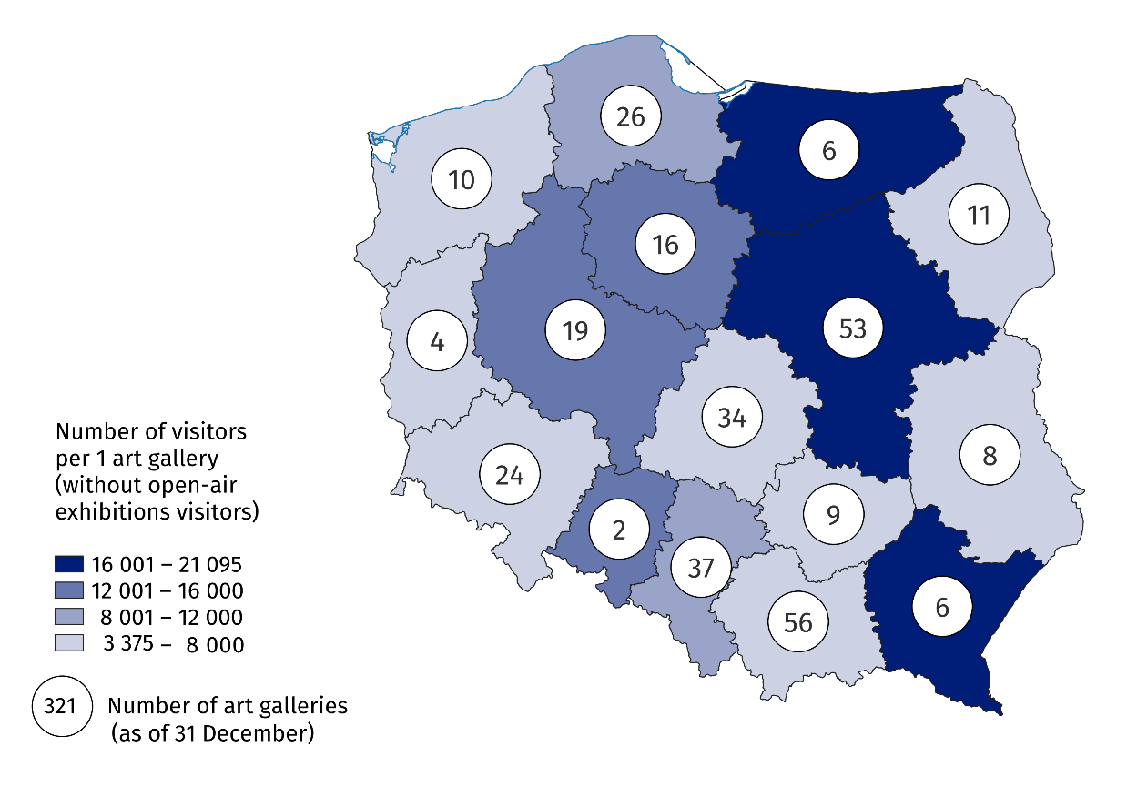
Map 1. Art galleries in 2025
¹ Without open-air exhibitions visitors.

In 2025, art galleries organised in Poland 4,172 exhibitions (an increase of 0.8%), of which 268 open-air exhibitions. There were 3,785 national exhibitions, including 230 open-air ones, while 244 international exhibitions were held, of which 28 open-air. In addition, 143 exhibitions from abroad were organised, including 10 open-air, and Polish art galleries organised 62 exhibitions abroad, 5 of which were open-air exhibitions.
Art galleries belonging to the public sector accounted for 65.7% of all galleries and attracted 92.0% of visitors.

Chart 1. Own collections of public art galleries in 2025
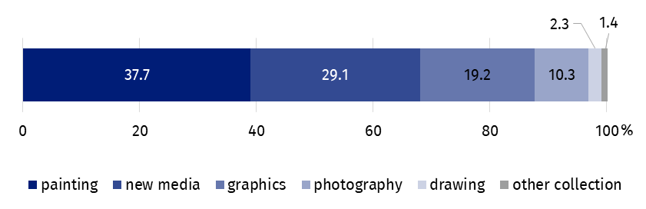
As of 31 December
State and local government art galleries had both 1.2 million items in their own collections (the same as in 2024), among which painting accounted for the largest share (37.7%), while objects in categories of new media, graphics and photography together accounted for more than half of the own collections of public art galleries (58.6%).
Among all the collections held by state and local government art galleries, painting made up the largest portion (37.7%)
Data presented in this study were compiled using the exhibition activity report (symbol K-05). Information on the survey methodology can be found in the Methodological report – Culture Statistics.
In the case of quoting data from the Statistics Poland, please provide information: "Statistics Poland data source", and in the case of publishing calculations made on data published by the Statistics Poland, please provide information: "Own study based on Statistics Poland data".

Prepared by:  Statistical Office in Kraków  Director Agnieszka Szlubowska  Phone: (+48 12) 420 40 50 | Issued by:  Press Office  Mobile: (+48) 695 255 032  Phone: (+48 22) 608 38 04, (+48 22) 449 41 45,  (+48 22) 608 30 09  e-mail: obslugaprasowa@stat.gov.pl

stat.gov.pl/en/

@StatPoland

@GlownyUrzadStatystyczny

gus_stat

glownyurzadstatystycznygus

glownyurzadstatystyczny
Related information
Culture and national heritage in 2024
Activity of art galleries in 2024
Methodological report. Culture statistics
Topic available in databases
Knowledge Databases – Society – Culture – Exhibition activity
Local Data Bank – Culture – Performances and exhibitions
Terms used in the official statistics
Art gallery
Exhibition
Open-air exhibition in the galleries
Visitor

Due to the place of presentation of exhibitions and the country of origin of their authors, we distinguish between national exhibitions (presentation of Polish art), exhibitions from abroad (presentation of foreign art), international exhibitions (presentation of foreign and Polish art) and Polish exhibitions abroad.

