Prices of agricultural products in May 2025
Procurement prices of basic agricultural products increased in May 2025 in comparison with the previous month (by 2.1%) as well as while compared to the corresponding period of the last year (by 15.0%).
15.0%
an increase in procurement prices of basic agricultural products in comparison with May 2024

Chart 1. Changes in procurement prices of basic agricultural products in relation to the previous month
In May 2025, in comparison with April 2025, only the procurement prices of animals for slaughter increased
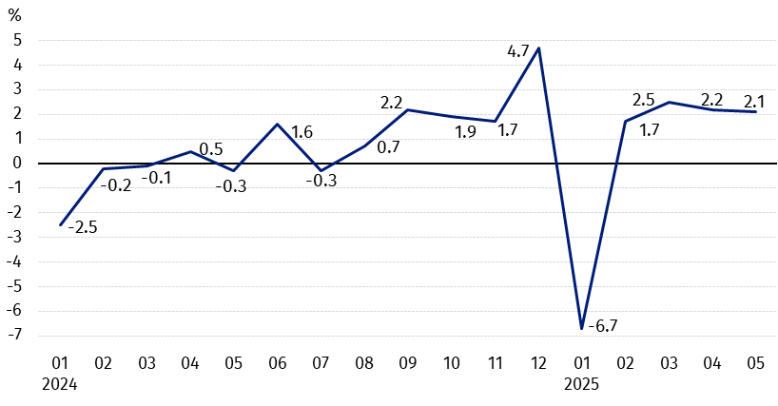

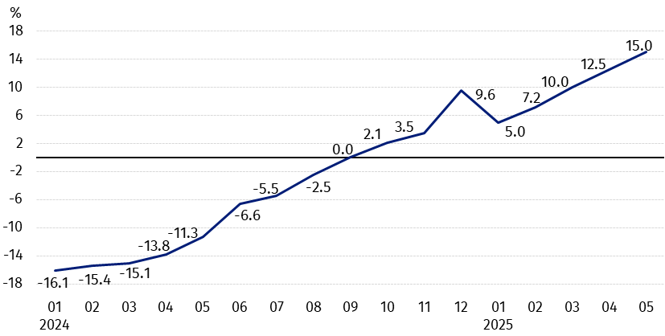
Chart 2. Changes in procurement prices of basic agricultural products in relation to the corresponding month of the previous year
Procurement prices of basic agricultural products, except pigs for slaughter prices, in May 2025 were higher than those recorded in May 2024

Procurement prices and marketplace prices received by farmers
In May 2025 barley, triticale and animals for slaughter purchased at higher prices than in the previous month, while prices of wheat, rye and cows’ milk decreased. On marketplaces barley and triticale were sold cheaper than in April this year. On both markets prices of maize increased, while prices of oats and potatoes decreased.
Compared to the corresponding month of the previous year, both in procurement and on marketplaces the growth in prices of most agricultural products was recorded, except oats and pigs for slaughter in procurement as well as potatoes on both markets.

Table 1. Prices of agricultural products (excluding VAT) in May 2025
Specification | Procurement prices |  |  | Marketplaces prices
Specification | 05 2025
Specification | in zloty | 04 2025=100 | 05 2024=100 | in zloty | 04 2025=100 | 05 2024=100
Cereal grain – per dt
Wheat | 89.76 | 98.9 | 111.9 | 114.68 | 100.0 | 109.0
Rye | 73.29 | 99.8 | 129.9 | 89.50 | 102.5 | 112.4
Barley | 83.49 | 101.5 | 118.3 | 109.62 | 99.6 | 107.8
Triticale | 83.54 | 100.5 | 124.4 | 98.72 | 99.8 | 110.8
Oat | 72.00 | 98.0 | 86.7 | 101.03 | 97.7 | 101.2
Maize | 88.96 | 101.7 | 118.9 | 124.57 | 100.6 | 105.0
Potatoes – per dt | 129.11 | 88.5 | 85.9 | 209.90 | 98.8 | 85.7
Animals for slaughter – per kg
Cattle (excl. calves) | 15.09 | 111.9 | 142.9 | 12.36 | 100.6 | 104.5
of which young cattle | 15.40 | 112.0 | 141.1 | . | . | .
Pigs | 7.18 | 102.2 | 93.4 | . | . | .
Poultry | 6.45 | 103.9 | 124.9 | . | . | .
Cows’ milk – per hl | 225.65 | 99.4 | 114.6 | . | . | .

Data on procurement prices were calculated on the basis of information on value and quantity of procurement by legal persons and independent organizational entities without legal personality (without natural persons).
Indices of procurement prices and prices received by farmers on marketplaces were calculated on the basis of absolute data expressed with more precision than In the tables.

Prices of major agricultural products in May 2025
In May 2025, PLN 89.76 was paid per dt of wheat in procurement, i.e. by 1.1% less than in the previous month, but by 11.9% more than a year ago. On the marketplaces, the price of wheat (PLN 114.68 per dt) has not changes in comparison with April this year, but it increased compared to May last year (by 9.0%).
The procurement price of rye (PLN 73.29 per dt) decreased by 0.2% in comparison with April this year, while compared to May 2024 was higher by 29.9%. The transaction price of rye on marketplace (PLN 89.50 per dt) increased on a monthly basis (by 2.5%), as well as on an annual basis (by 12,4%).
In May 2025, PLN 129.11 was paid per dt of potatoes in procurement, i.e. by 11.5% less than in the previous month and by 14.1% – than in the corresponding period of the last year. On the marketplaces, the price of potatoes (PLN 209.90 per dt) decreased by 1.2% in comparison with April this year and by 14.3% compared to May 2024.
The procurement price of cattle for slaughter (PLN 15.09 per kg) was higher on a monthly basis (by 11.9%), as well as on an annual basis (by 42.9%). On the marketplaces, cattle for slaughter (PLN 12.36 per kg) were sold more expensive compared to April this year (by 0.6%), as well as to May last year (by 4.5%).
In May 2025, PLN 7.18 was paid per kg of pigs for slaughter in procurement, i.e. by 2.2% more than a month ago, but by 6.6% less than a year ago.
The procurement price of poultry for slaughter (PLN 6.45 per kg) increased by 3.9% in comparison with April this year and by 24.9% compared to May 2024.
PLN 225.65 was paid in procurement per hl of cows’ milk, i.e. by 0.6% less than in the previous month, but by 14.6% more than a year ago.

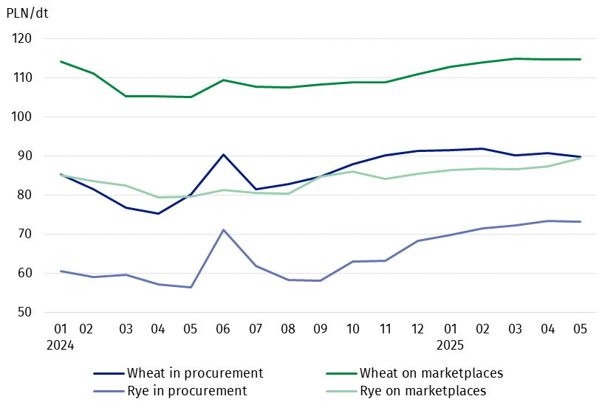
Chart 3. Procurement and marketplaces prices of wheat and rye

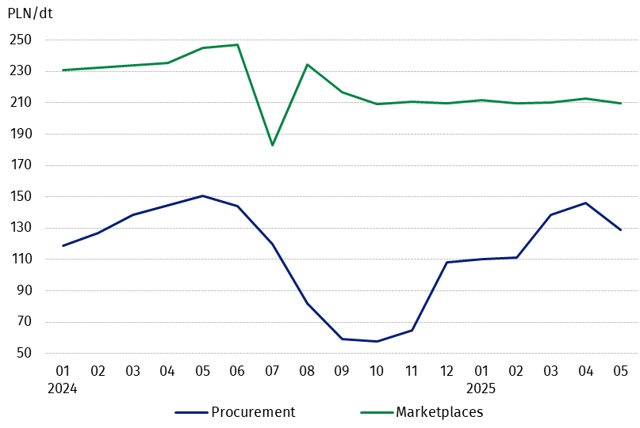
Chart 4. Procurement and marketplaces prices of potatoes

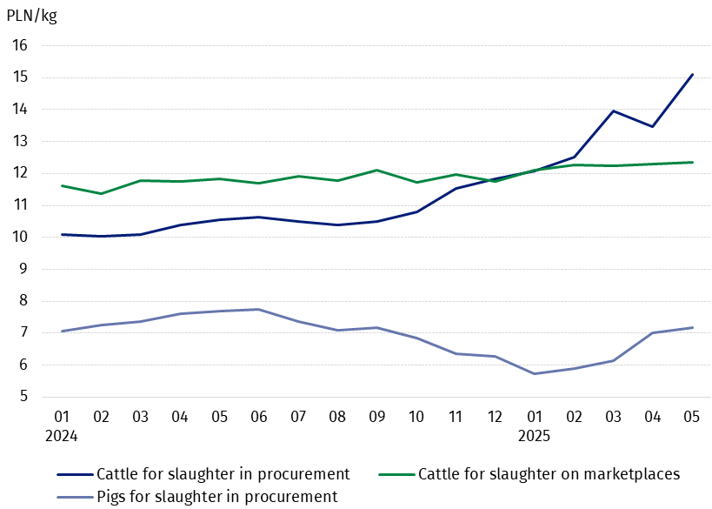
Chart 5. Procurement and marketplaces prices of cattle for slaughter and procurement prices of pigs for slaughter

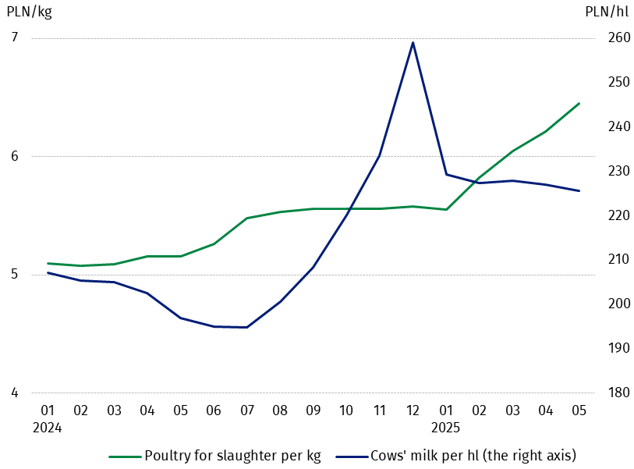
Chart 6. Procurement prices of poultry for slaughter and cows’ milk

The differentiation of the level of prices of basic agricultural products in particular voivodships is presented in Table 2 for procurement prices and in Table 3 for prices obtained by farmers on marketplaces (Excel sheet).
In case of quoting Statistics Poland data, please provide information: “Source of data: Statistics Poland”, and in case of publishing calculations made on data published by Statistics Poland, please include the following disclaimer: “Own study based on figures from Statistics Poland”.

Prepared by:  Trade and Services Departament  Director Ewa Adach-Stankiewicz  Phone: (+48 22) 608 31 24 | Issued by:  Press Office  Mobile: (+48) 695 255 032  Phone: (+48 22) 608 38 04, (+48 22) 449 41 45.  (+48 22) 608 30 09  e-mail: obslugaprasowa@stat.gov.pl

stat.gov.pl/en/

@StatPoland

@GlownyUrzadStatystyczny

gus_stat

glownyurzadstatystycznygus

glownyurzadstatystyczny
Related information
Socio-economic situation of the country in 2025
Procurement and prices of agricultural products in 2024

Data available in databases
BDL – Prices - Prices in agriculture
DBW – Database - Prices – Producer prices - Prices in agriculture

Terms used in official statistics
Procurement of agricultural products
Procurement prices
Marketplace
Marketplace prices

Wheat, rye, cattle for slaughter, pigs for slaughter, poultry, cows’ milk
Procurement prices – excluding sowing seed.
Procurement prices – total (of which: edible early kinds, seed, edible late, industrial, of which starch). Marketplaces prices – edible excluding early kinds.
Marketplaces prices – average weighted price of cattle for slaughter calculated with the adoption of the structure of procurement quantity of young cattle and cows for slaughter.

