Activity of theatres and music institutions in 2025
6.7%
Increase in the number of audience in theatres and music institutions in comparison to 2024
In 2025, the number of theatres and music institutions remained the same as in the previous year, but they organised 63.1 thousand performances and concerts (i.e. 4.3% more than in 2024), attended by 13.0 million audience (an increase of 6.7%).
In 2025, 206 theatres and music institutions conducted stage activities, of which 179 had their own artistic ensemble. The largest number of theatres and music institutions operated in Mazowieckie Voivodship (42), and the fewest in the following voivodships: Lubuskie, Opolskie, Podkarpackie and Świętokrzyskie (4 each).
The public sector comprised 174 theatres and music institutions (84.5%). For 162 of them (93.1%) the organiser was a local government entity.

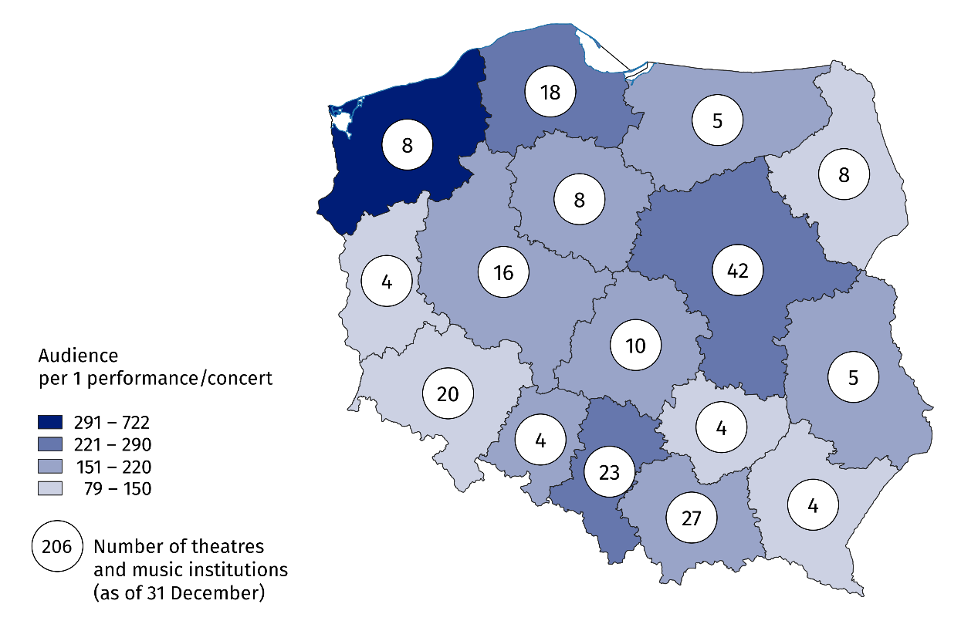
Map 1. Theatres and music institutions by locality in 2025
The highest number of audience per one performance/concert was recorded in Zachodniopomorskie Voivodship (722), and the fewest in Lubuskie Voivodship (79)

Performances and concerts organised by theatres and music institutions were attended by 13.0 million audience (6.7% more than in 2024). The largest number of audience visited theatres and music institutions from Mazowieckie Voivodship – 4.0 million people, while the lowest number from Lubelskie Voivodship (142.7 thousand).
Nearly one third of audience (31.1%) attended performances and concerts in Mazowieckie Voivodship

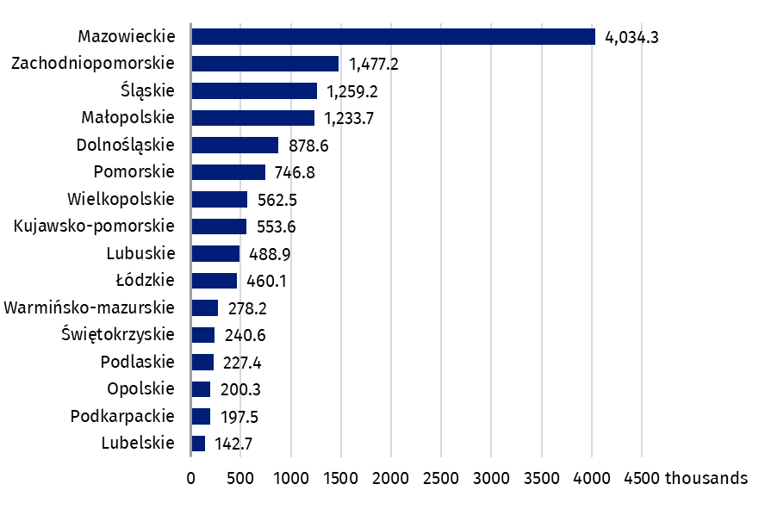
Chart 1. Audience in theatres and music institutions by locality in 2025
In 2025, theatres and music institutions organised 63.1 thousand performances and concerts, including 766 premieres. Compared to 2024, the number of performances and concerts increased by 4.3%, while the number of premieres decreased by 8.9%. The largest number of premieres were staged by drama theatres (438).
Theatres and music institutions organised 20.7 thousand performances and concerts for children and youth
One-third of all performances and concerts were addressed to children and youth. More than half (54.4%) of them were school music programs.
As of the end of the year, theatres and music institutions had a total of 379 stages and 102.1 thousand seats in permanent halls.
Data presented in this study were compiled using the artistic and entertainment activities report marked with symbol K-01. Information on the survey methodology can be found in the Methodological report. Culture Statistics.
In the case of quoting data from the Statistics Poland, please provide information: "Statistics Poland data source", and in the case of publishing calculations made on data published by the Statistics Poland, please provide information: "Own study based on Statistics Poland data".

Prepared by:  Statistical Office in Kraków  Director Agnieszka Szlubowska  Phone: (+48 12) 420 40 50 | Issued by:  Press Office  Mobile: (+48) 695 255 032  Phone: (+48 22) 608 38 04, (+48 22) 449 41 45,  (+48 22) 608 30 09  e-mail: obslugaprasowa@stat.gov.pl

stat.gov.pl/en/

@StatPoland

@GlownyUrzadStatystyczny

gus_stat

glownyurzadstatystycznygus

glownyurzadstatystyczny
Related information
Culture and national heritage in 2024
Activity of theatres and music institutions in 2024
Methodological report. Culture statistics
Topic available in databases
Knowledge Databases – Society – Culture – Exhibition activity
Local Data Bank – Culture – Performances and exhibitions
Terms used in the official statistics
Artistic activities and entertainment
Music institution
Concert
Premiere
Performance
Scene
Theatre
Audience
Own artistic team

