Mass events in 2025
In 2025, 7.0 thousand mass events were organised in Poland, which gathered 30.7 million participants. Compared to 2024, the number of events increased by 1.9% and the number of participants by 8.7%.
8.7%
Increase in the number of participants of mass events in comparison to 2024
In 2025, city and municipal offices issued permits for the organisation of 7.0 thousand mass events (1.9% more than in 2024). The largest number of mass events took place in Śląskie Voivodeship (914), and the fewest in Lubuskie Voivodeship (133). On average, 4.4 thousand people participated in a single mass event during the year. The highest average number of participants during the year was recorded in Mazowieckie Voivodeship (5.8 thousand), and the lowest in Warmińsko-Mazurskie Voivodeship (2.1 thousand).
A quarter of mass events (25.4%) took place in Śląskie and Mazowieckie Voivodeships

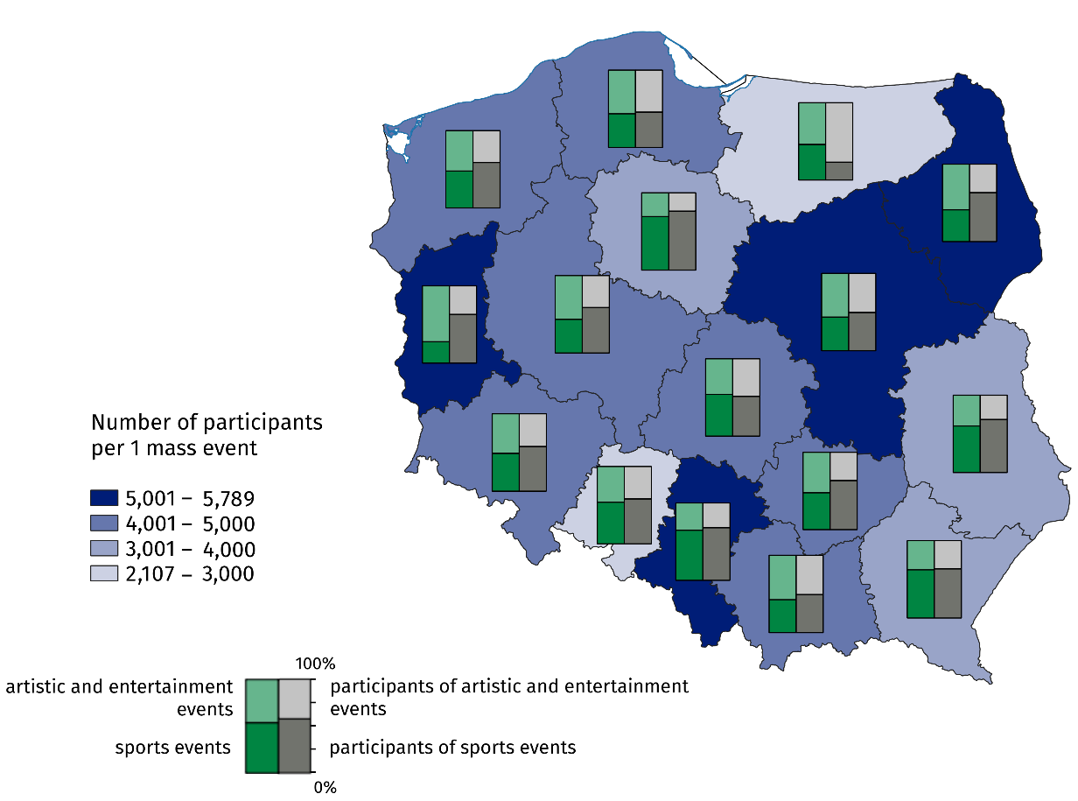
Map 1. Mass events in 2025
The majority of mass events were sports events (51.5%), most of which were organised in Śląskie Voivodeship (592), while the fewest were held in Lubuskie Voivodeship (37). In 2025, 3.4 thousand artistic and entertainment events were organised (8.3% more than in 2024). The largest number of artistic and entertainment events took place in Mazowieckie Voivodeship (489), and the fewest in Opolskie Voivodeship (79). Concerts accounted for the majority (66.8%) of all artistic and entertainment events.
Compared to 2024, the number of participants in mass events increased by 2.5 million people (by 8.7%), the number of participants in artistic and entertainment events increased by 0.9 million people (by 7.8%), and the number of participants in mass sports events increased by 1.5 million (by 9.4%). The majority of participants in mass events attended paid events (85.0%). For sports events, this share was 98.3%, while for artistic and entertainment events – 66.9%.
Compared to 2024, the number of participants in arts and entertainment events increased by 7.8%
Most mass events (4.2 thousand) were organised in indoor facilities (4.5% fewer than in 2024). A total of 2.8 thousand events were held outdoors (13.3% more than in 2024).
Data presented in this study were compiled using the organisation of mass events report (symbol K-09). Information on the survey methodology can be found in the Methodological report. Culture Statistics.
In the case of quoting data from the Statistics Poland, please provide information: "Statistics Poland data source", and in the case of publishing calculations made on data published by the Statistics Poland, please provide information: "Own study based on Statistics Poland data".

Prepared by:  Statistical Office in Kraków  Director Agnieszka Szlubowska  Phone: (+48 12) 420 40 50 | Issued by:  Press Office  Mobile: (+48) 695 255 032  Phone: (+48 22) 608 38 04, (+48 22) 449 41 45,  (+48 22) 608 30 09  e-mail: obslugaprasowa@stat.gov.pl

stat.gov.pl/en/

@StatPoland

@GlownyUrzadStatystyczny

gus_stat

glownyurzadstatystycznygus

glownyurzadstatystyczny
Related information
Culture and national heritage in 2024
Mass events in 2024
Methodological report. Culture statistics
Data available in databases
Knowledge databases – Society – Culture
Local Data Bank – Culture – Organization of mass events
Terms used in official statistics
Mass event
Event participant

An artistic, entertainment or sporting event aimed at the general public, organised in accordance with the regulations on the safety of mass events. The rules governing the organisation of mass events are set out in the Act of 20 March 2009 on the safety of mass events (Journal of Laws of 2023, item 616).

