Employment relationships established and terminated in Quarter 1 2025
In Quarter 1 2025, the number of employment relationships established was 10.8 thousand lower than the number of employment relationships terminated. The highest number of employment relationships established was recorded for the minor occupational group of Shop salespersons – these accounted for 6.0% of total employment relationships established. The most common mode of termination of an employment relationship was by mutual agreement of the parties (52.6% of total employment relationships terminated).
612.4 thousand
employment relationships established
623.2 thousand
employment relationships terminated
The publication focuses on the establishment and termination of employment relationships recorded in the administrative registers kept by the Social Insurance Institution (ZUS). These are events consisting in the commencement or termination of a formal relationship between an employer and an employee. Information on the number of employment relationships established and employment relationships terminated in a quarter covers all events that occurred during that period, regardless of the employee’s share of a full-timer’s normal hours or whether it was the employee’s main job. The analysis does not cover events concerning persons insured with the Agricultural Social Insurance Fund (KRUS).
Employment relationships established
In Quarter 1 2025, 612.4 thousand employment relationships established were recorded, of which 45.1% were entered into by women. The highest number of employment relationships established was recorded in the Warszawski stołeczny region (19.6% of the total), while the lowest in the Świętokrzyskie region (1.9% of the total). Of total employment relationships established, 11.2% were entered into by foreigners.
The highest numbers of employment relationships established and terminated were recorded in entities classified into the Manufacturing section
In the breakdown by PKD 2007/NACE Rev. 2 activity, the highest number of employment relationships established was recorded among entities from the Manufacturing section – 18.5% of all cases. A similar number of employment relationships established was recorded in the Trade; repair of motor vehicles∆ section, which accounted for 17.3% of total employment relationships established.
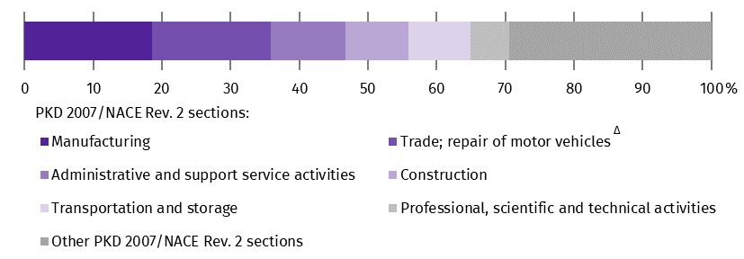
Chart 1. Structure of employment relationships established by PKD 2007/NACE Rev. 2 section in Quarter 1 2025
In terms of the number of employment relationships established, the Manufacturing section dominated in 14 NUTS 2 regions of Poland, while the Trade; repair of motor vehicles∆ section led in the Lubelskie and Wielkopolskie regions. In contrast, in the Warszawski stołeczny region, the largest share of employment relationships established was in the Administrative and support service activities sections – 21.5 thousand.
In Quarter 1 2025, among the major occupational groups, the highest number of employment relationships established was recorded in the group of Professionals (105.9 thousand, i.e. 17.3% of the total). At the level of minor occupational groups, in the analysed quarter of 2025, the most employment relationships were established with Shop salespersons. A total of 36.8 thousand employment relationships were established with them, i.e. 6.0% of the total number. The next minor occupational group with the highest number of employment relationships established was Heavy truck and bus drivers – 32.4 thousand, i.e. 5.3% of total employment relationships established.
Among the major occupational groups, the highest number of employment relationships established was recorded in the group of Professionals
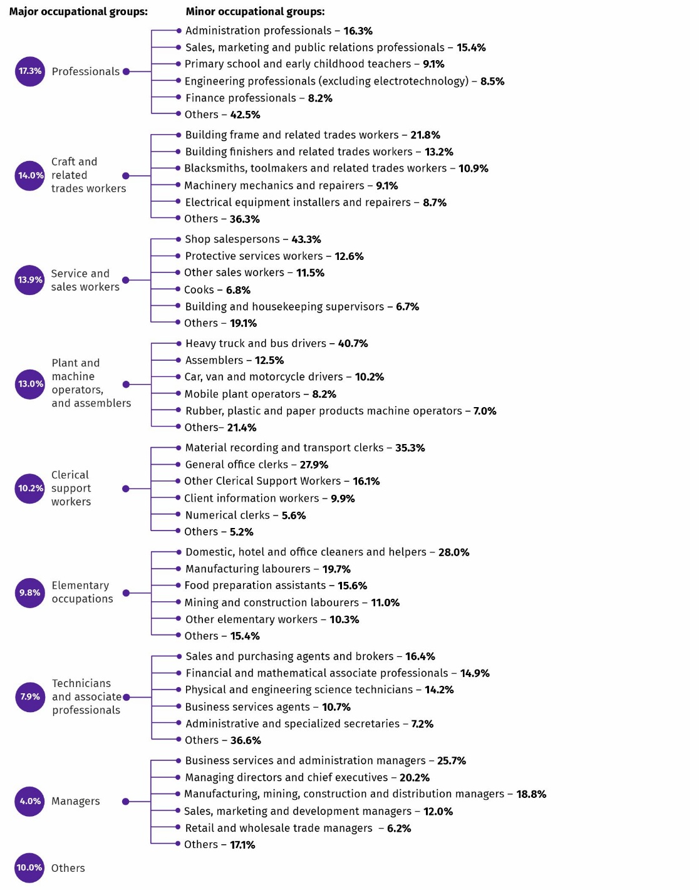
Diagram 1. Structure of employment relationships established by selected major and minor occupational groups (according to KZiS/ISCO-08) in Quarter 1 2025
Employment relationships terminated
In Quarter 1 2025, 44.6% of total 623.2 thousand employment relationships terminated concerned women. The highest number of employment relationships terminated was recorded in the Warszawski stołeczny region (20.7% of the total), while the lowest in the Świętokrzyskie region (2.0% of the total). Of total employment relationships terminated, 9.7% concerned foreigners.
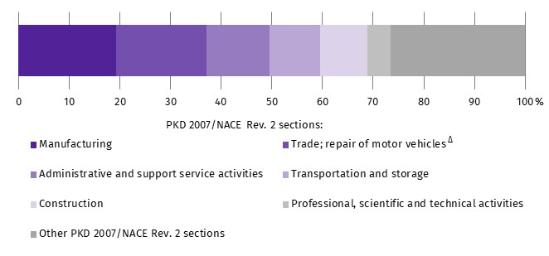
Chart 2. Structure of employment relationships terminated by PKD 2007/NACE Rev. 2 section in Quarter 1 2025
In the breakdown by PKD 2007/NACE Rev. 2 activity, in Quarter 1 2025, the largest share of the total number of employment relationships terminated was accounted for by the Manufacturing and Trade; repair of motor vehicles∆ sections. Entities classified into these sections accounted for a total of 37.1% of total employment relationships terminated.
In the Wielkopolskie and Lubelskie regions, the highest number of employment relationships terminated was recorded in the Trade; repair of motor vehicles∆ section (31.6% and 19.7% respectively), while in the Warszawski stołeczny region, the highest number was recorded in the Administrative and support service activities section (23.8%). In the rest of the country, the highest number of employment relationships terminated was observed in the Manufacturing section.
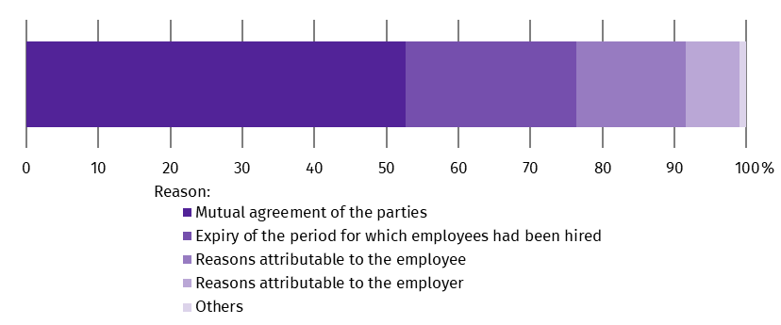
Chart 3. Structure of employment relationships terminated by reason for termination in Quarter 1 2025

During the analysed period, the most common mode of termination of an employment relationship was by mutual agreement of the parties (327.6 thousand). In almost all sections of the PKD 2007/NACE Rev. 2 classification, this was the most common mode of termination of an employment relationship. The exception is the Administrative and support service activities section, where the most common mode was the expiry of the period for which the employee had been hired.
In the Administrative and support service activities section, the most common reason for the termination of an employment relationship was the expiry of the period for which the employee had been hired – 37.7 thousand

Number of employment relationships established per 100 employment relationships terminated
In Quarter 1 2025, there were 98 employment relationships established per 100 employment relationships terminated. In the breakdown by kind of activity, the number of employment relationships established exceeded the number of employment relationships terminated in 10 out of 19 sections of the PKD 2007/NACE Rev. 2 classification. The largest advantage of employment relationships established over employment relationships terminated was recorded in the Education section, i.e. 133 employment relationships established per 100 employment relationships terminated. In the Public administration and defence; compulsory social security section, for every 100 employment relationships established, 100 employment relationships were terminated. In the remaining 8 of the 19 PKD 2007/NACE Rev. 2 sections, the number of employment relationships established was lower than the number of employment relationships terminated. The largest difference was recorded in the Mining and quarrying section, where there were 49 employment relationships established per 100 employment relationships terminated.

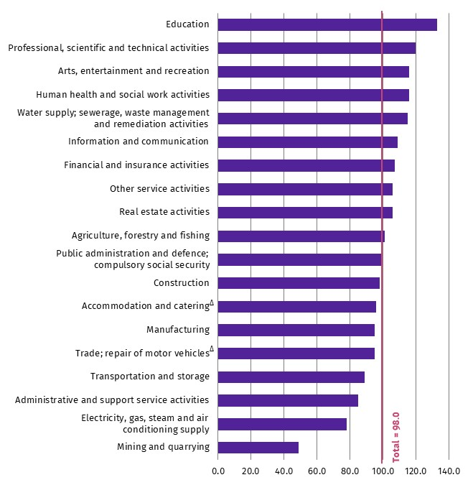
Chart 4. Number of employment relationships established per 100 employment relationships terminated by PKD 2007/NACE Rev. 2 section in Quarter 1 2025

Methodological notes
The information on employment relationships established and terminated has been prepared on the basis of administrative data from the registers kept by the Social Insurance Institution (ZUS). These data have been compiled as part of experimental work aimed at developing and refining new methods of statistical analysis. This means that the methodology is currently being tested and may be subject to further modifications.
Data in territorial breakdowns are presented according to the entity’s seat.
The information on the number of employment relationships established and terminated in a quarter covers all cases that occurred during that period, regardless of the employee’s share of a full-timer’s normal hours or whether it was the employee’s main job.
Establishment of an employment relationship
The commencement of a formal employment relationship between an employee, including a juvenile worker, and an employer. The number of employment relationships established in a quarter is determined on the basis of the date on which the obligation to provide social insurance cover arises and the relevant insurance title for such cover with the Social Insurance Institution (ZUS).
Termination of an employment relationship
The cessation of a formal employment relationship between an employee and an employer. The number of employment relationships terminated in a quarter is determined on the basis of the date of termination of an employment relationship and the relevant insurance title with the Social Insurance Institution (ZUS).

In this publication letter symbols and abbreviated names of PKD 2007/NACE Rev. 2 sections were used marking abbreviations with a ‘Δ’ symbol. The full names can be found in the list of PKD 2007/NACE Rev. 2 sections below.
Symbols of PKD 2007/NACE Rev. 2 sections:
A – Agriculture, forestry and fishing;
B – Mining and quarrying;
C – Manufacturing;
D – Electricity, gas, steam and air conditioning supply;
E – Water supply; sewerage, waste management and remediation activities;
F – Construction;
G – Wholesale and retail trade; repair of motor vehicles and motorcycles;
H – Transportation and storage;
I – Accommodation and food service activities;
J – Information and communication;
K – Financial and insurance activities;
L – Real estate activities;
M – Professional, scientific and technical activities;
N – Administrative and support service activities;
O – Public administration and defence; compulsory social security;
P – Education;
Q – Human health and social work activities;
R – Arts, entertainment and recreation;
S – Other service activities.

Data for the Other service activities (S) section also include the following sections: Activities of households as employers; undifferentiated goods- and services-producing activities of households for own use (T) and Activities of extraterritorial organisations and bodies (U).

When quoting Statistics Poland data, please provide the information: ‘Source of data: Statistics Poland’, and when publishing calculations made on data published by Statistics Poland, please include the following disclaimer: ‘Own study based on figures from Statistics Poland’.

Prepared by:  Statistical Office in Bydgoszcz  Acting Director Katarzyna Klamrowska  Phone: (+48 52) 366 93 90 | Issued by:  Press Office  Mobile phone: +48 695 255 032  Landline phones: +48 22 608 38 04, +48 22 449 41 45, +48 22 608 30 09  e-mail: obslugaprasowa@stat.gov.pl

stat.gov.pl/en/

@StatPoland

@GlownyUrzadStatystyczny

gus_stat

glownyurzadstatystycznygus

glownyurzadstatystyczny

https://stat.gov.pl/en/regional-statistics/classification-of-territorial-units/classification-of-territorial-units-for-statistics-nuts/the-nuts-classification-in-poland/ - data in territorial breakdowns are presented according to the entity’s seat.
REGULATION OF THE MINISTER OF FAMILY, LABOUR AND SOCIAL POLICY of 21 October 2025 on the classification of occupations and specialisations for the needs of the labour market

