Activity of museums in 2025
4.2%
Increase in the number of museum visitors in comparison to 2024

In 2025, 994 museums were operating, visited by 46.2 million people. Museums presented 3.0 thousand permanent exhibitions and organised 4.6 thousand temporary exhibitions in Poland.
The largest number of museums were located in Mazowieckie and Małopolskie Voivodships (146 and 107 respectively). In these two voivodships, visitors accounted for 59.2% of the total number of museum visitors. The lowest number of museums and visitors was recorded in Lubuskie Voivodship (17 museums and 287.2 thousand visitors).
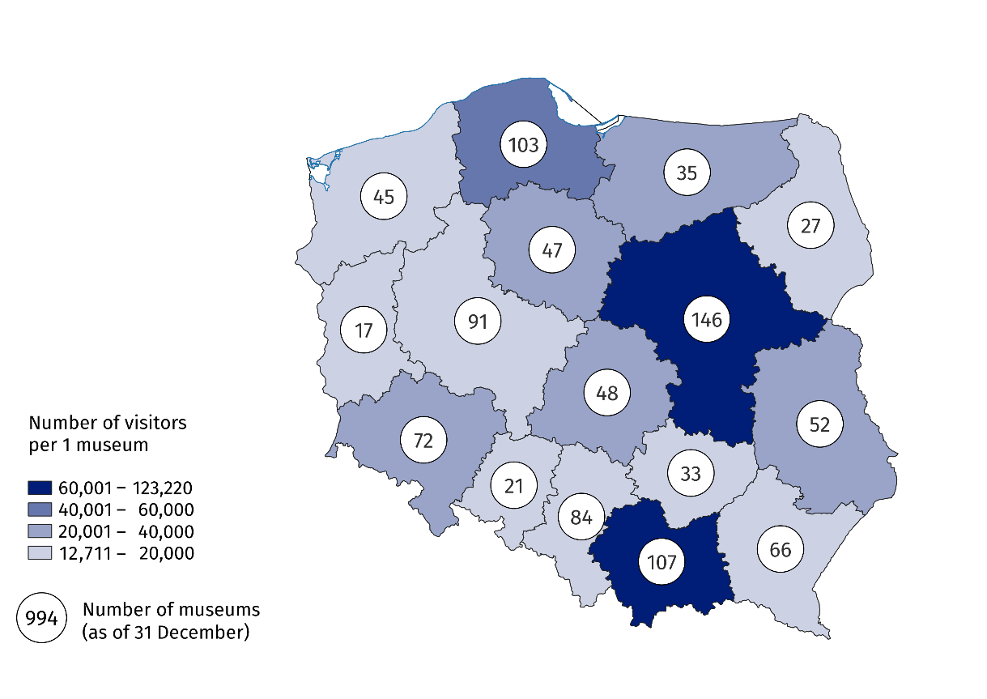
Map 1. Museums and museum visitors in 20255
More than a quarter of the total number of museums were located in Mazowieckie and Małopolskie Voivodships
71.3% of museums belonged to the public sector, the vast majority of which were organised by local government units (83.2%). In the private sector, however, museum were most often organised by natural persons (55.1% of private museums).
In 2025, museums were visited by 46.2 million people (4.2% more than in 2024), including 14.1 million free of charge. Of the total number of visitors, there were 7.4 million visitors with reduced-price tickets. Organised groups of school youth accounted for 8.2% of all visitors.
Art museums were the most popular among all visitors, attracting 17.7 million people (38.4% of the total number of visitors).
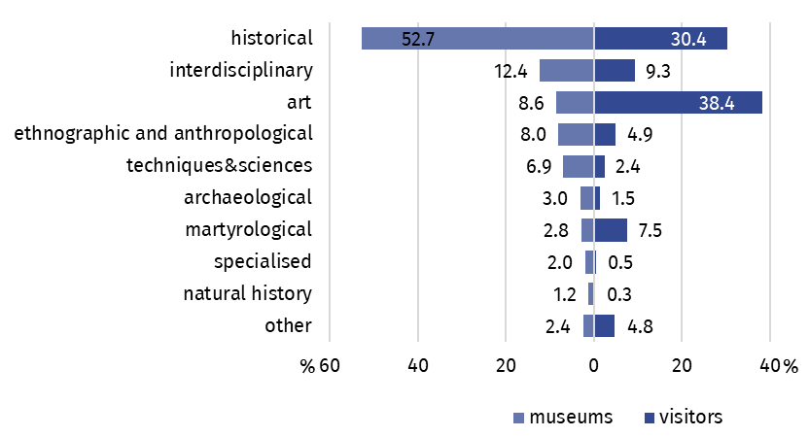
Chart 1. Museums and museum visitors by type in 2025
In 2025, "Night of Museums" was less popular than in previous years. 625.8 thousand visitors took part in it, i.e. 21.3% less than in 2024. During this event, the historical museums attracted the most visitors – 241.1 thousand people (20.9% less than in 2024).
As of the end of 2025, the total number of museum collections amounted to 22.0 million pieces (1.4% more than in 2024). Interdisciplinary museums have the largest number of collections (over a third of the total number of collections).
Museums presented 3.0 thousand permanent exhibitions (5.5% more than in 2024), of which 220 newly created. As in the previous year, there were 4.6 thousand temporary exhibitions, with historical museums organising the largest number of them (2.4 thousand).
In addition to exhibition activities, museums also organised 158.7 thousand cultural and educational events (4.2% more than in 2024), attended by 7.9 million people (3.3% more than in 2024). The largest number of them were museum lessons and workshops (111.7 thousand), attended by 2.3 million people.
The number of cultural and educational events increased by 4.2% compared to 2024
Museums organised also 13.0 thousand curatorial tours – 289.6 thousand people took advantage of this form of visiting.
Data presented in this study were compiled using the activities of the museums and institutions related to museum report (symbol K-02). Information on the survey methodology can be found in the Methodological report. Culture Statistics.
In the case of quoting data from the Statistics Poland, please provide information: "Statistics Poland data source", and in the case of publishing calculations made on data published by the Statistics Poland, please provide information: "Own study based on Statistics Poland data".

Prepared by:  Statistical Office in Kraków  Director Agnieszka Szlubowska  Phone: (+48 12) 420 40 50 | Issued by:  Press Office  Mobile: (+48) 695 255 032  Phone: (+48 22) 608 38 04, (+48 22) 449 41 45,  (+48 22) 608 30 09  e-mail: obslugaprasowa@stat.gov.pl

stat.gov.pl/en/

@StatPoland

@GlownyUrzadStatystyczny

@gus_stat

@GłównyUrządStatystycznyGUS

@Glówny Urząd Statystyczny
Related information
Culture and national heritage in 2024
Activity of museums in 2024
Methodological report. Culture statistics
Topic available in databases
Knowledge Databases – Society – Culture
Local Data Bank – Culture – Museums
Terms used in the official statistics
Museum
Museum branch
Unit’s organiser
Museum lesson
Exhibits
Temporary exhibitions
Permanent exhibitions
Visitor

Including museum branches.

