Construction and assembly production in March 2026
According to preliminary data construction and assembly production (in constant prices) carried out domestically was in March 2026 higher by 0.4% an annual. Compared to February 2026 an increse was noted by 37.0%.
0.4%
Increase of construction and assembly production
compared to March 2025

After seasonally adjusted, the decrease was noted in construction and assembly production of 2.1% an annual

In March 2026, after eliminating the seasonal factors, construction and assembly production reached the level by 2.1% lower than in the corresponding month of the previous year and higher by 6.2% in comparison to February 2026.
Chart 1. Construction and assembly production (constant prices; average monthly base 2021=100) ª
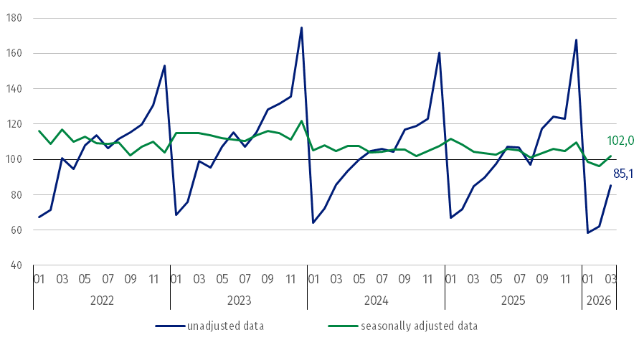
ª Preliminary data for March 2026.
Compared to the average monthly value of 2021 construction and assembly production in March 2026 (in constant prices), was lower than 14.9%.
Construction and assembly production in March 2026 increased for entities dealing mainly with construction of buildings of 1.4% and performing specialised construction activities of 0.2% whereas a decrease was noted in entities whose basic type of activity was civil engineering of 0.2% an annual.
In March 2026 compared to February 2026, an increase in the sales of construction and assembly production was noted in all divisions. In entities performing specialised construction activities of 43.9%, dealing mainly with civil engineering works of 38.4% and whose basic type of activity was construction of buildings of 29.7%.
Table 1. Construction and assembly production (constant prices) ª
Specification | 2026
Specification | 02 | 03 | 02 | 03 | 01-03
Specification | previous month = 100 |  | corresponding period of the previous year = 100
CONSTRUCTION | 106.4 | 137.0 | 86.3 | 100.4 | 93.0
Construction of buildings ^{Δ} | 110.0* | 129.7 | 83.2* | 101.4 | 94.2
Civil engineering works ^{Δ} | 105.1 | 138.4 | 88.4* | 99.8 | 92.4
Specialised construction activities | 103.8* | 143.9 | 87.8 | 100.2 | 92.3
ª Data including final information on production and prices in February and preliminary data in March 2026.
* The data has been changed compared to what was previously published.
^{Δ} Abbreviated form according to PKD 2007.
In the period January-March 2026 construction and assembly production decreased of 7.0%. Production was lower for restoration works and higher for investment works

In the period January-March 2026, in relation to the same period of the previous year, a decrease in the sales of construction and assembly production was noted of 7.7 in entities performing specialised construction activities, in entities dealing mainly with civil engineering works of 7.6% and whose basic type of activity was construction of buildings of 5.8%.
Analyzing the value of construction and assembly production in March 2026 in terms of construction works (investment and restoration works) were observed:
- an annual increase for investment works by 11.8% and a decrease for restoration works by 24.8% (in March 2025, an increase for investment of 3.6% and a decrease for restoration of 10.0%),
In March 2026, investment works increased significantly by 11.8% an annual and by 45.7% compared to February 2026
- compared to February 2026, an increase for investment works by 45.7% and by 14.4% for restoration works.
In the period January-March 2026, in relation to the same period of the previous year, a decrease in the sales of construction and assembly production were noted for restoration works by 29.9% and an increase for investment works by 3.6% (in 2025, a decrease for restoration works of 7.9% and an increase for investment works of 4.5%).

In case of quoting Statistics Poland data, please provide information: “Source of data: Statistics Poland” and in case of publishing calculations made on data published by Statistics Poland, please include the following disclaimer: “Own study based on figures from Statistics Poland”.

Prepared by:  Statistical Office in Lublin  Director Krzysztof Markowski, Ph.D.  Phone: (+48) 695 255 301 | Rozpowszechnianie:  Wydział Prasowy  Tel. komórkowy: +48 695 255 032  Tel. stacjonarne: +48 22 608 38 04, +48 22 449 41 45, +48 22 608 30 09  e-mail: obslugaprasowa@stat.gov.pl

stat.gov.pl

@GUS_STAT

@GlownyUrzadStatystyczny

@gus_stat

@GłównyUrządStatystycznyGUS

@Główny Urząd Statystyczny
Related information
Statistical Bulletin
Socio-economic situation of the country
Data available in databases
Knowledge Database - Construction
Macroeconomic Data Bank
Macroeconomic indicators
Local Data Bank

Terms used in official statistics
Sale of construction and assembly production
Seasonally unadjusted index of sale of construction and assembly production in constant prices
Seasonally adjusted index of sale of construction and assembly production
Sale of construction works with an investment character
Sale of construction works with a restoration character and other works

Preliminary data; comprise enterprises employing over 9 persons, whose the main type of activity is included in the section F “Construction” in accordance with the Polish Classification of Activities (PKD 2007).

