Stationary social welfare facilities in 2025
4.2%
Increase in the number of stationary social welfare facilities in comparison to 2024
As of 31 December 2025 in Poland there were 2 325 stationary social welfare facilities, which had 138.2 thousand places in total. 128.2 thousand residents stayed there, including 63.7 thousand women. In comparison to 2024 the number of facilities increased by 4.2%, the number of places by 3.1% and the number of residents by 3.0%.

Facilities
Social assistance houses accounted for over 39% of all stationary social welfare facilities
In 2025 there were 2 325 stationary social welfare facilities that is by 4.2% than in 2024. Social assistance houses accounted for 39.1% of all facilities, establishments ensuring 24–hour care for disabled persons, chronic patients or elderly persons within the scope of economic activity or their statutory activity – 31.1% and hostels for homeless persons and night shelters – 19.7%. Family–based assistance houses, community self–help centres (including round–the–clock available places), houses for mothers with children under age and pregnant women and other centres accounted in total for 10.1% of all facilities.

Chart 1. Stationary social welfare facilities by type in 2025

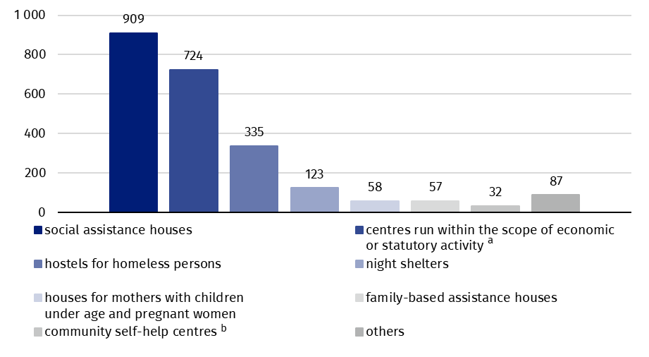
As of 31 December
a Establishments ensuring 24-hour care for disabled persons, chronic patients or elderly persons within the scope of economic activity or their statutory activity. b Including round-the-clock places.
91.0% of the objects were equipped with amenities for the disabled persons. The most of the facilities (75.9%) was equipped with bathrooms for persons with disabilities. Ramps, ascents and platforms facilitating the entrance were present in 67.7% facilities and lifts in 63.4% of them. There was no convenience for persons with disabilities in 9.0% of facilities, predominantly in hostels for homeless persons and night shelters.
Local government was a governing body for 797 stationary social welfare facilities (34.3% of all centres). 717 facilities were managed by natural and legal persons, 502 by associations, foundations and social organisations and 309 by the units of Catholic Church, other churches and religious unions.

Places
Stationary social welfare facilities had at their disposal 138.2 thousand places in total (increase by 3.1% in comparison to 2024). The places in social assistance houses accounted for 61.3% of all places in stationary social welfare facilities, 22.3% for establishments ensuring 24–hour care for disabled persons, chronic patients or elderly persons within the scope of economic activity or their statutory activity and 13.8% for hostels for homeless persons and night shelters. Family–based assistance houses, community self–help centres (with round–the–clock available places), houses for mothers with children under age and pregnant women and others accounted for 2.6% of all places.

Chart 2. Places in stationary social welfare facilities by governing bodies in 2025

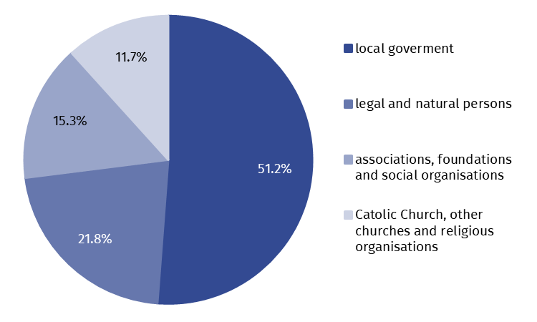
As of 31 December

The facilities for which local government was a governing body had at their disposal the biggest number of places – 70.7 thousand. The centres led by physical and legal persons had 30.1 thousand places, the ones led by associations, foundations and social organisations possessed 21.1 thousand places and the units of the Catholic Church, other churches or religious unions provided 16.2 thousand places.

Residents
As of 31 December, in stationary social welfare facilities there were 128.2 thousand residents (increase by 3.0% in comparison to 2024), out of which women accounted for 49.7%. Out of all residents, 64.4% were the residents of social assistance houses. Over 21% residents stayed in establishments ensuring 24–hour care for disabled persons, chronic patients or elderly persons within the scope of economic activity or their statutory activity and 12.6% in hostels for homeless persons and night shelters. The residents staying in houses for mothers, family–based assistance houses, community self–help centres (including round–the–clock available places) and other facilities accounted for 1.7% of all residents.
Nearly 32% of all residents in stationary social welfare facilities stayed in the centres for elderly persons
Likewise in 2024, most residents stayed in the centres for aged persons (31.5% of total number of the residents) and the smallest share of them in the centres for people addicted to alcohol (0.1%).

Chart 3. Residents of stationary social welfare facilities by their designation in 2025

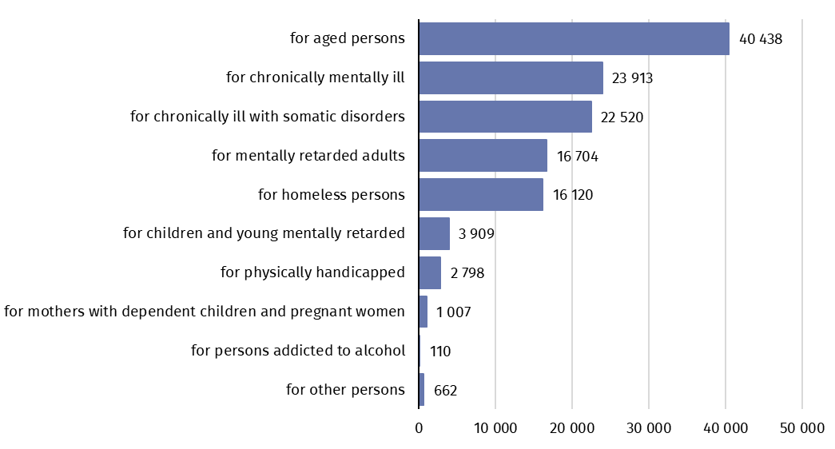
As of 31 December
Most residents in stationary social welfare facilities encompasses all elders over 60 years old (88.5 thousand, i.e. 69.0% of all residents), while the persons up to age of 18 constituted the smallest group (1.9 thousand).

Chart 4. Residents of stationary social welfare facilities by age groups in 2025

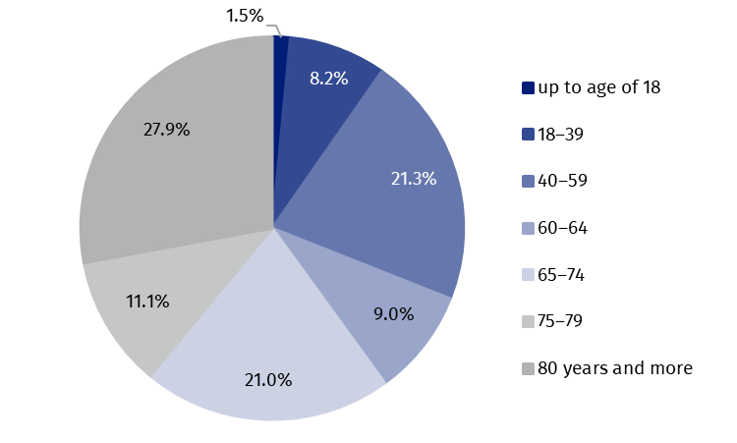
As of 31 December
Over 82% residents financed, at least partly, their stay from own income. For that purpose the resources from e.g. old age pension, disability pension, periodical allowance were incurred. The cost of accommodation for 9.7% of residents was entirely incurred by their families, while the accommodation for 6.7% was paid by the local government or by the state. About 1% of the residents were exempted from the payment.
Over 82% residents of stationary social welfare facilities at least partially financed their stay from own resources
The largest number of stationary social welfare facilities was located in the most populous voivodships, i.e, Mazowieckie and Śląskie. These voivodships accounted jointly for more than a quarter of all facilities in the country (27.2%). The highest surplus of places in relation to the number of residents was recorded in Podlaskie voivodship (the number of places exceeded the number of residents by 12.3%), while the lowest surplus was observed in Małopolskie voivodship (by 4.7%). On average, a single facility in the country had 59 places; the highest value of this indicator was recorded in Małopolskie voivodship (67 places), and the lowest in Warmińsko-Mazurskie voivodship (48 places).
Table 1. Stationary social welfare facilities by voivodships in 2025
As of 31 December
Most places in stationary social welfare facilities were in Mazowieckie voivodship, and the least number in Lubuskie voivodship
Specification | Centresª | Places^{b} | Residents^{b}
POLAND | 2 325 | 138 151 | 128 181
Dolnośląskie | 171 | 10 543 | 9 846
Kujawsko-pomorskie | 108 | 6 464 | 6 077
Lubelskie | 94 | 5 930 | 5 561
Lubuskie | 55 | 3 216 | 3 039
Łódzkie | 136 | 9 012 | 8 496
Małopolskie | 175 | 11 764 | 11 241
Mazowieckie | 338 | 20 419 | 18 513
Opolskie | 80 | 5 097 | 4 731
Podkarpackie | 103 | 6 735 | 6 214
Podlaskie | 79 | 4 175 | 3 719
Pomorskie | 175 | 9 230 | 8 652
Śląskie | 294 | 16 688 | 15 465
Świętokrzyskie | 108 | 5 992 | 5 367
Warmińsko-mazurskie | 126 | 6 004 | 5 487
Wielkopolskie | 176 | 10 165 | 9 575
Zachodniopomorskie | 107 | 6 717 | 6 198
a Excluding branches. b Including branches.
In the case of quoting data from the Statistics Poland, please provide information: "Statistics Poland data source", and in the case of publishing calculations made on data published by the Statistics Poland, please provide information: "Own study based on Statistics Poland data".

Prepared by:  Statistical Office in Kraków  Director Agnieszka Szlubowska  Phone: (+48 12) 420 40 50 | Issued by:  Press Office  Mobile: (+48) 695 255 032  Phone: (+48 22) 608 38 04, (+48 22) 449 41 45,  (+48 22) 608 30 09  e-mail: obslugaprasowa@stat.gov.pl

stat.gov.pl/en/

@StatPoland

@GlownyUrzadStatystyczny

@gus_stat

@GłównyUrządStatystycznyGUS

@Glówny Urząd Statystyczny
Related information
Social assistance, child and family services in 2024
Data available in databases
Database Local Data Bank – health care, social welfare and benefits to the family
Knowledge Databases - Society - Social assistance and social benefits
Terms used in official statistics
Community self-help centre
Establishment ensuring 24-hour care for disabled persons, chronic patients, or elderly persons within the scope of economic activity or their statutory activity
Family-based assistance house
Hostel for homeless persons
House for mothers with children under age and pregnant women
Night shelter
Social assistance house

