Foster care in 2025
1.3%
Increase in the number of children in foster care compared with 2024
At the end of 2025, in foster care there were 78.3 thousand children, including 60.7 thousand in family foster care and 17.5 thousand in institutional foster care. Compared with the end of 2024, the number of children in foster care increased by 1.0 thousand (1.3%).

Family foster care
63.5% of foster families were related families
As of 31 December 2025 in Poland there were 36.8 thousand foster families and 1.0 thousand foster homes. Among foster families, related families accounted for 63.5%, non-professional families – 30.2%, and professional families – 6.3%.
The function of foster family was fulfilled by 18.8 thousand married couples and 18.0 thousand lone persons. The families which admitted one child accounted for 71.7%, two children – 18.4%, three children – 5.7%, and four or more children 4.1% of all foster families. Over a half (52.8%) of persons performing the role of foster family were aged 51– 70. Foster homes were run by 796 married couples and 163 single persons. Foster homes which admitted from one to five children accounted for 21.8%, six children – 13.7%, seven children – 15.7%, and 8 or more children – 48.5% of all foster homes, whereas foster homes with no admitted children accounted for 0.3%. Most persons (74.5%) performing the function of a family foster home were in the 41–60 age group.

Children in family foster care
Of the children who stayed in family foster care 8.4 thousand held legal confirmation of disability or of level of disability
There were 60.7 thousand children in family foster care, including 7.3 thousand children in foster homes. Of all children provided with foster care, 8.4 thousand held legal confirmation of disability or of level of disability, 2.5 thousand were orphans, 0.6 thousand were foreigners (of which 0.5 thousand were under age). 25.1 thousand children enjoyed regularised legal status. There were 30.2 thousand girls in family foster care, including 0.1 thousand mothers under age. Children aged 7–13 constituted the major group (21.5 thousand in total) both in foster families and in foster homes, while infants were in the smallest group (1.0 thousand). Moreover 9.9 thousand adult residents stayed in family foster care. In 2025 10.0 thousand children were admitted for the first time to family foster care, while 8.5 thousand children up to the age of 18 left family foster care. The largest number of children was placed in another foster family or foster home (2.9 thousand). 2.6 thousand returned to their natural families and 1.2 thousand children went to adoption families. 1.0 thousand children left family foster care because they were moved to institutional foster care, while 0.8 thousand children left institutional foster care for other reasons. Of the 4.0 thousand adult residents who left foster care in 2025, 2.3 thousand set up their own households, 0.2 thousand returned to their own families or relatives and 0.3 thousand are the other residents who started to live independent life. Of the residents who left foster care aged over 18, 1.3 thousand did not start to live independent life.

Chart 1. Children in family foster care by age group in 2025
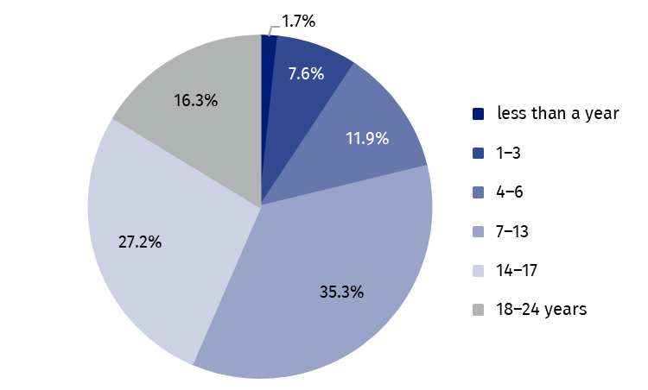
As of 31 December

Institutional foster care centres
Socialisation centres accounted for 62.3% of all institutional foster care centres
At the end of 2025 in Poland there were 1 328 institutional foster care centres, including 1 313 care and education centres, 12 regional care and therapy centres and 3 intervention pre-adoptive centres. The care and education centres encompass socialisation centres (828) centres combining tasks of the centres (207), family centres (180), intervention centres (62) and specialist therapy centres (36).
In 2025 institutional foster care was predominantly provided by centres supervised by local government – 995 centres (74.9%), including: powiat government (558), urban powiat government (406), gmina government (26) and voivodship government (5). Other bodies supervising institutional foster care centres included associations (127), Catholic Church, other churches and religious unions (111) and foundations (95).

Places in institutional foster care
There were in total 16.9 thousand places in institutional foster care centres, of which 11.0 thousand were in socialisation centres, 2.9 thousand were in centres combining tasks of the centres, 1.3 thousand in family centres, 0.8 in intervention centres and 0.4 thousand in specialist therapy centres. In other centres there were 0.4 thousand places in total.

Chart 2. Places in institutional foster care centres by type in 2025
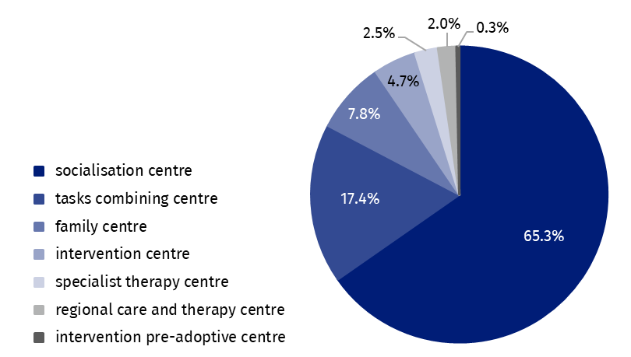
As of 31 December

Residents in institutional foster care
Children aged 14–17 constituted the major group of residents in institutional foster care (47.0%)
At the end of 2025, there were 17.5 thousand children in institutional foster care, of which 8.4 thousand were girls (48.0%). Of all children in foster care, 7.7 thousand had regularised legal status, including 4.6 thousand reported to adoptive centres. Children aged 14–17 constituted the major group (8.2 thousand). The second biggest group (4.6 thousand) included children aged 10–13 and the smallest group of residents encompassed children under the age of 1 (0.1 thousand). In institutional foster care centres there were 1.2 thousand adult residents who continued their education.
In institutional foster care there were 0.3 thousand orphans, 2.7 thousand half-orphans, 2.6 thousand chronically ill persons. Foreigners accounted for 2.6% of all residents, i.e. 0.5 thousand persons.

Chart 3. Residents in institutional foster care by age group in 2025
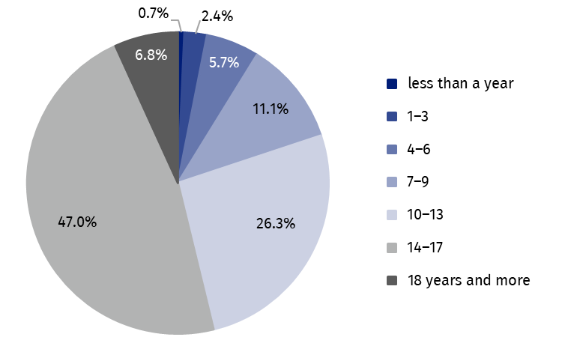
As of 31 December
By the end of 2025 there were 2.4 thousand disabled residents in institutional foster care, of which 2.2 thousand were persons certified as disabled or holding a certificate of the level of disability in care and education centres, and 0.3 thousand residents in regional care and therapy centres. In socialisation centres disabled persons accounted for 61.3% of all disabled residents staying in care and education centres, 18.9% in centres combining tasks of the centres, 9.1% in family centres, 7.0% in specialist therapy centres and 3.7% in intervention centres.
In 2025, 3.9 thousand residents up to the age of 18 left institutional foster care centres. The major group (43.0%) were residents who returned to their own family. Transfer to other type of institutional foster care was the reason for leaving the centres for 24.2% of children, 21.1% of residents were placed in family foster care, while 4.7% went to adoption families, 2.2% were placed in a social assistance house and 0.1% died. Remaining 4.7% left the centres for other reasons. Of the 2.2 thousand residents aged over 18 who left the centres, 1.3 thousand set up their own households and 0.7 thousand returned to their own families. Additionally, 0.2 thousand adult residents have not started to live independently.

Volunteers in institutional foster care
In 2025, 1.5 thousand volunteers did charity work in institutional foster care (including 1.4 thousand volunteers in education and care centres and a total of 0.1 thousand volunteers in regional care and therapy centres and pre-adoptive intervention centres).
Over three quarters of all children in foster care were in family foster care (77.6%), with the rest in institutional foster care. The lowest percentage of children in family foster care was recorded in Świętokrzyskie voivodship (68.7%), while the highest was recorded in Wielkopolskie voivodship (85.0%). Around one third of all children (34.7%) in foster care were located in three voivodships (Śląskie, Dolnośląskie and Mazowieckie).
Table 1. Foster care by voivodships in 2025
As of 31 December
About 78% children were in family foster care and 22% in institutional foster care
Specification | Family care |  | Institutional care
Specification | families | children | centres | residents
Poland | 37 747 | 60 748 | 1 328 | 17 519
Dolnośląskie | 4 027 | 6 360 | 153 | 2 037
Kujawsko-pomorskie | 2 325 | 3 775 | 95 | 1 346
Lubelskie | 1 801 | 2 840 | 91 | 965
Lubuskie | 1 381 | 2 196 | 42 | 545
Łódzkie | 2 737 | 4 067 | 85 | 1 185
Małopolskie | 2 071 | 3 201 | 94 | 1 142
Mazowieckie | 4 130 | 6 429 | 140 | 1 809
Opolskie | 1 032 | 1 652 | 31 | 440
Podkarpackie | 1 173 | 1 829 | 46 | 709
Podlaskie | 936 | 1 445 | 33 | 420
Pomorskie | 2 627 | 5 015 | 85 | 1 147
Śląskie | 5 007 | 8 142 | 179 | 2 345
Świętokrzyskie | 968 | 1 381 | 47 | 630
Warmińsko-mazurskie | 1 736 | 2 901 | 71 | 985
Wielkopolskie | 3 436 | 5 450 | 71 | 963
Zachodniopomorskie | 2 360 | 4 065 | 65 | 851
In the case of quoting data from the Statistics Poland, please provide information: “Statistics Poland data source”, and in the case of publishing calculations made on data published by the Statistics Poland, please provide information: “Own study based on Statistics Poland data”.
Prepared by:  Statistical Office in Kraków  Director Agnieszka Szlubowska  Phone: (+48 12) 420 40 50 | Issued by:  Press Office  Mobile: (+48) 695 255 032  Phone: (+48 22) 608 38 04, (+48 22) 449 41 45,  (+48 22) 608 30 09  e-mail: obslugaprasowa@stat.gov.pl

stat.gov.pl/en/

@StatPoland

@GlownyUrzadStatystyczny

@gus_stat

@GłównyUrządStatystycznyGUS

@Glówny Urząd Statystyczny
Related information
Social assistance, child and family services in 2024
Institutional foster care in 2024
Family foster care in 2024
Data available in databases
Database Local Data Bank – health care, social welfare and benefits to the family
Terms used inn official statistics
Pre-adoptive intervention centre
Family foster care coordinator
The organiser of family foster care
Foster care
Centres combining tasks of the centres
Care and education centre for children and young people
Intervention centre
Family centre
Socialization centre
Specialist therapy centre
Regional care and therapy centre

Regularised legal status means that both parents have been deprived of parental rights.

