Cinematography in 2025
As of the end of 2025, there were 534 indoor cinemas in Poland with 1.5 thousand screens and 285.4 thousand seats for the audience. During the year, 2.2 million film screenings were shown, watched by 49.7 million viewers.
0.3%
Increase in the number of audience in indoor cinemas in comparison to 2024

The number of films produced for cinema and television amounted to 302 (15.3% more than in the previous year).

Cinemas activity
As of the end of 2025, there were 534 indoor cinemas operating in Poland. The largest number of indoor cinemas operated in Mazowieckie Voivodship (85), and the lowest in Podlaskie Voivodship (11). Indoor cinemas had 1.5 thousand screens and 285.4 thousand seats for the audience.
During the year, indoor cinemas attracted 49.7 million viewers (0.3% more than in 2024), with the largest number of viewers visiting cinemas from Mazowieckie Voivodship (9.5 million), and the fewest from Opolskie Voivodship (0.8 million). The largest number of audience per one indoor cinema was recorded in Kujawsko-pomorskie Voivodship (118.3 thousand) and the lowest in Świętokrzyskie Voivodship (54.1 thousand).
Indoor cinemas in Mazowieckie Voivodship gathered almost one-fifth of the total number of audience
2.2 million screenings were shown in indoor cinemas (1.7% less compared to 2024). The highest number of screenings was recorded in cinemas in Mazowieckie Voivodship (390.5 thousand) and the lowest in Lubuskie Voivodship (38.3 thousand).

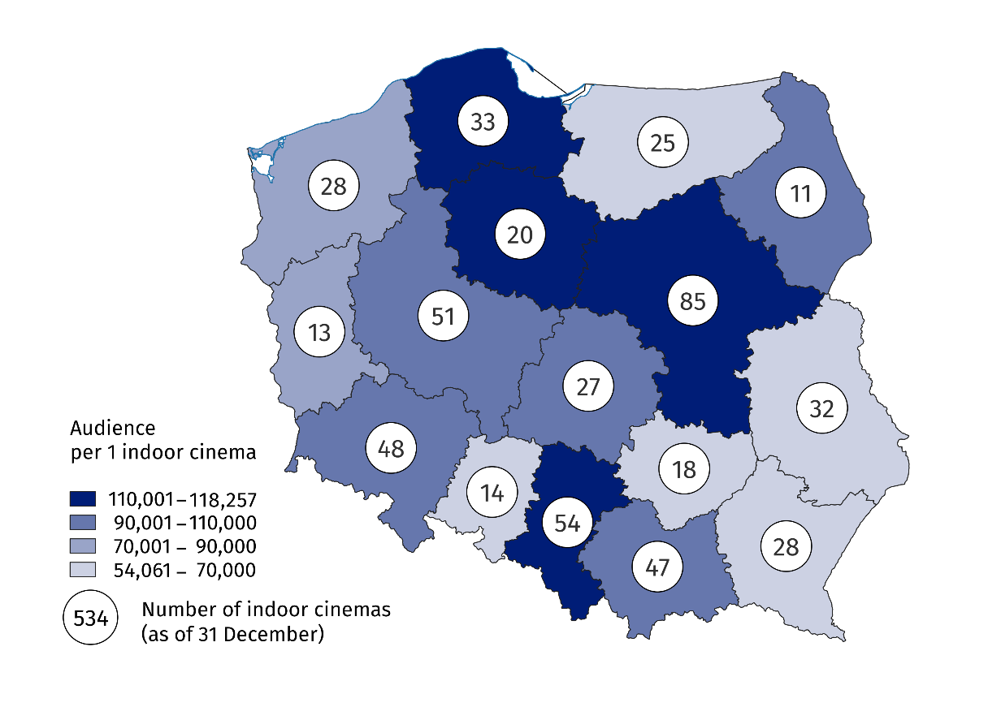
Map 1. Indoor cinemas and audience in 2025
In the reported year, there were 366 indoor cinemas with one or two screens, 109 miniplexes (with 3 to 7 screens) and 59 multiplexes (with 8 or more screens). Multiplexes displayed 48.4% of the total number of screenings, watched by 48.2% of the total audience. Miniplexes displayed 37.8% of screenings, watched by 36.1% of audience. One multiplex had an average of 2.0 thousand seats for the audience, displayed an average of 17.7 thousand screenings and was visited by 405.7 thousand audience.
Chart 1. Indoor cinemas, screenings and audience in 2025
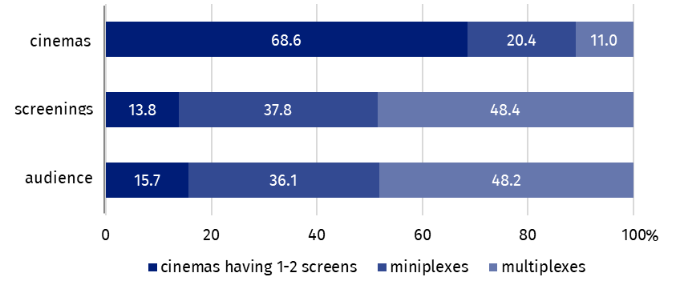
As of 31 December
Multiplexes accounted for nearly half of the total number of viewers and screenings in indoor cinemas

Film production
In 2025, 302 films (15.3% more than in 2024) were produced in Poland, including 120 full-length films (30.4% more than in 2024) and 182 medium- and short-length films (7.1% more than in 2024).

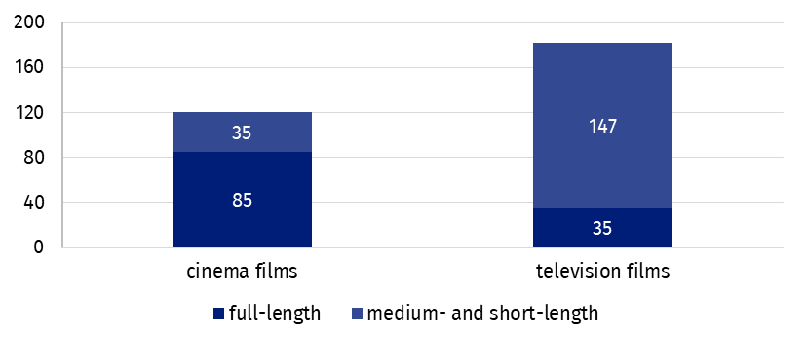
Chart 2. Films produced in 2025
The majority of full-length films produced were cinema films (70.8%), while among medium- and short-length films television films dominated (80.8%).

Of the total number of films produced in 2025, documentaries accounted for 48.7%, feature films – 33.1%, and cartoons – 18.2%. Feature films dominated among cinema films (48.3%), while in case of television films – documentaries (57.7%).

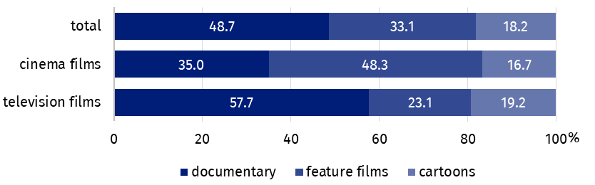
Chart 3. Films produced in 2025 by type
Documentary films accounted for 48.7% of the total number of films produced

Compared to 2024, the number of all cinema films produced increased by 29.0% and television films by 7.7%.
Data presented in this study come from the survey based on Report on Film Production (symbol K-06) and Cinema Report (symbol K-08). Information on the survey methodology can be found in the Methodological report. Culture Statistics.
In the case of quoting data from the Statistics Poland, please provide information: "Statistics Poland data source", and in the case of publishing calculations made on data published by the Statistics Poland, please provide information: "Own study based on Statistics Poland data".

Prepared by:  Statistical Office in Kraków  Director Agnieszka Szlubowska  Phone: (+48 12) 420 40 50 | Issued by:  Press Office  Mobile: (+48) 695 255 032  Phone: (+48 22) 608 38 04, (+48 22) 449 41 45,  (+48 22) 608 30 09  e-mail: obslugaprasowa@stat.gov.pl

stat.gov.pl/en/

@StatPoland

@GlownyUrzadStatystyczny

@gus_stat

@GłównyUrządStatystycznyGUS

@Glówny Urząd Statystyczny
Related information
Culture and national heritage in 2024
Cinematography in 2024
Methodological report. Culture Statistics
Topic available in databases
Knowledge Databases – Society – Culture – Cinematography
Local Data Bank – Culture – Cinemas
Terms used in the official statistics
Indoor cinema
Audience
Film

