Entities of the national economy in border areas in Poland in 2025
As of the end of December 2025, 879.6 thousand entities of the national economy located in the border areas in Poland were entered in the REGON register. It constituted 16.2% of the total number of entities in Poland. In comparison with 2024, in the analysed zone the number of entities increased by 16.4 thousand, i.e. by 1.9% (in Poland by 2.6%).
1.9%
Increase in the number of entities of the national economy in the border area in relation to 2024

Chart 1. Entities of the national economy
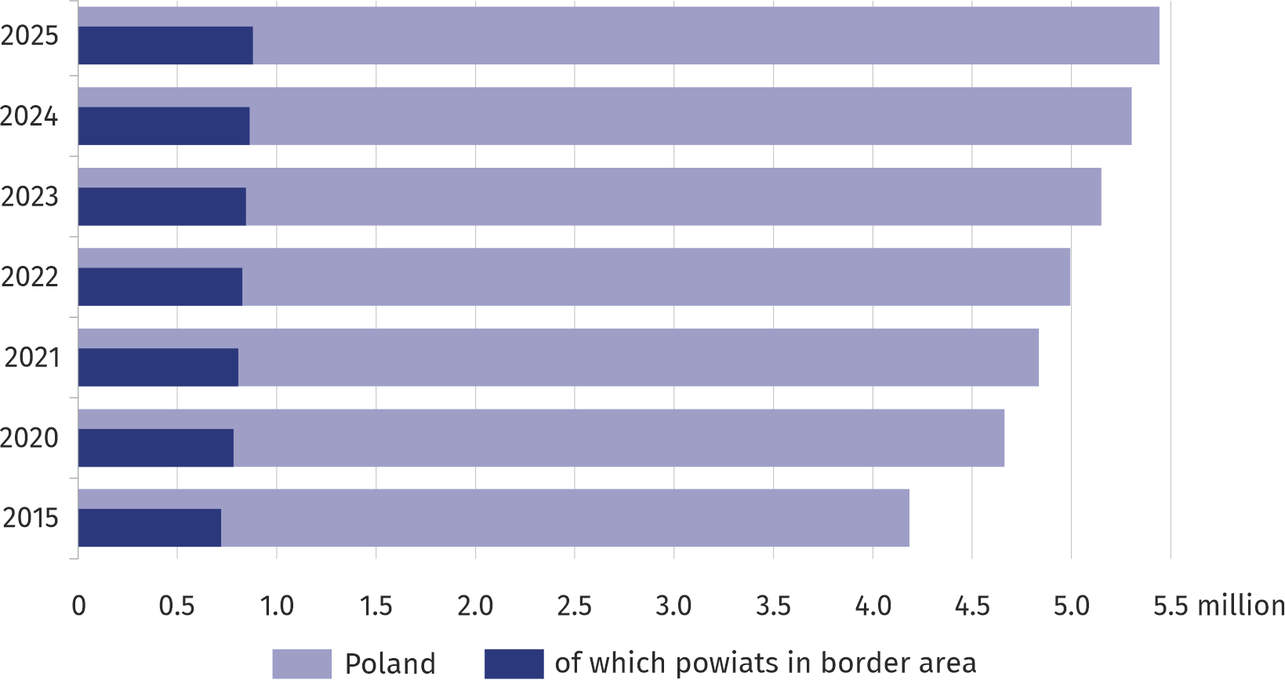

Structure of entities of the national economy by ownership sectors and selected legal forms
95.5% of the entities of the national economy of the border zone were in the private sector (in the country – 95.2%)
At the end of 2025, the vast majority of entities in the border area belonged to the private sector (95.5% compared to 95.2% in the country). In comparison with 2024, the number of entities of the national economy in this sector increased by 15.0 thousand to 840.3 thousand, i.e. by 1.8% (in the country it increased by 2.5%). On the other hand, the public sector included 26.0 thousand entities, i.e. 192 less than in the previous year (in the country 112.1 thousand – 71 less than in 2024).
In the total number of entities located in the border area in 2025, the largest share was constituted by natural persons conducting economic activity – 72.7% (in Poland 70.8%). In comparison with 2024, there were 11.3 thousand more (1.8% more) natural persons conducting economic activity in the REGON register (in the country – 2.5% more).
Commercial companies operating within the zone in 2025 accounted for 8.5% of the entities entered in the REGON register (in Poland 13.5%). In the previous year, these shares were 8.3% and 13.2% respectively.
The REGON register also included civil law partnerships with a 5.5% share in the structure of entities of the national economy within the zone, foundations, associations and social organizations – 3.7%, cooperatives – 0.2% (in 2024: 5.6%, 3.6% and 0.2% respectively).
Of the total number of entities of the national economy operating in the border areas of Poland, almost half were located in the border zone of three voivodships: Śląskie (19.1%), Dolnośląskie (17.1%) and Zachodniopomorskie (13.5%).

Entities of the national economy per 1000 population
In the border zone, there were 126.6 entities per 1000 inhabitants (in Poland 145.5)
- most of them at the border with Germany (158.6),
- least at the border with Ukraine (97.4)

In the Polish border area, there were 126.6 entities per 1000 inhabitants in 2025, which is below the national average of 145.5. In the previous year, these indicators were 123.8 and 141.5 respectively.
The highest number of entities per 1000 population in 2025 was recorded in the zone on the border with Germany – 158.6 (154.8 last year), then on the border with Czechia – 130.5 (in 2024 – 127.6). In the zone near the remaining sections of the border the number of entities per 1000 population was lower than the average for the Polish border area as a whole. The smallest number of entities per 1000 population occurred near the border with Ukraine – 97.4, followed by the zone near the border with Lithuania – 100.6 (95.9 and 99.4
respectively a year ago).
Of the individual parts of the border area in 12 voivodships, the largest number of entities per 1000 population was in the following zones of: Zachodniopomorskie (182.7), followed by Pomorskie (161.6) and Dolnośląskie (145.3). These values for individual voivodships "in total" amounted respectively to: 160.2; 161.3; 164.1.
The smallest number of entities of the national economy per 1000 population was in the border zone located in Mazowieckie Voivodship (95.8) followed by Lubelskie Voivodship (96.6) and Podkarpackie Voivodship (101.2). These values were lower than the indicators for the aforementioned voivodships in total, which amounted respectively to: 197.9; 111.2; 106.4. It should be noted that in the case of Mazowieckie Voivodship the area of the border zone is relatively small and the region's potential is located mainly in the capital of the country.
Table 1. Entities of the national economy in border areas by border sections in 2025
Specification | Entities of the national economy | Natural  persons  conducting economic  activity | Commercial companies in the total number of entities in % | Companies with foreign capital  participation  2024=100
Specification | per 1000 population |  | Commercial companies in the total number of entities in % | Companies with foreign capital  participation  2024=100
Poland | 145.5 | 103.0 | 13.5 | 101.6
Border areas in Poland | 126.6 | 92.0 | 8.5 | 98.4
neighbouring with:
Russia | 111.6 | 79.8 | 6.4 | 98.1
Lithuania | 100.6 | 75.3 | 6.4 | 98.2
Belarus | 112.1 | 83.3 | 10.6 | 100.4
Ukraine | 97.4 | 72.6 | 7.0 | 92.0
Slovakia | 124.3 | 96.5 | 7.9 | 98.8
Czechia | 130.5 | 91.7 | 8.1 | 98.7
Germany | 158.6 | 113.7 | 10.2 | 99.6
Map 1. Entities of the national economy in 2025
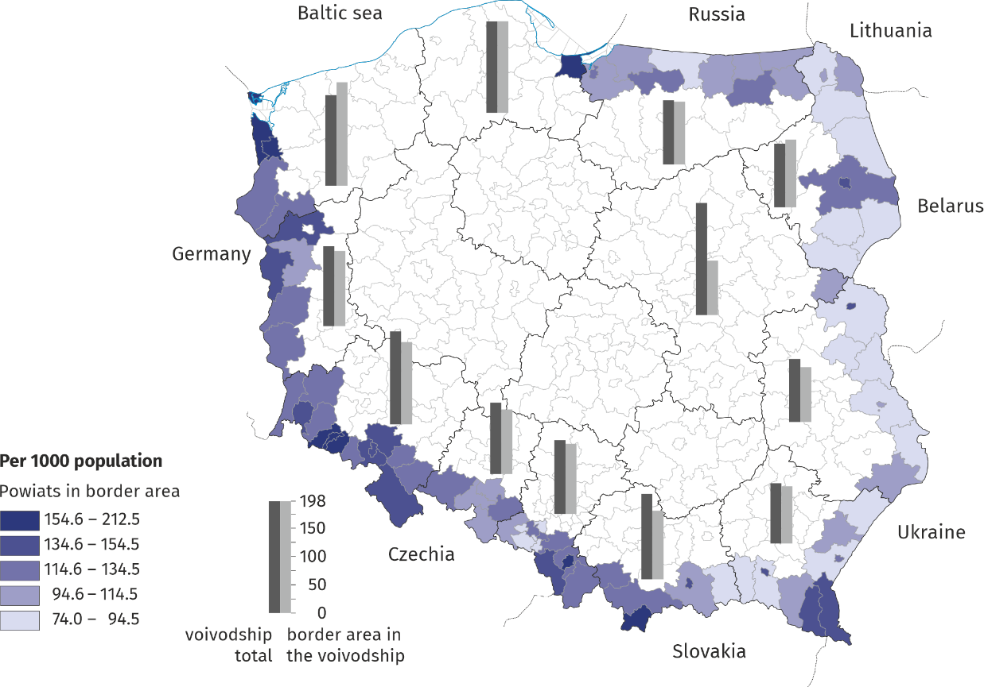

Commercial companies
Compared to 2024, the number of commercial companies operating in the border zone and in the country in 2025 increased by 4.6%.
At the end of 2025, 75.2 thousand commercial companies operating in the border zone were entered in the REGON register, i.e. 10.2% of the total number of companies registered in the country. In this group of entities, similarly as in Poland, capital companies predominated (87.5%), with limited liability companies constituting 86.1% and joint stock companies 1.4%. Partnerships had a 12.5% share in the total number of commercial partnerships within the zone (unlimited partnerships – 7.0%, limited partnerships – 4.7%, professional partnerships – 0.5%, limited joint-stock partnerships – 0.3%).
The number of commercial companies operating in the border zone in 2025 increased by 3315 units, i.e. by 4.6% (in Poland it increased also by 4.6%), compared to 2024. In relation to the previous year, the total number of capital companies increased - by 3574 units, i.e. by 5.7%, against a 5,6% increase in the country. On the other hand, in the group of entities of the national economy classified as partnerships, a decrease by 259 units was recorded by 2.7% (a decrease by 3.8% in the country).
In comparison with 2024, the number of commercial companies increased, both in individual parts of the zone analysed by neighbouring countries and by voivodships. The highest increase was observed at the Czech border – by 1317 units (by 4.7%), and the lowest at the Lithuanian border – by 59 units (by 4.1%). In the case of voivodships, the highest increase was recorded in the border zones of Śląskie Voivodship – by 648 units (by 4.0%) and Podlaskie Voivodship – by 558 units (by 5.4%), while the lowest in the zone of Mazowieckie Voivodship – by 6 companies (by 3.9%).
The number of companies with foreign capital operating in 2025 in border areas constituted 11.8% of the zone's total commercial companies
In the group of commercial companies an important role is played by companies with foreign capital participation, whose presence may prove the investment attractiveness of a given region. The number of entities of the national economy operating in 2025 in border areas in the form of companies with foreign capital participation (8875 units) constituted 11.8% of the total number of companies operating in the zone (in Poland this percentage was 12.6%). Their number decreased in comparison with the previous year by 140 units, i.e. by 1.6% (in Poland it increased by 1.6%). In six parts of the border zone (analysed according to neighbouring countries), decreases were recorded – the largest one was at the border with Ukraine (by 81 companies). Only at the border with Belarus the number of companies with foreign capital participation increased by 10 units compared to 2024.
When analysing the number of companies with foreign capital participation entered in the REGON register according to 12 voivodships in which the border area is located, it may be observed that in 2 of them the number of entities located in the border area was higher than in 2024 (the highest increase was recorded in Podlaskie Voivodship by 22 units). In the border area of Pomorskie Voivodship the number of operating companies with foreign capital did not change and amounted to 10 units, and in 9 voivodships their number decreased (the biggest decrease occurred in the border area of Podkarpackie Voivodship – by 81 units).
Map 2. Companies with foreign capital participation in 2025
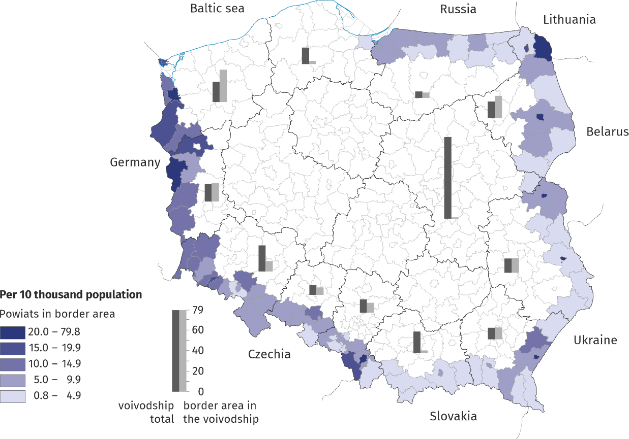

Entities of the national economy by type of economic activity
Trade; repair of motor vehicles – this is the dominant activity in border areas in Poland (18.4% of all entities in the zone as well as in the country)
Among the entities of the national economy entered in the REGON register and operating in border area in Poland, a significant percentage were entities of the national economy belonging to the following sections: trade; repair of motor vehicles – 18.4% (in the country 18.2%), construction – 16.6% (in the country – 14.3%), professional, scientific and technical activity – 8.2% (in the country – 11.1%) and manufacturing – 7.9% (in the country – 7.6%).
Chart 2. Entities of the national economy in the border zone according to the sections
of the Polish Classification of Activities in 2025
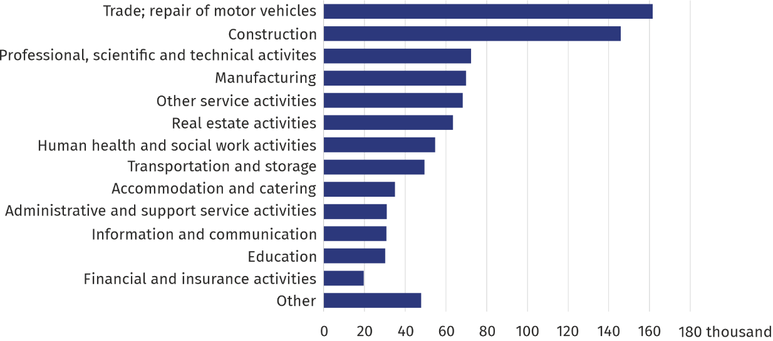
Entities from the trade; repair of motor vehicles and construction sections had the largest share in each of the individual parts of the analysed zone in the neighbouring countries. The share of entities included in the trade; repair of motor vehicles section in the total number of entities in 2025 amounted from 16.0% in the border zone with Russia to 20.2% in the border zone with Ukraine. Entities belonging to the construction section represented from 15.3% in the zone at the border with Belarus to 18.4% at the zone at the border with Slovakia.

Methodological notes
1. The border area (border zone) was defined using the following criteria:
  - The initial delimitation was based on the criterion of the distance of the place of purchase from the border crossing point by foreigners and the distance from the border crossing point of the place of residence of Poles returning from abroad complemented by data from accommodation establishments. The results of studies were used for this purpose: "Trips made by non-residents to Poland. The movement of vehicles and persons at the Polish border with the countries of the European Union" and "Participation of residents of Poland in trips", as well as "Tourist accommodation establishments and their occupancy”;
- all cities located in the area delimited by a 30 or 50 km radius from border crossings have been classified as border area;
- border powiats were delimited based on the criterion of area or population living in the delimited area. If more than 50% of the area of the powiat (the sum of the areas of the delimited municipalities) is located in the delimited border zone, the powiat belongs to the border zone. If more than 50% of the population of the powiat (sum of population in delimited municipalities) is located in the delimited border zone, the powiat belongs to the border zone. If one of the above conditions is fulfilled, the powiat is considered as belonging to the border zone.
2. 85 powiats are located in the border zone in Poland. They cover an area of 75 thousand km² (23.9% of Poland's area). As of 30 June 2025, the area is inhabited by over 7.0 million people (18.6% of Poland's population).
3. There are powiats which are border areas with two or three countries at the same time. In the characteristics the entire Polish border area, these powiats have been included once. When analysing the border zone in Poland according to the sections of the border with the neighbouring countries these powiats are included separately for each border area.

When quoting Statistics Poland data, please provide information: "Source of data: Statistics Poland", and when publishing calculations made on data published by Statistics Poland, please provide information: "Own study based on Statistics Poland data".

Prepared by:  Statistical Office in Rzeszów  Acting Director Andżelika Malinowska  Phone: (+48 17) 853 52 10, (+48 17) 853 52 19 | Issued by:  Press Office  Mobile: (+48) 695 255 032  Phone: (+48 22) 608 38 04, (+48 22) 449 41 45,  (+48 22) 608 30 09  e-mail: obslugaprasowa@stat.gov.pl

stat.gov.pl/en/

@StatPoland

@GlownyUrzadStatystyczny

@gus_stat

@GłównyUrządStatystycznyGUS

@Główny Urząd Statystyczny
Related information
Structural changes of groups of entities of the national economy located in the border area in Poland
Structural changes of groups of the national economy entities in the REGON register, 2025
Data available in databases
REGON Dashboard
Economic Dashboard
Local Data Bank
Terms used in official statistics
Entity of the national economy
Natural person conducting economic activity
Private sector
Public sector

More information on the REGON register

One powiat from Mazowieckie Voivodship is included in the border area.
Of the Polish Classification of Activities – PKD 2007.

