Pharmacies and pharmaceutical outlets in 2024
At the end of 2024, there were operating 11.2 thousand generally available pharmacies and 1.1 thousand pharmaceutical outlets in which 56.0 thousand pharmacists and pharmaceutical technicians were employed.
2.1%
Decrease in the number of generally available pharmacies compared to 2023

Pharmacies and pharmaceutical outlets

At the end of 2024, there were operating 11.2 thousand generally available pharmacies and 1.1 thousand pharmaceutical outlets (by 2.1% and 2.2% less respectively compared to 2023). Online sale of medicines was carried out by 236 pharmacies and 8 pharmacy outlets
(197 and 6 respectively in 2023).
The number of population per one generally available pharmacy and pharmaceutical outlet amounted to 3 049 persons
There were on average 3 049 persons per one generally available pharmacy and pharmaceutical outlet (by 53 more than in the previous year). The highest number of inhabitants per one generally available pharmacy and pharmaceutical outlet was recorded in Pomorskie Voivodship (3 506), while the lowest – in Lubelskie Voivodship (2 655).

Map 1. Generally available pharmacies and pharmaceutical outlets by voivodships in 2024
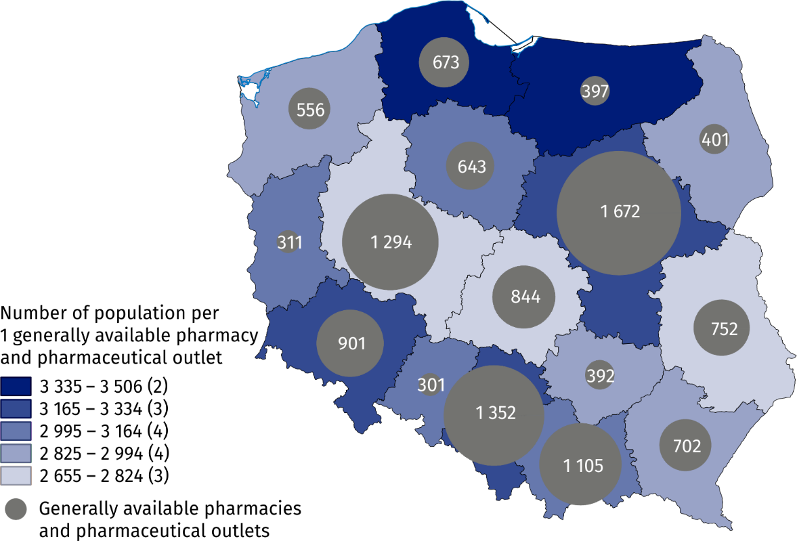
As of 31 December

Employed in generally available pharmacies and pharmaceutical outlets
Generally available pharmacies and pharmaceutical outlets employed 26.2 thousand pharmacists and 29.8 thousand pharmaceutical technicians
At the end of 2024, generally available pharmacies and pharmaceutical outlets employed 26.2 thousand pharmacists and 29.8 thousand pharmaceutical technicians (compared to 2023 respectively increase by 1.5% and decrease by 6.3%). Like a year earlier, the vast majority of employees were females (83.0% of pharmacists and 95.0% of pharmaceutical technicians).
Table 1. Employed in generally available pharmacies and pharmaceutical outlets in 2024
SPECIFICATION | Pharmacists | Pharmaceutical technicians
Generally available pharmacies | 26 151 | 28 371
Pharmaceutical outlets | 79 | 1 440

Map 2. Employed in generally available pharmacies and pharmaceutical outlets by voivodships in 2024
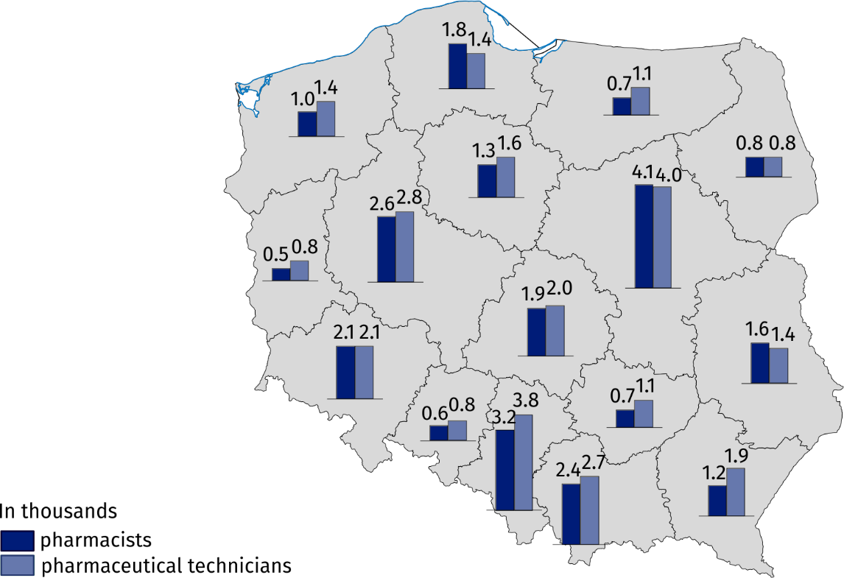
As of 31 December
Since 2024 data on generally available pharmacies and pharmaceutical outlets, together with data on the employed pharmacists and pharmaceutical technicians filling prescriptions, are compiled from the following databases: the National Register of Permits to Operate Generally Available Pharmacies, Pharmaceutical Outlets (Chief Pharmaceutical Inspectorate); list of pharmacists and pharmaceutical technicians engaged in the reimbursement of prescribed medicines (NFZ); the insured and contribution payers lists (ZUS, KRUS).
When quoting data from the Statistics Poland, please provide information: "Statistics Poland data source". When publishing own calculations based on data delivered by the Statistics Poland, please provide information: "Own study based on Statistics Poland data".

Prepared by:  Statistical Office in Kraków  Director Agnieszka Szlubowska  Phone: (+48 12) 420 40 50 | Issued by:  Press Office  Mobile: (+48) 695 255 032  Phone: (+48 22) 608 38 04, (+48 22) 449 41 45,  (+48 22) 608 30 09  e-mail: obslugaprasowa@stat.gov.pl

stat.gov.pl/en/

@StatPoland

@GlownyUrzadStatystyczny

gus_stat

glownyurzadstatystycznygus

glownyurzadstatystyczny
Related information
Health and health care in 2023
Data available in databases
Local Data Bank -> Health care, social welfare and benefits to the family
Knowledge Databases -> Society -> Health and healthcare
Terms used inn official statistics
Generally available pharmacy
Pharmaceutical outlet
Pharmacist

See information on changes in the data compilation methodology on page 2.
According to the Act of 6 September 2001 – the Pharmaceutical Law (Journal of Laws 2025, item 750) and Regulation of the Minister of Health of 26 March 2015 on online sale of medicines (Journal of Laws 2015, item 481).
Population as of 31 December was used to calculate the ratio.
Refers to employees for whom the establishment is the main workplace, as determined on the basis of NFZ data on the filled prescriptions.

