Market of works of art and antiques in 2025
17.1%
Decrease in the value of sale of works of art and antiques in comparison to 2024
In 2025, the value of sales of works of art and antiques in Poland amounted to PLN 544.6 million, of which 81.4% was the sale of paintings (PLN 443.1 million). The decline in the value of sales in this area (by 18.2%) was of key importance for the dynamics of the entire market of the works of art and antiques. Taking into account distribution channels, the largest decrease in the value of sales was recorded in retail outlets (by PLN 63.1 million, i.e. 29.1%).
In 2025, 185 entities were active on the market of works of art in Poland (in 2024 – 188). More than half of the entities (58.9%) were engaged exclusively in the sale of works of art and antiques, and 41.1% also conducted exhibition activities.
Nearly half of the entities operating on the art and antiques market were based in Mazowieckie and Małopolskie voivodeships
The largest number of entities operating on the market of works of art and antiques were based in Mazowieckie (27.6%) and Małopolskie (16.8%) voivodeships. More than two-thirds of entities selling works of art and antiques had their headquarters in the capitals of the voivodeships, including 23.8% in Warszawa and 14.1% in Kraków.
In 2025, the value of sales of works of art and antiques amounted to PLN 544.6 million and was lower by 17.1% compared to 2024. In Mazowieckie Voivodeship, works of art and antiques were sold for the amount of PLN 426.3 million, which accounted for 78.3% of the total amount of sales of works of art and antiques in Poland.
Paintings accounted for the highest share (81.4%) in the structure of sales of works of art and antiques in Poland. The value of their sales amounted to PLN 443.1 million (18.2% less than in 2024). The share of contemporary painting in the total value of sales of works of art and antiques accounted for 44.6% (PLN 242.9 million), while old paintings – 36.8% (PLN 200.2 million). Compared to 2024, the amount obtained from the sale of old paintings was lower by 29.7% and contemporary paintings – by 5.5%.
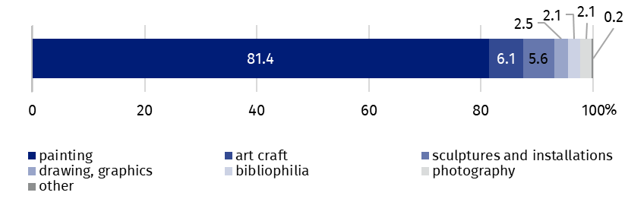
Chart 1. The sale of work of art and antiques by type in 2025
Two-thirds (66.8%) of the total amount of sales of works of art and antiques was obtained through auctions – PLN 363.9 million (9.9% less than in 2024), including PLN 55.0 million from online auctions (5.0% less than in 2024).
The value of sales of works of art and antiques obtained in retail outlets amounted to PLN 154.2 million (28.3% of the total sales amount) and decreased by 29.1% compared to 2024.

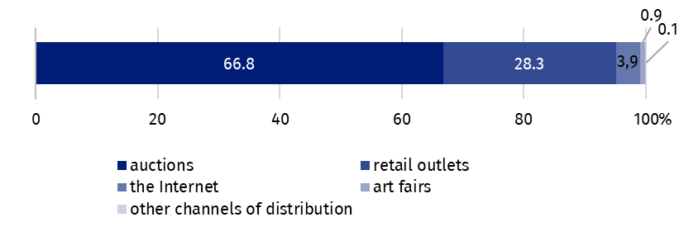
Chart 2. The sale of works of art and antiques by distribution channels in 2025
The highest value of sales of works of art and antiques was obtained through auctions (PLN 363.9 million)
Works of art and antiques were sold via the Internet (e.g. online stores, sales platforms, but excluding sales via online auctions) for a total of PLN 21.4 million (21.5% less than in 2024).
Data presented in this study were compiled using the market of works of art and antiques activity report (symbol K-10). Information on the survey methodology can be found in the Methodological report – Culture Statistics.
In the case of quoting data from the Statistics Poland, please provide information: "Statistics Poland data source", and in the case of publishing calculations made on data published by the Statistics Poland, please provide information: "Own study based on Statistics Poland data".

Prepared by:  Statistical Office in Kraków  Director Agnieszka Szlubowska  Phone: (+48 12) 420 40 50 | Issued by:  Press Office  Mobile: (+48) 695 255 032  Phone: (+48 22) 608 38 04, (+48 22) 449 41 45,  (+48 22) 608 30 09  e-mail: obslugaprasowa@stat.gov.pl

stat.gov.pl/en/

@StatPoland

@GlownyUrzadStatystyczny

@gus_stat

@GłównyUrządStatystycznyGUS

@Glówny Urząd Statystyczny
Related information
Culture and national heritage in 2024
Market of works of art and antiques in 2024
Methodological report. Culture statistics
Terms used in official statistics
Works of art
Antiques
Art gallery

These include among others art galleries and auction houses.

