ICT usage by public administration units in 2025
In 2025, 51.8% of government administration employees (2.6 pp. more than in previous year) and 23.4% of self-government administration employees (0.4 pp. less) were equipped with portable devices enabling mobile access to the Internet for business purposes. 34.4%
of employees had access to such devices across the entire public administration (0.3 pp. more than in 2024).
90.4%
The percentage of public administration units that equipped employees with
portable devices that allow mobile Internet connection for business purposes

The percentage of government administration units equipping employees with portable
devices that allow mobile access to the Internet for business purposes amounted to 99.1% while self-government – 90.0%.

Electronic Document Management System (EDMS)
Non-commercial EDMS was used by 30.5% of public
administration units, while commercial – 76.2%ª

Electronic Document Management System enables efficient transmission, processing, and verification of documents between various institutions and administrative authorities.
In 2025, 86.2% of public administration units declared using EDMS. It was more frequently used by government administration units than self-government administration units (95.5% units) compared to (85.8%).
Chart 1. Public administration units using Electronic Document Management System in 2025 by unit type
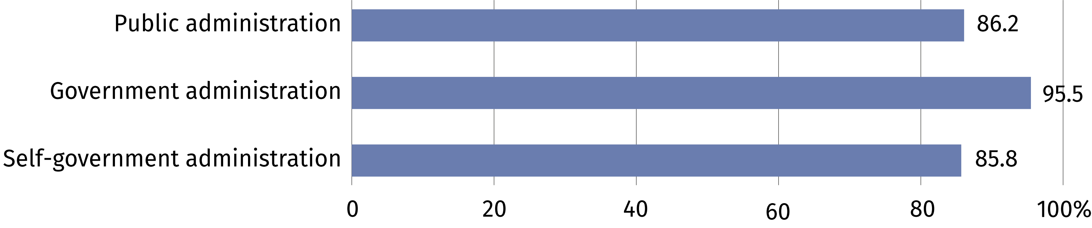

Training for employees in the field of information and communication technologies
Dynamic digital development is associated with the need to constantly improve competences of persons employed in public administration units. In 2025, appropriate training for employees was provided by 77.4% of administration units.

ª Public administration units were able to use commercial and non-commercial Electronic Document Management System at the same time.
Chart 2. Public administration units providing training for employees in the field
of information and communication technologies in 2025 by unit type
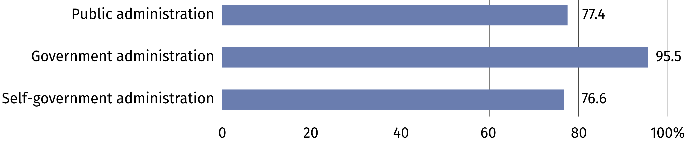

Digital skills support
Development of digital skills
of citizens was supported
by 10 out of 16 marshal offices
Actively supporting the development of digital skills among citizens is a task undertaken
by the public sector. In 2025, 41.2% of public administration entities declared such initiatives.
Chart 3. Public administration units that supported the development of digital skills among citizens in 2025
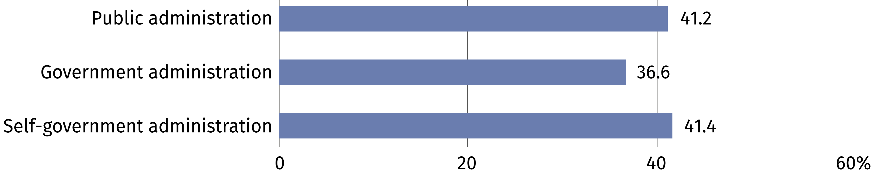

E-Procurement platform
In 2025, 99.2% of public administration units used this platform.
E-Procurement is a system made for electronic communication and information exchange
in public procurement procedures. The platform supports the public procurement process and enhances access to information for contractors about ongoing national and EU procedures.

Artificial Intelligence
The use of artificial intelligence (AI) creates opportunities to improve the functioning of public administration. AI solutions can bring many benefits, such as process optimization and automation of time-consuming tasks. In 2025, 17.7% of public administration units declared
implementation of artificial intelligence – it was used more frequently by government
administration units (50.9%) than self-government administration units (16.4%).

E-services
Adaptation of public administrations websites to foreigners was declared by 41.0%
of units
Public administration is constantly developing and improving e-services and introducing new solutions that will enable citizens to deal with official matters from anywhere and
at any time. In 2025, 97.5% of public administration units declared that their websites were compatible with mobile devices. Applications offering e-services, which can be downloaded to mobile devices, were provided by 35.7% of public administration units while the ability
to participate in voting or social consultations online was provided by 31.4%.

Chart 4. Public administration units providing application for mobile devices offering
e-services in 2025 by unit type
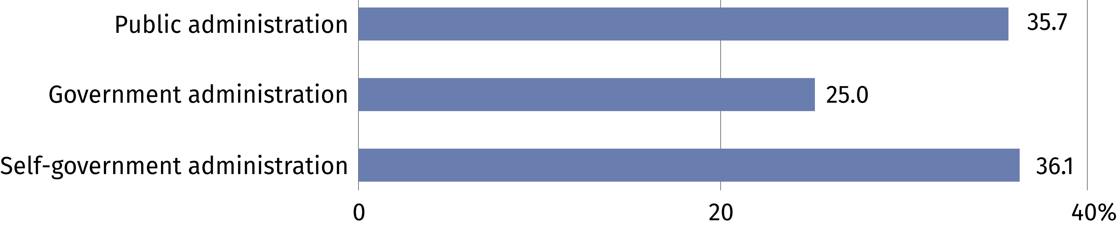

When quoting data from Statistics Poland, please include the following information: "Source of data from Statistics Poland", and in the case of publishing calculations made on the data published by Statistics Poland, please include the following information: "Own study based on Statistics Poland data".

Prepared by:  Statistical Office in Szczecin  Director Magdalena Wegner  Phone: (+48 91) 459 77 00 | Issued by:  Press Office  Mobile: (+48) 695 255 032  Phone: (+48 22) 608 38 04, (+48 22) 449 41 45,  (+48 22) 608 30 09  e-mail: obslugaprasowa@stat.gov.pl

stat.gov.pl/en/

@StatPoland

@GlownyUrzadStatystyczny

@gus_stat

@GłównyUrządStatystycznyGUS

@Glówny Urząd Statystyczny
Related information
Information society in Poland in 2025
Terms used in official statistics
Electronic procurement system
Artificial intelligence

