Activity of centres of culture, cultural centres and establishments, clubs and community centres in 2025
In 2025, there were 3,913 centres of culture, cultural centres and establishments, clubs and community centres. During the year, these entities organised 290.5 thousand events (5.0% more than in 2024), with 37.0 million participants (5.2% more than in 2024).
5.2%
Increase in the number of participants in events organised by centres of culture, cultural centres and establishments, clubs and community centres compared to 2024
The largest number of centres of culture, cultural centres and establishments, clubs and community centres operated in Małopolskie Voivodship (424), while the lowest in Lubuskie Voivodship (77). Among all types of units, the largest share were cultural centres (32.5% of the total number of entities), while the smallest share was accounted for by clubs (7.0%). The majority of entities (59.9%) were located in the countryside.
79
313
348
203
228
342
333
163
284
214
372
123
452

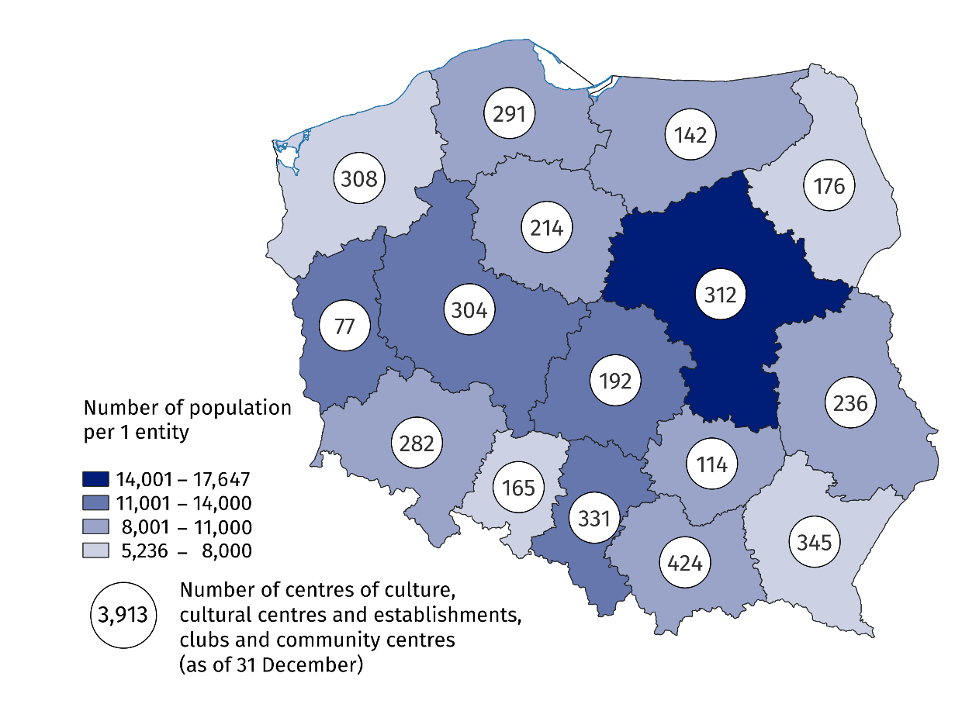
Map 1. Centres of culture, cultural centres and establishments, clubs and community centres in 2025
In Małopolskie Voivodeship operated 10.8% of the total number of entities
The vast majority of centres of culture, cultural centres and establishments, clubs and community centres (93.0%) belonged to the public sector. Local government units were the organisers of 90.4% of all public institutions.
Centres of culture, cultural centres and establishments, clubs and community centres organised a total of 290.5 thousand events, attended by 37.0 million people. Compared to 2024, both the number of events organised and the number of participants increased (by 5.0% and 5.2%, respectively). During the year, one entity organised an average of 74 events – the most were organised by centres of culture (138), and the fewest by clubs (19).
On average, 127 people participated in one event, with festivals and art reviews being the most numerous (680 people on average), and the least numerous were workshops (18 people on average).
Compared to 2024, the number of groups (clubs/sections) increased by 5.1% and their members by 1.4%
In 2025, there were 27.1 thousand different types of groups (clubs/sections) in centres of culture, cultural centres and establishments, clubs and community centres (5.1% more than a year earlier), with 542.0 thousand members (1.4% more than a year earlier). As part of the activities of groups (clubs/sections), the largest number of art and technical classes were organised (7.7 thousand), which were also the most numerous in terms of participation (115.3 thousand people).
Centres of culture, cultural centres and establishments, clubs and community centres conducted a total of 5.0 thousand courses. The largest number of courses conducted were foreign language courses (22.1% of the total number of courses) and learning to play instruments (21.7%). 74.7 thousand people obtained the status of a course graduate (an increase of 5.4% compared to 2024).

Chart 1. Groups (clubs, sections) and their members in centres of culture, cultural centres and establishments, clubs and community centres by type in 2025

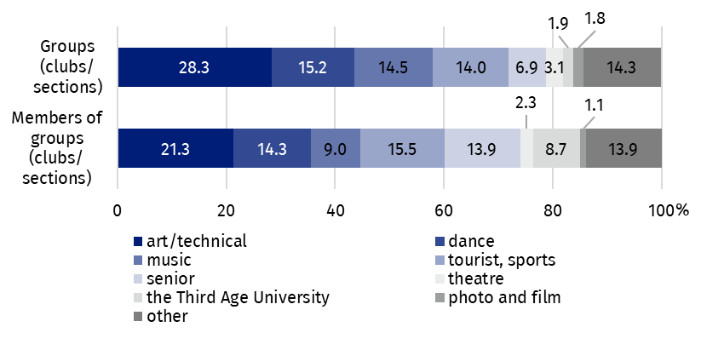
As of December 31
As of the end of 2025, there were 15.0 thousand artistic groups operating in centres of culture, cultural centres and establishments, clubs and community centres (2.6% more than in 2024), including the largest number of dance groups (3.9 thousand). Out of the total number of 260.9 thousand members of artistic groups, 63.5% were children and youth, while person aged over 60 years accounted for 20.7%.
Children and youth constituted 63.5% of the members of artistic groups
The activities of artistic groups focused on dance (26.2% of groups and 30.4% of participants), singing (21.1% groups and 19.4% of participants), folk (17.7% of groups and 20.2% of participants), and music-making (17.5% of groups and 15.0% of participants). Theatrical activities were slightly less popular (11.8% of groups and 9.8% of participants).

Chart 2. Artistic groups and their members centres of culture, cultural centres and establishments, clubs and community centres by type in 2025
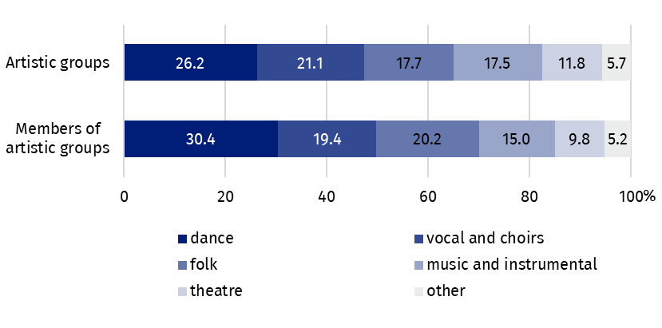
As of December 31
The largest number of artistic groups were dance groups (3.9 thousand)
Data presented in this study were compiled using the centres of culture, cultural centres and establishments, clubs and community centres activity report (symbol K-07). Information on the methodology of the study can be found in Methodological report – Culture Statistics.
In the case of quoting data from the Statistics Poland, please provide information: "Statistics Poland data source", and in the case of publishing calculations made on data published by the Statistics Poland, please provide information: "Own study based on Statistics Poland data".

Prepared by:  Statistical Office in Kraków  Director Agnieszka Szlubowska  Phone: (+48 12) 420 40 50 | Issued by:  Press Office  Mobile: (+48) 695 255 032  Phone: (+48 22) 608 38 04, (+48 22) 449 41 45,  (+48 22) 608 30 09  e-mail: obslugaprasowa@stat.gov.pl

stat.gov.pl/en/

@StatPoland

@GlownyUrzadStatystyczny

@gus_stat

@GłównyUrządStatystycznyGUS

@Glówny Urząd Statystyczny
Related information
Culture and national heritage in 2024
Activity of centres of culture, cultural centres and establishments, clubs and community centres in 2024
Methodological report. Culture statistics
Topic available in databases
Knowledge Databases – Society – Culture
Local Data Bank – Culture – Activity of centres of culture, cultural centres and establishments, clubs and community centres
Terms used in the official statistics
Cultural establishment
Show (event)
Club
Group in cultural institution
Unit’s organiser
Cultural centre
Community centre
Event participant

