Financial results of non-financial enterprises
in the 1st quarter of 2026 (preliminary results)
In the 1st quarter of 2026 gross financial result of the surveyed non-financial enterprises was higher by 22.6% comparing to a year earlier. The economic and financial indicators improved. Investment outlays were higher by 8.7% than in the previous year (when there was a decrease by 3.6%).
5.7%
Increase in total revenues y/y

Total revenues were higher by 5.7% comparing to the previous year (1,321.6 bn PLN in the 1st quarter of 2026, 1,250.6 bn PLN a year before) and total costs of obtaining the revenues increased by 4.9% (from 1,197.3 bn PLN to 1,256.2 bn PLN). The cost level indicator was lower than in the previous year (95.1% in the 1st quarter of 2026, 95.7% a year before). Gross turnover profitability indicator improved (4.9%, compared to 4.3% a year before) as well as net turnover profitability indicator (respectively, 3.8% and 3.4%). Net revenues from sale of products and goods increased by 5.6% and the costs of obtaining by 4.8%.
The financial result from the sale of products and goods amounted to 64.7 bn PLN and was by 22.9% higher than in the 1st quarter of 2025. The financial result from other operating activity amounted to 4.8 bn PLN and was higher by 0.3 bn PLN over the year, the result on financial activities amounted to minus 4.1 bn PLN compared to minus 3.8 bn PLN in the 1st quarter of 2025.
In the 1st quarter of 2026 net financial result of non-financial enterprises was by 20.5% higher than
a year before
Gross financial result amounted to 65.4 bn PLN (compared to 53.3 bn PLN in the 1st quarter of 2025) and its obligatory encumbrances amounted to 14.6 bn PLN (compared to 11.2 bn PLN a year before). Net financial result amounted to 50.8 bn PLN and was by 20.5% higher than the year before. Net profit amounted to 73.9 bn PLN and was higher by 9.7 bn PLN (by 15.1%) than in the 1st quarter of 2025 while net loss amounted to 23.1 bn PLN and was higher by 1.1 bn PLN compared to the previous year. Net profit was recorded by 66.4% of all enterprises (compared to 65.1% a year before) and the revenues obtained by them constituted 77.0% of total revenues of the surveyed enterprises (compared to 75.2% a year before). In manufacturing, net profit was recorded by 68.9% of all enterprises (it was 67.5% a year before) and the share of the total revenues generated by these entities in the total revenues of all enterprises in this section was 80.3% (compared to 79.6% a year before).
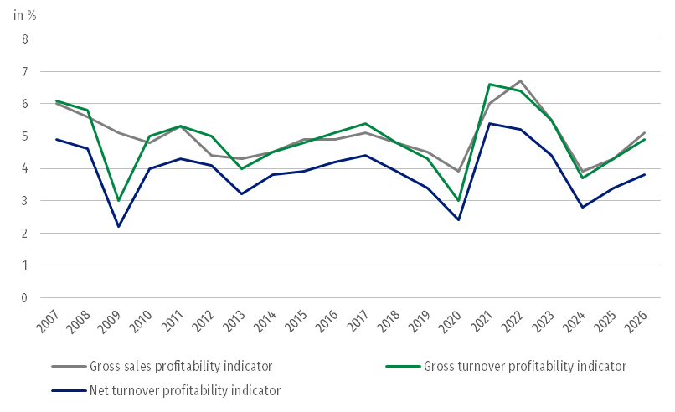
Chart 1. Profitability indicators from 2007 to 2026

Table 1. Basic financial data of surveyed non-financial enterprises
SPECIFICATION | Jan.-March 2025 | Jan.-March 2026 | Jan.-March 2025 = 100
SPECIFICATION | in million PLN |  | Jan.-March 2025 = 100
Total revenues | 1,250,617.2 | 1,321,573.4 | 105.7
of which net revenues from sale  of products and goods | 1,211,979.8 | 1,279,792.2 | 105.6
Total costs | 1,197,268.9 | 1,256,193.2 | 104.9
of which cost of products and  goods sold | 1,159,354.4 | 1,215,126.8 | 104.8
Financial result from the sale of products and goods | 52,625.3 | 64,665.4 | 122.9
Financial result from other  operating activity | 4,533.2 | 4,843.9 | 106.9
Result on financial activity | -3,810.2 | -4,129.1 | .
Gross financial result | 53,348.3 | 65,380.2 | 122.6
Net financial result | 42,173.5 | 50,816.6 | 120.5
Net profit | 64,197.4 | 73,920.0 | 115.1
Net loss | 22,023.9 | 23,103.3 | 104.9
 | in %
Cost level indicator | 95.7 | 95.1 | .
Gross sales profitability indicator | 4.3 | 5.1 | .
Gross turnover profitability indicator | 4.3 | 4.9 | .
Net turnover profitability indicator | 3.4 | 3.8 | .
First degree financial liquidity indicator | 44.5 | 43.7 | .
Second degree financial liquidity indicator | 108.0 | 107.7 | .
Gross sales profitability indicator improved (5.1% in the 1st quarter of 2026 compared to 4.3% a year before) as well as gross turnover profitability indicator (4.9% compared to 4.3%) as well as net turnover profitability indicator (3.8% compared to 3.4%).
An improvement in net turnover profitability indicator was recorded i.a. in mining and quarrying (from minus 7.5% to 6.5%), in professional, scientific and technical activities (from 3.3% to 5.8%), in information and communication (from 6.7% to 7.5%), in transportation and storage (from 3.6% to 4.2%), in water supply; sewerage, waste management and remediation activities (from 6.2% to 6.7%), in real estate activities (from 4.3% to 4.8%), in trade; repair of motor vehicles (from 1.4% to 1.9%) as well as in manufacturing (from 3.8% to 4.0%). A deterioration of net turnover profitability indicator was recorded i.a. in construction (from 2.9% to 0.7%), in accommodation and catering (from 2.6% to 1.6%), in administrative and support service activities (from 4.8% to 3.9%) as well as in electricity, gas, steam and air conditioning supply (from 8.3% to 7.9%)
First degree financial liquidity indicator decreased to 43.7% (compared to 44.5% in the 1st quarter of 2025) and second degree financial liquidity indicator amouted to 107.7% (compared to 108.0% a year before). First degree financial liquidity indicator at the level over 20% was achieved by 57.0% of the surveyed enterprises (compared to 56.6% a year before). Second degree financial liquidity indicator ranged from 100% to 130% was recorded by 11.4% of the surveyed enterprises, 11.6% in the 1st quarter of 2025.
Chart 2. Net turnover profitability indicator
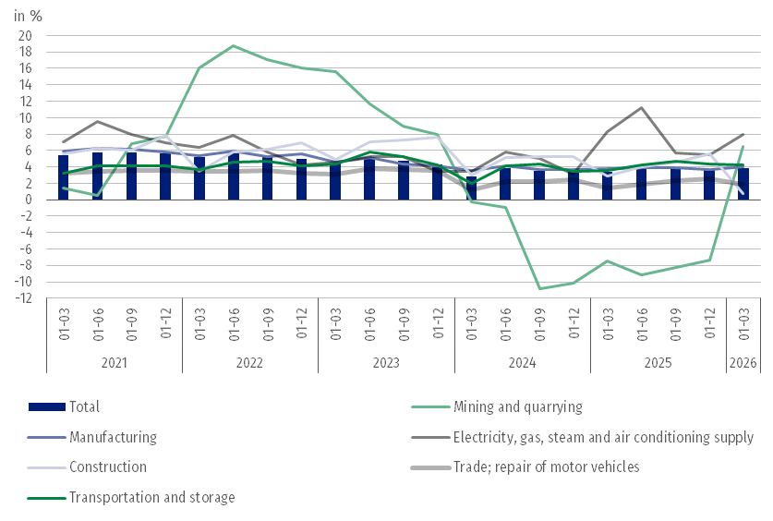
In the total costs by type the share of external services increased the most (by 0.6 pp.), whereas share of consumption of materials decreased the significantly (by 1.6 pp.)

In the structure of total costs by type, there was an increase compared to the 1st quarter of 2025 in the share of external services (by 0.6 pp.), other costs by type (by 0.4 pp.), wages and salaries (by 0.3 pp.), in the share of taxes and fees (by 0.3 pp.) as well as social insurances and other benefits (by 0.1 pp.). The share of depreciation was the same as a year before. There was a decrease in the share of consumption of materials (by 1.6 pp.) as well as consumption of energy (by 0.1 pp.).
Chart 3. Structure of costs by type in the 1st quarter of 2026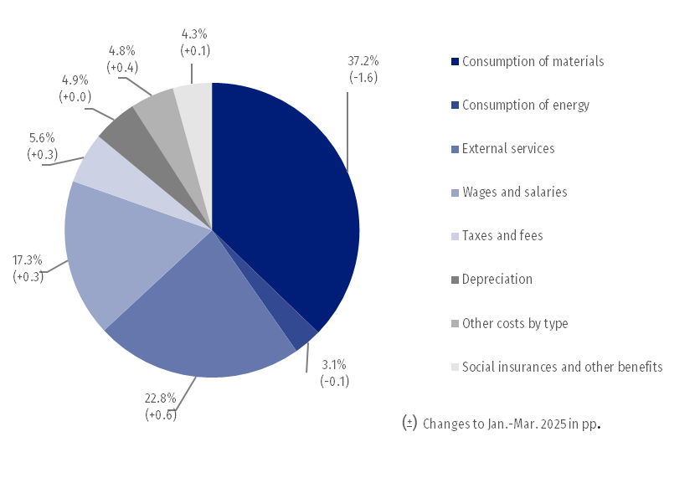

51.4% of the surveyed enterprises reported net revenues from sale of products and goods for export in the 1st quarter of 2026 (compared to 52.8% in the 1st quarter of 2025). The revenues from export sales were by 2.9% higher than a year before. The share of export sales in total sales revenues of all surveyed enterprises amounted to 23.1% (23.7% in the
1st quarter of 2025). The share of the exporting enterprises which reported net profit was 68.8% (compared to 66.9% a year before). The basic economic and financial relations of the exporting enterprises improved in profitability indicators and deteriorated in liquidity indicators.
There was an increase in investment outlays of the surveyed enterprises by 8.7% compared to the 1st quarter of 2025. Expenditures on purchases and outlays on buildings and structures increased
In January-March 2026 investment outlays of the surveyed enterprises amounted to 42.4 bn PLN and were (in constant prices) by 8.7% higher than a year before (when a decrease by 3.6% was recorded). The expenditures on buildings and structures increased by 5.4% (in the 1st quarter of 2025 they decreased by 5.5%). Expenditures on purchases increased by 10.4% (in the 1st quarter of 2025 they decreased by 2.7%), including increase of outlays on transport equipment – by 17.1% (in comparison to the decrease in the 1st quarter of 2025 – 8.1%) as well as of outlays on machinery, technical equipment and tools by 7.8% (in comparison to the decrease in the 1st quarter of 2025 by 0.4%).
The increase in investment outlays (in current prices) was noticed i.a. in transportation and storage (by 48.6% compared to the increase by 4.3% a year before), administrative and support service activities (by 11.7% compared to the decrease by 1.3%), water supply; sewerage, waste management and remediation activities (by 9.5% compared to the decrease by 0.5%), accommodation and catering (by 9.4% compared to the increase by 13.6%), information and communication (by 8.6% compared to the increase by 12.0%), manufacturing (by 6.9% compared to the decrease by 11.9%), trade; repair of motor vehicles (by 5.9% compared to the increase by 4.7%), construction (by 3.4% compared to the increase by 40.6%). The decrease in investment outlays was recorded i.a. in real estate activities (by 26.8% compared to the increase by 93.5%), mining and quarrying (by 11.4% compared to the decrease by 7.0%), electricity, gas, steam and air conditioning supply (by 0.6% compared to the decrease by 1.0%).
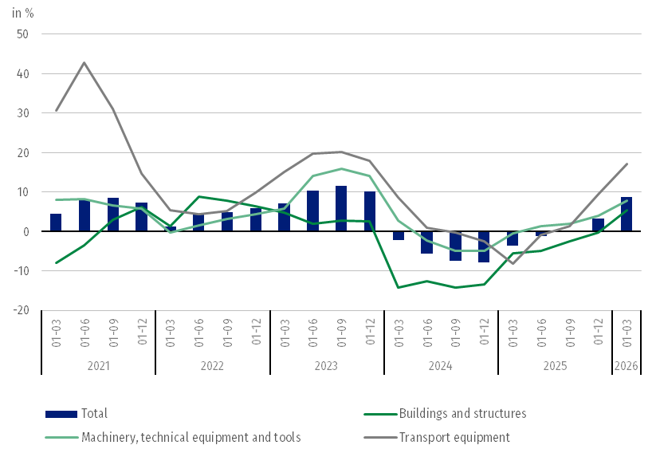
Chart 4. Investment outlays – change compared to the corresponding period of the previous year

Table 2. Basic financial data of surveyed non-financial enterprises
SPECIFICATION | Jan.-March 2025 | Jan.-March 2026 | Jan.-March 2025 = 100
SPECIFICATION | in million PLN |  | Jan.-March 2025 = 100
Total revenues | 1,250,617.2 | 1,321,573.4 | 105.7
of which net revenues from sale  of products and goods | 1,206,130.4 | 1,279,792.2 | 106.1
Total costs | 1,197,268.9 | 1,256,193.2 | 104.9
of which cost of products and  goods sold | 1,154,157.2 | 1,215,126.8 | 105.3
Financial result from the sale of products and goods | 51,973.2 | 64,665.4 | 124.4
Financial result from other  operating activity | 5,185.3 | 4,843.9 | 93.4
Result on financial activity | -3,810.2 | -4,129.1 | .
Gross financial result | 53,348.3 | 65,380.2 | 122.6
Net financial result | 42,173.5 | 50,816.6 | 120.5
Net profit | 64,197.4 | 73,920.0 | 115.1
Net loss | 22,023.9 | 23,103.3 | 104.9
 | in %
Cost level indicator | 95.7 | 95.1 | .
Gross sales profitability indicator | 4.3 | 5.1 | .
Gross turnover profitability indicator | 4.3 | 4.9 | .
Net turnover profitability indicator | 3.4 | 3.8 | .
First degree financial liquidity indicator | 44.5 | 43.7 | .
Second degree financial liquidity indicator | 108.0 | 107.7 | .

The data refer to 17 142 non-financial enterprises (legal units) with 50 and more persons employed keeping accounting ledgers. The data do not include agriculture, forestry, hunting and fishing (section A according to NACE Rev. 2); financial and insurance activities (section K according to NACE Rev. 2); higher education institutions; independent public health care facilities; cultural institutions with legal personality; trade unions, religious and political organisations.

In terms of the amendment of the Accounting Act, starting from 2026 the classification of revenues from the sale of materials has changed. They were previously presented as part of main operating activity (under "net revenues from sales of goods and materials" and correspondingly under "value of sold goods and materials"), are now reported under other operating activity ("other operating revenues" and "other operating costs"). The influence of the reclassification on the data is not essential therefore the data from the previous years are comparable. The scale of the change is visible in table 2 where the data from the 1st quarter of 2025 are presented after the reclassification.

Due to the rounding of data, in some cases sums of components may slightly differ from the amount given in the item ‘total’. Relative numbers (indices, percentages) are usually calculated on the basis of absolute data expressed with greater precision than that presented in the news release.

When quoting Statistics Poland data, please provide the information: “Source of data: Statistics Poland”, and when publishing calculations made on data published by Statistics Poland, please include the following disclaimer: “Own study based on figures from Statistics Poland”.
Prepared by:  Enterprise Statistics Department  Director Katarzyna Walkowska-Macias  Phone: (+48 22) 608 31 25 | Issued by:  Press Office  Mobile: (+48) 695 255 032  Phone: (+48 22) 608 38 04, (+48 22) 449 41 45,  (+48 22) 608 30 09  e-mail: obslugaprasowa@stat.gov.pl

stat.gov.pl/en/

@StatPoland

@GlownyUrzadStatystyczny

@gus_stat

@GłównyUrządStatystycznyGUS

@Główny Urząd Statystyczny
Related information
Statistical Bulletin
Information on the socio-economic situation of the country
News releases. Financial results of non-financial enterprises
Methodological report. Non-financial enterprises surveys
Data available in databases
Local Data Bank
Knowledge Database Non-financial Enterprises
Macroeconomic Data Bank
Terms used in official statistics
Total revenues
Total costs
Gross financial result
Net financial result
Cost level indicator
Gross turnover profitability indicator
Net turnover profitability indicator
First degree financial liquidity indicator
Second degree financial liquidity indicator
Investment outlays

Machinery, technical equipment and tools as well as transport equipment.
Data for the 1st quarter of 2025 include reclassification of the sale of materials to other operating activity.

