Public libraries in 2025
3.0%
Increase in library users aged 60 years or more compared to 2024
As of the end of 2025, 7,438 public libraries were operating, including 4,825 library branches. During the year, 5.4 million library users (0.3% more than in 2024) borrowed 99.5 million volumes of the collection (0.6% more than in 2024).
The largest number of public libraries operated in Mazowieckie Voivodship (935), and the smallest number in Podlaskie Voivodship (220). Libraries also operated 675 library points, most of which were located in Lubelskie Voivodship (112). Nearly two-thirds of libraries (63.7%) operated in rural areas.
On average, one library had 164 square meters of library space and offered 16 seats in the reading room.

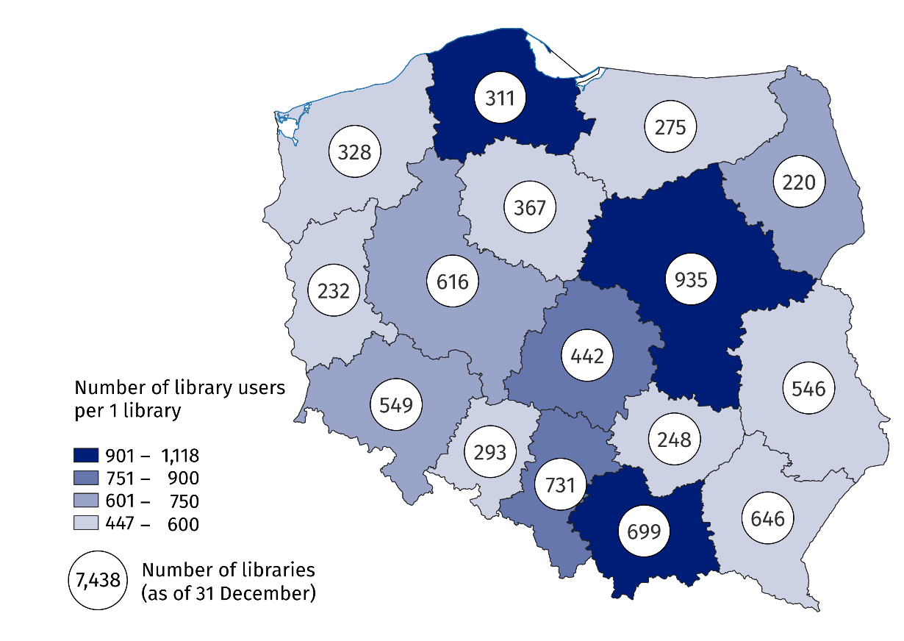
Map 1. Public libraries and library users in 2025
On average, there were 724 library users per one public library

Library collections
At the end of 2025, public libraries had a collection consisting of 123.9 million volumes, of which books accounted for the largest share (98.5%).
Libraries also had 6.2 million special collections, of which audio-visual materials were the largest group (56.6%). Compared to 2024, the number of audio-visual materials increased by 0.7%.

Library users and loans
The number of registered users in the library, i.e. people who had an active account and a valid library card during the year, amounted to 6.5 million and remained at a similar level to the previous year.
On average, each library user borrowed 19 books from the collection
In 2025, public libraries recorded 5.4 million library users, who borrowed 99.5 million volumes of the collection and 2.6 million library materials constituting special collections.
There were 19 volumes of loans of collection per library user, on average. The highest rate was recorded in Świętokrzyskie Voivodship (23), and the lowest in Pomorskie Voivodship (15).

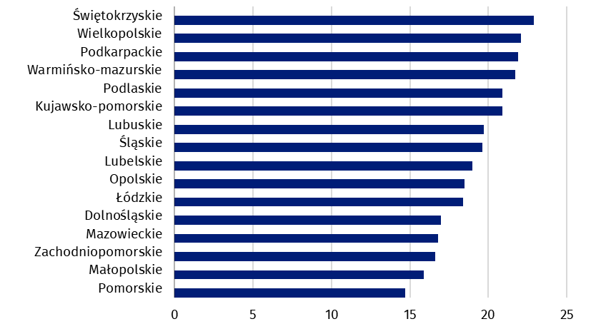
Chart 1. Loans of collection in volumes per 1 library user in public libraries by voivodeship in 2025
On average, there were 724 library users per one library – the highest rate was recorded in Pomorskie Voivodship (1,118) and the lowest in Podkarpackie Voivodship (447).
The largest group of library users in public libraries were people aged 25–44 (24.7%). The smallest share was among people aged 20–24 (4.5%). Compared to 2024, the largest increase in the number of library users was observed among people aged 60 years or more (by 3.0%), while the largest decrease was among people aged 20–24 (by 5.7%).

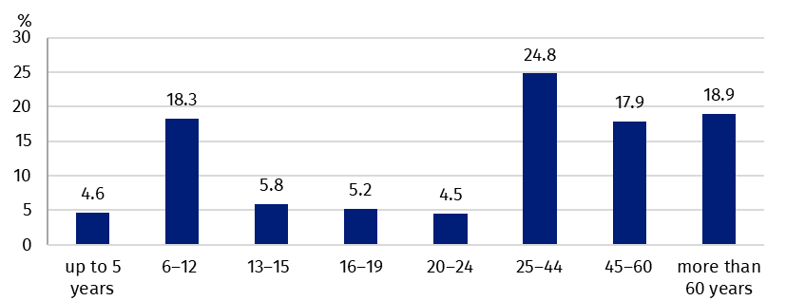
Chart 2. Public library users by age group in 2025

Other activities of libraries
In 2025, 168.5 thousand stationary events were held in public libraries, attended by 5.6 million participants. In addition, the average library spent 57 hours over the course of the year on various training and educational activities. Nationwide 4.5 million people participated in these trainings and educational activities.

Computerisation and electronic services
By the end of 2025, nearly all public libraries were equipped with computers (96.3%). Of the 48.7 thousand computers used by libraries, 43.6% were made available to users, and nearly all of them were connected to the Internet (96.8%). The computer library program was used by the majority of public libraries (87.4%).
The majority of libraries (89.8%) provide access to their offer through electronic services. These included, among others: an on-line catalogue (93.4%), remote placement of orders for library materials (74.1%), electronic notification of deadlines for the return of library materials (70.1%) and on-line registration of new library users (26.6%).

Employees in libraries
On average, there was one employee with tertiary librarian education per one public library
At the end of 2025, public libraries employed 22.1 thousand employees, including 15.0 thousand people in librarian positions. The majority of librarians (62.6%) had secondary or tertiary librarian education. Out of all library employees, 68.2% took part in trainings to improve their professional qualifications.
Data presented in this study were compiled using the Library Report (symbol K-03). Information on the survey methodology can be found in the Methodological report – Culture Statistics.
In the case of quoting data from the Statistics Poland, please provide information: "Statistics Poland data source", and in the case of publishing calculations made on data published by the Statistics Poland, please provide information: "Own study based on Statistics Poland data".
Prepared by:  Statistical Office in Kraków  Director Agnieszka Szlubowska  Phone: (+48 12) 420 40 50 | Issued by:  Press Office  Mobile: (+48) 695 255 032  Phone: (+48 22) 608 38 04, (+48 22) 449 41 45,  (+48 22) 608 30 09  e-mail: obslugaprasowa@stat.gov.pl

stat.gov.pl/en/

@StatPoland

@GlownyUrzadStatystyczny

@gus_stat

@GłównyUrządStatystycznyGUS

@Glówny Urząd Statystyczny
Related information
Culture and national heritage in 2024
Public libraries in 2024
Methodological report. Culture statistics
Topic available in databases
Knowledge Databases – Society – Culture
Local Data Bank – Culture – Libraries
Terms used in the official statistics
Library
Branch
Library collections
Collection
Audiovisual materials
Library user (user actively borrowing items)

Including branches.
A registered user in the library who borrowed at least one volume of collection during the reporting period.
Library events of a community, special – occasion, or literary nature, organised for users.
Improving professional qualifications does not include training courses paid for by the employee.

