Financial results of cultural institutions in 2025
The value of assets (liabilities) of the surveyed cultural institutions as of 31 December 2025 amounted to PLN 30,141.8 million. Total revenues were higher by 10.9% and total costs were higher by 10.7% compared to 2024.
The assets (liabilities) of cultural institutions were higher by 6.1% than at the end of 2024
10.9%
Increase in total revenues in comparison to the previous year
Assets (liabilities) amounted to PLN 30,141.8 million (PLN 1,723.4 million more than at the end of 2024). The largest amount, i.e. 47.1% of the value of assets (liabilities), belonged to entities employing from 50 to 249 people (345 entities), 25.1% to institutions employing 250 or more people (31 entities), 23.7% to entities employing from 10 to 49 people (1,628 entities), and 4.1% to institutions employing less than 10 people (2,704 entities).
Assets (liabilities) of local government cultural institutions amounted to PLN 18,034.1 million (59.8%), and of state cultural institutions to PLN 12,107.7 million (40.2%).
The highest value of assets (liabilities) was recorded in libraries, archives, museums and institutions conducting other activity in the field of culture – PLN 18,402.0 million, i.e. 61.1% of the total value.
Table 1. Basic data on the finances of cultural institutions
Specification | 01–12 2024 | 01–12 2025
Specification | in PLN million |  | 01–12 2024=100
Assets (liabilities) | 28,418.4 | 30,141.8 | 106.1
Total revenues | 16,666.2 | 18,477.0 | 110.9
Total costs | 16,504.3 | 18,272.8 | 110.7
Gross financial result | 161.9 | 204.2 | 126.1
Net financial result | 159.7 | 201.4 | 126.2
At the end of 2025, total fixed assets of cultural institutions amounted to PLN 27,023.6 million and were 4.9% higher compared to the previous year. As in the previous year, the largest share in their structure was accounted for by tangible fixed assets (99.0%), of which fixed assets accounted for 85.0% and fixed assets under construction for 14.8%.
Current assets of cultural institutions amounted to PLN 3,118.2 million and were higher by 17.6% compared to the end of 2024. Short-term investments accounted for 67.3% of current assets.

Chart 1. Current assets of cultural institutions in 2025

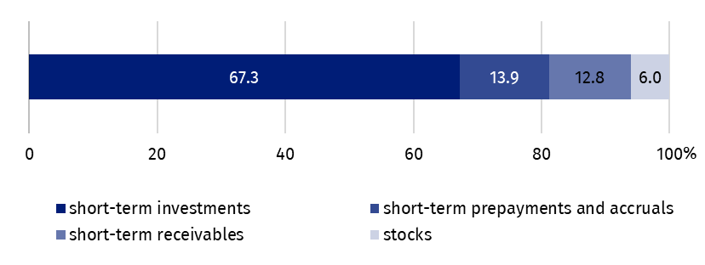
As of 31 December
Equities amounted to PLN 9,166.7 million (representing 30.4% of liabilities) and remained at a similar level to the previous year (increase by 0.2%). The share of liabilities and provisions for liabilities in the structure of total liabilities amounted to 69.6%.
At the end of 2025, liabilities and provisions for liabilities amounted to PLN 20,975.1 million (an increase of 8.9% compared to the end of 2024). In their structure, prepayments and accruals accounted for 91.9%, short-term liabilities – 4.3%, reserves for liabilities – 3.4%, and long-term liabilities – 0.4%.

Chart 2. Liabilities of cultural institutions in 2025

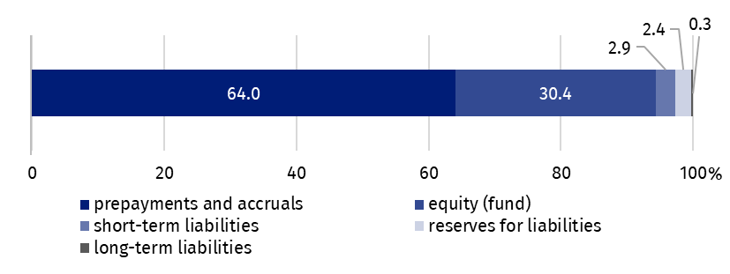
As of 31 December
The value of total revenues generated by cultural institutions amounted to PLN 18,477.0 million and was 10.9% higher compared to 2024. Subsidies for the basic activities accounted for 76.0% of total revenues. The largest share was recorded for cultural institutions employing from 50 to 249 people (39.1% of the total value of revenues). More than 25% of all revenues of cultural institutions were the total revenues of entities located in Mazowieckie Voivodship. Total revenues of local government cultural institutions amounted to PLN 15,009.4 million (81.2%), and of state cultural institutions – PLN 3,467.6 million (18.8%).
Subsidies for the basic activities accounted for 76.0% of total revenues

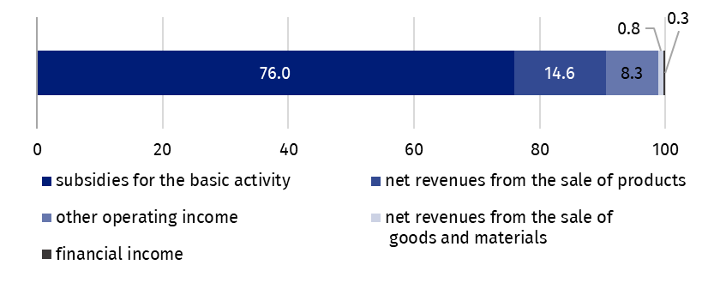
Chart 3. Total revenues of cultural institutions in 2025
In 2025, the total costs of cultural institutions amounted to PLN 18,272.8 million and were higher by 10.7% compared to the previous year. The largest share was accounted for by the own cost of products, goods and materials sold (98.4%). The costs of cultural institutions from Mazowieckie Voivodship accounted for more than 25% of the total costs.
Own costs of products, goods and materials sold accounted for 98.4% of total costs

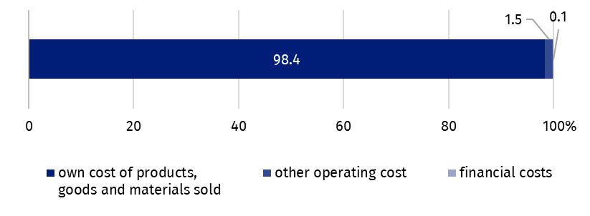
Chart 4. Total costs of cultural institutions in 2025
The largest share in total revenues and costs was recorded by institutions conducting creative arts and entertainment activity, their revenues amounted to PLN 11,169.0 million (60.4% of the total value of revenues), and costs – PLN 11,098.8 million (60.7% of the total value of costs).
The gross financial result of cultural institutions increased from PLN 161.9 million in 2024 to PLN 204.2 million in 2025 (gross profit amounted to PLN 339.5 million and gross loss to PLN 135.3 million).
Compared to 2024, obligatory encumbrances on gross financial result due to income taxes increased by 25.0% and amounted to PLN 2.8 million.
The net financial result of cultural institutions amounted to PLN 201.4 million (compared to PLN 159.7 million in 2024), with an increase in net profit (by 12.0%) and a decrease in net loss (by 4.0%). Out of the total number of cultural institutions surveyed, 46.7% achieved net profit and 36.5% recorded net loss.
As of 31 December 2025, 89.8 thousand people worked in cultural institutions, of which 12.8% in state institutions and 87.2% in local government institutions. Among the surveyed institutions, small entities with less than 10 employees prevailed, accounting for 57.4% of the total number of entities. As in previous years, the largest number of people worked in cultural institutions conducting creative arts and entertainment activities (55.7% of the total number of employees).

Table 2. Total revenues and total costs by selected divisions and classes of PKD 2007 in 2025
Specification | Total | Of which
Specification | Total | Crea-tive, arts and enterta-inment activi-ties | of which |  | libraries, archives, muse-ums and other cultural activities | of which
Specification | Total | Crea-tive, arts and enterta-inment activi-ties | perfor-ming arts | opera-tion of arts facili-ties | libraries, archives, muse-ums and other cultural activities | library and  archives active-ties | muse-ums activi-ties
Number of cultural institutions | 4,708 | 2,342 | 153 | 2,180 | 2,360 | 1,955 | 397
Total revenues in PLN million | 18,477.0 | 11,169.0 | 3,386.8 | 7,605.6 | 7,060.4 | 2,947.5 | 3,999.8
of which:
net revenues from the sale of products | 2,691.7 | 1,855.3 | 664.7 | 1,169.7 | 751.6 | 35.3 | 707.3
subsidies for the basic activity | 14,038.1 | 8,330.8 | 2,464.2 | 5,719.7 | 5,595.3 | 2,748.6 | 2,751.9
of which:
state budget | 2,759.5 | 1,265.7 | 585.8 | 674.0 | 1,403.1 | 221.7 | 1,104.3
local government units | 11,123.9 | 6,994.1 | 1,868.2 | 4,986.1 | 4,118.8 | 2,496.9 | 1,607.0
Total costs in PLN million | 18,272.8 | 11,098.8 | 3,390.2 | 7,532.7 | 6,933.5 | 2,950.0 | 3,869.6
of which:
depreciation | 1,157.9 | 561.1 | 183.5 | 374.8 | 566.0 | 167.3 | 393.7
usage of materials and energy | 1,580.0 | 958.7 | 182.0 | 769.4 | 604.6 | 282.8 | 315.4
external services | 3,692.8 | 2,499.2 | 498.0 | 1,940.5 | 1,115.8 | 327.5 | 763.1
remuneration | 8,935.1 | 5,336.0 | 1,919.2 | 3,342.7 | 3,520.2 | 1,687.8 | 1,776.4
social insurance and other benefits | 1,810.6 | 1,041.9 | 375.5 | 652.7 | 753.2 | 360.1 | 381.1

The balance sheet and profit and loss account for 2025 were obtained from 4,708 cultural institutions with legal personality: 76 state cultural institutions and 4,632 local government cultural institutions.
Data presented in this study come from the survey Annual report on the finances of cultural institutions (with symbol F-02/dk). Information on the survey methodology can be found in the Methodological report. Culture Statistics.
In the case of quoting data from the Statistics Poland, please provide information: "Statistics Poland data source", and in the case of publishing calculations made on data published by the Statistics Poland, please provide information: "Own study based on Statistics Poland data".

Prepared by:  Statistical Office in Kraków  Director Agnieszka Szlubowska  Phone: (+48 12) 420 40 50 | Issued by:  Press Office  Mobile: (+48) 695 255 032  Phone: (+48 22) 608 38 04, (+48 22) 449 41 45,  (+48 22) 608 30 09  e-mail: obslugaprasowa@stat.gov.pl

stat.gov.pl/en/

@StatPoland

@GlownyUrzadStatystyczny

@gus_stat

@GłównyUrządStatystycznyGUS

@Glówny Urząd Statystyczny
Related Studies
Financial results of cultural institutions in 2025 (preliminary data)
Financial results of cultural institutions in 2024
Methodological report. Culture statistics
Major terms available in the glossary
Total revenues
Total costs
Gross financial result
Net financial result
Cultural institution

