Financial results of cultural institutions in in the first quarter of 2026 (preliminary data)
In the first quarter of 2026, total revenues of cultural institutions increased by 9.1% compared to 2025, while total costs – by 9.9%. The financial result was 1.6% higher than a year earlier. Investment outlays increased by 6.7%.
9.1%
Increase in total revenues y/y

In the first quarter of 2026, total revenues of cultural institutions amounted to PLN 4,584.5 million and were higher by 9.1% compared to the first quarter of the previous year. In the structure of revenues, 93.9% were net revenues from sales of products, goods and materials, 5.9% – other operating revenues, and 0.2% – financial revenues. Cultural institutions located in Mazowieckie Voivodship had the largest share in the total revenues (24.7%).
Total revenues of local government cultural institutions accounted for 83.5% of total revenues
The average total revenues per one cultural institution amounted to PLN 974.8 thousand. The highest total revenues per institution were achieved by cultural institutions located in Mazowieckie Voivodship (PLN 1,737.1 thousand), and the lowest in Lubelskie Voivodship (PLN 473.1 thousand).
Total revenues of local government cultural institutions amounted to PLN 3,828.6 million (83.5%) and total revenues of national cultural institutions amounted to PLN 755.9 million (16.5%). The revenues of entities conducting operation of art facilities accounted for the largest share in the total revenues of cultural institutions – 41.3%.
The total costs of cultural institutions amounted to PLN 4,151.7 million and were 9.9% higher than those incurred a year earlier. In the cost structure, 99.4% were operating costs. More than 24% of all costs were the total costs of cultural institutions from Mazowieckie Voivodship. The costs of entities conducting operation of arts facilities had the largest share in the total costs of cultural institutions – 40.0%.
The gross financial result of cultural institutions amounted to PLN 432.8 million (gross profit – PLN 506.9 million, and gross loss – PLN 74.1 million). The net financial result of cultural institutions amounted to PLN 432.3 million (compared to PLN 425.6 million a year ago), with an increase in net profit by 0.6% and decrease in net loss by 4.6%.

Table 1. Financial results of cultural institutions
The net financial result of cultural institutions in the first quarter of 2026 amounted to PLN 432.3 million
Specification | 01–03 2025 | 01–03 2026
Specification | in PLN million |  | 01–03 2025=100
Total revenues | 4,203.9 | 4,584.5 | 109.1
Total costs | 3,777.9 | 4,151.7 | 109.9
Gross financial result | 426.0 | 432.8 | 101.6
Net financial result | 425.6 | 432.3 | 101.6
Net profit | 503.5 | 506.5 | 100.6
Net loss | 77.9 | 74.3 | 95.4
Investment outlays | 239.4 | 255.3 | 106.7
Outlays on intangible fixed assets | 5.1 | 5.9 | 114.9
In the first quarter of 2026, investment outlays incurred by cultural institutions amounted to PLN 255.3 million and were 6.7% higher than a year earlier. Almost 33% of total investment outlays were total investment outlays of entities located in Mazowieckie Voivodship.
Investment outlays incurred by local government cultural institutions in Poland amounted to PLN 166.5 million, i.e. 65.2% of the total amount of investment outlays.
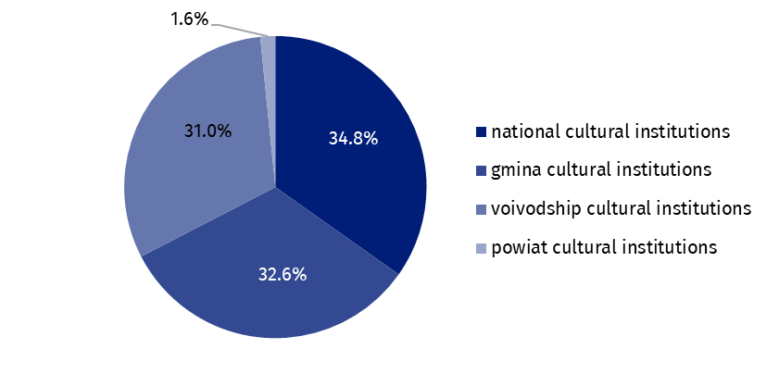
Chart 1. Investment outlays of cultural institutions by legal forms in the first quarter of 2026
In the first quarter of 2026, outlays incurred by cultural institutions on intangible and legal assets increased by 14.9% compared to the first quarter of 2025 and amounted to PLN 5.9 million. Almost 47% of the total outlays on intangible and legal assets came from cultural institutions from Mazowieckie Voivodship.
Table 2. Total revenues and total costs of cultural institutions by selected divisions and classes of PKD 2007 classification in the first quarter of 2026
The revenues of entities conducting operation of art facilities had the largest share in the total revenues of cultural institutions – 41.3%
Specification | Number of cultural institutions | Total revenues | Total costs
Specification | Number of cultural institutions | in PLN million
Grand total | 4,703 | 4,584.5 | 4,151.7
local government units property | 4,627 | 3,828.6 | 3,453.3
government property | 76 | 755.9 | 698.4
of which:
creative, arts and entertainment activities | 2,343 | 2,817.6 | 2,530.5
of which:
performing arts activities | 153 | 880.4 | 831.2
operation of arts facilities | 2,182 | 1,891.7 | 1,662.1
libraries, archives, museums and other cultural activities | 2,354 | 1,710.0 | 1,566.0
of which:
libraries and archives activities | 1,947 | 778.2 | 690.5
museums activities | 399 | 903.8 | 853.0
Data presented in this study were compiled using the Finances of cultural institutions report (symbol F-01/dk). Information on the survey methodology can be found in the Methodological report. Culture Statistics.
In the case of quoting data from the Statistics Poland, please provide information: "Statistics Poland data source", and in the case of publishing calculations made on data published by the Statistics Poland, please provide information: "Own study based on Statistics Poland data".

Prepared by:  Statistical Office in Kraków  Director Agnieszka Szlubowska  Phone: (+48 12) 420 40 50 | Issued by:  Press Office  Mobile: (+48) 695 255 032  Phone: (+48 22) 608 38 04, (+48 22) 449 41 45,  (+48 22) 608 30 09  e-mail: obslugaprasowa@stat.gov.pl

stat.gov.pl/en/

@StatPoland

@GlownyUrzadStatystyczny

@gus_stat

@GłównyUrządStatystycznyGUS

@Glówny Urząd Statystyczny
Related information
Financial results of cultural institutions in 2025 (preliminary data)
Methodological report. Culture statistics
Terms used in official statistics
Total revenues
Total costs
Gross financial result
Net financial result
Investment outlays
Outlays on intangible fixed assets
Cultural institution

