Active enterprises in the first quarter of 2026

In the first quarter of 2026, there were 2 872 113 active enterprises in Poland. With regard to the kind of economic activity, the largest population were enterprises from section trade; repair of motor vehicles (16.7% of total). The largest number of active enterprises had their registered offices in the Mazowieckie voivodship (20.1% of total).
2.0%
Increase in the number of active enterprises in the first quarter of 2026 compared to the corresponding period of the previous year

Basic information on active enterprises
The share of micro entities increased year-on-year to 95.9% of active enterprises

In the first quarter of 2026, compared to the same period in 2025, there was an increase of 2.0% in the number of active enterprises. Micro entities (i.e. with up to 9 employees) accounted for 95.9% of all active enterprises, and compared to the first quarter of 2025, their number increased by 2.2%. Small entities (i.e. with 10 to 49 employees), medium entities (i.e. with 50 to 249 employees), and large entities (i.e. with 250 or more employees) accounted for 3.3%, 0.6%, and 0.2% of all active enterprises, respectively. In these three size classes, a decrease in the number of enterprises was observed compared to the first quarter of 2025: for small enterprises by 1.1%, medium-sized enterprises by 1.0% and large enterprises by 0.3%.

Table 1. Number of active enterprises by the number of persons employed
Quarter | Active enterprises
Quarter | total | by the number of persons employed
Quarter | total | up to 9 persons | 10-49 | 50-249 | 250 and more persons
Q1 2026 | 2 872 113 | 2 755 076 | 95 618 | 17 251 | 4 168
Q1 2025 | 2 815 480 | 2 697 166 | 96 716 | 17 419 | 4 179
The largest increase in the number of active enterprises was observed in administration and support service activities section

Active enterprises by kind of economic activity
In the first quarter of 2026, the majority of enterprises operated in the sections: trade; repair of motor vehicles (16.7% of all active enterprises), construction (15.1%), and professional, scientific and technical activities (13.9%). The smallest share was held by enterprises in the mining and quarrying section (0.1%).
Compared to the same period in 2025, the largest increase in the number of enterprises was recorded in the administration and support service activities section (13.1%).
In populations of large and medium-sized enterprises, the largest share was held by manufacturing enterprises, accounting for 42.4% and 34.4%, respectively. Among small enterprises, the largest share was held by entities in the trade; repair of motor vehicles (22.3%), manufacturing (21.6%), and construction (14.1%).
In the number of micro entities, the largest share was noticed, similarly to enterprises in general, in the sections: trade; repair of motor vehicles (16.5%), construction (15.2%), and professional, scientific and technical activities (14.2%).
Chart 1. Number of active enterprises

Table 2. Number of active enterprises by size classes and NACE Rev. 2 section in the first quarter of 2026
Specification | Active enterprises
Specification | total | by the number of persons employed
Specification | total | up to 9 persons | 10-49 | 50-249 | 250 and more persons
Total | 2 872 113 | 2 755 076 | 95 618 | 17 251 | 4 168
Agriculture, forestry, hunting and fishing | 24 730 | 22 561 | 1 711 | 440 | 18
Mining and quarrying | 2 400 | 1 938 | 326 | 104 | 32
Manufacturing | 235 145 | 206 785 | 20 652 | 5 942 | 1 766
Energy generation and supply | 9 088 | 8 557 | 317 | 165 | 49
Water supply; sewage and waste management | 8 316 | 6 238 | 1 320 | 660 | 98
Construction | 433 349 | 418 556 | 13 499 | 1 168 | 126
Trade; repair of motor vehicles | 479 518 | 454 590 | 21 362 | 3 038 | 528
Transportation and storage | 167 487 | 156 109 | 9 747 | 1 336 | 295
Accomodation and catering | 78 260 | 73 149 | 4 693 | 333 | 85
Information and communication | 238 857 | 235 567 | 2 451 | 625 | 214
Financial and insurance activities | 57 640 | 55 959 | 1 072 | 472 | 137
Real estate activities | 76 771 | 74 354 | 1 985 | 398 | 34
Professional, scientific and technical activities | 398 469 | 392 303 | 5 148 | 769 | 249
Administrative and support service activities | 132 375 | 127 535 | 3 605 | 901 | 334
Education | 89 033 | 86 286 | 2 394 | 323 | 30
Human health and social work activities | 255 471 | 250 699 | 4 172 | 455 | 145
Arts, entertainment and recreation activities | 32 652 | 32 174 | 402 | 63 | 13
Other service activities | 152 552 | 151 716 | 762 | 59 | 15

Active enterprises by registered office
In the first quarter of 2026, the largest number of active enterprises (according to the place of registered offices) was in the Mazowieckie (20.1% of all active enterprises), as well as in the Wielkopolskie (10.3%), Śląskie (10.3%), and Małopolskie (10.1%) voivodships. The smallest number of enterprises were located in the Opolskie voivodship (1.9% of active entities).
Compared to the same period in 2025, the largest increase in the number of active enterprises was recorded in the Dolnośląskie (2.9%), Małopolskie (2.7%) and Mazowieckie (2.6%) voivodeships, the smallest increase was in the Warmińsko-Mazurskie, Lubuskie, Świętokrzyskie, and Kujawsko-Pomorskie voivodships (the percentage did not exceed 1.0%).
In the population of large entities, the largest share was held by enterprises based in the Mazowieckie (27.3%), Śląskie (11.7%), and Wielkopolskie (10.9%) voivodships. In the population of micro-entities, the highest percentage of entities was recorded in the Mazowieckie (20.1%), Wielkopolskie (10.3%), Śląskie (10.2%), and Małopolskie (10.1%) voivodships.
In the first quarter of 2026, the highest number of active enterprises per 1000 population was recorded in the Mazowieckie (104.5), Wielkopolskie (85.1), Pomorskie (84.7), Małopolskie (84.2), and Dolnośląskie (82.4) voivodships. The lowest number was observed in the Podkarpackie voivodship (56.6).
In the powiats that are not cities with powiat status, the highest number of active enterprises per 1000 population was observed in the powiats: piaseczyński (125.5), pruszkowski (114.9), and warszawsko zachodni (113.1). The lowest number of active enterprises per 1000 populaton occurred in the powiats: chełmski (34.0), przemyski (35.5) and hrubieszowski (35.7).

Chart 2. Structure of active enterprises by voivodships in the first quarter of 2026

%
Table 3. Number of active enterprises by size classes and voivodships in the first quarter of 2026
Specification | Active enterprises
Specification | total | by the number of persons employed
Specification | total | up to 9 persons | 10-49 | 50-249 | 250 and more persons
Total | 2 872 113 | 2 755 076 | 95 618 | 17 251 | 4 168
Dolnośląskie | 236 452 | 228 236 | 6 562 | 1 283 | 371
Kujawsko-Pomorskie | 126 092 | 120 505 | 4 589 | 829 | 169
Lubelskie | 116 004 | 111 271 | 4 050 | 585 | 98
Lubuskie | 66 542 | 63 822 | 2 199 | 434 | 87
Łódzkie | 165 050 | 157 994 | 5 863 | 990 | 203
Małopolskie | 288 877 | 277 422 | 9 579 | 1 518 | 358
Mazowieckie | 575 888 | 553 997 | 17 289 | 3 463 | 1 139
Opolskie | 54 991 | 52 480 | 2 035 | 389 | 87
Podkarpackie | 117 639 | 112 242 | 4 475 | 768 | 154
Podlaskie | 69 867 | 67 077 | 2 314 | 413 | 63
Pomorskie | 199 751 | 192 176 | 6 195 | 1 128 | 252
Śląskie | 294 997 | 281 440 | 11 070 | 2 000 | 487
Świętokrzyskie | 67 863 | 65 060 | 2 360 | 373 | 70
Warmińsko-Mazurskie | 76 379 | 73 354 | 2 490 | 461 | 74
Wielkopolskie | 296 074 | 282 506 | 11 135 | 1 979 | 454
Zachodniopomorskie | 119 647 | 115 494 | 3 413 | 638 | 102

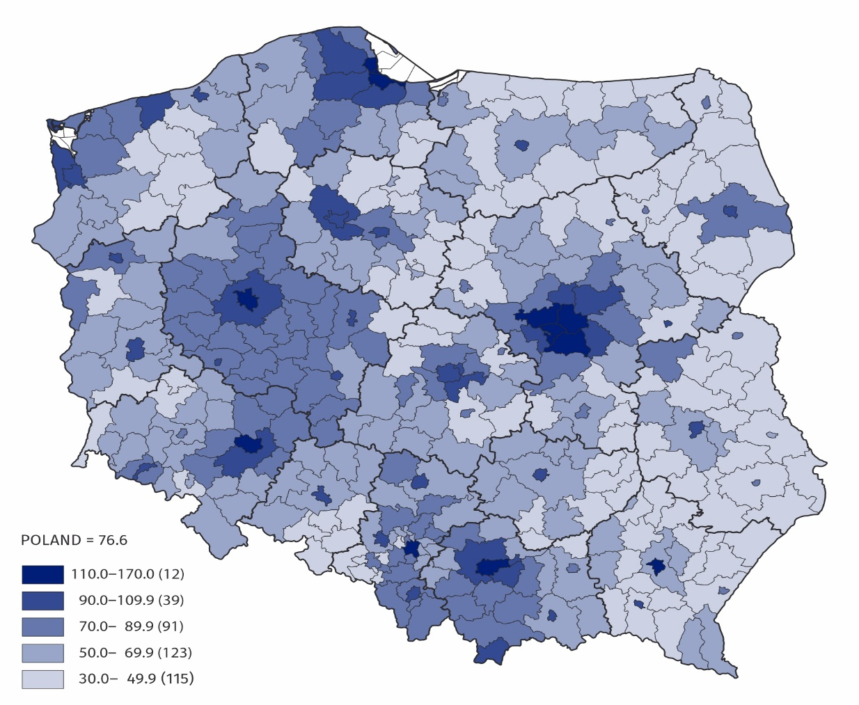
Map 1. Number of active enterprises by powiats per 1 000 population in the first quarter of 2026

The data presented in this news release concern active enterprises (understood as a one legal unit) regardless of the size class by number of persons employed and the kind of accounting record kept. The data include entities of the national economy which are market producers, for which the predominant activity is classified according to the NACE Rev. 2 to section A (excluding indywidual agricultural holdings), B, C, D, E, F, G, H, I, J, K, L, M, N, P, Q, R, S (excluding division 94).
The enterprises method was used for preparing the data, and this method involves taking entire enterprises as the basic for grouping data according to clasifications and territorial divisions.
Code | Full name | Abbreviation
A* | Agriculture, forestry, hunting and fishing | –
B | Mining and quarrying | –
C | Manufacturing | –
D | Electricity, gas, steam, hot water and air conditioning manufacturing and supply | Energy generation and supply
E | Water supply; sewerage, waste management and remediation activities | Water supply; sewage and waste management
F | Construction | –
G | Wholesale and retail trade; repair of motor vehicles including motorcycles | Trade; repair of motor vehicles
H | Transportation and storage | –
I | Accommodation and food service activities | Accommodation and catering
J | Information and communication | –
K | Financial and insurance activities | –
L | Real estate activities | –
M | Professional, scientific and technical activities | –
N | Administrative and support service activities | –
P | Education | –
Q | Human health and social work activities | –
R | Arts, entertainment and recreation activities | –
S** | Other service activities | –
An enterprise is considered to have been active in the quarter if it conducted economic activity at least in one month of that quarter (regardless of the number of days of activity conduted).
In this news release, abbreviated names of some sections of NACE Rev. 2 were used; the list of letter symbols of the section (code), full names and abbreviated names is as follows:

* Section A– excluding indywidual agricultural holdings
** Section S – excluding division 94 Activities of membership organisations

An integral part of this news release are tables in XLSX format (downloadable files) with a set of tables presenting data in detailed breakdown, including by NACE Rev. 2 groups and by powiats.

In case of quoting Statistics Poland data, please provide information: “Source of data: Sta-tistics Poland”, and in case of publishing calculations made on data published by Statistics Poland, please include the following disclaimer: “Own study based on figures from Statistics Poland”.

Prepared by:  Enterprise Statistics Department  Director Katarzyna Walkowska-Macias  Phone: (+48 22) 608 31 25 | Issued by:  Press Office  Mobile: (+48) 695 255 032  Phone: (+48 22) 608 38 04, (+48 22) 449 41 45,  (+48 22) 608 30 09  e-mail: obslugaprasowa@stat.gov.pl

stat.gov.pl

@GUS_STAT

@GlownyUrzadStatystyczny

@gus_stat

@GłównyUrządStatystycznyGUS

@Główny Urząd Statystyczny

Related publications
Enterprises active in the fourth quarter of 2025

