Tourist accommodation establishments in coastal areas in July and August 2025
(concerns tourist accommodation establishments with 10 or more bed places)
In July and August 2025, 2.1 million tourists were accommodated in tourist accommodation establishments located in coastal areas, and 9.0 million overnight stays were provided for them. Compared to the same period last year, the number of tourists was higher by 6.0%, and number of overnight stays by 3.3%.
6.0%
Increase in the number of tourists in tourist accommodation establishments in coastal areas in July and August 2025 compared to the corresponding months of the previous year

Coastal gminas according to Eurostat methodology
According to the Eurostat methodology, 55 gminas of the voivodships: Pomorskie (26), Zachodniopomorskie (23) and Warmińsko-Mazurskie (6) are classified as coastal areas in Poland. They are situated by the Baltic Sea or are in direct proximity to the sea. They cover 2.5% of Poland's territory (7.9 thousand square kilometres) and are inhabited by 4.2% of the country's population (1.6 million people).
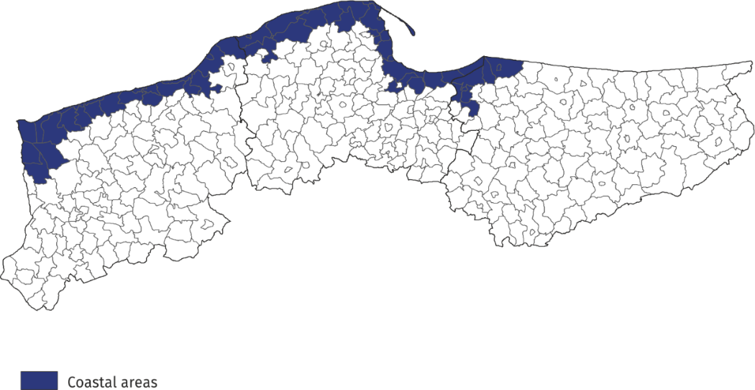
Map 1. Coastal gminas
Tourist accommodation establishments in coastal areas
As of the end of July 2025, 2437 tourist accommodation establishments operated in coastal areas, i.e. 21,9% of all establishments in Poland. The vast majority of them (almost 2/3) operated on a seasonal basis (the percentage of seasonal establishments in Poland was less than 30%). Almost half of the holiday centres operating in the country functioned here, as well as 38.2% of holiday youth centres, 38.0% of complexes of tourist cottages, 33.5% of rooms for guest, and 28.6% of camping sites. Compared to the previous year, the number of accommodation establishments in coastal areas increased by 93, i.e. by 4.0%.
The structure of accommodation establishments in coastal areas is fundamentally different from the structure of establishments in total in Poland (concerns tourist accommodation establishments with 10 or more bed places). Rooms for guests prevail – at the end of July this year there were 929 of them and they accounted for 38.1% of all establishments in these areas. There were numerous holiday centres – 424 (17.4% of all establishments in coastal area) and complexes of tourist cottages – 276 (11.3%). Hotels accounted for 10.3% of tourist accommodation establishments in coastal areas (23.7% in Poland).
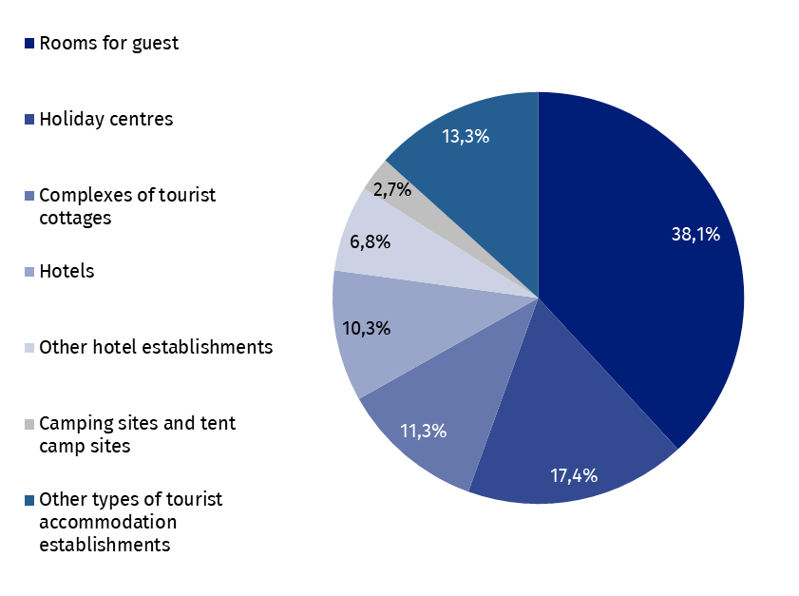
Chart 1. Tourist accommodation establishments in coastal areas in 2025
as of 31 July
At the end of July 2025, tourist accommodation establishments located in coastal gminas had 238.2 thousand bed places, which accounted for 26.9% of the total number of bed places in accommodation establishments in Poland, and it was 9.6 thousand (i.e. 4.2%) more than a year ago. Compared to the corresponding period of the previous year, the number of bed places increased the most in rooms for guests/private lodgings and complexes of tourist cottages (by 2.7 thousand), followed by hotels (2.4 thousand).

Chart 2. Bed places in tourist accommodation establishments in coastal areas in 2025
as of 31 July
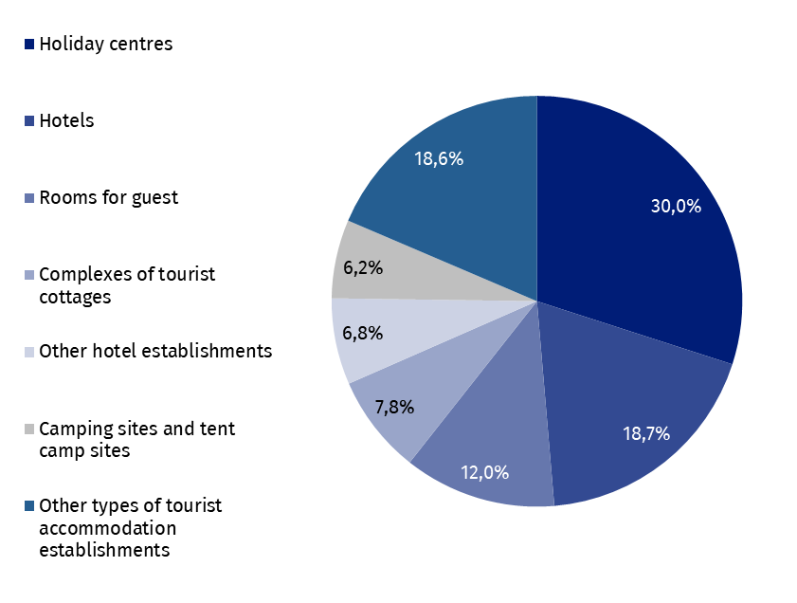
The largest number of bed places was offered by holiday centres – 71.5 thousand, i.e. 30.0% of the total number of bed places in the area. Hotels had 44.5 thousand (i.e. 18.7%) places prepared for tourists, while rooms for guest had 28.5 thousand (i.e. 12.0%). Among other types of establishments, 18.6 thousand bed places were available for tourists in complexes of tourist cottages, 16.1 thousand in other hotel establishments and 11.7 thousand in health establishments.
Establishments in coastal areas are larger than the average in Poland. One establishment functioning in coastal areas had an average of 98 places (80 places in the country).
In 2025, the density index of the accommodation establishments in coastal areas was 26.1 places per 1 square kilometre of area (in the country – 2.8).
Tourists accommodated in tourist accommodation establishments
Tourists accommodated in establishments in coastal areas during the holiday period 2025 constituted 21.7% of all tourists accommodated in the whole country during that period

During the holiday season (i.e. in July and August) of 2025, 2.1 million tourists were accommodated in accommodation establishments located in coastal gminas (1.0 million in July and 1.1 million in August), i.e. 21.7% of tourists accommodated in accommodation establishments throughout the country during this period (in the corresponding period of 2024 this percentage amounted to 22.0%). Compared to the corresponding period of 2024, the number of tourists using overnight stays in July and August was higher by 120.2 thousand, i.e. by 6.0% (in July higher by 5.6% and in August by 6.4%).
Over 1/3 of tourists (716.9 thousand) staying in these areas were accommodated in hotels.
A large number of tourists chose to stay in holiday centres – 479.3 thousand (22.6%) and in other types of establishments – 225.4 thousand (10.6%).
Among the total number of tourists accommodated in tourist accommodation establishments 81.4% (1.7 million) were domestic tourists, and 18.6% (0.4 million) were foreign tourists. In relation to the same period of 2024, the number of domestic tourists was higher by 5.6% and the number of foreign tourists by 8.0%.
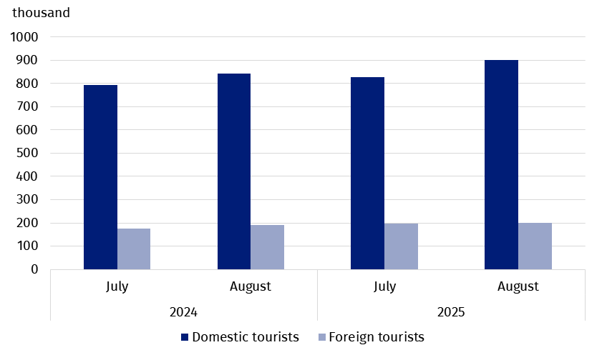
Chart 3. Tourists accommodated in coastal areas in July-August
In July and August 2025, as in previous years, visitors from Germany accounted for the majority of foreign tourists staying in coastal areas. During this period, 198.7 thousand visitors arrived, which was 14.6 thousand more than in the same period last year, and their share in the total number of foreign tourists remained at the same level as last year, at 50.3%. The share of guests from other countries did not exceed 8.0%; most of them were from Czechia (29.2 thousand), followed by Sweden (24.5 thousand) and Norway (20.4 thousand), who constituted, respectively, 7.4%, 6.2% and 5.2% of the total number of foreign tourists accommodated in coastal areas.
Overnight stays provided at tourist accommodation establishments
Overnight stays provided in July and August in coastal areas accounted for 31.6% of all overnight stays in Poland during this period

A total of 9.0 million overnight stays were provided for tourists staying in coastal areas in July and August this year, which accounted for 31.6% of all overnight stays provided at tourist accommodation establishments in Poland during that period. In the same period last year, the share was 0.7 percentage points lower.
This year, both July and August saw 4.5 million overnight stays each for tourists. Compared to the same period in 2024, the total number of overnight stays provided in July and August this year was higher by 3.3% (i.e. 285.7 thousand) – in July by 3.0% (131.0 thousand), and in August by 3.6% (154.7 thousand).
On average, 4.2 overnight stays were provided for tourists during their holiday trips, while the average length of a tourist stay in Poland during that period was 2.9 nights.
7.7 million overnight stays were provided for domestic tourists (3.6% more than in July and August last year) in the period July-August 2025, and they accounted for 85.7% of the total number of overnight stays in coastal areas and 32.6% of the total number of overnight stays provided for domestic tourists in the same period in Poland. A total of 1.3 million overnight stays were provided for foreign tourists, which was 1.5% more than in the previous year. Most overnight stays were provided to tourists from countries neighbouring Poland, i.e. Germany (770.4 thousand – 60.2% of overnight stays of foreign tourists), Czechia (112.6 thousand – 8.8%) and also Sweden (53.1 thousand – 4.1%).
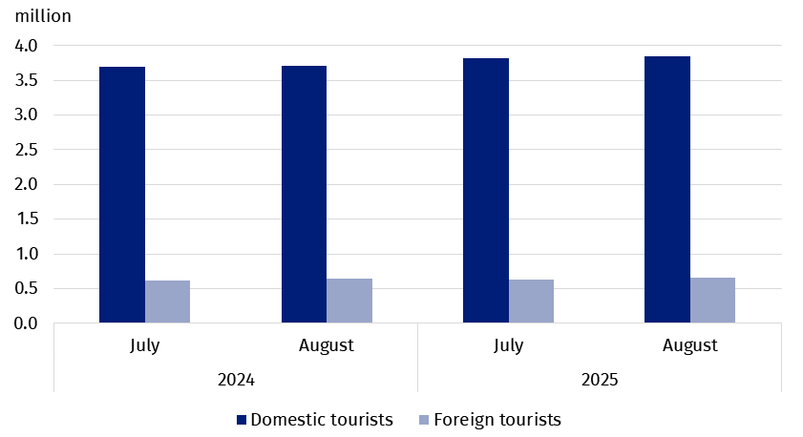
Chart 4. Overnight stays provided tourist accommodation establishments in coastal areas
in July-August
Occupancy rate of bed places in tourist accommodation establishments
During the holiday season (July, August), places in tourist accommodation establishments located in coastal gminas are usually better occupied than in other areas of the country.
The occupancy rate of bed places in coastal gminas was higher than the national average and amounted to 60.7% in July and 61.9% in August

In July, the occupancy rate of bed places amounted to 60.7%, and in August – 61.9%, while the average for the entire country amounted to 50.2% and 53.1%, respectively.
Similarly, in the corresponding months of 2024, the indicator for coastal areas was higher than for the country – in July 61.1% and 50.8%, and in August, 62.3% and 52.8%, respectively.
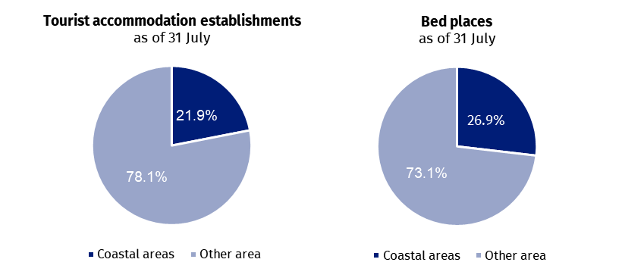
Chart 5. Tourist accommodation establishments in coastal areas in comparison with the country in July-August 2025
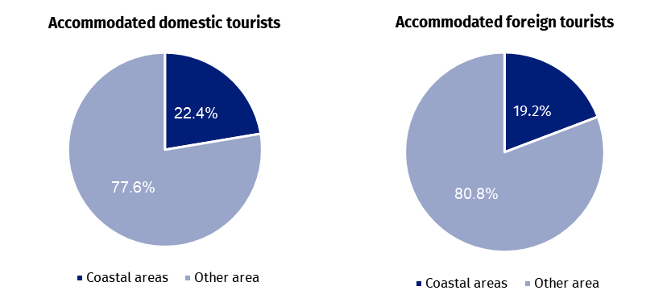
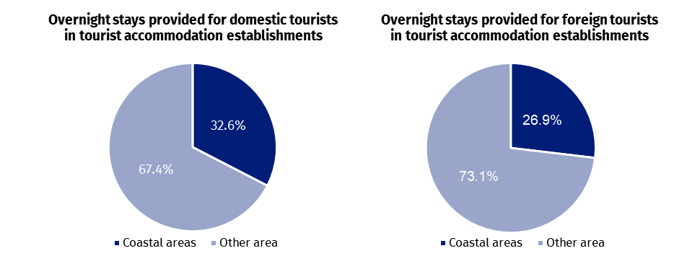

Occupancy of tourist accommodation establishments in gminas located in coastal areas in July and August 2025
In the coastal areas in July and August this year the highest number of overnight stays were provided in accommodation establishments located in Kołobrzeg urban gmina – 985.8 thousand, which constituted 11.0% of all overnight stays provided in this area. 176.4 thousand tourists were accommodated there. This indicates that during the two summer months, an average of 423 tourists using accommodation facilities and 2,229 overnight stays were recorded per 100 residents of the city.
In the period July-August, the largest number of overnight stays in coastal gminas was provided in Kołobrzeg and Gdańsk

Large tourist traffic was also recorded in Gdańsk, where in July-August with almost 952.5 thousand overnight stays were provided to 372.0 thousand tourists. There was an average of 72 tourists and 189 overnight stays per 100 inhabitants of the city.
From approximately 500 thousand up to 700 thousand overnight stays were provided in 4 gminas: Rewal – 683.8 thousand, Władysławowo – 559.1 thousand, Mielno – 555.7 thousand and Świnoujście – 529.1 thousand.
After over 400 thousand overnight stays were recorded in tourist night establishments in the following gminas: Ustronie Morskie (413.5 thousand), Kołobrzeg rural gmina (408.5 thousand) and Międzyzdroje (402.6 thousand).
Table 1. Tourist accommodation establishments and its occupancy in the period July-August in 2025
Gmina | Overnight stays provided |  |  | Tourists accommodated
Gmina | in thousand | July-August 2024=100 | in per-centages | in thousand | July-August 2024=100
Coastal area  of which: | 8 952.1 | 103.3 | 100,0 | 2 123.1 | 106.0
Kołobrzeg  (urban gmina) | 985.8 | 101.9 | 11.0 | 176.4 | 96.1
Gdańsk | 952.5 | 103.4 | 10.6 | 372.0 | 105.9
Rewal | 683.8 | 115.1 | 7.6 | 135.5 | 108.7
Władysławowo | 559.1 | 97.6 | 6.2 | 120.8 | 100.6
Mielno | 555.7 | 104.1 | 6.2 | 108.6 | 108.4
Świnoujście | 529.1 | 105.2 | 5.9 | 131.8 | 110.6
Ustronie Morskie | 413.5 | 103.9 | 4.6 | 79.7 | 109.3
Kołobrzeg  (rural gmina) | 408.5 | 104.6 | 4.6 | 86.5 | 105.1
Międzyzdroje | 402.6 | 109.0 | 4.5 | 106.0 | 120.1
Łeba | 368.8 | 135.4 | 4.1 | 87.5 | 176.0
In total, over 60% of tourist traffic from coastal areas was concentrated in the above-mentioned 10 gminas, both in terms of the number of tourists using accommodation establishments and overnight stays.
In case of quoting Statistics Poland data, please provide information: “Source of data: Statistics Poland”, and in case of publishing calculations made on data published by Statistics Poland, please include the following disclaimer: “Own study based on figures from Statistics Poland”.

Prepared by:  Statistical Office in Rzeszów  Acting Director Teresa Krzemińska  Office: tel. (+48 17) 853 52 10 | Issued by:  Press Office  Mobile: (+48) 695 255 032  Phone: (+48 22) 608 38 04, (+48 22) 449 41 45,  (+48 22) 608 30 09  e-mail: obslugaprasowa@stat.gov.pl

stat.gov.pl/en/

@StatPoland

@GlownyUrzadStatystyczny

gus_stat

glownyurzadstatystycznygus

glownyurzadstatystyczny
Related information
Occupancy of tourist accommodation establishments in the first quarter of 2025
Tourism in 2024
Data available in databases
Local Data Bank
Terms used in official statistics
Tourist
Tourist accommodation establishment
Bed places in tourist accommodation establishments
Foreign tourists in tourist accommodation establishments
Nights spent (overnight stays) in tourist accommodation establishments.
Duration of stay
Occupancy rate of bed places or rooms

According to the Eurostat methodology, coastal areas are classified on the basis of the distance of a given gmina from the sea: if a gmina borders on the sea, it is, as a rule, a coastal gmina; if a gmina does not border on the sea but 50% of its area is within 10 km from the sea, it is also considered a coastal gmina.
The indicator takes into account the total area of the units, including the area of internal sea waters.
Population balance as of 30th June 2025
The indicator takes into account the total area of the units, including the area of internal sea waters.

