Energy efficiency in the years 2014–2024
Poland's energy efficiency increased by 0.7% in 2024 compared to 2023. Between 2014 and 2024, the annual cumulative growth rate of energy efficiency amounted to 1.2%. Primary energy intensity of GDP decreased by an average of 3.3% per year during this period, while final energy intensity of GDP decreased by 2.2% per year. The fastest rate of energy efficiency improvement was observed in industry (by 2.8% per year).
0.7%
An increase of energy efficiency in Poland in 2024 compared to 2023.

Total primary energy consumption increased between 2014 and 2024 from 89.5 Mtoe to 92.3 Mtoe (cumulative annual growth rate - 0.3%). Final energy consumption increased from 60.2 Mtoe to 69.2 Mtoe during the analysed period (a cumulative annual growth rate of - 1.4%). Total consumption reached its peak in 2018 (104.1 Mtoe) and final energy consumption in 2021 (74.2 Mtoe).
In 2024, total primary energy consumption was lower than in 2023
Chart 1. Total primary energy consumption and final energy consumption
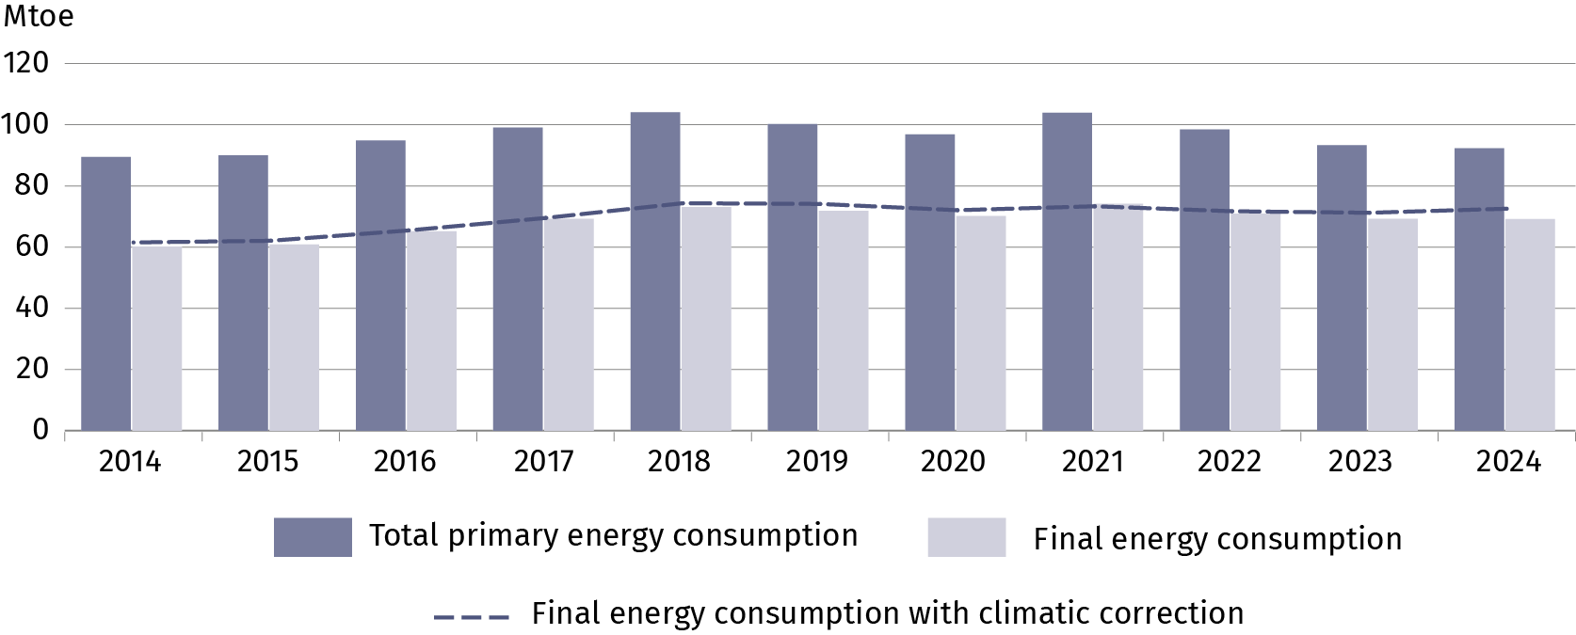
Primary energy intensity of GDP in 2024 decreased by 3.5% compared to the previous year, while final energy intensity of GDP decreased by 3.2%.
Compared to 2014, the primary energy intensity of GDP in 2024 decreased by 28.4% and final energy intensity of GDP by 19.9%. After taking into account the influence of climatic conditions, the rate of improvement was slightly lower – a decrease of 27.0% for primary energy intensity and 17.8% for final energy intensity, respectively.

Table 1. The annual cumulative growth rate of energy efficiency of GDP
Rate of improvement | 2014–2019 | 2020–2024 | 2014–2024
Rate of improvement | %/year
Primary energy intensity of GDP | -2.4 | -4.2 | -3.3
Primary energy intensity of GDP  with climatic corrections | -2.2 | -3.9 | -3.1
Final energy intensity of GDP | -1.0 | -3.3 | -2.2
Final energy intensity of GDP  with climatic corrections | -0.9 | -3.0 | -1.9

Households
In 2024 household energy consumption accounted for 28.4% of final energy consumption. The most commonly consumed energy carrier was natural gas with a share of 21.6%, followed by solid fossil fuels (18.4%), heat (16.7%) electricity (14.2%) liquid fuels (2.7%). The consumption of other energy carriers, which included among others solid biofuels and ambient heat, was 26.4%.
The most important direction of energy use was space heating, with a 61.7% share in 2024. Water heating consumed 18.7% of energy, lighting and electrical appliances 11.6% and preparing meals 8.0%.
Table 2. Structure of energy consumption in households by directions of use
The share of energy used for space heating in 2024 decreased by 5.1 percentage points compared to 2019
Specification | 2019 | 2020 | 2021 | 2022 | 2023 | 2024
Specification | %
Total | 100.0 | 100.0 | 100.0 | 100.0 | 100.0 | 100.0
Space heating | 66.8 | 66.3 | 65.5 | 62.9 | 62.1 | 61.7
Water heating | 16.0 | 16.2 | 17.0 | 18.1 | 18.6 | 18.7
Cooking | 8.0 | 8.1 | 8.3 | 9.1 | 9.1 | 8.0
Lighting and electrical  appliances | 9.2 | 9.4 | 9.2 | 9.8 | 10.2 | 11.6
The household energy consumption rate per m² showed a decreasing trend. The volume of consumption in 2024 amounted to 18.4 kgoe/m², compared with 20.0 kgoe/m² in 2014 (cumulative annual decrease of 0.8% per year). Adjusted for climatic corrections, consumption per m² decreased by 0.1% per year.

Chart 2. Energy consumption in households per m²
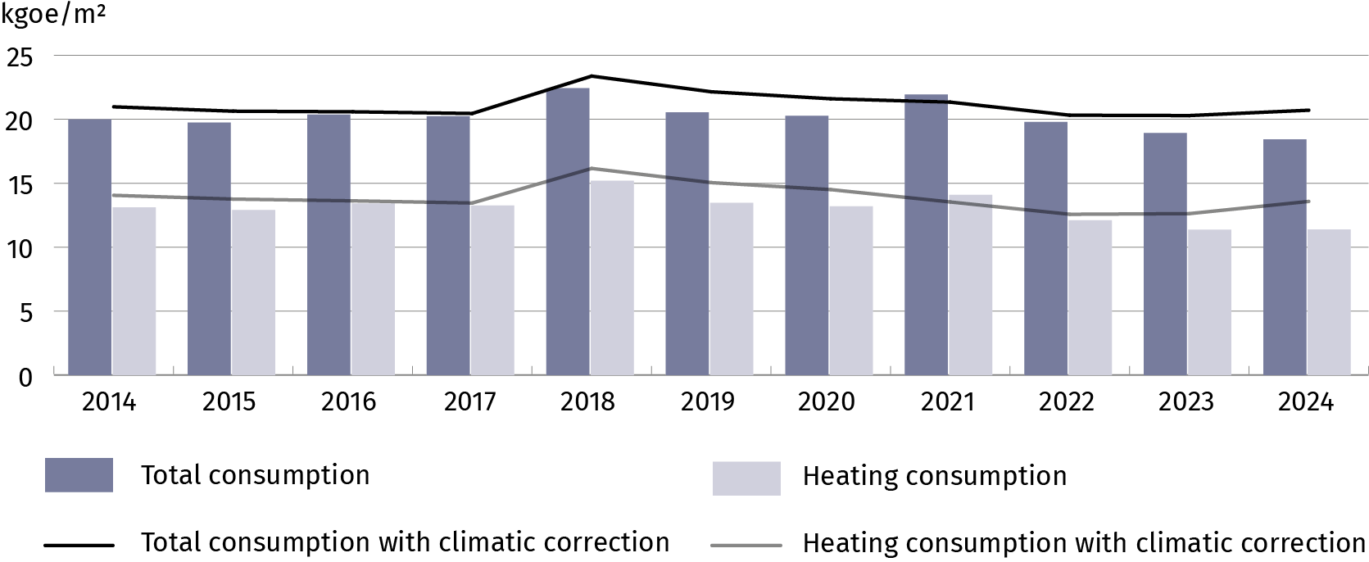

Industry
Between 2014 and 2015, final energy consumption in industry showed only minor fluctuations, after which a marked increase began in 2016, reaching a peak of 16.5 Mtoe in 2019. Since 2021, energy consumption has been gradually declining. In 2024, it amounted to 14.5 Mtoe (accounted for 21.0% of total energy consumption), which was 4.1% lower than in 2022.
Final energy consumption in the industrial sector has continued to decline. Compared with 2021, this decrease amounted to 10.9%
Over the period 2014–2024, a decline in consumption was observed for solid fossil fuels (by 41.9%) and manufactured gases (by 41.8%)." At the same time, consumption increased for non-renewable waste (by 50.5%), heat (by 25.3%), natural gas (by 21.9%), renewable energy sources (RES) and biofuels (by 20.2%), electricity (by 12.1%), and petroleum products (by 10.8%).
The structure of final energy consumption in manufacturing industry was dominated by the three most energy-intensive branches: the food, chemical, and mineral industries, which together accounted for 55.5% of total energy consumption in this sector in 2024, (compared to 54.1% in 2014).
Chart 3. Structure of final energy consumption in manufacturing by branch
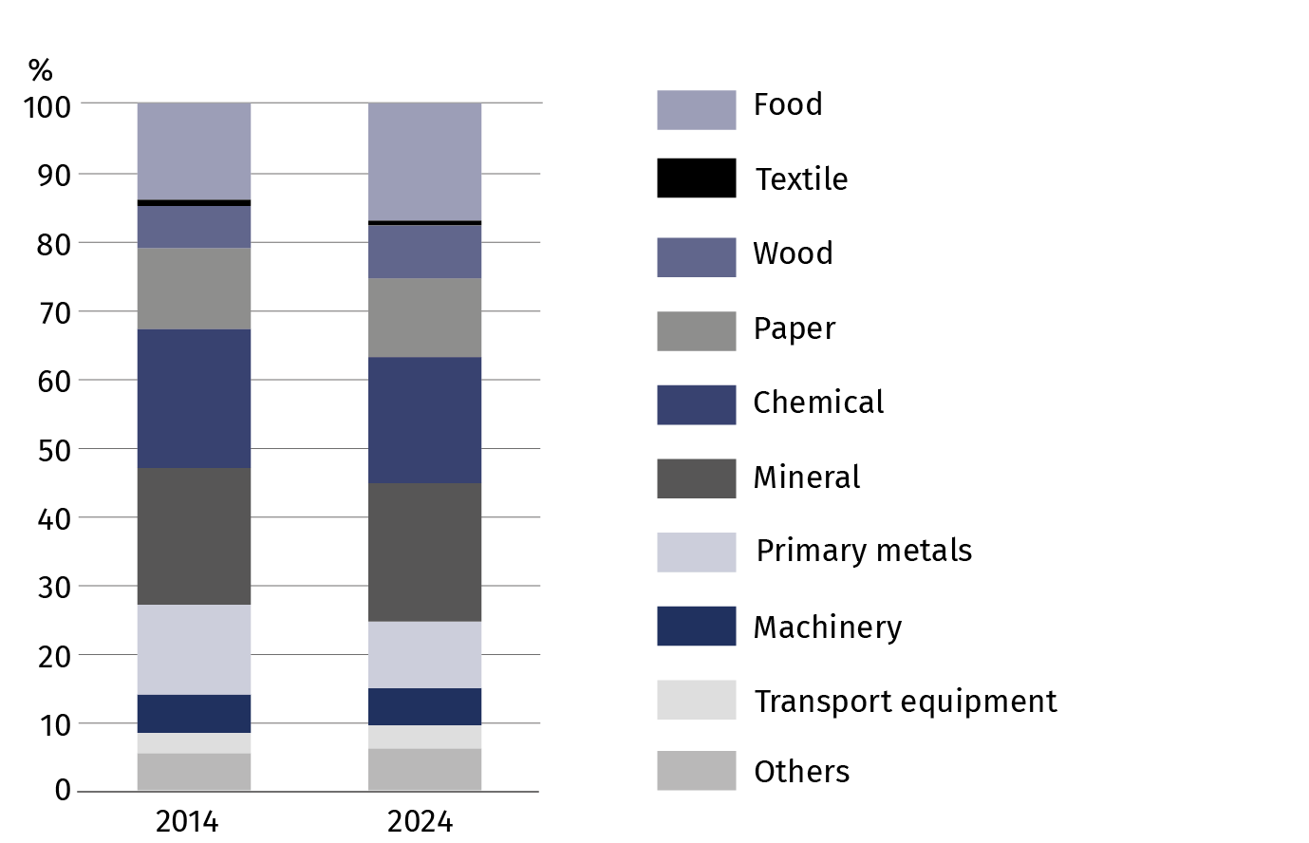

ODEX indicator
The ODEX index, which measures progress in energy efficiency for the entire economy (base year 2010 = 100), decreased across the entire economy from 89.1 in 2014 to 78.8 in 2024. This indicates an improvement in energy efficiency by 11.5% during the analysed period. The average annual improvement rate amounted to 1.2%.
Energy efficiency of the economy improved during the 2014–2024 period. The fastest rate of improvement (2.8% per year) was recorded in industry, while the slowest was in the transport sector (0.08% per year)
The greatest progress was recorded in the industrial sector, where energy efficiency improved by 24.5%, corresponding to an average annual improvement rate of 2.8%. A significant improvement was also observed in the services sector, where energy efficiency increased by 16.7%, and the average annual improvement rate was 1.8%. In the household sector, energy efficiency improved by 10.0%, with an average annual improvement rate of 1.0%.
The slowest improvement was observed in the transport sector. Over the period analysed, energy efficiency increased by only 0.8%, corresponding to an average annual improvement rate of 0.08%.
Chart 4. ODEX indicator
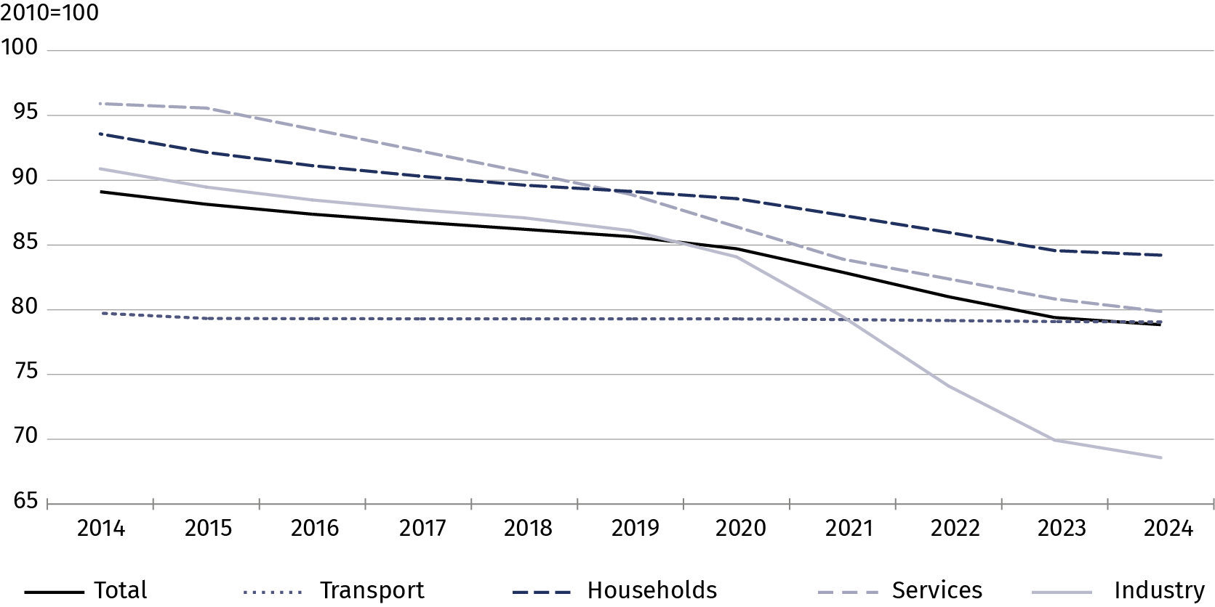
Decomposition of energy consumption
Economic activity had the greatest impact on the increase in energy demand
Between 2014 and 2024, final energy consumption in the economy increased by 8.3 Mtoe. This increase was mainly driven by factors related to economic activity (14.4 Mtoe), particularly in industry (6.5 Mtoe) and transport (4.5 Mtoe). The increase in consumption was also influenced by the growing number of households (1.7 Mtoe) and changes in lifestyle (0.7 Mtoe). The most significant factor limiting energy consumption was the implementation of energy-saving measures (8.0 Mtoe), especially in industry (4.3 Mtoe) and households (2.2 Mtoe). Additionally, favourable weather conditions contributed to a reduction of 1.8 Mtoe. The transport sector recorded the largest increase in energy consumption (8.6 Mtoe), whereas in households, consumption remained unchanged, and in agriculture and services, it declined slightly.

Table 3. Influence of factors on the change in final energy consumption in years 2014–2024
Specification | Industry | Households | Transport | Services | Agriculture | Total
Specification | Mtoe
Consumption change | 0.4 | 0.0 | 8.6 | -0.4 | -0.3 | 8.3
Factors:
Activity | 6.5 | — | 4.5 | 3.5 | 0.0 | 14.4
Stock of dwellings | — | 1.7 | — | — | — | 1.7
Lifestyle | — | 0.7 | — | — | — | 0.7
Structural changes | -1.9 | — | 0.7 | — | — | -1.3
Energy  savings | -4.3 | -2.2 | 0.0 | -1.4 | — | -8.0
Weather  conditions | — | -1.3 | — | -0.5 | — | -1.8
Others | 0.2 | 1.1 | 3.4 | -1.9 | -0.3 | 2.6

When quoting Statistics Poland data, please provide the information: “Source of data: Statistics Poland”, and when publishing calculations made on data published by Statistics Poland, please include the following disclaimer: “Own study based on figures from Statistics Poland”.
Prepared by:  Statistical Office in Rzeszow  Acting Director Andżelika Malinowska  Phones: 17 853 52 10, 17 853 52 19 | Issued by:  Press Office  Mobile: (+48) 695 255 032  Phone: (+48 22) 608 38 04, (+48 22) 449 41 45,  (+48 22) 608 30 09  e-mail: obslugaprasowa@stat.gov.pl

stat.gov.pl/en/

@StatPoland

@GlownyUrzadStatystyczny

@gus_stat

@GłównyUrządStatystycznyGUS

@Glówny Urząd Statystyczny
Related information
Energy statistics
Energy efficiency in Poland
Data available in databases
Knowledge databases - Energy statistics
Poland macroeconomic indicators
Macroeconomic Data Bank
Terms used inn official statistics
Primary energy
Derived energy
Energy consumption

