Sales of prescription medicines in 2025
In 2025, the sales value of prescription medicines amounted to PLN 33.4 billion and it was 13.1% more than in the previous year. The number of completed prescriptions also increased, but only by 0.4%, reaching 515.6 million prescriptions. Up to 97.8% of all prescriptions were electronic prescriptions.
The share of reimbursements from the National Health Fund reached 45.9% of the value of all prescription medicines sold.
13.1%
Increase in prescription medicines sales value in 2025

15.5%
Lorem ipsum dolor sit amet,
consectetur adipiscing elit

In 2025, pharmacies and pharmacy outlets throughout Poland dispensed 515.6 million prescriptions. This was 2.3 million more than in the previous year, representing an increase of 0.4%.
In 2025, an average of 13.8 prescriptions were dispensed per resident of Poland.
The highest number of prescriptions per capita was implemented in the Łódzkie voivodeship (15.8) and the least - in Podkarpackie (12.5), while the national average was 13.8 prescriptions per capita per year.
The variation in the number of completed prescriptions per capita was much greater at the poviat level than at the voivodeship level. The least prescriptions in relation to the number of inhabitants served pharmacies and pharmacy outlets in the land poviats surrounding cities with poviat rights. The least prescriptions in relation to the population of the poviat – i.e. between 3.2 and 3.7 prescriptions per capita – were carried out in przemyski (without the city of Przemyśl), łomżyński (without the city of Łomża) and suwalski (without the city of Suwałki). On the other hand, at the opposite end of the noted values of this indicator there were cities with poviat rights acting as service centers, where there were medical institutions, pharmacies and pharmacy outlets also visited by residents of nearby low-urbanized poviats. The highest number of completed prescriptions in relation to the number of poviat inhabitants was noted in the following poviats which were also cities with poviat rights: Zamość (31.1 prescriptions per capita), Krosno (29.6), Chełm (26.7) and Tarnów (26.4).
Map 1. Number of prescriptions per capita poviat in 2025
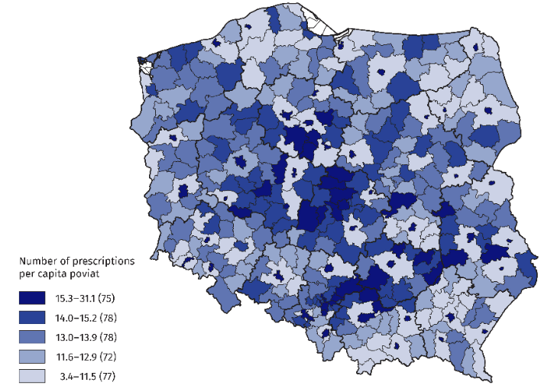
Data source: Medical Information System of the Ministry of Health.
Electronic prescriptions accounted for 97.8% of all completed prescriptions. This percentage increased by 0.4 percentage points compared to 2024, and was at a similar level in all voivodeships (the difference between the extreme values was only 1.2 percentage points). There was greater diversity between poviats (the spread was less than 7 percentage points for the collective of all 380 poviats). The highest percentage of electronic prescriptions occurred in poviats: moniecki, siedlecki and nowomiejski (99.5% each), and the lowest - in golubsko-dobrzyński poviat (92.8%).
It is worth recalling that electronic prescriptions were introduced relatively recently, i.e. in 2020, and after a year they accounted for 94.4% of all completed prescriptions.

In 2025, the value of sales of medicines increased by 13.1% and the value of reimbursements by 15.8%. The share of reimbursements in the cost of purchased medicines increased to 45.9%
Electronic prescriptions accounted for 97.8% of all completed prescriptions

In 2025, the value of sales of prescription medicines amounted to PLN 33.4 billion, which was an increase by PLN 3.8 billion (i.e. by 13.1%) compared to 2024. Patients buying prescription medicines paid a total of PLN 18.1 billion for them, i.e. PLN 1.8 billion more than in the previous year (an increase of 10.9%). The value of reimbursement from the National Health Fund reached PLN 15.3 billion, PLN 2.1 billion more compared to 2024 (an increase of 15.8%).
Between 2022 and 2025, the value of sales of prescription medicines increased by 52.8%, with higher growth dynamics for the value of reimbursements from the NHF than for patient co-payments for medicines – 78.7% vs. 36.1%, respectively. As a result, the share of NFZ reimbursement in the value of sales of prescription medicines increased from 39.3% in 2022 to 45.9% in 2025.
The average value of prescription medicines issued per capita of Poland amounted to PLN 893 (an increase of PLN 106 year on year), including reimbursement from the National Health Fund amounted to PLN 410. The statistical patient paid PLN 483 from his own funds, which accounted for 54.1% of the value of purchased medicines.

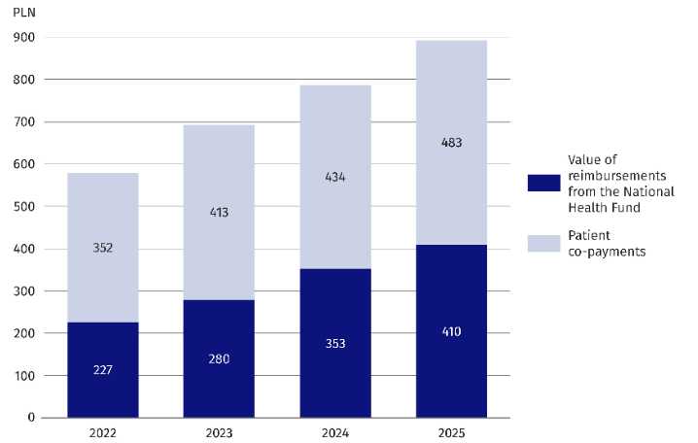
Chart 1. Value of reimbursements and patient co-payments for prescriptions medicines per capita in Poland in 2025
Data source: Medical Information System of the Ministry of Health.
In 2025 (as in the previous year), the highest value of sales of prescription medicines and reimbursement per capita was characterized by the łódzkie voivodeship. These values were respectively: 1005 PLN (sales of medicines) and 484 PLN (refund). In turn, the mazowieckie voivodeship had the highest amount of fees from a private pocket per capita (PLN 573), and the total value of sales of prescription medicines reached PLN 970 per capita, which was the second highest among all 16 voivodeships in terms of the value of medicines sold.
As in 2024, also in 2025 the lowest value of sales and refunds per capita was noted in the podkarpackie voivodeship (PLN 748 and PLN 349 respectively).
On the other hand, the lowest value of patient co-payments per capita was noted in the warmińsko-mazurskie voivodeship (PLN 397).

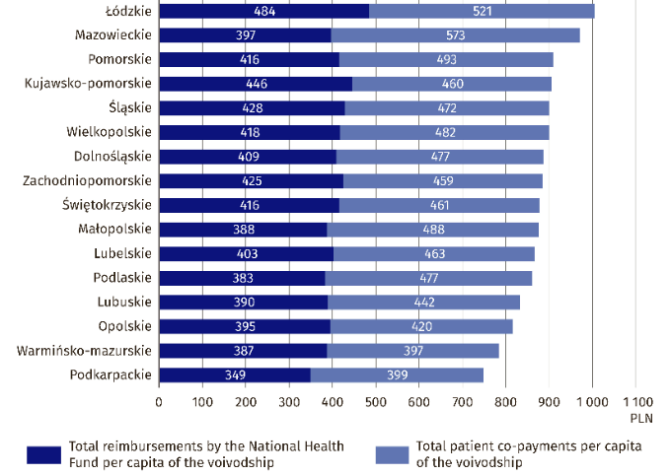
Chart 2. Prescription medicines sales value per capita by voivodeship in 2025
Data source: Medical Information System of the Ministry of Health.
In 2025, pharmaceuticals related to the treatment, relief of symptoms or prevention of gastrointestinal and metabolic disorders, including those helping to reduce overweight, accounted for the largest share of the value of prescription medicines sold. This broad category of medicines accounted for as much as 24.8% of total sales and its share is clearly increasing in recent years (17.5% in 2022, 18.9% in 2023, 21.4% in 2024).
In 2025, for the second time in a row, gastrointestinal and metabolic medicines accounted for the largest share of the value of medicines sold (24.8%). There has been a significant increase in the share of this group of medicines since 2022, when its share was 17.5%
The second largest share of sales of prescription medicines are cardiovascular medicines (17.7%). This group of medicines was the leader in the sales ranking until 2023, but in 2024 it was overtaken by the aforementioned category of pharmaceuticals prescribed for disorders of the gastrointestinal tract and metabolism.

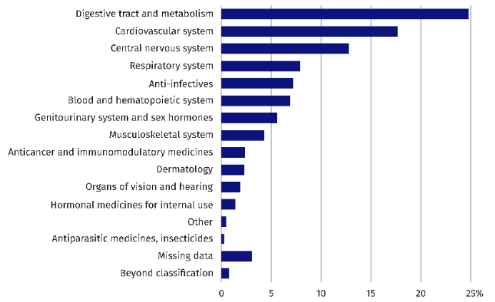
Chart 3. Share of prescription medicines sales by Anatomical-Therapeutic-Chemical Classification (ATC) groups in 2025
Data source: Medical Information System of the Ministry of Health.

Compared to the data on sales of medicines from the previous year, there was one change in the ranking for 2025: the group of medicines used for infections (anti-infectious) increased its share of total sales of prescription medicines from 5.5% to 7.2%, and advanced from seventh to fifth, slightly ahead of the group of medicines related to blood and hematopoietic system (6.9%) and the category of drugs aimed at the genitourinary system and sex hormones (5.6%).

This signal information is based on the analysis of data on the sale of prescription medicines sent by pharmacies and pharmacy outlets to the Medical Information System of the Ministry of Health.
When quoting Statistics Poland data, please provide the information: “Source of data: Statistics Poland”, and when publishing calculations made on data published by Statistics Poland, please include the following disclaimer: “Own study based on figures from Statistics Poland”.
Prepared by:  Social Research Department  Director  Izabela Grabowska, PhD  Phone: (+48 22) 608 31 22 | Issued by:  Press Office  Mobile: (+48) 695 255 032  Phone: (+48 22) 608 38 04,  (+48 22) 449 41 45,  (+48 22) 608 30 09  e-mail: obslugaprasowa@stat.gov.pl

stat.gov.pl/en/

@StatPoland

@GlownyUrzadStatystyczny

@gus_stat

@GłównyUrządStatystycznyGUS

@Glówny Urząd Statystyczny
Related information
Health and healthcare in 2024
Methodological booklet. Health and healthcare statistics – CSO reporting

