Municipal Infrastructure – Water Supply and Sewage System in 2025
In Poland in 2025 the length of the sewage network increased by 5.0 thousand km (by 2.7%), and the number of sewage connections to residential buildings by 116.9 thousand pcs (by 2.9%).
2.7%
An increase in the length
of the sewage network
compared to the end of 2024

Sewage system
Compared to 2024, increase in the number of connections to residential buildings of 2.9%.
At the end of 2025, the sewage network in Poland reached the length of 190.8 thousand km, whereas the number of connections to residential buildings – 4.2 million pcs. Compared to the previous year, the length of the newly built or reconstructed sewage network increased by about 5.0 thousand km, i.e. by 2.7%, with a simultaneous increase in the number of connections to residential buildings of almost 116.9 thousand pcs, i.e. of 2.9%.

Table 1. Infrastructure of the sewage system in 2024–2025
Specification | 2024 | 2023 = 100 | 2025 | 2024 = 100
Sewage network in thousand km (as of 31 December) | 185,8 | 102,4 | 190,8 | 102,7
Sewage network in km per 100 km² (as of 31 December) | 59,2 | 102,4 | 60,8 | 102,7
Connections to residential buildings in thousand pcs (as of 31 December) | 4045,0 | 102,8 | 4161,9 | 102,9
Wastewater from households discharged by sewage system during the year in hm³ | 1027,0 | 102,5 | 1026,2 | 99,9
61.2% of all sewage network was located in rural areas
In rural areas was located 61.2% of the sewage network and 47.9% of all sewage connections to residential buildings. Compared to the previous year, the length of the sewage network in rural areas increased by 4.0 thousand km (by 3.6%), and the number of connections to residential buildings of almost 65.9 thousand pcs (by 3.4%). In the same period, in urban areas of almost 1.0 thousand km of the sewage network was built (an increase of 1.3%), and 51.0 thousand pcs of connections to residential buildings was installed (an increase of 2.4%).
Data broken down by voivodships show, compared to 2024, the most significant increase in the length of the sewage network in voivodships: Małopolskie – of 4.4%, Lubelskie and Świętokrzyskie – of 3.7%, Podlaskie – of 3.1%, Podkarpackie – of 3.0% while the least in Kujawsko-pomorskie – of 1.6%.
The highest density of the sewage network at the end of 2025 was in voivodships: Śląskie – 154.5 km per 100 km², Małopolskie – 133.8 km per 100 km², and, Podkarpackie – 119.4 km per 100 km² whereas the lowest in voivodships: Podlaskie – 20.7 km per 100 km², and Lubelskie – 32.6 km per 100 km².

At the end of 2025 in the country, the percentage of residential buildings connected to the sewage network amounted to 55.5%, and was higher by 0.6 percentage point, compared to 2024. In urban areas, 78.1% of residential buildings were connected to the sewage network, whereas in rural areas – 42.2%.
The amount of wastewater discharged from households decreased by 0.7%
The amount of wastewater discharged from households by the sewage system in 2025 was 1026.3 hm³ (in urban areas – 881.0 hm³, and in rural areas – 145.3 hm³), and decreased, compared to 2024, by 0.7 hm³ (in urban areas it was an decrease of 0.2 hm³, and in rural areas an decrease of 0.5 hm³).

Chart 1. The length of the sewage network in 2025

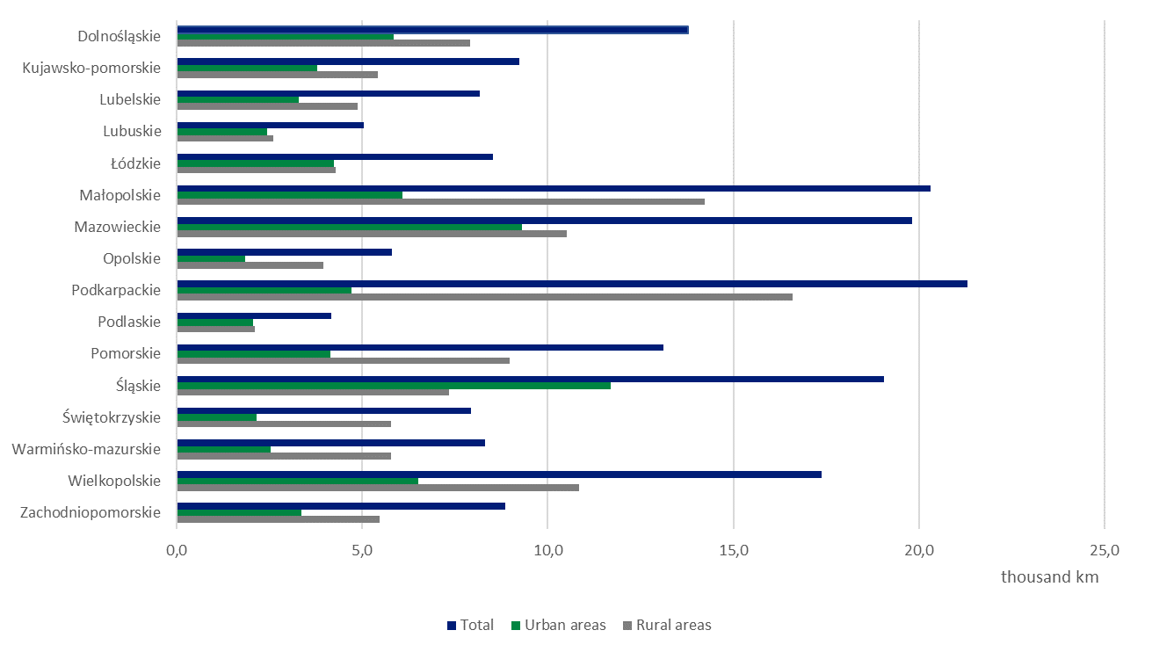

On-site systems for wastewater discharge
80.0% of on-site systems for wastewater discharge were septic tanks, and 20.0% were household wastewater treatment systems
The number of on-site systems for wastewater discharge as of the end of 2025 in Poland was 2,608.0 thousand pcs, of which 80.0% (2,283.8 thousand pcs) were septic tanks, and 20.0% (324.2 thousand pcs) – household wastewater treatment systems. The amount of liquid waste (domestic wastewater) collected from septic tanks during 2025 was 46,1 hm³, of which 10,9 hm³ (23.7% of the total amount) was collected in urban areas, and 35,2 hm³ (76.3%) in rural areas.

Water supply system
Compared to 2024, the length of the water supply network increased by 1.1%
At the end of 2025, the length of the water supply network reached 347.8 thousand km, and the number of connections to residential buildings – almost 6.5 million pcs. Compared to 2024, the length of the newly built or reconstructed water supply network increased by 3.9 thousand km (by 1.1%), and an increase of 122.1 thousand pcs (of 1.9%) in the number of connections to residential buildings was observed.

Table. 2 Infrastructure of the water supply system in 2024–2025
Specification | 2024 | 2023 = 100 | 2025 | 2024 = 100
Water supply network in thousand km (as of 31 December) | 343,9 | 100,8 | 347,8 | 101,1
Water supply network in km per 100 km² (as of 31 December) | 109,5 | 100,7 | 110,8 | 101,2
Connections to residential buildings in thousand pcs (as of 31 December) | 6 387,9 | 101,7 | 6 510,0 | 101,9
Household consumption of water during the year in hm³ | 1 334,6 | 102,9 | 1 333,4 | 99,9
Average household consumption of water per capita during the year in m³ | 35,5 | 103,2 | 35,6 | 100,3
75.6% of the length of water supply network is located in rural areas
75.6% of the length of the water supply network, and 62.1% of connections to residential buildings were located in rural areas. Compared to the previous year, the length of the water supply network in rural areas increased by 3.1 thousand km (by 1.2%) and amounted to 263.0 thousand km, whereas the number of connections to residential buildings – by 80.5 thousand pcs (by 2.0%). In urban areas however, there was an increase of 0.8 thousand km in the network (of 1.0%) – it’s length amounted to 85.0 thousand km, whereas the number of connections rose by 41.6 thousand pcs (by 1.7%).
Data broken down by voivodships show the most significant increase in the length of the water supply network in voivodships: Podkarpackie – of 3.0%, and Małopolskie – of 2.1%, whereas the lowest in voivodships: Lubuskie - of 0.2%, Łódzkie and Kujawsko-pomorskie – of 0.6%.
Along with the development of water supply infrastructure, the network density within the country area increases systematically. As of the end of 2025, it was 110.8 km per 100 km² and, compared to the previous year, it increased by 1.3 km per 100 km². The highest density of the water supply network still occurs in voivodships: Śląskie – 205.2 km per 100 km² (an increase, compared to the previous year, of 2.3 km per 100 km²) and Małopolskie – 162.9 km per 100 km² (an increase of 3.4 km per 100 km²), while the lowest in voivodships: Zachodniopomorskie – 56.4 km per 100 km² (an increase of 0.8 km per 100 km²) and Lubuskie – 60.5 km per 100 km² (an increase of 0.1 km per 100 km²).
As of the end of 2025, the percentage of residential buildings connected to the water supply system amounted to 86.4% and was higher by 0.4 percentage point, compared to 2024. In urban areas, 88.9% of residential buildings were connected to the water supply system, whereas in rural areas – 84.9%.
In 2025, household consumption of water per capita decreased slightly
In 2025, the household consumption of water amounted to 1,333.4 hm³ and, compared to the previous year, decreased by 1.2 hm³ (by 0.1%), whereas the average household consumption of water per capita amounted to 35.6 m³ and, compared to 2024, increased by 0.1 m³. In rural areas the consumption of water per capita decreased by 0.1 m³, and in urban areas rose by 0.3 m³.

Chart 2. The length of the water supply network in 2025
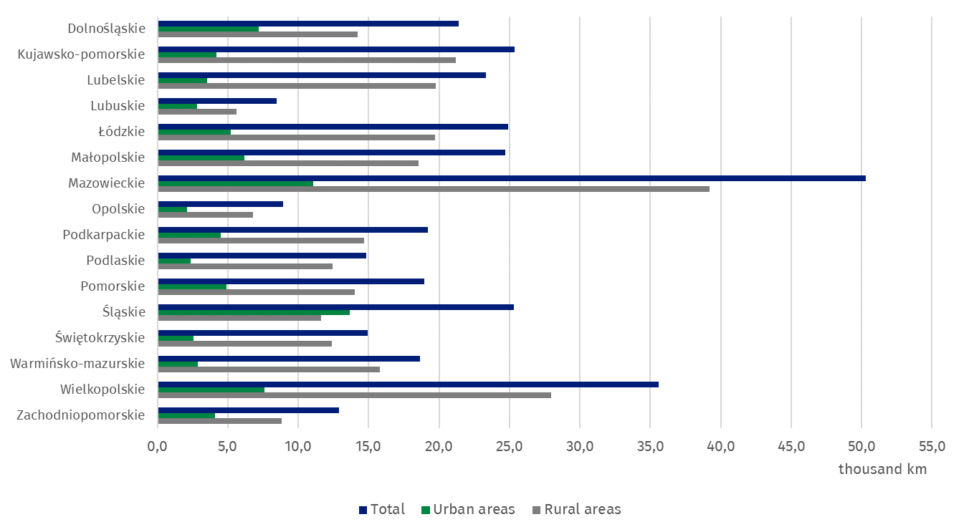

In case of quoting Statistics Poland data, please provide information: “Source of data: Statistics Poland”, and in case of publishing calculations made on data published by Statistics Poland, please include the following disclaimer: “Own study based on figures from Statistics Poland”.

Prepared by:  Statistical Office in Lublin  Director dr Krzysztof Markowski  Phone: (+48 81) 465 20 18 | Issued by:  Press Office  Mobile: (+48) 695 255 032  Phone: (+48 22) 608 38 04, (+48 22) 449 41 45,  (+48 22) 608 30 09  e-mail: obslugaprasowa@stat.gov.pl

stat.gov.pl/en/

@StatPoland

@GlownyUrzadStatystyczny

@gus_stat

@GlównyUrządStatystycznyGUS

@Glówny Urząd Statystyczny
Related information
Municipal Infrastructure – water supply and sewage system in 2024
Housing Economy and Municipal Infrastructure in 2024
Data available in databases
Local Data Base
Knowledge Databases Municipal and Dwelling Infrastructure
Terms used in official statistics
Sewage system
Active sewage network
Building equipped with sewage network
Septic tank
Liquid waste
Water supply network
Water supply system
Building fitted with water supply network

