Financial results of investment fund companies
in 2025
The value of total assets acumulated by investment fund companies at the end of 2025 amounted to PLN 4.0 billion and was by 4.9% higher than at the end of the previous year.
⇧ 4.9%
Increase in the value of assets of investment fund companies

At the end of December 2025, 55 investment fund companies (TFI) were in operation. They managed a total of 411 investment funds (excluding funds in liquidation).
Balance sheets of investment fund companies
Assets of investment fund companies amounted to PLN 4,022.7 million (4.9% more than at the end of December 2024), including current assets which reached PLN 3,102.6 million (increased by 2.7%) and accounted for 77.1% of total assets. Current assets mainly consisted of short-term investments, which increased to PLN 2,301.8 million (by 16.7%). Fixed assets accounted for 22.8% of total assets, increasing by 12.8% compared to 2024, to PLN 918.7 million. Long-term investments had the largest share in the fixed asset structure, at 73.6%.
The value of investment fund companies' assets increased by 4.9% during the year

In the liabilities of investment fund companies, equity (funds) amounted to PLN 3,068.6 million (increase of 17.0% compared to 2024) and represented 76.3% of the total liabilities. The value of share capital was PLN 743.3 million (increased by 5.5% compared to 2024).
The value of foreign capital in the share capital of TFI decreased to PLN 156.7 million (the share of foreign investors decreased by 2.6 percentage points to 21,1%). Ten investment fund companies had a share of foreign capital, of which eight exceeded 50%, one had an equal share of foreign and Polish capital (50% each), and one had a share of less than 50%.

Table 1. Selected items of the balance sheets of investment fund companies
Specification | 2024 | 2025
Specification | in milion PLN |  | 2024=100
Total assets: | 3 836,5 | 4 022,7 | 104,9
Fixed assets | 814,1 | 918,7 | 112,8
of which:
long-term investments | 552,9 | 676,4 | 122,3
Current assets | 3 019,9 | 3 102,6 | 102,7
of which:
short-term investments | 1 972,4 | 2 301,8 | 116,7
Total equity and liabilities: | 3 836,5 | 4 022,7 | 104,9
Equity capital | 2 622,7 | 3 068,6 | 117,0
of which:
share capital | 704,4 | 743,3 | 105,5
supplementary capital | 984,6 | 1 002,4 | 101,8
Liabilities and provisions for liabilities | 1 213,8 | 954,1 | 78,6
Profit and loss account of investment fund companies
TFI's net operating income in 2025 amounted to PLN 1.6 billion
In 2025, revenues from TFI's operating activities amounted to PLN 4,832.4 million and were by 15.4% higher than the value recorded in the previous year. The increase was mainly influenced by the change in revenue from the management of investment funds, which amounted to PLN 4,695.9 million and was higher by 16.3%. The operating costs of TFI at the end of 2025 amounted to PLN 3,267.1 million and were higher by 5.8% compared to the previous year. In the cost structure, the main items were external services (57.9% of the value of operating costs), which increased by 5.3% and remuneration with other related expenses (18.1%), which increased by 3.6% in 2025. The operating result of TFI in 2025 amounted to PLN 1,575.5 million and was 38.0% higher than in the previous year.

Chart 1. Selected financial data of investment fund companies
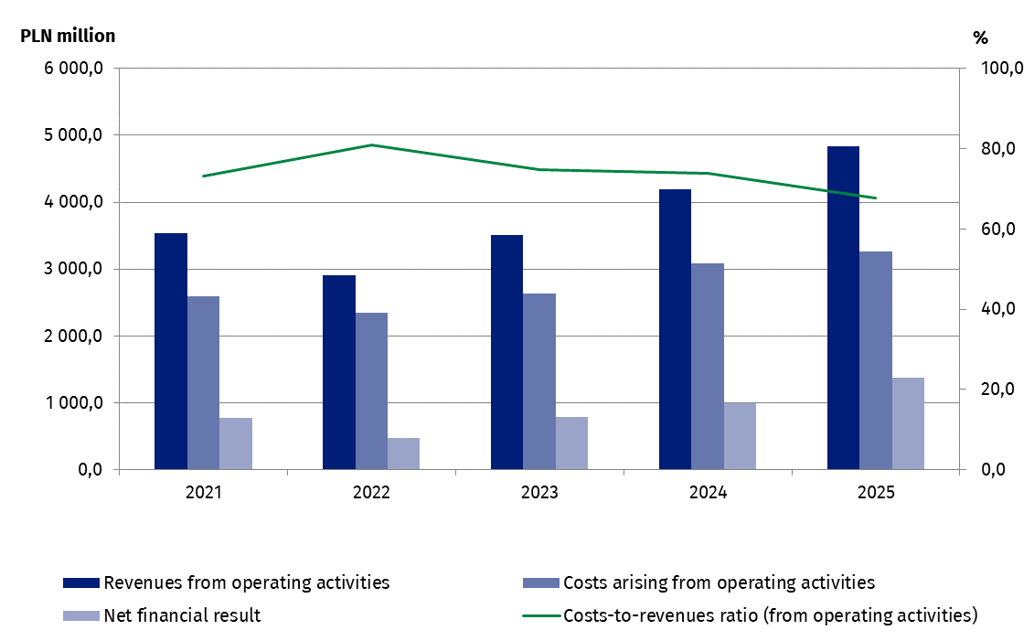
The gross financial result of TFI in 2025 amounted to 1,694.4 million PLN and was higher by 37.7% compared to the previous year. The net financial result of PLN 1,371.3 million was made up of the profits of 46 investment fund companies with a total value of PLN 1,394.2 million and of the loss of 10 investment fund companies amounting toPLN 22.8 million.

Table 2. Selected items of the profit and loss account of investment fund companies
TFI's net profit in 2025 amounted to PLN 1.4 billion
Specification | 2024 | 2025
Specification | in milion PLN |  | 2024=100
Revenues from operating activities | 4 186,7 | 4 832,4 | 115,4
of which:
remunerations for managing the funds | 4 037,2 | 4 695,9 | 116,3
Costs arising from operating activities | 3 089,3 | 3 267,1 | 105,8
of which:
external services | 1 794,8 | 1 890,3 | 105,3
Gross profit | 1 230,2 | 1 694,4 | 137,7
Net profit | 995,0 | 1 371,3 | 137,8

When quoting Statistics Poland data, please provide the information: “Source of data: Statistics Poland”, and when publishing calculations made on data published by Statistics Poland, please include the following disclaimer: “Own study based on figures from Statistics Poland”.

Prepared by:  Enterprise Statistics Department  Director Katarzyna Walkowska-Macias  Phone: (+48 22) 608 35 66 | Issued by:  Press Office  Mobile (+48) 695 255 032  Phone (+48 22) 608 38 04, (+48 22) 449 41 45,  (+48 22) 608 30 09  e-mail: obslugaprasowa@stat.gov.pl

stat.gov.pl/en/

@StatPoland

@GlownyUrzadStatystyczny

@gus_stat

@GłównyUrządStatystycznyGUS

@Glówny Urząd Statystyczny
Related information
Financial results of investment fund companies

Data available in databases
Macroeconomic Data Bank

Terms used in official statistics
Investment fund
Investment fund company

According to the data provided by the Polish Financial Supervision Authority on 3.03.2026 the total number of investment funds at the end of 2025 (including funds in liquidation) was 559, compared to 605 funds at the end of 2024. The decrease in the number of funds resulted mainly from the liquidation of closed-end investment funds.
The financial data presented in this news release concern 56 investment fund companies (TFI), including one TFI acquired by another in 2025.

