Statistics of Warszawa No. 1/2026
In January 2026, there was a decrease in the average employment and an increase in the number of unemployed persons compared to the corresponding period of previous year. Sold production of industry was higher than a year ago, while construction and assembly production was lower. Retail sale increased compared to January of the previous year, while wholesale decreased. January 2026 was characterised by a significantly lower number of dwellings completed than a year earlier.

Average paid employment
Average paid employment in the enterprise sector in January 2026 amounted to 1117.6 thousand persons (converted into full-time equivalents) and was by 0.6 thousand persons, i.e. by 0.05% smaller than in December 2025, and by 4.8 thousand persons, i.e. by 0.4% smaller than in January 2025.
Compared to December 2025, the decrease in the average employment was recorded in the following sections: administrative and support service activities (by 2.0%), accommodation and catering (by 1.5%), real estate activities (by 1.2%), transportation and storage (by 0.2%).
Whereas an increase in the average employment was recorded in the sections: construction as well as information and communication (by 0.7% each), professional, scientific and technical activities (by 0.5%), industry (by 0.3%), trade; repair of motor vehicles (by 0.2%).

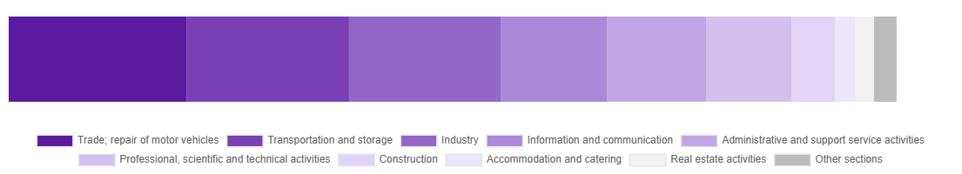
Chart 1. Structure of average paid employment by sections of PKD in January 2026

Compared to January 2025, a decrease in average employment was recorded in the sections: transportation and storage (by 3.6%), accommodation and catering (by 1.9%), trade; repair of motor vehicles (by 1.4%), real estate activities (by 1.3%), industry (by 0.3%), information and communication (by 0.2%).
An increase in average employment occurred in the sections: professional, scientific and technical activities (by 4.1%), construction (by 3.1%), administrative and support service activities (by 1.0%).

Registered unemployment*
At the end of January 2026, the number of registered unemployed persons amounted to 20082 and was by 128 persons, i.e. by 0.6% larger than at the end of December 2025 and by 943 persons, i.e. by 4.9% larger than in the corresponding period of 2025.
The number of registered unemployed women amounted to 9562, which accounted for 47.6% of the total unemployed (47.7% a month before and 46.9% a year before) and 16.7% of unemployed women in Mazowieckie Voivodship. As compared to December 2025, the number of unemployed women increased by 53 persons, i.e. by 0.6% and compared to January 2025 increased by 590 persons, i.e. by 6.6%.
The registered unemployment rate amounted to 1.5% (as in the previous month and 1.4% in the previous year), in Mazowieckie Voivodship it was 4.5% (4.3% a month before and 4.2% a year before), while in the country at a level of 6.0% (5.7% a month before and 5.4% a year before).
In January 2026, there were 3040 unemployed persons registered in labour offices (2492 in December 2025, and 2860 in January 2025). Registered unemployed persons accounted for 21.8% of the total registered unemployed in the Voivodship.
The number of persons registering for the first time amounted to 1141 (951 a month before), which accounted for 37.5% of the total unemployed who registered in January 2026 and 30.7% of persons registering for the first time in the Voivodship. The share of persons terminated due to company reasons among unemployed persons registered in January 2026 amounted to 4.0% (in Mazowieckie Voivodship 4.2%), 2.7% a month before and 3.2% a year before.
In January 2026, 2912 persons were removed from unemployment rolls (3638 in December 2025, and 2434 in January 2025), which accounted for 30.7% of unemployed persons removed from unemployment rolls in Mazowieckie Voivodship. Out of the unemployed removed from unemployment rolls, 1096 persons took up work. Moreover, 1592 persons lost their status of the unemployed as a result of not maintaining contact with the labour office at least once every 90 days. The reason for removing from the register was also starting training or traineeship, acquisition of retirement or pension rights, and others.

There were 17468 persons who were not entitled to the unemployment benefit, i.e. 87.0% of the total unemployed (16506 persons a year before, i.e. 86.2%), whereas 2614 unemployed persons were entitled to the unemployment benefit.

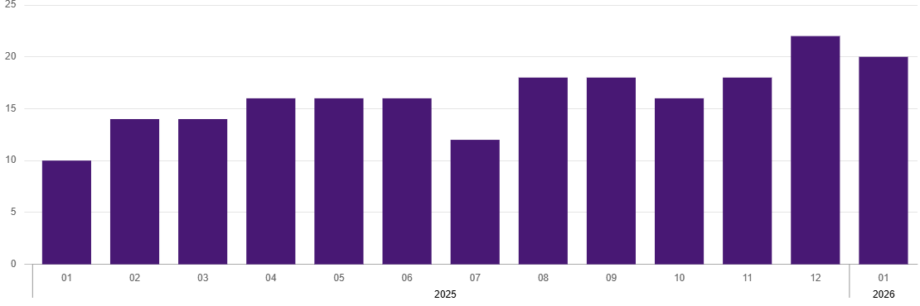
Chart 2. Number of unemployed persons per job offer (as of end of month)
* On 1 June 2025, the new Act on the Labour Market and Employment Services (Journal of Laws of 2025, item 620) entered into force, introducing changes to the rules for registering and recording unemployed persons. As a result, some published data has been adjusted to reflect the current legal status and statutory terminology, which may affect the comparability of current data with previous periods.
In January 2026, there were 1250 job offers submitted to labour offices, which accounted for 37.6% of job offers in Mazowieckie Voivodship and at the end this month the labour offices had job offers for 986 persons. At the end of January 2026, there were 20 persons per one job offer (22 in the previous month), while in Mazowieckie Voivodship, there were 39 persons (42 a month before) registered as unemployed.
Wages and salaries
The average monthly gross wages and salaries in the enterprise sector in January 2026 amounted to PLN 10847.21 and were by 5.7% lower as compared to the previous month and by 6.6% higher than in the corresponding period of 2025.
Compared to December 2025, a decrease in the average gross wages and salaries was recorded in the following sections: transportation and storage (by 16.5%), construction (by 11.7%), real estate activities (by 11.3%), industry (by 5.1%), professional, scientific and technical activities (by 4.8%), trade; repair of motor vehicles (by 1.9%), information and communication (by 1.8%).
Whereas an increase in the average wages and salaries was recorded in the section of accommodation and catering (by 8.8%) and administrative and support service activities (by 1.5%).
Compared to January 2025, an increase in the average gross wages and salaries was recorded in the sections: transportation and storage (by 11.7%), accommodation and catering (by 8.7%), information and communication (by 7.7%), real estate activities (by 7.4%), professional, scientific and technical activities (by 6.5%), industry (by 5.1%), trade; repair of motor vehicles (by 4.5%), administrative and support service activities (by 3.5%).
Whereas a decrease in the average gross wages and salaries was recorded in the section of construction (by 0.6%).

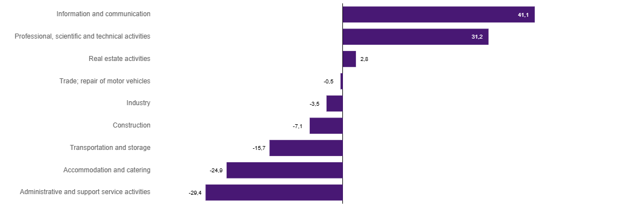
Chart 3. Relative deviations (in %) of monthly gross wages and salaries in selected sections from average wages and salaries in enterprise sector in Warszawa in January 2026

Construction
Sold production of construction in January 2026 amounted (at current prices) to PLN 4093.4 million and compared to December 2025 was smaller by 51.7% and compared to January 2025 it decreased by 25.6%.
Construction and assembly production in January 2026 amounted to PLN 963.4 million (at current prices) and accounted for 23.5% of sold production of construction. Compared to the previous year, construction and assembly production decreased by 57.5%, and compared to January 2025 it was smaller by 8.4%.
The decrease in production in relation to the corresponding period of 2025 occurred in units dealing with construction of buildings (by 11.9%), specialised construction activities (by 7.8%), and units dealing with civil engineering (by 5.5%).
Labour productivity measured by production per employed person in construction in January 2026 amounted to PLN 75.2 thousand and was by 52.0% lower than a month before and by 27.8% than in January 2025.

Trade
Retail sales in trade and non-trade enterprises in January 2026 (at current prices) were by 24.2% smaller than in December 2025 and by 4.7% higher compared to January 2025.
Compared to December 2025, the decrease was recorded in sales of newspapers, books, other retail sales in specialised stores (by 40.3%), sales of pharmaceuticals, cosmetics, orthopedic equipment (by 31.6%), sales of furniture, electronic goods and household equipment (by 30.6%), sales of textiles, clothing and footwear (by 29.6%), sales of food, beverages and tobacco (by 27.1%), , and sales in the “others” group (by 18.7%), sales of motor vehicles, motorcycles, parts (by 16.9%), other retail sales in non-specialised stores (by 11.8%), sales of solid, liquid and gas fuels (by 3.6%).
Compared to January 2025, there was an increase in other retail sales in non-specialised stores (by 45.5%), sales of textiles, clothing and footwear (by 14.6%), sales in the “others” group (by 12.3%), sales of pharmaceuticals, cosmetics, orthopedic equipment (by 9.0%), sales of newspapers, books, other sales in specialised stores (by 8.2%), and also sales of food, beverages and tobacco (by 4.4%), sales of furniture, electronic goods and household equipment (by 0.9%).
However, there was a decrease in sales of motor vehicles, motorcycles, parts (by 23.4%), sales of solid, liquid and gas fuels (by 6.1%).
Wholesale in trade enterprises in January 2026 (at current prices) was by 14.5% smaller as compared to the previous month and by 1.3% lower than in January 2025, and in wholesale enterprises it was lower by 11.1% and higher by 4.2%, respectively.

Industry
The sold production of industry in January 2026 amounted to (in current prices) PLN 16030.5 million and was (at constant prices) larger than in the corresponding month of 2025 by 7.5%. As compared to January 2025, an increase in sold production of industry was recorded in manufacturing by 4.3%.
Among the divisions classified as manufacturing, the increase in sales was recorded, among others, in: manufacture of textiles (by 97.1%), other manufacturing (by 72.3%), manufacture of machinery and equipment n.e.c. (by 36.1%), manufacture of furniture (by 27.7%), manufacture of computer, electronic and optical products (by 22.2%), manufacture of motor vehicles, trailers and semi-trailers (by 11.3%), repair and installation of machinery and equipment (by 8.3%), manufacture of beverages (by 6.6%), manufacture of food products (by 4.8%), manufacture of basic metals (by 3.9%), manufacture of chemicals and chemical products (by 0.1%).
The decrease in sales was recorded, among others, in: manufacture of wearing apparel (by 33.4%), manufacture of other non-metallic mineral products (by 21.5%), manufacture of products of wood, cork, straw and wicker (by 19.5%), manufacture of electrical equipment (by 18.3%), manufacture of metal products (by 14.7%), manufacture of coke and refined petroleum products (by 14.2%), manufacture of pharmaceutical products (by 10.8%), printing and reproduction of recorded media (by 9.8%), manufacture of paper and paper products (by 7.0%), manufacture of rubber and plastic products (by 2.7%).
Labour productivity in industry measured by production per employed person, in January 2026 amounted to PLN 84.0 thousand (at current prices) and was – at constant prices – by 7.9% higher than in the previous year.

Residential construction
According to preliminary data, 854 dwellings were completed in Warszawa in January 2026 (by 30.6% less than in the corresponding period of 2025), and in Mazowieckie Voivodship – 2983 dwellings, i.e. by 10.9% less than in January 2025. The decrease in sales was recorded in construction for sale or rent from 1153 to 804, i.e. by 30.3%, in private construction from 54 to 50, i.e. by 7.4%.

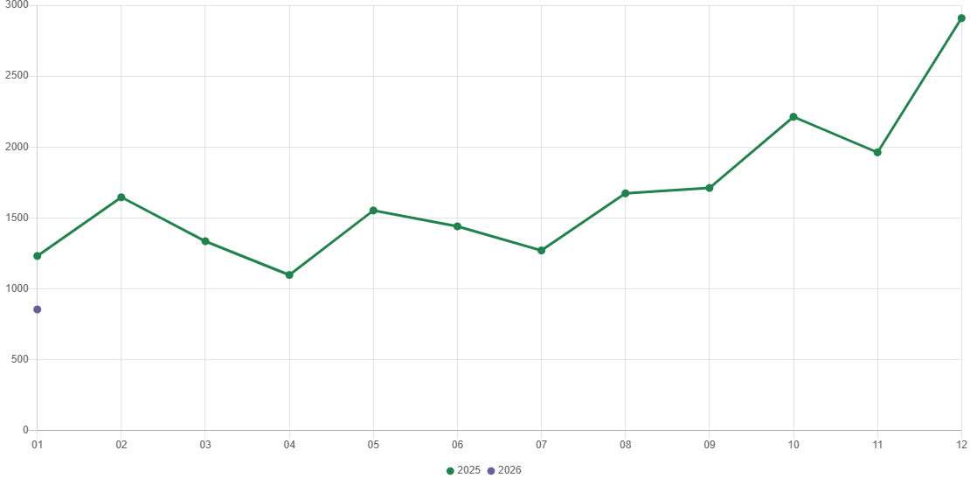
Chart 4. Dwellings completed

In January 2026, construction begun in 1477 dwellings (by 34.1% less than in the corresponding period of 2025) of which: 1458 in construction for sale or rent, 19 in private construction.
In January 2026, the number of dwellings for which permits have been granted or which have been registered with a construction project amounted to 1440 (by 181.8% more than in the corresponding period of 2025), of which 25 dwellings in buildings built by private investors.
The average useful floor area of a dwelling completed in January 2026, amounted to 71.5 m² and increased by 7.2 m². In private construction, the average useful floor area of dwellings amounted to 190.8 m² (by 6.1 m² less than in the corresponding period of 2025), in construction for sale or rent – 64.1 m² (by 5.5 m² more).

Entities of the national economy
At the end of January 2026, there were 600037 entities of the national economy registered in the REGON register in Warszawa, which accounted for 55.0% of the total in Mazowieckie Voivodship. Compared with December 2025, the number of entities of the national economy increased by 1086 (i.e. by 0.2%), and compared to January 2025 increased by 21023 (i.e. by 3.6%).
As of the end of January this year, there were 270806 legal persons and organisational units without legal personality registered in the REGON register, of which 196263 commercial companies. The number of these entities increased by 0.3% each compared to the previous month, and on an annual basis by 3.5% and 4.2%, respectively.
The number of registered natural persons conducting economic activity as of the end of January 2026 amounted to 329231 and compared to December 2025 it was higher by 0.1%, and compared to the corresponding period of the previous year increased by 3.7%.
In Warszawa, in January 2026, the most numerous were entities dealing with: professional, scientific and technical activities (19.4% of total registered units), trade; repair of motor vehicles (15.8%), as well as information and communication (13.0%).
Compared to December 2025, the number of entities increased, among others, in the sections: electricity, gas, steam and air conditioning supply (by 0.8%), administrative and support service activities (by 0.6%), agriculture, forestry and fishing and human health and social work activities (by 0.5% each), information and communication (by 0.4%), art, entertainment and recreation, education and construction (by 0.3% each). However there was a decrease in the number of entities in the sections: trade; repair of motor vehicles (by 0.2%), manufacturing (by 0.1%).
Compared to January 2025, the largest increase in the number of entities was recorded, among others, in the sections: administrative and support service activities (by 9.7%), electricity, gas, steam and air conditioning supply (by 7.3%), human health and social work activities (by 6.6%), education (by 6.1%), construction (by 5.5%), information and communication (by 4.8%), entertainment and recreation (by 4.2%), accommodation and catering (by 4.1%). Whereas a decrease was noted in the sections: trade; repair of motor vehicles (by 0.8%), water supply; sewerage, waste management and remediation activities (by 0.4%), and agriculture, forestry and fishing (by 0.1%).
In January 2026, 3492 new entities were entered into the REGON register, i.e. by 5.5% more than in the previous month. The newly registered entities were dominated by natural persons conducting economic activity – 2188 (by 12.6% more than in December 2025). The number of newly registered commercial companies was larger compared to the previous month by 1.5%, including limited liability companies larger by 0.8%.
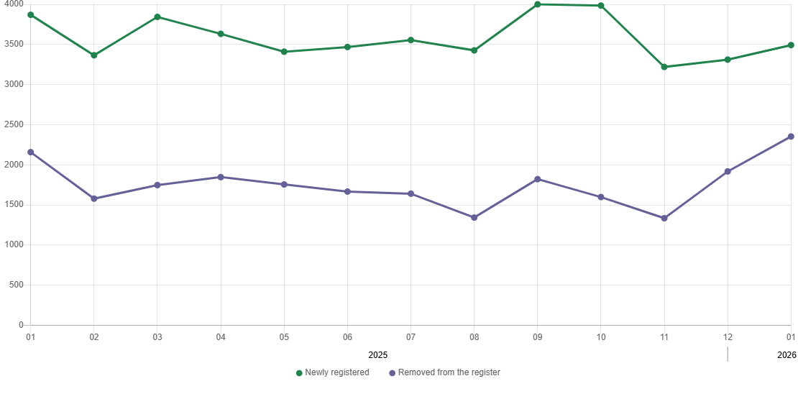
Chart 5. Entities newly registered and removed from the register

In January 2026, 2353 entities were removed from the REGON register (compared to 1918 in the previous month), including 1688 natural persons conducting economic activity (by 15.4% more).
As of the end of January 2026, 73889 entities had suspended activity in the REGON register (by 1.8% more than a month before). The vast majority were natural persons conducting economic activity (91.0%).

When quoting Statistics Poland data, please provide the information: “Source of data: Statistics Poland”, and when publishing calculations made on data published by Statistics Poland, please include the following disclaimer: “Own study based on figures from Statistics Poland”.
Prepared by:  Statistical Office in Warszawa  Director Agnieszka Ajdyn  Phone: (+48 22) 464 23 15 | Issued by:  Mazovian Centre for Regional Surveys  Information Centre  Mobile: (+48) 783 940 141
Press office in the Statistical Office  Mobile: (+48) 783 940 141  e-mail: m.kaluski@stat.gov.pl |   warszawa.stat.gov.pl/en/

@Warszawa_STAT

@UrzadStatystycznywWarszawie

gus_stat

glownyurzadstatystycznygus

glownyurzadstatystyczny

Related information
Communications and Announcements
Data available in databases
Local Data Bank → Labour market
Terms used in official statistics
Registered unemployed persons
Registered unemployment rate
Average paid employment
Average monthly gross wages and salaries
Dwellings completed

