The demand for labour in Mazowieckie Voivodship in 2025
At the end of 2025, 24.4 thousand job vacancies were recorded in the Voivodship, i.e. 0.1% more than the year before. The number of newly created jobs in 2025 decreased by 18.5% compared to the previous year, and the number of liquidated jobs increased by 3.8%. Per every 10 jobs liquidated, 17 were newly created.
0.1%
Increase in the numer of vacancies y/y
Demand for labour is the number of jobs that an economy offers under certain socio-economic conditions. The labour demand survey is carried out quarterly, it is representa-tive and covers entities of the national economy employing at least one person. As a result of the survey, data on newly created and liquidated jobs as well as data on the number of jobs filled and vacant, including those newly created and reported to labour offices, are obtained

Newly created and liquidated jobs
In total, there were 38.7 thousand more newly created jobs than those liquidated
From January to December 2025, 91.7 thousand new jobs were created in Mazowieckie Voi-vodship, i.e. less by 20.7 thousand (by 18.5%) than in the previous year. The largest contribution to the creation of jobs was made by microenterprises (up to 9 persons) in which 37.0 thousand new jobs were created (a decrease of 15.6% year-on-year); in entities with 10-49 employees, 22.7 thousand jobs were created (a decrease of 20.6%), and in entities employing 50 or more persons – 31.3 thousand (a decrease of 20.3%).
At the same time, 52.3 thousand jobs were liquidated, which means an increase by 1.9 thousand, i.e. by 3.8% compared to 2024. In the smallest units, 16.8 thousand jobs were liquidated (by 12.6% less than in the previous year), in units with the number of employees from 10 to 49 persons, 15.6 thousand (an annual increase by 19.2%), and in the largest entities – 19.9 thousand (an increase of 9.9%).
Chart 1. Newly created jobs and jobs removed from the register by size of reporting units in 2025

In each of the groups of units, the number of newly created jobs in 2025 exceeded the number of liquidated jobs. In the Voivodship, there were fewer than two newly created jobs for every liquidated job (1.7 compared to 2.2 a year before). In microenterprises this indicator reached the value of 2.2; in units with 10–49 employees it amounted to 1.5; in the largest entities 1.6.
The number of jobs created from January to December was almost twice as high as the number of jobs liquidated during the same period

Table 1. New jobs created and removed from the register by sections of PKD in 2025
In human health and social work activities, the number of newly created jobs was more than six times higher than the number of luquidated ones
PKD sections | Newly created |  | Liquidated
PKD sections | In thou-sands | 2024=100 | In thou-sands | 2024=100
Total | 91,0 | 81,5 | 52,3 | 103,8
Agriculture, forestry and fishing | 0,3 | 36,4 | 0,2 | 146,5
Mining and quarrying | 0,1 | 115,6 | 0,1 | 138,6
Manufacturing | 9,2 | 76,6 | 6,9 | 121,8
Electricity, gas, steam and air conditioning supply Δ | 0,3 | 83,0 | 0,1 | 115,5
Water supply; sewerage, waste management and remediation activities | 0,5 | 73,3 | 0,2 | 157,0
Construction | 12,3 | 110,6 | 5,5 | 81,5
Trade; repair of motor vehicles Δ | 16,3 | 64,5 | 12,2 | 111,4
Transportation and storage | 8,4 | 101,0 | 8,0 | 221,8
Accommodation and catering Δ | 3,0 | 95,4 | 1,2 | 61,3
Information and communication | 6,4 | 95,3 | 3,6 | 81,4
Financial and insurance activities | 3,5 | 97,3 | 1,8 | 86,1
Real estate activities | 1,3 | 117,0 | 0,6 | 87,7
Professional, scientific and technical activities | 10,4 | 74,9 | 5,4 | 125,0
Administrative and support service activities | 4,3 | 48,5 | 2,3 | 52,4
Public administration and national defence; compulsory social security | 3,1 | 135,7 | 0,7 | 97,1
Education | 7,0 | 104,1 | 2,1 | 75,4
Human health and social work activities | 2,7 | 59,8 | 0,4 | 40,6
Arts, entertainment and recreation | 0,9 | 111,6 | 0,6 | 314,6
Other service activities | 0,9 | 69,9 | 0,5 | 97,1
Note: the symbol Δ means that the categories of applied classification are presented in an abbreviated form.
Entities operating in the section of trade; repair of motor vehicles had the largest share in creating new jobs, but also in liquidating existing ones. 16.3 thousand, i.e. 18.0% of the total number of new jobs, were created in this section, and 12.2 thousand, i.e. 23.4%, were liquidated. Moreover, entities in the sections of construction (13.6%) and professional, scientific and technical activities (11.5%) had a significant share in the creation of new jobs, and in the sections of transportation and storage (15.3%) and manufacturing (13.1%) in liquidation.

Filled jobs and vacancies
The largest number of oc-cupied jobs were concen-trated in the trade; repair of motor vehicles section
At the end of 2025, the number of filled (occupied) jobs in Mazowieckie Voivodship amounted to 2,656.4 thousand (22.1% of such jobs in the country), which means an annual decrease by 13.5%, i.e by 0.5% (a decrease of 1.3% a year earlier). The largest decrease in the numer of filled jobs was recorded the section of trade; repair of motor vehicles (55.7 thousand, i.e. by 11.5%), and the largest increase in transportation and storage (by 20.5 thousand, i.e. by 8.3%). Entities operating in the trade; repair of motor vehicles section continued to account for the largest number of occupied jobs (16.1%), followed by manufacturing (13.7%) and transportation and storage (10.1%).
There were 24.4 thousand job vacancies (unoccupied), i.e. 0.1% more than in the previous year. The largest increase in the numer of vacancies was recorded in transportation and storage (by 1.1 thousand, i.e. by 46.3%), and the most significant decrease in construction (by 1.3 thousand, i.e. by 52.5%). Taking into account the type of economic activity, the largest number of jobs was recorded in enterprises operating in trade; repair of motor vehicles (18.4% of the total number of jobs that were unfilled at the end of 2025).
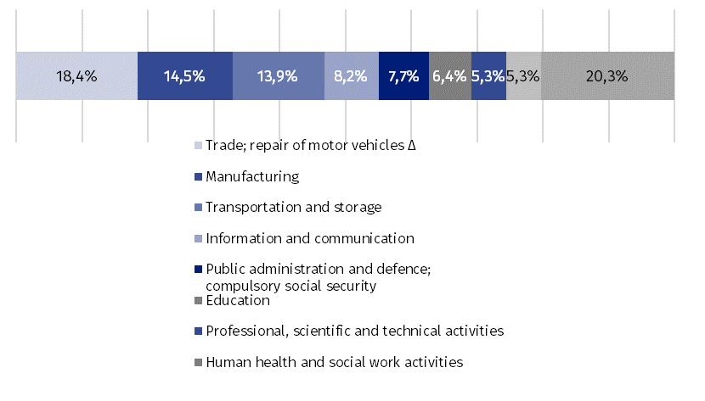
Chart 2. Job vacancies by sections of PKD at the end of 2025
At the end of the year, the largest number of job vacan-cies remained in trade; repair of motor vehicles
Note. Symbol Δ means that categories of applied classification presented in an abbreviated form.
Unoccupied jobs in the Voivodship accounted for 28.4% of job vacancies in the country (26.7% a year before). Of all positions that remained unfilled at the end of the year, 2.6 thousand, i.e. 10.5%, were reported to labour offices
Most of the vacancies were prepared for specialists; 8.4 thousand vacancies waited for persons working in the occupations included in this group, i.e. 34.7% of the total number. The next groups of professions in which the number of vacancies was relatively high were clerks – 3.0 thousand, i.e. 12.3% and plant and machine operators, and assemblers – 2.9 thousand, i.e. 12.0% of the total vacancies.

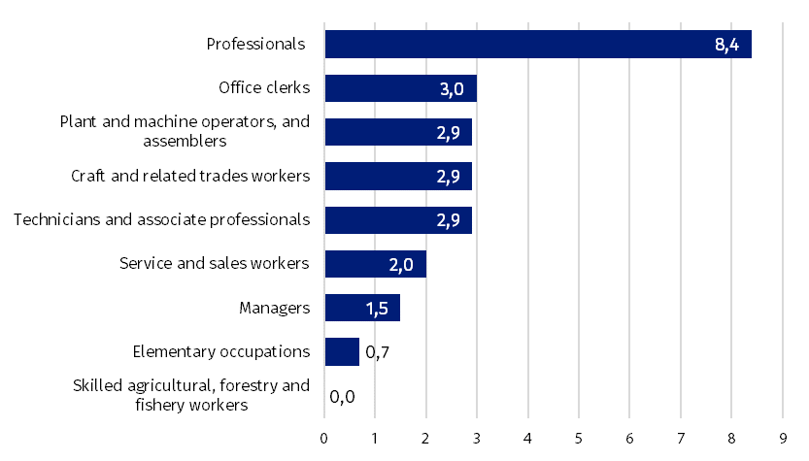
Chart 3. Job vacancies by groups of occupations at the end of 2023 (in thousands)
Note. Grouping of occupations is in line with the Occupations and Specializations Classification used in the labour market statistics.
One of the measures enabling the assessment of the situation on the labour market is the job vacancy rate, which determines the share of vacancies in the total of occupied and unoccupied jobs in a given period. At the end of 2025, this indicator totaled 0.91%. This means that 0.91% of the total jobs in the Voivodship (occupied and vacant) remained unfilled (0.90% the year before).
The highest rate of job vacancies at the end of the year was recorded in the other service activities section
Comparing the vacancy rate in units depending on the type of activity, it can be stated that the highest value was in the other service activities section (1.76%), followed by public administration and national defence; compulsory social security (1.49%) and water supply; sewerage, waste management and remediation activities (1.45%). On the other hand, it was the lowest in mining and quarrying (0.16%), agriculture, forestry and fishing (0.27%), as well as in the section of administrative and support service activities (0.35%).
The same measure is slightly more diversified in individual groups of occupations. The highest rate of job vacancies at the end of 2025 was recorded in the group of industrial workers and craftsmen where it amounted to 1.47%, followed by plant and machine operators and assemblers (1.20%) as well as technicians and associate professionals (1.12%). The lowest was recorded in the skilled agricultural, forestry and fishery workers occupational group (0.09%). Compared to the end of 2024, the vacancy rate was higher in five groups of occupations, and the largest increase was recorded in the group of technicians and associate professionals.
In entities employing up to 9 persons, the rate of job vacancies was the highest
Depending on the size of the entity, the highest job vacancy rate was recorded in microenterprises, where it reached 1.60%, exceeding the voivodship average. In the largest entities (employing at least 50 persons), it was 0.84%, and in entities employing 10 to 49 persons, it was the lowest – 0.69%.

When quoting Statistics Poland data, please provide the information: “Source of data: Statistics Poland”, and when publishing calculations made on data published by Statis-tics Poland, please include the following disclaimer: “Own study based on figures from Statistics Poland”.

Prepared by:  Statistical Office in Warszawa  Director Agnieszka Ajdyn  Phone: (+48 22) 464 23 15 | Issued by:  Statistitcal Information Centre  Marcin Kałuski  Mobile: (+48) 783 940 141
Press office in the Statistical Office in Warszawa  Mobile: (+48) 783 940 141  e-mail: m.kaluski@stat.gov.pl |   warszawa.stat.gov.pl/en/

@Warszawa_STAT

@UrzadStatystycznywWarszawie

gus_stat

glownyurzadstatystycznygus

glownyurzadstatystyczny

Related information
Methodological report. Demand for labour
The demand for labour in 2024
The demand for labour quarter 4 2025 - Statistics Poland publication
Data available in databases
Local Data Bank – labour market/vacancies
Terms used in official statistics
Demand for labour
Newly created jobs
Vacancies
Liquidated jobs
Classifications used
Polish Classification of Activities (PKD)
Occupations and Specializations Classification

