Economic activity of population in Mazowieckie Voivodship in Q2 2025
29.3%
Decrease in the number of unemployed persons compared
to the previous quarter

29 September 2025
In Q2 2025, there was a decrease in the number of unemployed persons and economically inactive persons compared to Q1 2025. Unemployed men looked for a job shorter than women, and unemployed urban residents shorter than rural residents.

Economic activity of population aged 15–89 according to LFS
Almost 38% of population aged 15-89 did not work

In the second quarter of 2025, among the total population of Mazowieckie Voivodship aged 15-89, 62.3% represented employed persons, 1.4% – unemployed, and 36.3% ¬– economically inactive persons. This means that less than half of the population aged 15-89 (37.7%) did not work. In urban and rural areas this structure looked similar. However, significant differences were visible in the structure of men and women. 42.3% of women and 32.8% of men remained unemployed (economically inactive and unemployed).
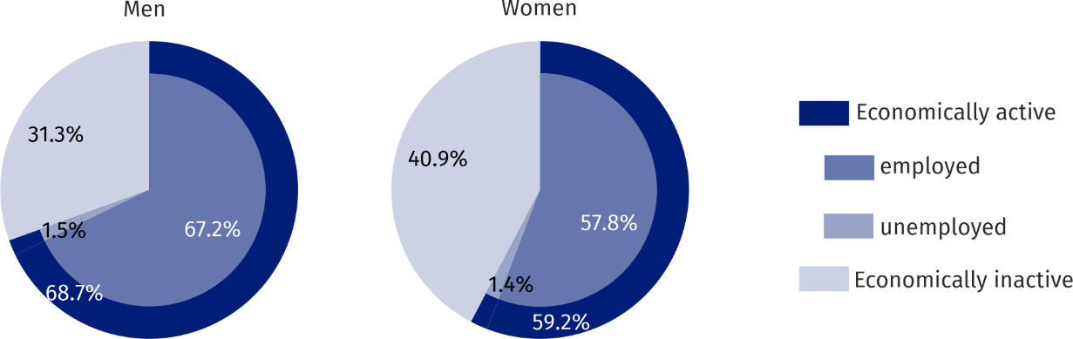
Chart 1. Structure of population aged 15-89 by sex in Q2 2025
Compared to the first quarter of 2025, the number of unemployed persons decreased by 29.3%, and the number of employed persons increased by 1.4%. On the other hand, the number of economically inactive persons decreased by 0.5%. A decrease in the ratio of non-working population over working population was observed as well. In the second quarter of 2025, there were 606 unemployed and economically inactive persons per 1,000 employed persons (by 22 employed person more than in the first quarter of 2025).
There were 606 unemployed and economically inactive persons per 1,000 employed persons

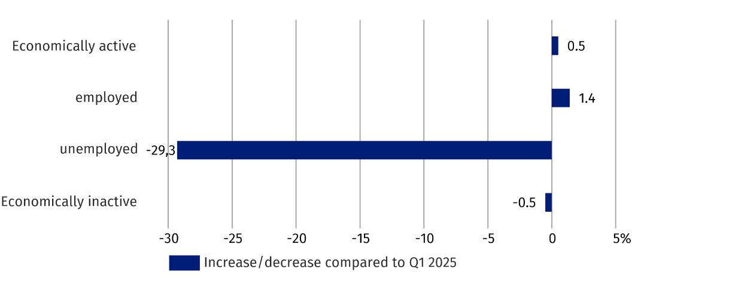
Chart 2. Changes in the economic activity of population compared to Q1 2025
The economic activity rate was 63.7% and increased by 0.3 pp compared to the previous quarter. There was a decrease in the level of economic activity among men (0.8 pp), and an increase among women (by 1.2 pp). This indicator decreased in urban areas (by 0.7 pp), but increased in rural areas (by 2.0 pp).
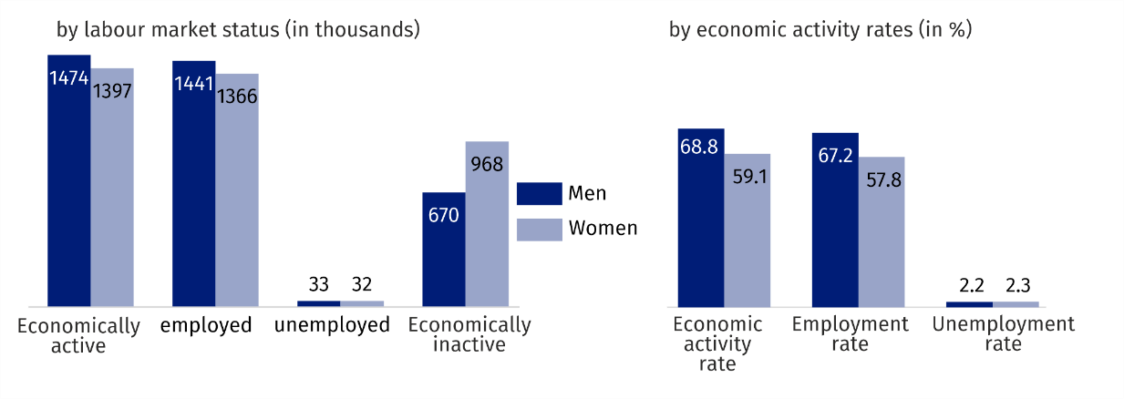
Chart 3. Economic activity of population in Q2 2025

The highest value of the rate in terms of age was recorded for the age group 35–44, which amounted to 93.6%, while the lowest among persons aged 55-89 (31.5%). For working age population, this rate was 85.2%.

Employed persons
In the second quarter of 2025, in Mazowieckie Voivodship, the population of employed per-sons counted 2807 thousand persons, and the employment rate was estimated at 62.3% and increased by 0.9 pp compared to the previous quarter.
Compared to the first quarter of 2025, the number of employed persons increased by 1.4%. There was an increase among women (by 3.6%), and decrease among men (by 0.6 pp). The number of employed persons increased in urban areas (by 0.2%) and in rural areas (by 3.9%).
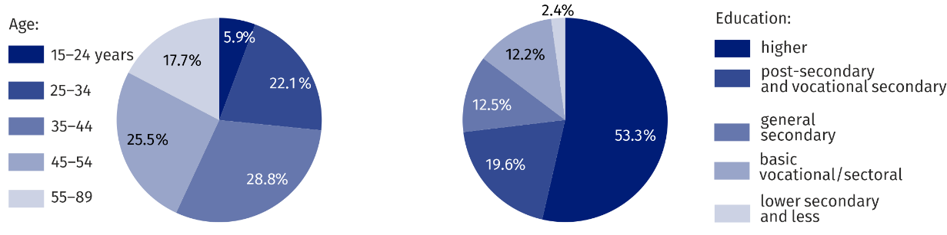
Chart 4. Structure of employed persons by age and education Q2 2025

In the second quarter of 2025, the highest employment rate was recorded among persons aged 35–44 (92.0%), and the lowest among persons aged 15-24 (30.9%). The highest increase of the rate was recorded among persons aged 25–34 (by 1.5 pp). The employment rate for working age population amounted to 83.2% (an increase of 0.2 pp compared to the first quarter of 2025).
Among employed persons according to the level of education, the highest employment rate recorded persons with higher education – 83.3%, and the lowest among persons with lower secondary and less education – 13.6%. The highest increase in the employment rate occurred among persons with tertiary education (by 1.5 pp), and the highest drop among employed persons with post-secondary, vocational secondary and sectoral vocational education (by 0.6 pp).
In the second quarter of 2025, there were 2192 thousand persons employed in the public and private sector (i.e. 78.1% of total employees), and their number increased by 1.0% compared to the first quarter of 2025. There was an increase both among contributing family workers (from 24 thousand to 26 thousand), and an increase among employers and self-employed persons (from 573 thousand to 589 thousand).
More than 68% of total employed persons worked in the private sector

The vast majority of employed persons supported the private sector (68.2% of the total). Of these, the majority (51.5%) were men. The situation was different among persons employed in the public sector, where women predominated among 697 thousand employed persons (61.8%). There were 85.7% of employees employed for an indefinite period (a 0.1 pp decrease compared to the first quarter of 2025).
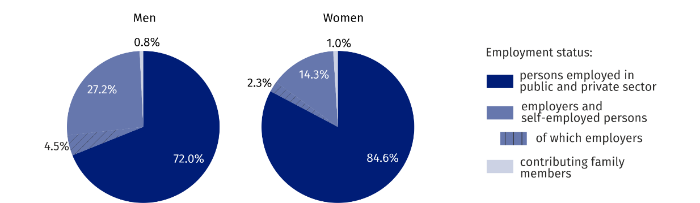
Chart 5. Structure of employed persons by employment status in the second quarter of 2025
27% of men and more than 14% of women worked as employers and self-employed persons

Unemployed persons
The number of unemployed men decreased by more than 21%, and women by 36%

In the second quarter of 2025, the population of unemployed persons (aged 15-74) in Ma-zowieckie Voivodship amounted to 65 thousand persons and decreased by 29.3% compared to the first quarter of 2025. Compared to the previous quarter, the number of unemployed men decreased (by 21.4%), as well as the number of women (by 36.0%). There was a decrease both among urban residents (by 37.1%), and among rural residents (by 16.1%).
The total unemployment rate in the Voivodship amounted to 2.3% and decreased by 0.9 pp compared to the first quarter of 2025. It was 2.1% In urban areas (by 0.5 pp lower than in rural areas). For working age population the unemployment rate was 2.3%.
Compared to the first quarter of 2025, the unemployment rate decreased both among men (by 0.6 pp), and women (by 1.4 pp). There was an increase both in urban areas (by 1.2 pp), and in rural areas (by 0.6 pp).
Unemployed men looked for a job shorter than women, and urban residents shorter than rural residents

An average time of job seeking by unemployed persons amounted to 8.4 months. Men looked for a job for 8.3 months on average (by 0.1 months shorter than women), and urban residents for 8.2 months (by 0.4 months shorter than rural residents).

Economically active persons
Women predominated among economically inactive persons (more than 59%)
In the second quarter of 2025, in Mazowieckie Voivodship, 1637 thousand persons remained economically inactive, which accounted for 36.3% of total population aged 15-89 (in urban areas – 36.5% and in rural areas – 36.0%). Women were the majority in this population – 59.1%. Among economically inactive persons, persons with lower secondary and less education predominated – 25.4%. Working age population made up 28.8% of total economically inactive persons.
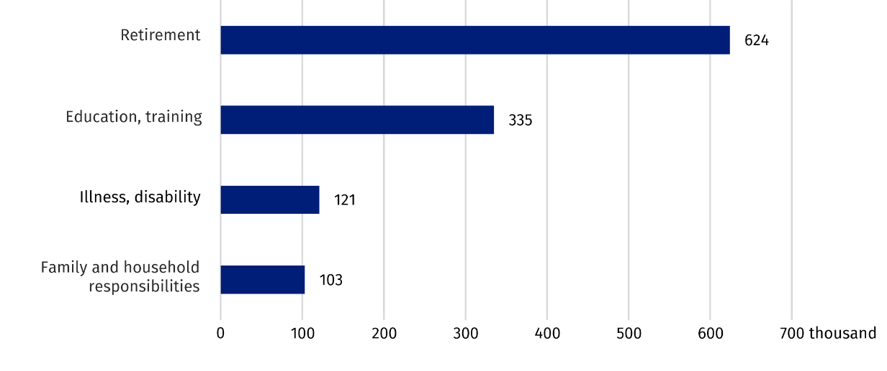
Chart 6. Economically inactive persons aged 15–74 by selected causes of economic inactivity in Q2 2025

Compared to Q1 2025, the economically inactive population decreased by 0.5% (an increase of 2.9% among men, a decrease of 2.8% among women). Considering the place of residence, there was an increase in the number of economically inactive persons among urban residents (by 2.0%), and a decrease among rural residents (by 5.1%).
Out of total economically inactive persons (aged 15-74), 50.2% accounted for persons who did not seek work because of being retired. Other reasons for economic inactivity were: education and training – 27.0%, illness or disability – 9.7%, family and household responsibilities – 8.3%.

When quoting Statistics Poland data, please provide the information: “Source of data: Statistics Poland”, and when publishing calculations made on data published by Statistics Poland, please include the following disclaimer: “Own study based on figures from Statistics Poland”.

Prepared by:  Statistical Office in Warszawa  Director Agnieszka Ajdyn  Phone: (+48 22) 464 23 15 | Issued by:  Statistical Information Centre  Mobile: (+48) 783 940 141  e-mail: m.kaluski@stat.gov.pl

warszawa.stat.gov.pl/en/

@Warszawa_STAT

@UrzadStatystycznywWarszawie

gus_stat

glownyurzadstatystycznygus

glownyurzadstatystyczny

Related information
Methodological report. Labour force survey
Labour Force Survey in Poland
Employed, unemployed and economically inactive persons (preliminary LFS results)

Data available in databases
Local Data Bank /Labour market

Terms used in official statistics
Activity rate by LFS
Employment rate by LFS
Unemployment rate

